An Explainable Machine Learning Approach for Credit Risk Prediction
Abedalaziz Abualhayja'a
Computer Engineering Department
Princess Sumaya University for Technology
Amman, Jordan

Abstract—Credit risk prediction is an important problem in financial decision-making because it helps estimate whether a loan applicant is likely to repay a loan or become a bad credit risk. In this project, an explainable Machine Learning (ML) approach was applied to the Statlog German Credit dataset. The dataset contains 1,000 applicants with 20 input features related to credit history, financial status, employment, and personal background. The target variable was converted to binary, with 0 indicating good credit risk and 1 indicating bad credit risk. Since the dataset contains both numerical and categorical features, numerical features were scaled, and categorical features were transformed using one-hot encoding. Four supervised models—Logistic Regression (LR), Decision Tree (DT), Random Forest (RF), and Histogram-Based Gradient Boosting (HGB)—were trained for direct comparison on predictive performance. Each model was evaluated using accuracy, precision, recall, F1-score, and Receiver Operating Characteristic-Area Under the Curve (ROC-AUC). Logistic Regression achieved the highest recall of 0.800 and the highest ROC-AUC of 0.806, making it the most suitable model for identifying bad credit risk in this dataset. For explainability, LR coefficients, RF feature importance, and Shapley Additive Explanations (SHAP) were analyzed. The explainability results showed that account status, loan duration, credit amount, credit history, savings status, and age were among the most impactful features. These findings show how model comparison and interpretability together support transparent credit risk prediction.

Keywords—credit risk prediction; explainable machine learning; Logistic Regression; Random Forest; SHAP; German Credit dataset.

I. INTRODUCTION
Credit risk prediction is important in banking and finance, as it estimates whether a loan applicant will repay the loan or become a bad credit risk. Incorrect decisions can result in financial loss for banks and unfair outcomes for applicants. Credit scoring uses applicant information and past credit behavior to support lending decisions [1].
A Machine Learning (ML) approach can be used to predict credit risk by learning patterns from historical data. Instead of depending only on fixed rules, ML models use various applicant features, such as checking account status, credit history, loan duration, credit amount, savings status, employment period, housing, and age. These features can help the model classify whether the applicant is a good or bad credit risk. Previous studies have shown that various ML models, such as Logistic Regression (LR), Decision Trees (DT), Random Forests (RF), and boosting models, have been applied to credit scoring and credit prediction tasks [2].

Credit risk prediction is not only about achieving high accuracy. The model should also be understandable because lending decisions directly affect people. If an applicant is classified as a bad credit risk, it is important to know which features contributed to that decision. Some models provide predictions without clear explanations, which may reduce trust in the model, especially in financial applications where transparency is important [3].

Explainable Machine Learning shows which features affect predictions, making decisions clearer. For instance, LR coefficients indicate whether a feature raises or lowers bad credit risk probability. RF feature importance identifies the most useful features for prediction. SHAP explains both overall model behavior and single predictions [4], improving transparency and analysis.

In this project, an explainable ML approach was applied to the Statlog German Credit dataset from the University of California, Irvine (UCI) Machine Learning Repository. The dataset contains 1,000 applicants and 20 input features related to financial status, loan information, and personal background [5]. The target variable groups applicants into good credit risk or bad credit risk. This feature was converted to a binary format, where good credit risk is represented by 0 and bad credit risk by 1. In the preprocessing stage, categorical features were transformed using one-hot encoding, and numerical features were scaled.

Four supervised models were trained and compared: LR, DT, RF, and Histogram-Based Gradient Boosting (HGB). These models were evaluated using accuracy, precision, recall, F1-score, and Receiver Operating Characteristic-Area Under the Curve (ROC-AUC). Since the main goal is explainability, LR coefficients, RF feature importance, and SHAP were used to interpret influential factors and individual predictions.

This project is structured to support both accuracy and explainability in credit risk modeling. Section II reviews the literature; Section III describes data and preprocessing; Section IV covers algorithms; Section V presents results and the explainability analysis; and Section VI concludes.

II. LITERATURE REVIEW
Credit scoring has been studied over the years as a classification problem in which applicants are classified as good or bad credit risk. Hand and Henley reviewed classification methods used in credit scoring and explained that credit scoring mainly involves classifying applicants as good or bad risk [1]. Traditional statistical methods such as Logistic Regression, discriminant analysis, and scorecards were widely used because they are simple and understandable.
With the growth of Machine Learning (ML), more advanced models have been used for credit risk prediction. Lessmann et al. compared multiple state-of-the-art classification algorithms for credit scoring and showed that different models can be evaluated and compared using different performance metrics [2]. Their work showed that credit scoring should not rely on a single model but should compare multiple models to identify the best approach. This is the method used in this project, where LR, DT, RF, and HGB were trained and evaluated.

In addition, explainability has become an important issue in financial ML applications. Bussmann et al. proposed an explainable Artificial Intelligence (AI) model for credit risk prediction and pointed out the importance of understanding the factors underlying these predictions [3]. This is important because credit decisions directly affect applicants, and a model that makes predictions without an explanation can be difficult to trust.
Explainability methods such as Shapley Additive Explanations (SHAP) have been used to understand ML model predictions. Lundberg and Lee introduced SHAP as a unified framework to understand model predictions by giving each feature an importance value for a certain prediction [4]. This is important because it helps identify the features that are important and why an applicant was classified as a good or bad credit risk.
The Statlog German Credit dataset has been widely used as a benchmark for credit risk prediction. The dataset contains 1,000 instances and 20 features, with a target variable that classifies each applicant as a good or a bad credit risk [5]. Because the dataset is small and has a clear binary target, it is suitable for ML model comparison and explainability techniques. In this project, this dataset was used to evaluate a credit risk prediction approach. The project differs from a typical classification task by focusing not only on model performance but also on explaining model behavior using LR coefficients, RF feature importance, and SHAP.

III. EXPERIMENTAL SETUP
- Dataset Description
The dataset used in this project is the Statlog German Credit dataset obtained from the University of California, Irvine (UCI) Machine Learning Repository [5]. The dataset contains 1,000 instances and 20 features. Each instance represents a loan applicant, and the target label classifies the applicant as a good or bad credit risk.

The original target labels ranged from 1 to 2, with 1 indicating a good risk and 2 indicating a bad risk. In this project, the target label was converted to a binary format. Good credit risk was encoded as 0, and bad credit risk was encoded as 1.

The dataset contains categorical and numerical features. Categorical features include checking account status, credit history, loan purpose, savings status, employment duration, personal status, property type, housing, job type, telephone status, and foreign worker status, and numerical features include loan duration, credit amount, installment rate, residence duration, age, number of existing credits, and number of dependents.

The dataset is suitable for this project because it was widely used for credit risk classification. It also enables both model comparison and explainability analysis due to the mixture of features, which is the core of this project.

- Dataset Attribute Information
Table I presents the main attributes in the dataset. The table includes the attribute name, type, and a short description of its meaning.

TABLE I
DATASET ATTRIBUTE INFORMATION
Attribute | Type | Description
checking_status | Categorical | Existing checking account status
duration_months | Numerical | Loan duration in months
credit_history | Categorical | Previous credit history
purpose | Categorical | Purpose of the loan
credit_amount | Numerical | Requested credit amount
savings_status | Categorical | Savings account status
employment_since | Categorical | Current employment duration
installment_rate | Numerical | Installment rate of income
personal_status_sex | Categorical | Personal status and sex
other_debtors | Categorical | Debtors or guarantors
residence_since | Numerical | Current residence duration
property | Categorical | Property type
age | Numerical | Applicant age
other_installment_plans | Categorical | Other installment plans
housing | Categorical | Housing status
existing_credits | Numerical | Existing bank credits
job | Categorical | Job category
num_dependents | Numerical | Number of dependents
telephone | Categorical | Registered telephone status
foreign_worker | Categorical | Foreign worker status
target | Categorical | Original credit risk label
target_binary | Binary | 0 = good, 1 = bad credit risk

The dataset uses coded categorical values such as A11, A34, and A43. These values represent categories defined in the dataset documentation. For example, the checking account status feature includes categories A11, A12, A13, and A14.

- Exploratory Data Analysis
Exploratory Data Analysis (EDA) was performed before training the models to understand the dataset better. The dataset was first loaded and checked for its shape, data types, missing values, and target distribution. The dataset contained 1,000 rows and 21 columns, including 20 input features and 1 original target column. After creating the binary target, the processed dataset included the target_binary column.

The dataset had no missing values, so missing-value imputation was not required. The target class distribution showed that the dataset is imbalanced. It had 700 good-risk applicants and 300 bad-risk applicants. This means that 70% of the dataset belongs to the good credit risk class, and only 30% belongs to the bad credit risk class.

TABLE II
TARGET CLASS DISTRIBUTION
Class | Meaning | Count | Percentage
0 | Good Credit Risk | 700 | 70%
1 | Bad Credit Risk | 300 | 30%

The target class distribution is shown in Fig. 1. Because the dataset is imbalanced, accuracy alone cannot evaluate model performance. Therefore, additional metrics such as precision, recall, F1-score, and Receiver Operating Characteristic-Area Under the Curve (ROC-AUC) were added.
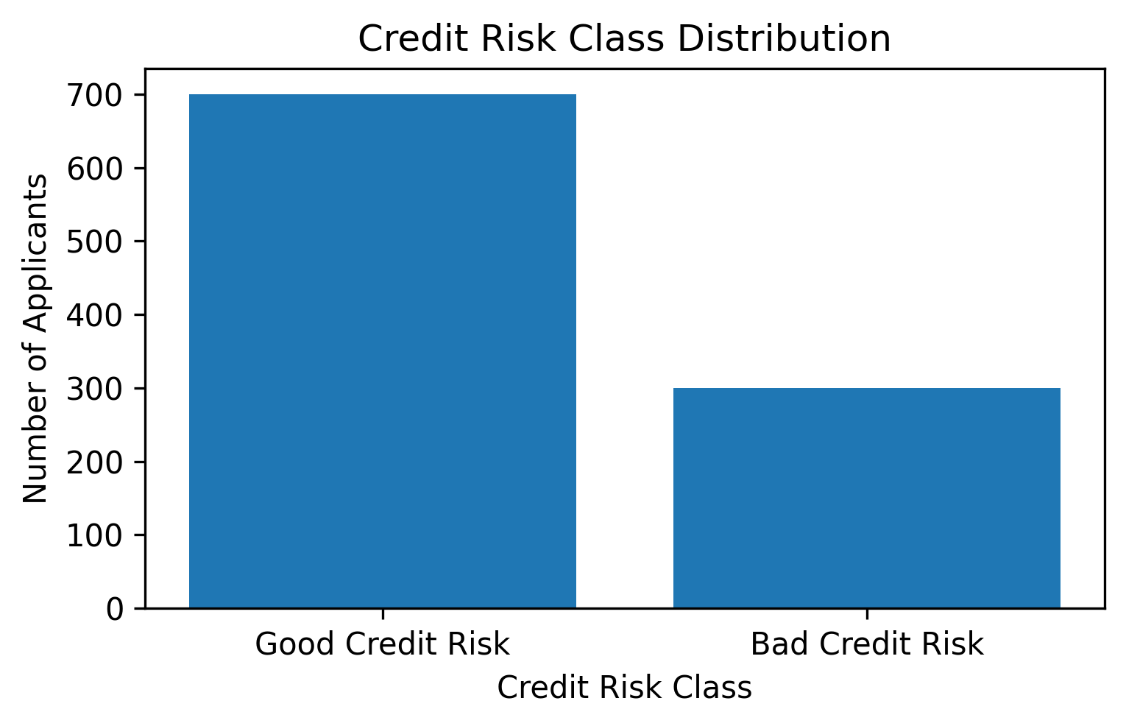
Fig. 1. Credit risk class distribution.

- Data Preprocessing
Several data preprocessing steps were applied to the dataset before training the model. First, the target label was converted to a binary format. In the original dataset, 1 was mapped to 0 to represent good credit risk, and 2 was mapped to 1 to represent bad credit risk.

Second, the features were separated into numerical and categorical features. Numerical features were standardized using z-score normalization. This was done because numerical features had different scales. For example, the credit amount can be in the thousands, while the number of dependents is much smaller. The effect of different scales is reduced by standardization, especially for models such as Logistic Regression.

The standardization formula is shown in Equation (1):

$$z=\frac{x-μ}{σ}$$
where x is the original value, μ is the mean, and σ is the standard deviation.

Categorical features were transformed using one-hot encoding. This is necessary because the dataset contains categorical codes such as A11, A34, and A43 that most models cannot interpret directly. One-hot encoding converts each category into a separate binary column, which avoids treating categories as ordered numerical values.

Preprocessing was implemented using ColumnTransformer and Pipeline from the Scikit-learn library. This allowed numerical and categorical features to be processed separately. The full dataset was split into 80% training data and 20% testing data. A stratified split was used to maintain class ratios in both the training and test sets.

- Experimental Environment
The implementation was completed using Python. The main libraries used were:
- pandas for data loading and manipulation
- NumPy for numerical values
- Matplotlib for visualization
- Scikit-learn for preprocessing and model training
- SHAP for explainability analysis
- joblib for saving trained models
The experiments were developed using Visual Studio Code and Jupyter Notebook files. The project files were split into separate folders for raw data, processed data, notebooks, figures, tables, and saved models.

IV. ALGORITHMS
After the dataset was prepared as described in Section III, four supervised Machine Learning (ML) classifiers were trained and evaluated. The models were Logistic Regression (LR), Decision Tree (DT), Random Forest (RF), and Histogram-Based Gradient Boosting (HGB).

All models were trained and tested using the same split: 80% training and 20% testing. The same feature groups were applied to all models to ensure a fair comparison. The data preprocessing steps, including standardization and encoding, were applied using Scikit-learn pipelines before training [6].

- Logistic Regression
Logistic Regression (LR) was used as the baseline model. It predicts the probability that an applicant belongs to the bad-credit-risk class [7]. LR was selected because it is simple, widely used in classification problems, and interpretable through its coefficients.

In LR, each feature is assigned a coefficient. A positive coefficient increases the predicted probability of the positive class, and a negative coefficient decreases it. Since the positive class in this project is the bad credit risk class, the coefficients can be used to understand which features increase or reduce credit risk.

- Decision Tree
A Decision Tree (DT) classifier was trained as a simple non-linear model. DT works by splitting the dataset into smaller groups based on feature values until a final decision is made. This model can be understood as a sequence of if-else rules, which makes it easy to understand [8].

The DT model was used because it can capture non-linear relationships between the input features and the target. However, decision trees can easily overfit the training data if the depth is not controlled. In this project, the maximum depth was limited to reduce overfitting and improve generalization on unseen data.

- Random Forest
Random Forest (RF) was used as an ensemble learning model. RF builds multiple decision trees and combines their predictions to produce a more robust result [9]. Instead of relying on a single tree, RF averages the outputs of many trees, reducing variance.

RF was included in this project because it performs better than a single DT in many tabular tasks and can capture non-linear feature interactions. It is also useful for the explainability part of this project because it provides feature importance values. These values help identify which features contributed most to the prediction.

- Histogram-Based Gradient Boosting
Histogram-Based Gradient Boosting (HGB) was used as a boosting-based model. It works by sequentially training weak learners, with each new learner attempting to correct the errors of the previous learners [10]. This allows the model to detect complex patterns in the dataset.

HGB was included because boosting-based models usually perform well on tabular data. In this project, HGB was used to compare boosting performance with the simpler LR model and RF ensemble model. To control complexity, the learning rate and the maximum number of leaf nodes were limited.

- Model Parameters
The main parameters for each model are shown in Table III.

TABLE III
MODEL PARAMETERS USED IN THE EXPERIMENTS
Model | Parameters
Logistic Regression | max_iter = 1000; class_weight = balanced; random_state = 42
Decision Tree | max_depth = 5; class_weight = balanced; random_state = 42
Random Forest | n_estimators = 300; max_depth = 8; class_weight = balanced; random_state = 42
Histogram-Based Gradient Boosting | max_iter = 200; learning_rate = 0.05; max_leaf_nodes = 15; random_state = 42

Balanced class weights were used in LR, DT, and RF because the dataset contains more good-credit-risk applicants than bad-credit-risk applicants. This gives more importance to the minority class during training. Depth parameters were limited in DT and RF to reduce overfitting. For HGB, the learning rate and maximum number of leaf nodes were selected to control the learning process and model complexity.

- Evaluation Method
All models were evaluated using the same test set. The evaluation metrics used were accuracy, precision, recall, F1-score, and Receiver Operating Characteristic-Area Under the Curve (ROC-AUC). Since the dataset is imbalanced, accuracy alone is not sufficient to measure model performance. Recall and ROC-AUC were especially important because the main goal is to identify bad credit risk applicants, and failing to detect a bad risk applicant may lead to financial loss.

- Explainability Methods
Explainability methods were applied after model training to understand how the models made their predictions. LR coefficients were used to analyze the direction and strength of each feature. RF feature importance was used to identify the influential features in the ensemble model. In addition, SHAP was applied to the RF model to explain both global feature influence and individual applicant predictions [11].

SHAP was used because it assigns each feature a contribution value to the prediction, making it easier to explain why each applicant was predicted as high or low risk. The explainability stage supported the project's main goal: building a credit risk prediction model that is not only predictive but also explainable.

V. RESULTS AND ANALYSIS
- Evaluation Metrics
The models were evaluated using accuracy, precision, recall, F1-score, and Receiver Operating Characteristic-Area Under the Curve (ROC-AUC). These metrics were selected because the dataset is imbalanced, with 70% good-credit-risk applicants and 30% bad-credit-risk applicants. Therefore, accuracy alone is not enough to judge model performance.

Accuracy measures the overall percentage of correct predictions. Precision measures how many applicants predicted as bad credit risk were actually bad credit risk. Recall measures how many actual bad credit risk applicants were correctly detected. F1-score provides a balance between precision and recall. ROC-AUC measures the ability of the model to separate good credit risk applicants from bad credit risk applicants at different thresholds.

In this project, recall and ROC-AUC were especially important because the positive class represents the bad credit risk. Missing a bad-credit risk applicant is more harmful in lending because it means approving a risky applicant incorrectly.

- Model Comparison Results

TABLE IV
MODEL COMPARISON RESULTS
Model | Accuracy | Precision | Recall | F1-score | ROC-AUC
Logistic Regression | 0.750 | 0.558 | 0.800 | 0.658 | 0.806
Decision Tree | 0.570 | 0.377 | 0.667 | 0.482 | 0.599
Random Forest | 0.755 | 0.590 | 0.600 | 0.595 | 0.803
Histogram-Based Gradient Boosting | 0.765 | 0.644 | 0.483 | 0.552 | 0.797

From Table IV, HGB achieved the highest accuracy, 0.765. However, its recall was 0.483, indicating that it missed many bad-credit risk applicants. This is not ideal for credit risk prediction, as the main goal is to identify risky applicants.

Logistic Regression (LR) achieved an accuracy of 0.750, slightly lower than HGB. However, LR achieved the highest recall of 0.800, the highest F1-score of 0.658, and the highest ROC-AUC of 0.806. This makes LR the best model for detecting applicants with bad credit risk among the tested models. Since the goal of credit risk prediction is not only to maximize accuracy and also to minimize the number of missed risky applicants, LR is considered the most suitable model for this project.

Random Forest (RF) achieved an accuracy of 0.755 and ROC-AUC of 0.803. ROC-AUC was very close to LR, indicating that RF was able to separate good and bad credit-risk applicants across different thresholds. However, recall was lower than LR, at 0.600.

Decision Tree (DT) model had the weakest performance, with an accuracy of 0.570 and an ROC-AUC of 0.599. This indicates that a single tree was not good enough for this dataset compared with other models.

- Confusion Matrix Analysis
The confusion matrix for Logistic Regression is shown in Fig. 2. LR was selected for the confusion matrix analysis because it achieved the best recall and ROC-AUC among all models.

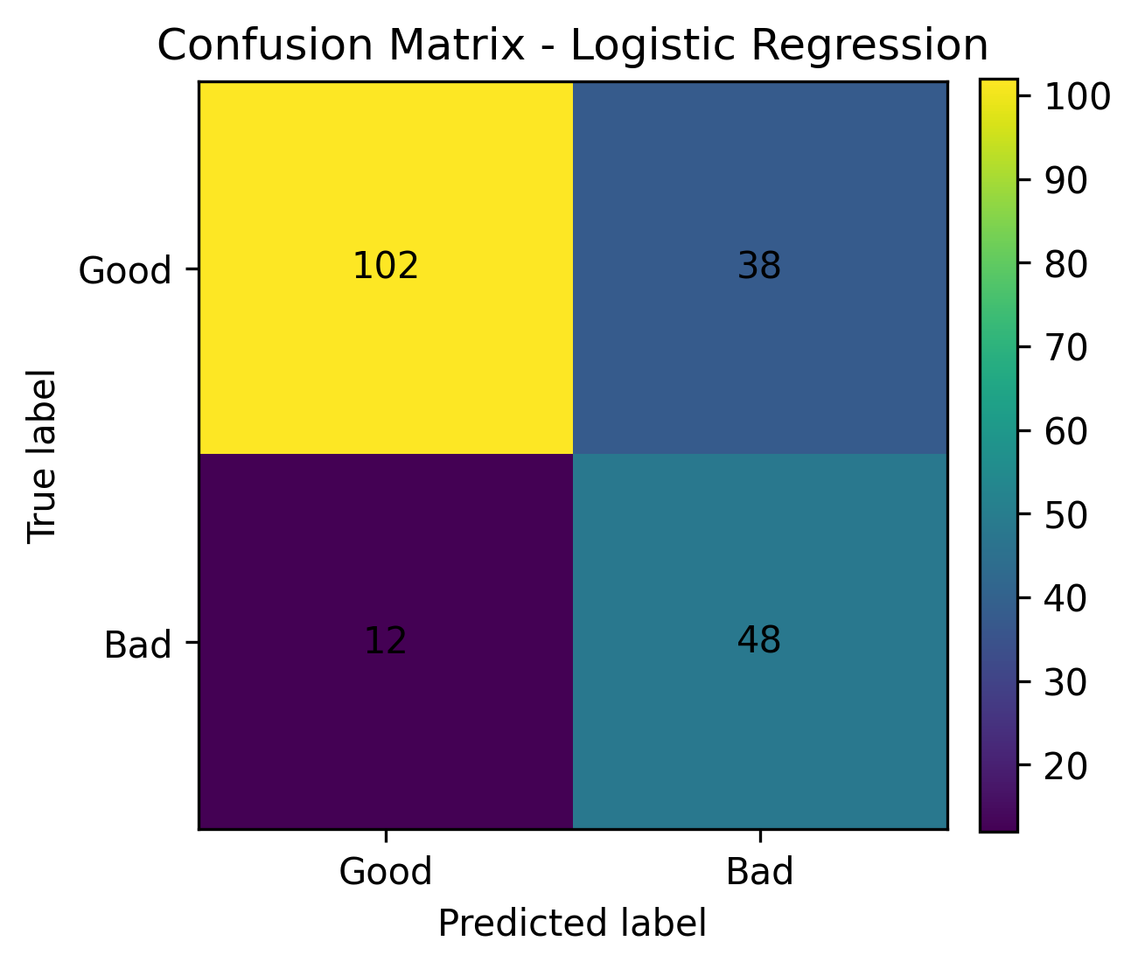
Fig. 2. Confusion matrix for Logistic Regression.

The model correctly classified 102 good-credit-risk applicants and 48 bad-credit-risk applicants. It incorrectly classified 38 good-credit applicants as bad-credit risk and 12 bad-credit applicants as good-credit risk. The most important error in credit risk prediction is misclassifying a bad credit applicant as good. This happened for 12 applicants in the LR model.

Recall for the bad credit class was 0.800, meaning the model detected 80% of applicants with actual bad credit risk.

- ROC Curve Analysis

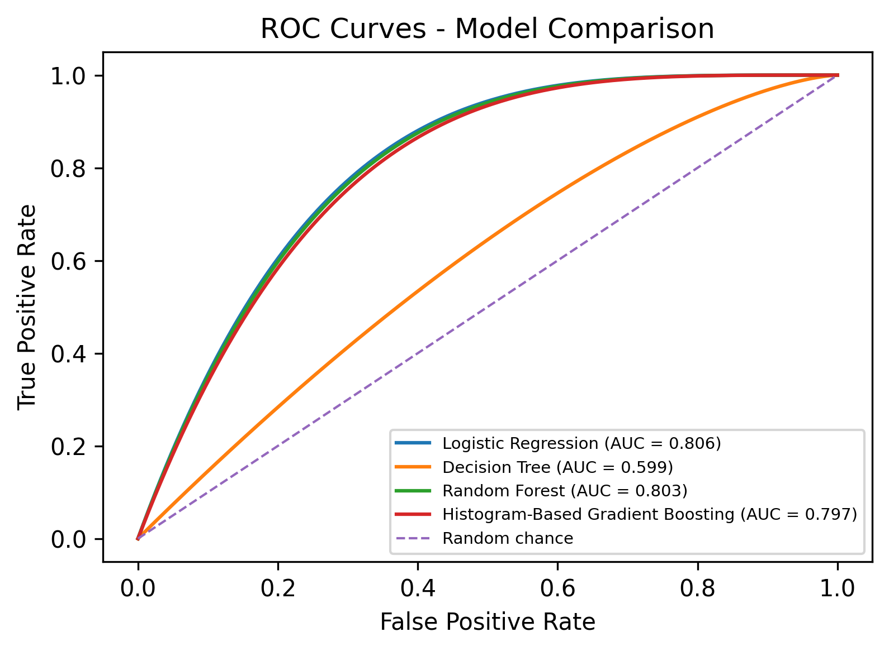
Fig. 3. ROC curves for model comparison.

Logistic Regression achieved the highest ROC-AUC value of 0.806. Random Forest followed with a ROC-AUC value of 0.803. Histogram-Based Gradient Boosting achieved an ROC-AUC of 0.797, while Decision Tree achieved the lowest ROC-AUC of 0.599. These results show that LR and RF had the strongest ability to separate the two credit risk classes.

Although HGB achieved the highest accuracy, its lower recall and slightly lower ROC-AUC made it less appropriate than LR for credit risk classification. Selecting a model based on accuracy alone is insufficient, particularly in risk-sensitive contexts where the cost of missed risky applicants is high. Across the most important metrics for this task, LR provided the best balance between overall classification performance and reliable risk detection.

- Comparison with Related Work
Comparing the results of this study with prior work is necessary, particularly since the project brief explicitly requires comparing to others who have used the same dataset. The Statlog German Credit dataset is a well-established benchmark in credit scoring research, comprising 1,000 instances across 20 features [5].
Table V presents this comparison, drawing on selected studies that either used the German Credit dataset directly or evaluated credit scoring models in a comparative framework.

Study | Dataset | Best / Reported Model | Reported Result | Notes
Lessmann et al. [2] | Credit scoring datasets, including German Credit | Multiple benchmark classifiers | Compared state-of-the-art credit scoring classifiers | Showed the importance of benchmarking several models
Trivedi [11] | German Credit dataset | Random Forest with feature selection | Random Forest with Chi-Square feature selection reported as best pair | Focused on feature selection with multiple classifiers
Ma [13] | German Credit dataset | XGBoost / Stacking | Accuracy around 0.78 for top models | Reported comparable performance for several classifiers
Hu [14] | Statlog German Credit dataset | Support Vector Classifier / XGBoost | SVC: accuracy 0.765, ROC-AUC 0.8074, F1-score 0.6569 | Reported strong ROC-AUC for SVC
Proposed work | German Credit dataset | Logistic Regression | Accuracy = 0.750; Recall = 0.800; F1-score = 0.658; ROC-AUC = 0.806 | Selected for recall, ROC-AUC, and interpretability
TABLE V
COMPARISON WITH RELATED WORK USING THE GERMAN CREDIT DATASET

The results obtained here compare reasonably well with those reported in recent studies using the same dataset. Hu [14], for instance, found that a Support Vector Classifier achieved 0.765 accuracy and 0.8074 ROC-AUC on the Statlog German Credit dataset. This project's Logistic Regression model reached 0.750 accuracy and 0.806 ROC-AUC. This is a modest difference in accuracy, but nearly identical discriminative performance, while remaining more interpretable.
The findings also reflect a more general pattern in the literature: model selection is tied to the prioritized metric. Ma [13] observed that Logistic Regression and Support Vector Machines can achieve comparable accuracy to Random Forest but may still underperform on F1-score when class imbalance is present. A similar pattern appeared here: HGB led in accuracy, but LR achieved higher recall and ROC-AUC. This reinforces the view that accuracy alone is not enough for model selection in credit risk contexts.
This project differs from much of the related work through its emphasis on explainability. Predictive performance was not the only objective; interpretation was also applied using Logistic Regression coefficients, Random Forest feature importance, and SHAP values. In a financial decision-making context, where the reasoning behind a prediction carries practical and regulatory importance, this focus on interpretability makes the approach more applicable than one optimized solely for performance metrics.

- Explainability Analysis
Since the main goal of this project is to build an explainable credit risk prediction system, the models were interpreted after evaluation. Three methods were used to do this: Logistic Regression coefficients, Random Forest feature importance, and SHAP values. These methods helped explain how the models behave overall, and also why they made specific predictions for individual cases.
1) Logistic Regression Coefficient Analysis
The Logistic Regression coefficients were examined to assess how each feature affected the probability that an applicant was a bad credit risk. The target variable was encoded as 0 for good credit risk and 1 for bad credit risk. This means that a positive coefficient increases the predicted probability of bad credit risk, while a negative coefficient decreases it.
TABLE VI
TOP LOGISTIC REGRESSION COEFFICIENTS
Feature | Coefficient | Interpretation
cat__checking_status_A14 | -0.987 | Decreases bad-risk prediction
cat__purpose_A46 | 0.959 | Increases bad-risk prediction
cat__purpose_A41 | -0.887 | Decreases bad-risk prediction
cat__credit_history_A34 | -0.852 | Decreases bad-risk prediction
cat__savings_status_A64 | -0.677 | Decreases bad-risk prediction
cat__foreign_worker_A202 | -0.651 | Decreases bad-risk prediction
cat__property_A124 | 0.635 | Increases bad-risk prediction
cat__checking_status_A11 | 0.621 | Increases bad-risk prediction
cat__employment_since_A74 | -0.595 | Decreases bad-risk prediction
cat__credit_history_A30 | 0.590 | Increases bad-risk prediction
As Table VI shows, checking_status_A14 had the largest negative coefficient in the model, indicating that applicants in this category were much less likely to be predicted as bad credit risk. In contrast, purpose_A46, property_A124, and checking_status_A11 all had positive coefficients, so they pushed the prediction toward bad credit risk. Overall, checking account status, loan purpose, property type, savings status, and credit history were key factors in the model's decision-making.
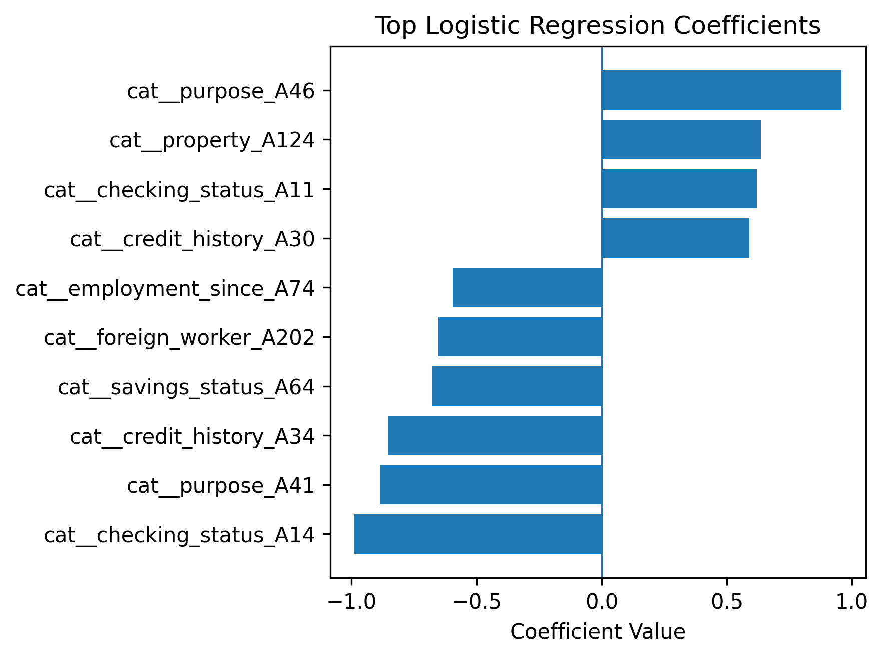
Fig. 4. Top Logistic Regression coefficients.
2) Random Forest Feature Importance
Random Forest feature importance was used to identify the features most important to the model's predictions. It differs from Logistic Regression coefficients because it shows how useful a feature was, but it does not show whether that feature increased or decreased the risk.
TABLE VII
TOP RANDOM FOREST FEATURE IMPORTANCES
Feature | Importance
cat__checking_status_A14 | 0.0998
num__credit_amount | 0.0819
num__duration_months | 0.0807
num__age | 0.0607
cat__checking_status_A11 | 0.0460
cat__credit_history_A34 | 0.0318
num__installment_rate | 0.0289
cat__savings_status_A61 | 0.0277
cat__other_installment_plans_A143 | 0.0221
cat__checking_status_A12 | 0.0220
Table VII shows that checking_status_A14 was the most important feature in the Random Forest model, followed by credit amount, loan duration, age, checking_status_A11, and credit history. These results are reasonable because financial status, the amount borrowed, repayment duration, and past credit behavior are expected to affect credit risk.
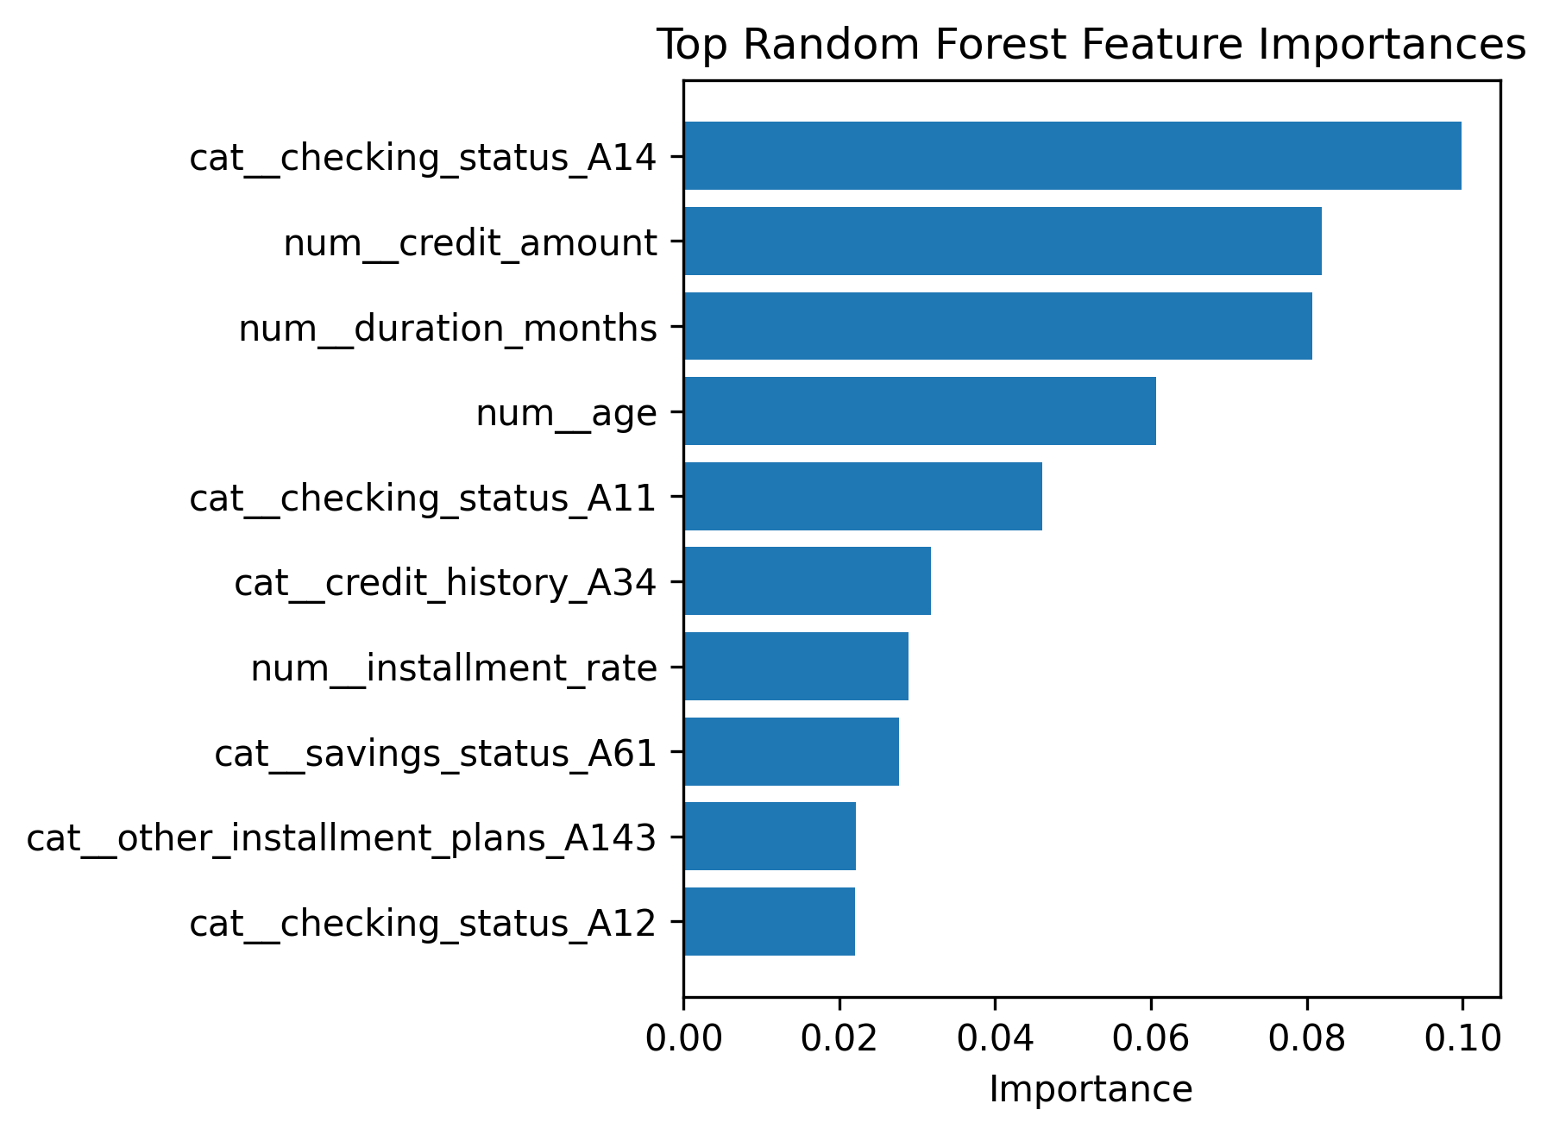
Fig. 5. Top Random Forest feature importances.

3) SHAP-Based Global Explanation
SHAP was then applied to the Random Forest model to provide a clearer explanation of how each feature influenced predictions. The SHAP bar plot ranked features by average impact, with the most influential being checking account status, loan duration, credit history, savings status, credit amount, property status, and age.
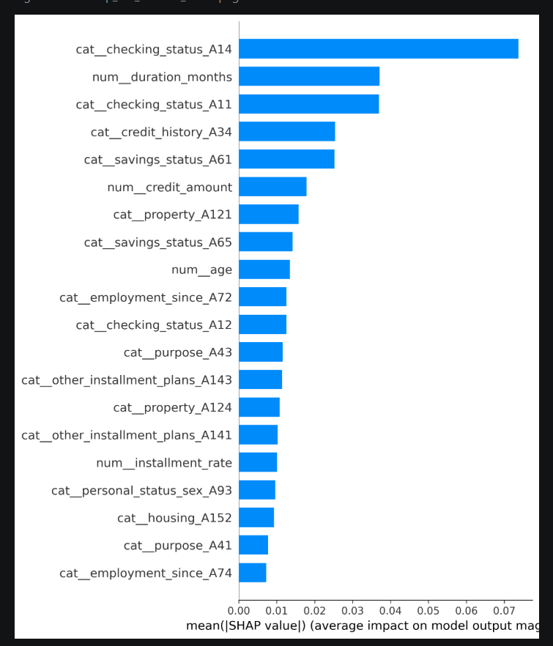
Fig. 6. SHAP feature importance bar plot for Random Forest.
The SHAP summary plot also showed which direction each feature pushed the prediction. Positive SHAP values moved the model toward predicting bad credit risk, while negative values pushed it toward good credit risk. For example, checking_status_A14 generally lowered the bad-risk probability when present, whereas checking_status_A11 had the opposite effect. Longer loan durations and higher credit amounts also tended to increase the predicted risk.

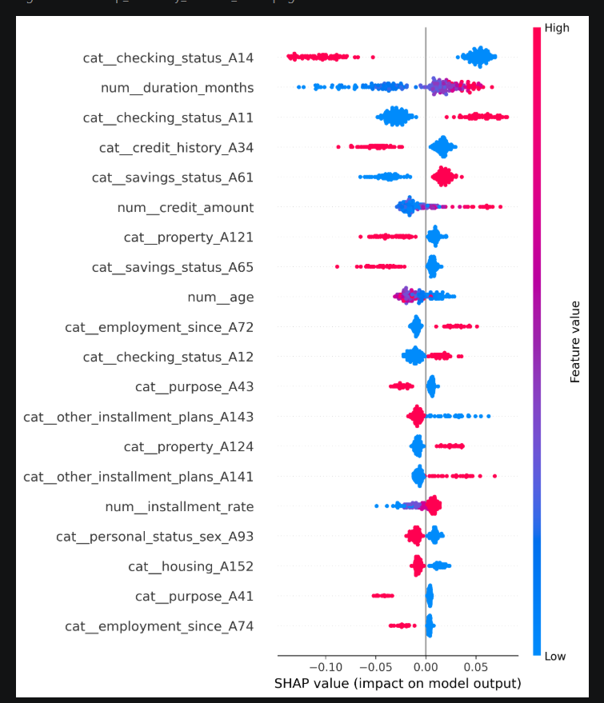
Fig. 7. SHAP summary plot for Random Forest.
These SHAP findings correspond with the results from Logistic Regression coefficients and Random Forest feature importance. Checking account status, credit amount, loan duration, and credit history appeared as important across all three explanation methods, which strengthens confidence in these results.
4) SHAP-Based Local Explanation
Local explainability was also used to explain predictions for individual applicants. Two cases were selected — one with the highest predicted bad-risk probability and one with the lowest.
TABLE VIII
LOCAL EXPLANATION EXAMPLES
Example | Duration | Credit Amount | Checking Status | Credit History | Property | Predicted Bad-Risk Probability | Actual Target
Highest Risk | 48 | 7119 | A11 | A30 | A124 | 0.817 | 1
Lowest Risk | 4 | 1544 | A14 | A34 | A121 | 0.050 | 0
The highest-risk applicant had a predicted bad-risk probability of 0.817 and was correctly labeled as a bad credit risk. This applicant had a loan duration of 48 months, a credit amount of 7119, a checking status of A11, and a property category of A124. All of these features pushed the model toward predicting high credit risk.
The lowest-risk applicant had a predicted bad-risk probability of 0.050 and was correctly labeled as a good credit risk. This applicant had a much shorter loan duration of 4 months, a lower credit amount of 1544, a checking status of A14, and a credit history of A34, which reduced the predicted risk.
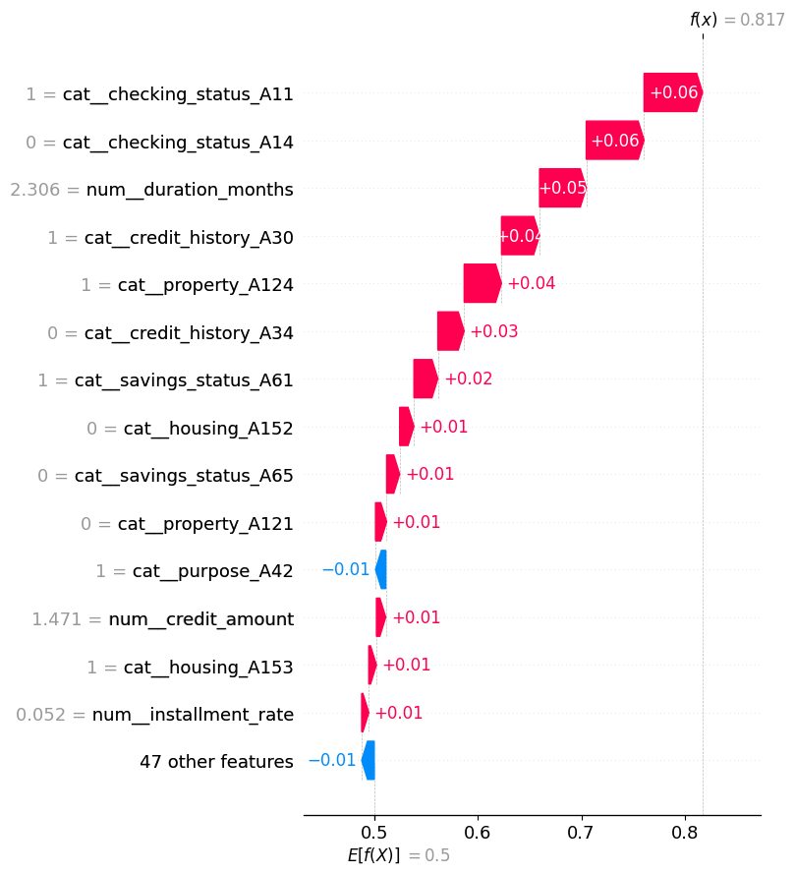
Fig. 8. SHAP waterfall plot for the highest-risk applicant.
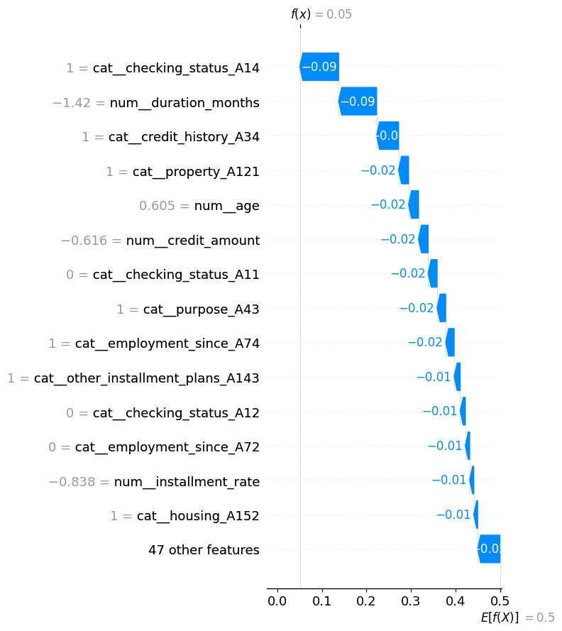
Fig. 9. SHAP waterfall plot for the lowest-risk applicant.
These local explanations show that the model does not only provides a final prediction but also explains the decision in each case. This matters in credit risk because financial decisions need to be understandable and should not rely solely on a black-box output. Overall, the explainability results suggest that the approach can identify the features that drive risk and clearly explain individual predictions.

- Main Findings
The model comparison yielded several clear patterns:
- Histogram-Based Gradient Boosting achieved the highest accuracy, although it had the lowest recall among the better-performing models.
- Logistic Regression led on recall, F1-score, and ROC-AUC.
- Random Forest came close to Logistic Regression on ROC-AUC but fell short on recall.
- Decision Tree produced the weakest results overall and showed signs of instability on this dataset.
- For credit risk prediction, Logistic Regression proved to be the most suitable model because it identified the largest number of high-risk applicants while remaining interpretable.
Overall, these outcomes challenge the assumption that the best-performing model is simply the most accurate one. When the cost of misclassifying a bad-credit-risk applicant is high, recall and ROC-AUC are more informative than accuracy. Logistic Regression struck the right balance between predictive performance and explainability, making it a natural fit for the explainable credit risk framework this project set out to develop.

VI. CONCLUSION
This project developed an explainable machine learning approach for credit risk prediction using the Statlog German Credit dataset. The task was framed as a binary classification problem — applicants were either good or bad credit risks. The dataset has 1,000 applicants and 20 features covering financial status, loan details, credit history, employment, and personal background.
Before training, the data was preprocessed by converting the target labels to binary, standardizing numerical features, and one-hot encoding categorical features. Four models were then trained and compared: Logistic Regression (LR), Decision Tree (DT), Random Forest (RF), and Histogram-Based Gradient Boosting (HGB). They were evaluated on accuracy, precision, recall, F1-score, and ROC-AUC.
HGB achieved the highest accuracy (0.765), but LR performed best on the metrics that matter more for this task: recall (0.800), F1-score (0.658), and ROC-AUC (0.806). Since the main purpose of credit risk prediction is to identify bad-risk applicants before approval, recall and ROC-AUC were weighted more heavily than accuracy. Therefore, LR was chosen as the most suitable model.
The project also focused on making the models explainable. LR coefficients showed which features pushed the prediction toward or away from bad credit risk. RF feature importance and SHAP were used to rank the most influential features and explain individual predictions. Across all three methods, checking account status, loan duration, credit amount, credit history, savings status, and age consistently came up as the most important factors.
The results show that explainable ML is useful for credit risk prediction because it not only provides a final classification, but also shows the reasoning behind it. In financial settings, that kind of transparency is important because decisions need to be justifiable to the people they affect.
The project has some limitations. The German Credit dataset is relatively small, with 1,000 instances, so these results are better suited as benchmarks than as a measure of production-level banking performance. The dataset is also older, which may not fully reflect modern credit behavior. Future work could test this approach on larger, more recent datasets, apply additional feature engineering, tune hyperparameters more thoroughly, and explore fairness issues in credit risk modeling.

VII. REFERENCES
[1] D. J. Hand and W. E. Henley, “Statistical classification methods in consumer credit scoring: A review,” Journal of the Royal Statistical Society: Series A (Statistics in Society), vol. 160, no. 3, pp. 523–541, 1997.
[2] S. Lessmann, B. Baesens, H. V. Seow, and L. C. Thomas, “Benchmarking state-of-the-art classification algorithms for credit scoring: An update of research,” European Journal of Operational Research, vol. 247, no. 1, pp. 124–136, 2015.
[3] N. Bussmann, P. Giudici, D. Marinelli, and J. Papenbrock, “Explainable machine learning in credit risk management,” Computational Economics, vol. 57, no. 1, pp. 203–216, 2021.
[4] S. M. Lundberg and S.-I. Lee, “A unified approach to interpreting model predictions,” in Advances in Neural Information Processing Systems, vol. 30, 2017.
[5] UCI Machine Learning Repository, “Statlog (German Credit Data).” Accessed: 2026. [Online]. Available: https://archive.ics.uci.edu/dataset/144/statlog+german+credit+data
[6] F. Pedregosa et al., “Scikit-learn: Machine learning in Python,” Journal of Machine Learning Research, vol. 12, pp. 2825–2830, 2011.
[7] D. W. Hosmer, S. Lemeshow, and R. X. Sturdivant, Applied Logistic Regression, 3rd ed. Hoboken, NJ, USA: Wiley, 2013.
[8] J. R. Quinlan, “Induction of decision trees,” Machine Learning, vol. 1, no. 1, pp. 81–106, 1986.
[9] L. Breiman, “Random forests,” Machine Learning, vol. 45, no. 1, pp. 5–32, 2001.
[10] J. H. Friedman, “Greedy function approximation: A gradient boosting machine,” The Annals of Statistics, vol. 29, no. 5, pp. 1189–1232, 2001.
[11] S. K. Trivedi, “A study on credit scoring modeling with different feature selection and machine learning approaches,” Technology in Society, vol. 63, 2020.
[12] J. P. Noriega, E. Rivera, A. Herrera, C. P. Mora, J. J. Ramirez, and C. A. Rivero, “Machine learning for credit risk prediction: A systematic literature review,” Data, vol. 8, no. 11, p. 169, 2023.
[13] R. Ma, “German Credit Risk Prediction Using Machine Learning Models,” in Proc. 2025 3rd Int. Conf. Image, Algorithms and Artificial Intelligence (ICIAAI 2025), pp. 283–292, 2025, doi: 10.2991/978-94-6463-823-3_27.
[14] C. Hu, “Evaluating Machine Learning Strategies for Credit Risk Anomaly Detection,” in Proc. 2nd Int. Conf. Data Science and Engineering (ICDSE 2025), pp. 436–441, 2025, doi: 10.5220/0013699000004670.

