Test Description: sanity test emoji keyboard
<Describe shortly what are you going to test>
Test Purpose: <Describe shortly what is the purpose of this test>
Test Run Instructions: <Describe any special instructions needed to execute this test>
Test Run Information:  Tester Name: AbedAlrhman Natour  Date of Test: | Prerequisites for this test: add contact to your phone  Mahmoud 054-1234567,whatsapp language(eng),  Save the pic conan.d.ping
Software Versions:
Application: whatsapp web
Browser: microsoft browser
Operating System:
Required Configuration: [ browser setup, security or user ID roles]
No special setup needed
NOTES and RESULTS: the feature is highly user-friendly and easy to use and also there is logic searching for related things

TEST SCRIPT STEPS/RESULTS
STEP | TEST STEP/INPUT | EXPECTED RESULTS | ACTUAL RESULTS | Requirements Validated | PASS/FAIL
functional-emoji keyboard
 | Navigate to https://web.whatsapp.com | Menu opens correct | Menu opens correct | R. 1.1001 | pass
 | Click on the new message button (message mark with plus inside) in the top the fourth option on the right | Contact list opens | Contact list opens | R 1.1003 | Pass
 | Click on Mahmoud (054-1234567) contact | Converstion window with Mahmoud opens | Converstion window with Mahmoud opens |  | Pass
 | Click on the gray smile emoji inside the writing field (at the bottom of the conversation window)  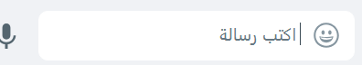 | Small window with emojis opens (in the conversation window)with the first option of emojis type (recently used) | Small window with emojis opens (in the conversation window)with the first option of emojis type (recently used) |  | Pass
 | click on the third option from the right in the top of the emojis window (animals & nature)  | Passs to animal emojis | Passs to animal emojis |  | pass
 | Click on the lion emoji (in the second raw the fourth emoji from the right)  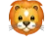 | The lion emoji inserted to the writing message field | The lion emoji inserted to the writing message field |  | Pass
 | Click on send button (horizontal triangle to the left of the writing field)   | The emoji message (lion face) sent with tow gray hooks in the bottom of the message | The emoji message (lion face) sent with tow gray hooks in the below the message |  | Pass
- s | Go to mahmouds phone and check if the emoji message received | The emoji message (lion face) received and | The emoji message(lion face) received and |  | pass
Recovery- emoji keyboard
 | go to the emoji keyboard in conversation window with "Mahmoud 054-1234567" | Emoji keyboard opens | Emoji keyboard opens |  | Pass
 | Disconnect the internet | The internet disconnected | The internet disconnected |  | Pass
 | Click on the lion face emoji | The emoji inserted to the writing message field | The emoji inserted to the writing message field |  | Pass
 | Click on send button | The lion emoji inserted to the conversation window with gray clock mark (not sent yet) in the bottom of the message | The lion emoji inserted to the conversation window with gray clock mark (not sent yet) in the bottom of the message |  | Pass
 | Reconnect the internet | the emoji sent (with tow gray hooks) in the bottom of the message | the emoji sent (with tow gray hooks) the bottom of the message |  | pass
 | Check if the emoji message was received on the "mahmuods" phone | The message received and two hook markers were colored blue | The message received and two hook markers were colored blue |  | pass
backward compatibility - emoji keyboard
 | Open WhatsApp mobile on your phone and send a monkey emoji to "Mahmoud" | Monkey emoji sent to "mahmuod" | Monkey emoji sent to "mahmuod" |  | Pass
 | Connect to your whatsappweb account | Menu page opens in your account | Menu page opens in your account |  | pass
 | Click on last message have sent to  "Mahmoud 054-1234567" | Conversation window opens with  mahmoud | Conversation window opens with a contact who sent the message |  | pass
 | Click on the gray smile emoji inside the writing field (at the bottom of the converstion window)  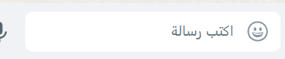 | Small window with emojis opens (in the conversation window)with the first option of emojis type (recently used)  "emoji keyboard opens" | Small window with emojis opens (in the conversation window)with the first option of emojis type (recently used)  "emoji keyboard opens" |  | pass
 | Verify that monkey emoji is in recently used emojis | The monkey emoji is in the recently used option | The monkey emoji is not in the recently used option |  | fail
Functional-emoji keyboard-Search in emoji keyboard
 | Open emoji keyboard | Emoji key board opens with search field at the top of the keyboard window | Emoji key board opens with search field at the top of the keyboard window |  | Pass
 | Click on the search field | A write cursor enters the search field | A write cursor enters the search field |  | Pass
 | Write in the search "ita" | Getting search results related to Italy | Getting search results related to Italy  |  | Pass
Functional – emoji keyboard – GIFs keyboard
 | Open WhatsApp web | Main page opens | Main page opens |  | Pass
 | Click on the new message button (message mark with plus inside) in the top the fourth option on the right | Contact list opens in the left half of the screen | Contact list opens in the left half of the screen |  | Pass
 | Click on Mahmoud (054-1234567) contact | Conversation window with Mahmoud opens in the right half of the screen | Conversation window with Mahmoud opens in the right half of the screen |  | Pass
 | Open emoji keyboard | Emoji key board opens with three options at the bottom | Emoji key board opens with three options at the bottom 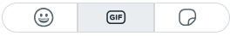 |  | Pass
 | Click on the middle option at the bottom of the emoji keyboard  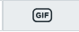 | Gifs keyboard opens with bar for options for GIF types at the top on the "trending" option by default | Gifs keyboard opens with bar for options for GIF types at the top on the "trending" option by default  |  | Pass
 | Click on the second option gifs type from the right  "sports"   | Get sport gifs in the keyboard window | Get sport gifs in the keyboard window |  | pass
 | Choose the football player "James Rodriguez" gif  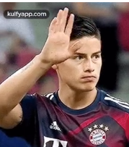 | the gif pass to sending window with writing field at the bottom for adding message with the gif | the gif pass to sending window with writing field at the bottom for adding message with the gif  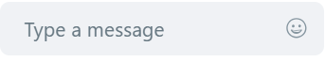 |  | pass
 | Click on the writing message field | A write marker goes into the writing field and you can write | A write marker goes into the writing field and you can write |  | Pass
 | Write the word "James Rodriguez" | The word will enter the filed | The word entered the field 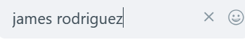 |  | Pass
 | Click on the sending bottom at the lower right corner | The gif and the message inserted to the conversation window and the gif successfully sent with | The gif and the message inserted to the conversation window and the gif successfully sent with |  | Pass
 | Check if the gif was received on Mahmoud's phone | The message successfully received | The message successfully received 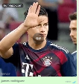 |  | Pass
Functional – emoji keyboard- stickers keyboard
 | Open emoji keyboard in mahmouds conversation window | Emoji keyboard opens with three options at the bottom | Emoji keyboard opens with three options at the bottom  |  | Pass
 | Click on the first option from the right "stickers"  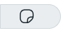 | Stickers keyboard opens with stickers category bar at the top on the first option type of the stickers  "recently used" by default | Stickers keyboard opens with stickers category bar at the top on the first option type of the stickers  "recently used" by default 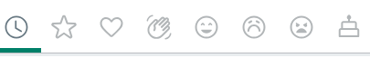 |  | Pass
 | Click on the fourth option from the left  in the top bar "greetings"   | Get greeting stickers in the keyboard window | Get greeting stickers in the keyboard window |  | Pass
 | Click on the lion sticker   | The sticker will be sent with tow gray hooks without closing the sticker keyboard to enable sending more stickers | The sticker sent with tow gray hooks without closing the sticker keyboard to enable sending more stickers |  | Pss
 | Check if the sticker was received on Mahmoud's phone | The sticker the sticker was successfully received | The sticker the sticker was successfully received  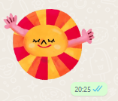 |  | Pass

