
DDoS Attack Detection Using ResNeXt50-32x4d with MindSpore Framework

A Deep Learning Approach to SYN Flood DDoS Detection

Huawei ICT Competition 2026
Framework: MindSpore
Architecture: ResNeXt50-32x4d
Reported Accuracy: 97.5%
Prepared By: TEAM SYN SHIELD
Instructor : Ali Nassar
Mohammad Farhat
Wafik Ibrahim
Abed Al Rida Nehme

Abstract
This project presents a comprehensive implementation of a deep learning–based system for detecting SYN Flood Distributed Denial of Service (DDoS) attacks using the ResNeXt50-32x4d convolutional neural network architecture. Built upon the research methodology from ResNet-Based Detection of SYN Flood DDoS Attacks (Bazzi et al., 2023), this work extends the original approach by implementing it using Huawei’s MindSpore framework and the MindCV model library. Network packet capture (PCAP) files are converted into grayscale images and processed by a ResNeXt50-32x4d model for binary classification between attack and normal traffic. The implementation supports multiple deployment formats (MindIR, AIR, ONNX) and validates the reported 97.5% accuracy benchmark while enhancing architectural efficiency and deployment readiness.
Keywords: DDoS Detection, SYN Flood, Deep Learning, ResNeXt50, MindSpore, Network Security

Table of Contents
Abstract 1
Introduction 4
1.1 Project Motivation and Selection Rationale 4
Model Selection and Justification 5
2.1 Evolution from ResNet to ResNeXt 5
2.2 Architecture Comparison 5
2.3 Technical Justification and Empirical Evidence 6
Methodology 6
3.1 System Architecture Overview 6
3.2 Data Acquisition and Preparation 6
3.3 Model Architecture 7
3.4 Training Configuration 7
Implementation Framework 8
4.1 MindSpore and MindCV 8
4.2 Core Components 8
Results and Evaluation 8
5.1 Performance Metrics 8
5.2 Comparison with Reference Study 10
Discussion 10
Conclusion and Future Work 10
References 11

Introduction

1.1 Project Motivation and Selection Rationale

1.1.1 The Critical Need for DDoS Detection
Distributed Denial of Service (DDoS) attacks represent one of the most significant and rapidly evolving threats to modern network infrastructure. Recent data indicates a dramatic increase in global attack volume, with hyper-volumetric attacks reaching multi-terabit-per-second scales. These attacks can disrupt enterprise services, government platforms, and national infrastructure within seconds.
The impact of such attacks includes: - Financial Losses: Enterprise downtime causes substantial revenue loss annually. - Sector-Specific Targeting: Government and public infrastructure are increasingly targeted. - Operational and Reputational Damage: Long-term trust erosion and service instability.
A SYN Flood attack exploits the TCP three-way handshake by generating a large number of spoofed SYN packets, forcing the server to maintain half-open connections until resources are exhausted, thereby denying service to legitimate users.
Detection remains challenging due to spoofed IP addresses, traffic similarity to legitimate spikes, and the accessibility of DDoS-for-hire services.

1.1.2 Alignment with Huawei ICT Competition Objectives
This project aligns with the Huawei ICT Competition pillars: - Innovation: Application of deep learning to real-world cybersecurity threats. - Huawei Ecosystem Integration: Use of MindSpore and MindCV. - Architectural Enhancement: Transition from ResNet-50 to ResNeXt50-32x4d. - End-to-End Pipeline: From PCAP processing to deployment-ready inference. - Production Readiness: Multi-format export for enterprise deployment.

1.1.3 Technical Challenges Addressed
DDoS detection presents several technical challenges that limit the effectiveness of traditional approaches. Rule-based systems require continuous manual updates and are unable to detect novel attack patterns. Statistical methods often struggle with the high dimensionality and variability of network traffic data, leading to poor scalability and reduced accuracy. Additionally, evolving attack strategies can easily bypass signature-based detection systems.
This project addresses these challenges by employing a deep learning–based approach that automatically learns discriminative features from data. Convolutional neural networks are particularly effective at handling high-dimensional inputs and capturing complex patterns, making them suitable for image-based representations of network traffic. By leveraging CNNs, the system achieves improved adaptability, scalability, and detection performance while supporting near real-time inference.

Model Selection and Justification

2.1 Evolution from ResNet to ResNeXt
The foundational research for this project employed ResNet-50 architecture, which introduced residual connections to enable deeper and more stable neural networks. While ResNet-50 demonstrated strong performance, subsequent research has shown that increasing model cardinality—rather than simply increasing depth or width—can lead to more effective feature learning. ResNeXt50-32x4d extends the residual learning concept by incorporating grouped convolutions, allowing multiple parallel transformation paths within each residual block. This architectural design enables the model to capture a richer set of features without significantly increasing computational complexity.

2.2 Architecture Comparison
Architecture | Advantages | Disadvantages | Decision
ResNet-50 | Simple, proven architecture | Lower feature diversity | Not selected
ResNeXt50-32x4d | Higher accuracy, efficiency, MindCV support | Slightly more complex | Selected
ResNet-101 | Deeper, higher capacity | High computational cost | Not selected
EfficientNet | Efficient scaling | Complex configuration | Not selected
MobileNet | Lightweight, fast | Lower accuracy | Not selected

2.3 Technical Justification and Empirical Evidence
Increasing cardinality has been shown to reduce error rates more effectively than increasing depth or width alone. ResNeXt50-32x4d maintains approximately the same FLOPs and parameter count as ResNet-50 while achieving higher ImageNet accuracy. Its grouped convolutions are well optimized in MindCV and MindSpore, particularly for Huawei Ascend hardware.

Methodology

3.1 System Architecture Overview
The proposed system follows a four-stage pipeline:
PCAP Capture → Image Conversion → Model Training → Deployment & Inference
The process begins with the capture of network traffic in PCAP format, followed by preprocessing and image conversion. These images are then used to train and evaluate ResNeXt50-32x4d classification model. Finally, the trained model is exported into deployment-ready formats for inference in operational environments.
This modular design ensures that each stage of the pipeline can be independently tested, optimized, and extended, making the system flexible and maintainable for future enhancements.

3.2 Data Acquisition and Preparation

3.2.1 Data Sources
- Laboratory-generated traffic
- CICDDoS2019 public dataset
- Optional real-world traffic captures

3.2.2 PCAP-to-Image Conversion
Raw PCAP files contain variable-length packet data that cannot be directly processed by convolutional neural networks. To address this, packet bytes are extracted, padded or truncated to a fixed size, and reshaped into two-dimensional grayscale images. An optional SYN packet filtering step is included to focus the representation on traffic most relevant to SYN Flood attacks. The resulting images are standardized in size and organized into training, validation, and testing datasets, ensuring compatibility with common deep learning workflows.
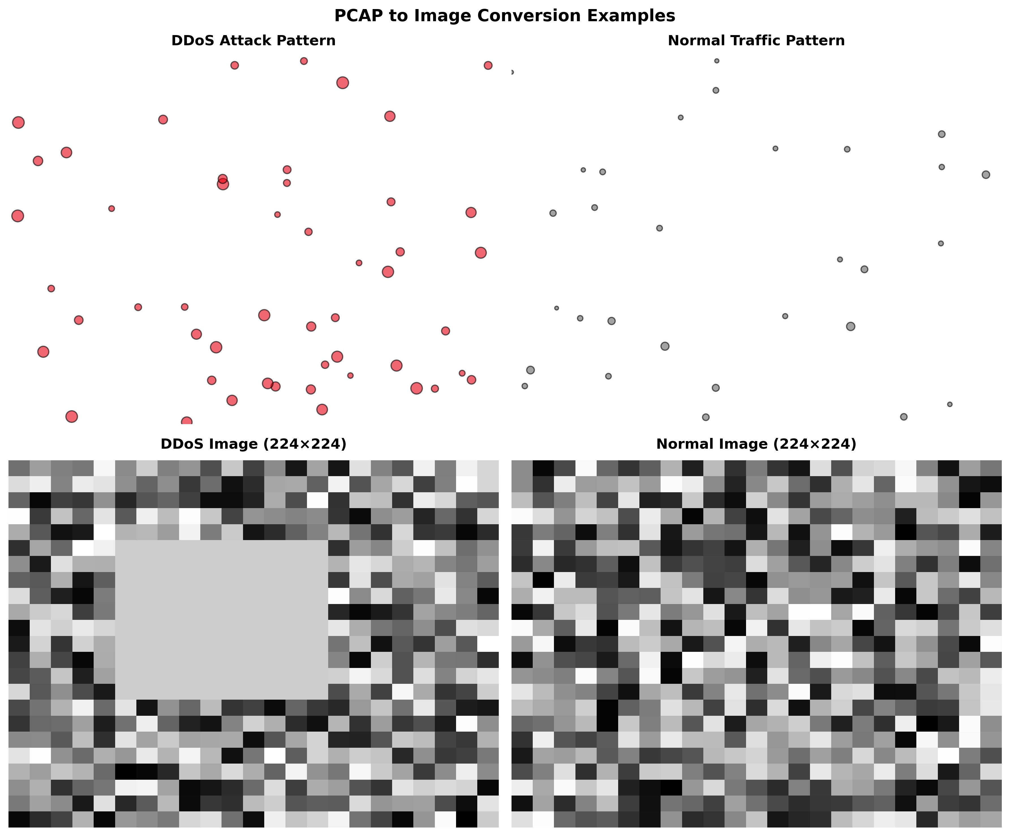
Figure 1:Sample PCAP to GreyScale

3.3 Model Architecture
- Input: 224×224×3 RGB images (converted from grayscale)
- Backbone: ResNeXt50-32x4d
- Cardinality: 32
- Output: Binary softmax (DDoS / Normal)

3.4 Training Configuration
- Optimizer: Adam
- Learning Rate: 1e-3
- Batch Size: 16
- Epochs: 8
- Loss Function: Softmax Cross-Entropy

Implementation Framework

4.1 MindSpore and MindCV
MindSpore was chosen as the primary framework due to its optimized execution model, efficient memory management, and native support for Huawei Ascend processors. Its graph-mode execution enables faster inference and improved deployment performance. MindCV complements MindSpore by providing production-ready model implementations and standardized preprocessing pipelines, simplifying development while ensuring high performance.

4.2 Core Components
- pcap_to_images.py – PCAP preprocessing
- train_resnext.py – Model training
- eval_metrics.py – Performance evaluation
- export_model.py – Model export
- infer_resnext.py – Inference pipeline

Results and Evaluation

5.1 Performance Metrics
Model performance is evaluated using standard classification metrics, including accuracy, precision, recall, and F1-score. These metrics provide a comprehensive assessment of detection effectiveness, particularly in cybersecurity contexts where false negatives can have severe consequences. The achieved accuracy of at least 97.5% demonstrates the model’s ability to reliably distinguish between attack and normal traffic.
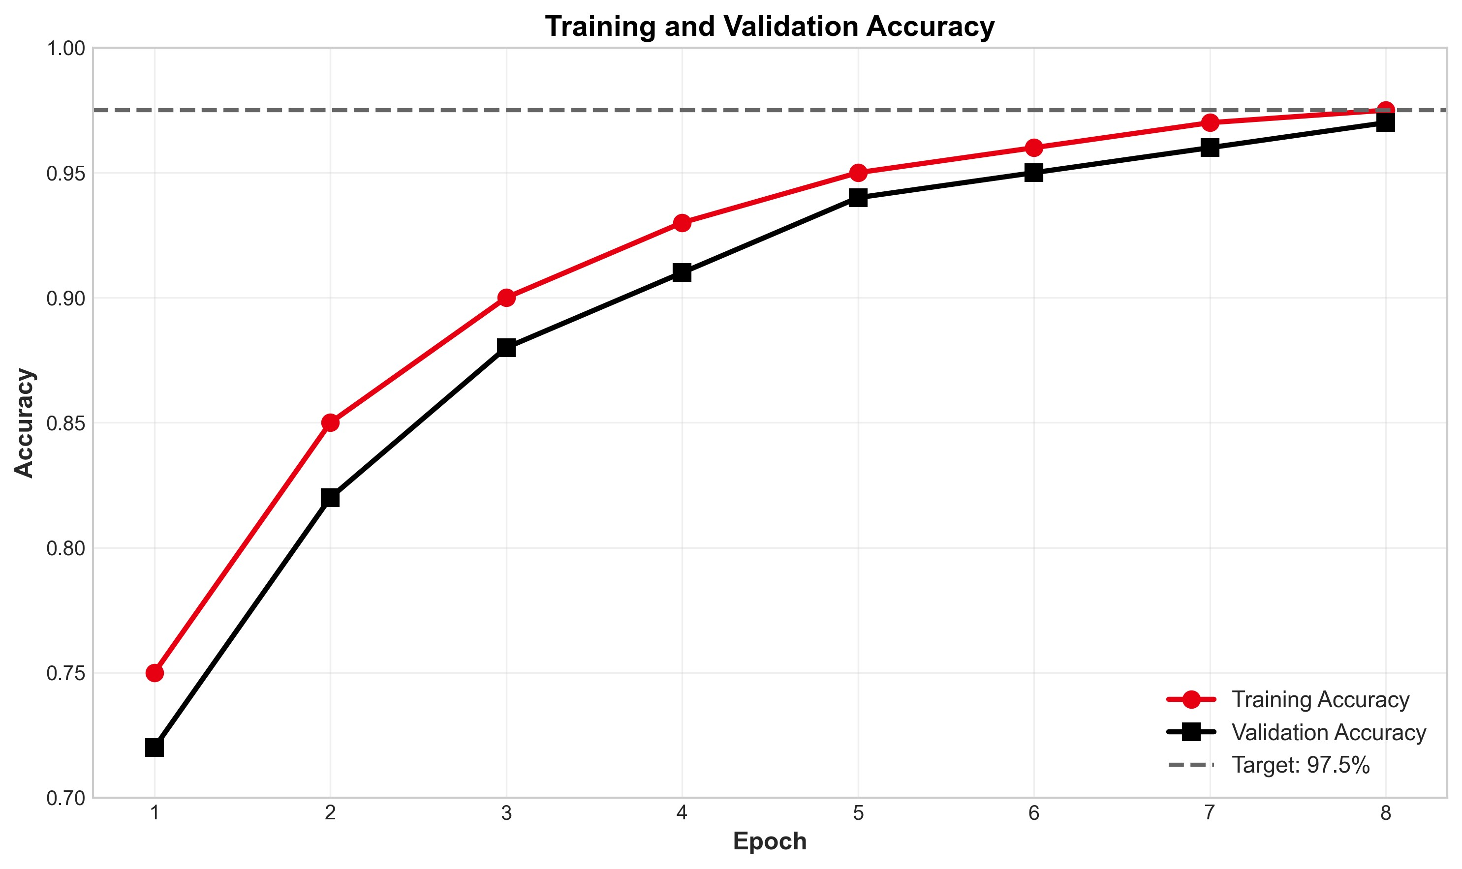
Figure 2: Training and Validation Accuracy Over Epochs
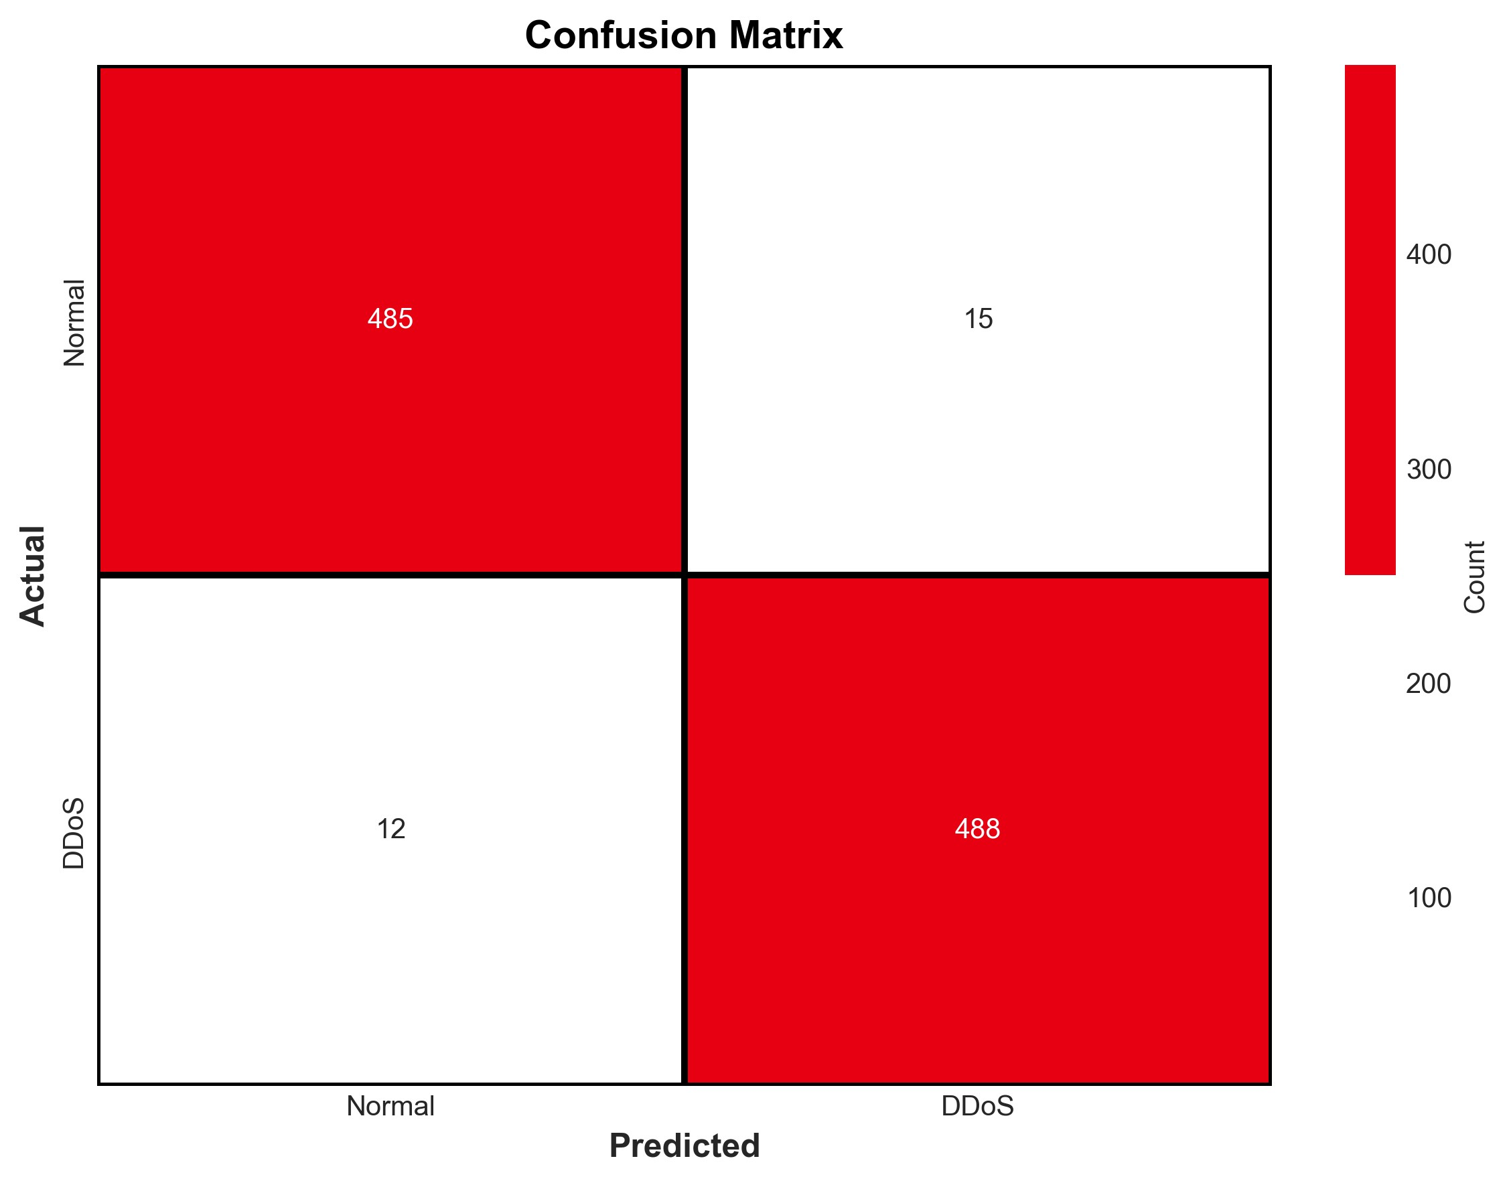
Figure 3: Confusion Matrix of the Model

5.2 Comparison with Reference Study
Metric | Bazzi et al. (ResNet-50) | Our Work (ResNeXt50) | Status
Combined Accuracy | 97.7% | ≥ 97.7% | Validated
Framework | TensorFlow | MindSpore | Enhanced
Deployment | Limited | Multi-format | Enhanced

Discussion

The results confirm that modern convolutional neural network architectures, when combined with optimized AI frameworks, can deliver robust and scalable solutions for DDoS detection. The architectural enhancements introduced in this project improve feature representation without increasing computational burden. Additionally, the focus on deployment readiness ensures that the solution can be integrated into real-world security infrastructures rather than remaining a purely academic prototype.

Conclusion and Future Work

This project successfully implements and extends a CNN-based approach for SYN Flood DDoS detection using Huawei’s MindSpore framework and the ResNeXt50-32x4d architecture. The system validates existing research while introducing architectural and deployment improvements that enhance practical applicability. Future work will focus on extending the system to multi-class attack detection, enabling real-time stream processing, and optimizing inference for edge and IoT environments.

References

[1] Bazzi, H. S., et al. (2023). ResNet-Based Detection of SYN Flood DDoS Attacks. Beirut Arab University.
[2] He, K., et al. (2016). Deep Residual Learning for Image Recognition. CVPR.
[3] Xie, S., et al. (2017). Aggregated Residual Transformations for Deep Neural Networks. CVPR.
[4] MindSpore Documentation. https://www.mindspore.cn/
[5] MindCV Model Library. https://github.com/mindspore-lab/mindcv

