**NATIONAL UNIVERSITY OF SCIENCES AND TECHNOLOGY**

**Fundamentals of Programming**

**LAB TASK (MANUAL 6)**

**Course Instructor:** Dr Khawaja Fahad Iqbal

**Lab Instructor:** Muhammad Affan

**Student Name:** Abeeha Zehra

**CMS ID:** 470226

**DATE:**

**14-11-2023**

**TASK 1**

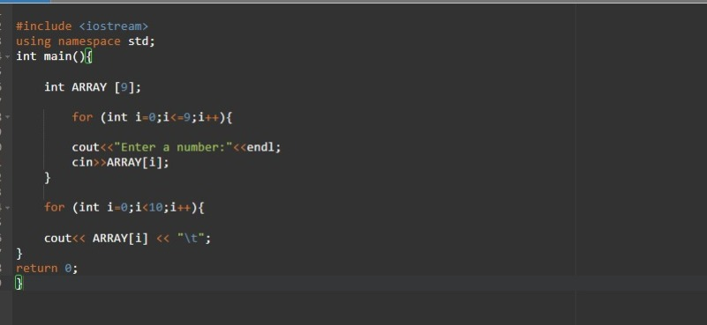

**TASK 2**

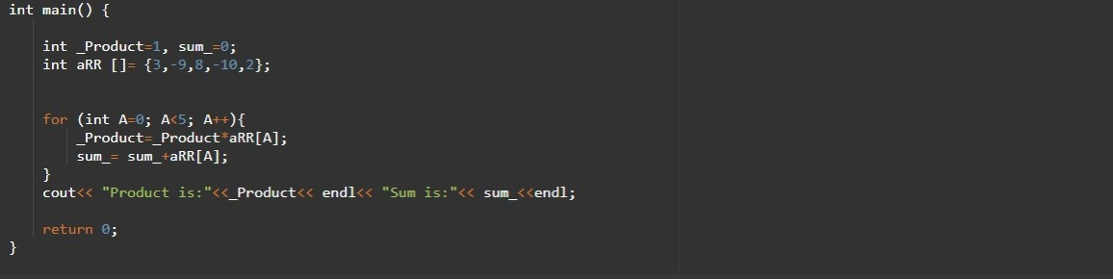

**TASK 3**



