**NATIONAL UNIVERSITY OF SCIENCES & TECHNOLOGY**

**Fundamentals of Programming**

**Assignment 03**

**Course instructor:** Khawaja Fahad Iqbal

**Lab instructor:** Muhammad Affan

**Student Name:** Abeeha Zehra

**CMS ID: 470226**

**Task 1**

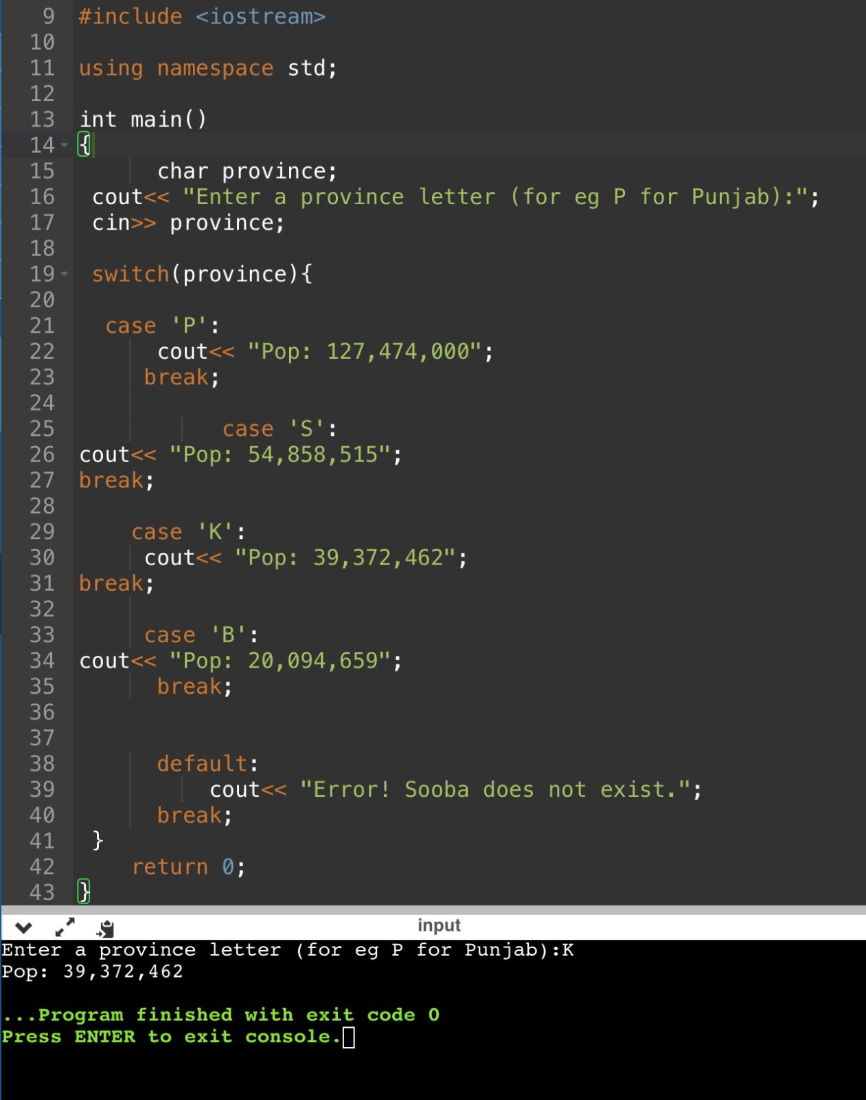

**Task 2**

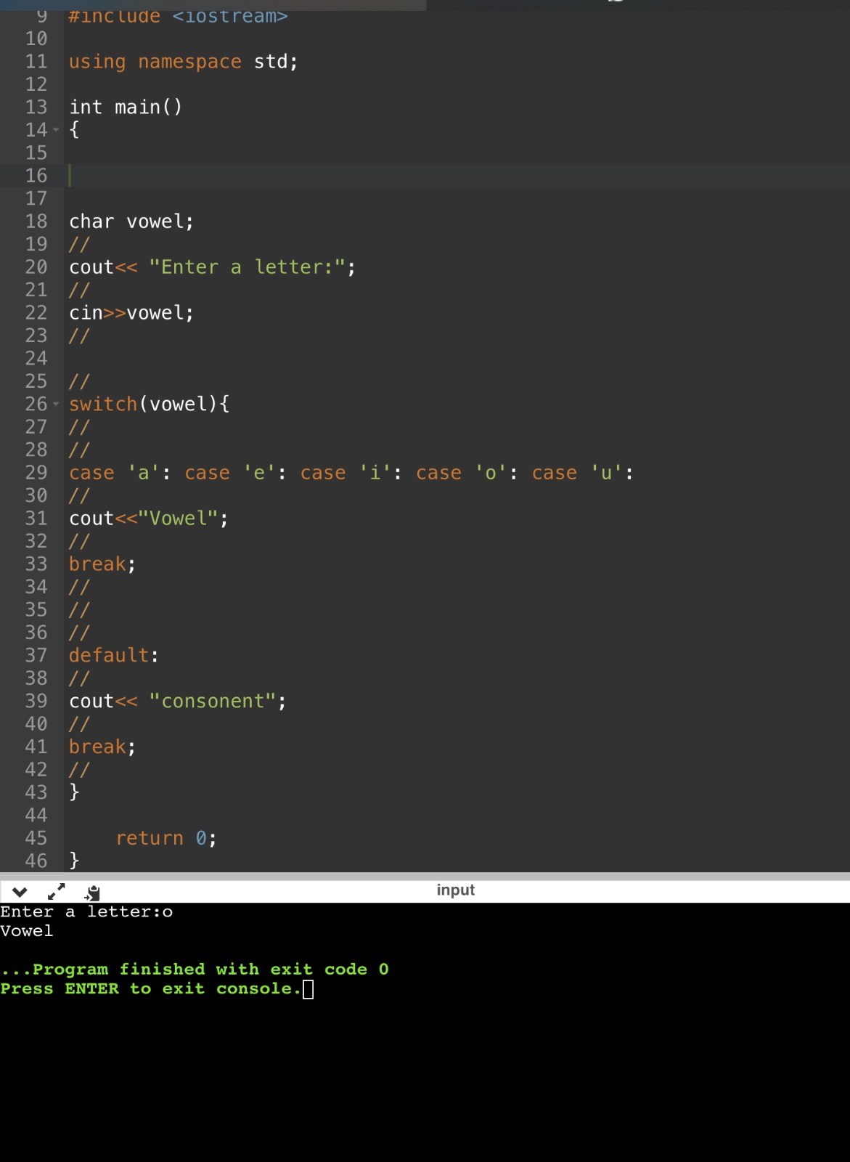

**Task 3**

**Task 4**

**Task 5**

**Task 6**

