**NATINAL UNIVERSITY OF SCIENCES AND TECHNOLOGY**



**FUNDAMENTALS OF PROGRAMMING**

**Assignment #2**

**Lab Instructor:** Muhammad Affan

**Student Name:** Abeeha Zehra

**CMS ID:** 470226

**DATE:**

**11-10-2023**

**TASK 1:**

**Code:**

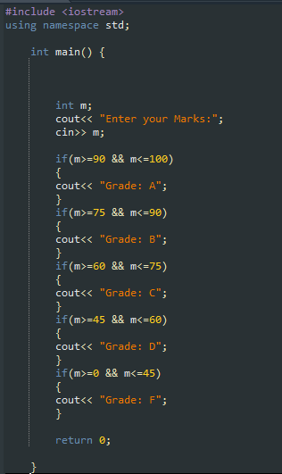

**Output**

**Explanation:**

**We first declare our integer for the marks scored and then define it. We then put if statements one by one for each condition and define a certain grade for each criteria in cout. Close the program by returning it to 0**

**TASK 2:**

**Code**

**Output**

**Explanation:**

**Start by declaring the integer by n. Put the first if statement to but the condition that the number is both even and divisible by 5.**

**Give a relevant cout string**

**Then use else if to give another condition i.e. number is even**

**Give it's relevant cout string**

**Then use else if statement to give the condition that the number is divisible by 5. Give relevant string**

**Then use else for all the numbers that don't fall in the categories above.**

**Give relevant cout string.**

**TASK 3:**

**Code**

**Output**

**Explanation:**

**Declare an integer for the year entered.**

**Put an if statement for the condition that the year entered is divisible by 4.**

**Give relevant cout string.**

**Then use else to define the Integers that don't fall in the category above.**

**Give relevant cout string**

**TASK 4:**

**Code**

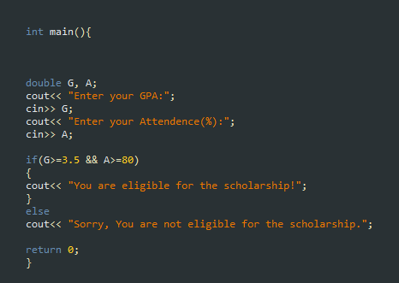

**Output**

**Explanation: In this software, two variables that require user input for attendance and student GPA must be declared. The conditions that the student must meet in order to qualify for a scholarship must then be defined in the if statement. To test the condition in this case, the AND operator is utilized.**

**TASK 5:**

**Code**

**Output**

**Explanation:**

**In order to run this program, we must first establish a character that accepts user input in the form of letters. The criterion that the input letter must satisfy in order to be a vowel must then be defined using the if statement and OR operator.**