Software Test Plan- STP

Version: 1.0

Created: 10/03/2023

Last Updated: 10/03/2023

**Test Plan Template**:

World of PS : Most common games

**Prepared by**:

Abeer Affan

**Document History:**

|  |  |  |  |
| --- | --- | --- | --- |
| **Version** | **Date** | **Author** | **Description of Change** |
| **1.0** | **10.03.2023** | **Abeer Affan** | **Initial draft of the test plan** |

**2. INTRODUCTION**

The PlayStation Games web application is a platform that allows users to discover, browse, and purchase games for the PlayStation gaming console. The application features a user-friendly interface that showcases new releases of games, popular titles, and exclusive games, and access exclusive discounts and promotions.

Overall, the PlayStation Games web application provides an information from the common games in the world of PS & the user can comment in a specific game.

**3.Objectives**

The objectives of testing the web application of PlayStation Games are as follows:

1. Ensure that the application is functioning as per the requirements and specifications
2. Identify and report any defects or issues in the application
3. Ensure that the application is user-friendly and easy to navigate
4. Ensure that the application is secure and free from vulnerabilities
5. Ensure that the application is compatible with various browsers, devices, and platforms
6. Ensure that the application performs well under different load conditions

**4. Support documents**

SRS and STD documents.

**5. Tree Testing**

The test tree will be as follows:

1. Functional testing:

* User registration and login
* Game search and selection
* Purchase and payment
* Download and installation
* Game library management

1. Usability testing:

* Navigation and layout
* User interface design
* User experience

1. Performance testing:

* Load testing
* Stress testing
* Endurance testing

1. Security testing:

* Authentication and authorization
* Data protection
* Network security

1. Compatibility testing:

* Browser compatibility
* Device compatibility
* Platform compatibility

**6. Testing Methodology**

The testing methodology will be a combination of black-box testing and grey-box testing. The testing team will use various testing techniques such as boundary value analysis, equivalence partitioning, and error guessing to identify defects and issues in the application.

**7. Entry and Exit Criteria**

The entry criteria for testing will be the completion of the development phase, availability of test environment and test data, and the readiness of the testing team. The exit criteria will be the completion of all planned tests, resolution of all critical and high-priority defects, and the approval of the application for release by the stakeholders.

**8. TEST STRATEGY**

**8.1. Test Approach**

The testing approach will be a combination of manual and automated testing. The primary focus will be on functional testing, usability testing, performance testing, security testing, and compatibility testing

**8.3. In Scope**

The scope of testing includes the following:

1. All the features and functionalities of the web application
2. The compatibility of the application with different browsers, devices, and platforms
3. The performance of the application under different load conditions
4. The security of the application

**8.3.1. Functional Test**

***PURPOSE***: The functional testing is carried out by feeding the input and validates the output from the application.

***TESTERS***: Testing Team.

***METHOD***: The test will be performed according to Functional scripts, which are stored in test rail.

***TIMING***: After manual test is completed.

**9.1 Validation and Defect Management**

Defects found during the Testing will be categorized according to the bug-reporting tool “Jira” and the categories are:

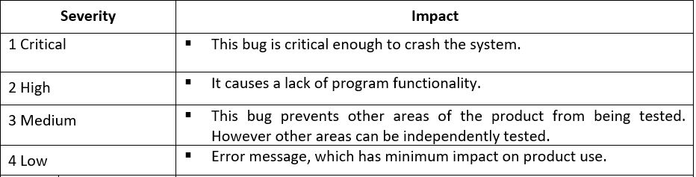

**9.2. Defect tracking & Reporting**

Flowchart depicts Defect Tracking Process

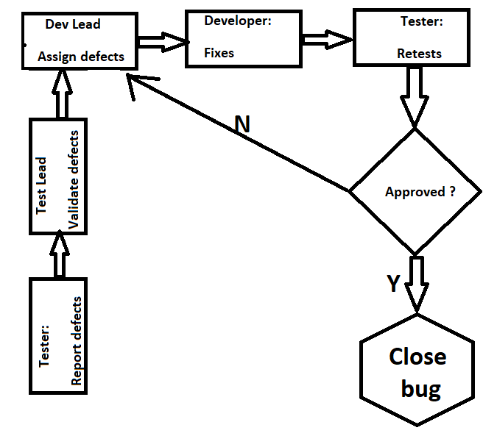

**9.3. Status of the Bug/Fault**

- New: Just created bug;

- Open: Opened bug and still not solved;

- Rejected: Dev Lead rejected it (it's not bug);

- Fixed: SOLVED bug;

- Closed: After bug is fixed, need close this bug;

- Re-Open: Bug was been fixed and closed but appear again with time;

**9.4 TEST MANAGEMENT PROCESS**

1. Test Planning and Preparation

* Review the project requirements, specifications, and user stories
* Identify the testing scope, objectives, and risks
* Develop a test plan and test strategy
* Create test cases, test scenarios, and test data
* Set up the test environment and test tools
* Assign roles and responsibilities to the testing team

1. Test Execution

* Execute test cases and record the results
* Log defects and issues in the defect tracking tool
* Re-test the defects after they are fixed
* Perform regression testing to ensure that the fixes have not caused any new issues
* Perform exploratory testing to identify new defects and issues
* Automate repetitive test cases using test automation tools

1. Test Reporting and Analysis

* Prepare test reports and metrics
* Analyze the test results and identify trends and patterns
* Identify the areas of the application that require further testing
* Report defects and issues to the development team
* Update the test plan and test strategy based on the analysis of the test results

1. Retesting and Regression Testing

* Retest the defects after they are fixed
* Perform regression testing to ensure that the fixes have not caused any new issues
* Repeat the testing cycle until all the defects and issues are resolved

1. Test Closure

* Evaluate the test results and the overall testing process
* Provide feedback and suggestions for improving the testing process
* Document the lessons learned and best practices
* Archive the test artifacts and test results
* Obtain the sign-off from the stakeholders

**9.4.1 TOOLS**

|  |  |
| --- | --- |
| **Tool** | **Comment** |
| Test Management Tool | A tool that will be used to manage test cases, test plans, and defect. |
| Test Automation Tool | A tool that will be used to automate repetitive test cases and reduce the testing time. |
| Performance Testing Tool | A tool that will be used to measure the performance of the application under different load conditions |
| Security Testing Tool | A tool that will be used to identify security vulnerabilities in the application |
| Browser and Device Testing Tool | A tool that will be used to test the compatibility of the application with different browsers and devices |

**9.5. Assumptions / Risks**

**9.5.1. Risks**

|  |  |
| --- | --- |
| **Risk** | **Explenation** |
| Security risks | The web application may be vulnerable to attacks such as SQL injection, cross-site scripting (XSS), and session hijacking, which could result in data breaches, financial loss, and damage to the company's reputation. |
| Performance risks | The web application may not perform optimally under high traffic or load conditions, leading to slow response times, timeouts, and errors. |
| Compatibility risks | The web application may not be compatible with all browsers and devices, which could result in a poor user experience and reduced accessibility. |
| Usability risks | The web application may have usability issues that could result in low user adoption, user frustration, and increased support requests |
| Functionality risks  Functionality risks(countinue) | The web application may have bugs, defects, or missing functionality, which could result in user dissatisfaction, negative reviews, and loss of revenue. |
| Data integrity risks | The web application may have issues with data storage, retrieval, and manipulation, which could result in data corruption, data loss, and compliance issues. |
| Integration risks | The web application may have issues with integrating with third-party services and APIs, which could result in downtime, errors, and data inconsistencies. |
| Maintenance risks | The web application may require regular maintenance, updates, and patches, which could result in downtime, disruption of service, and increased costs. |

**9.5.2. Suspension Criteria:**

Suspension criteria for the web application of PlayStation Games could include:

* Critical defects - If a critical defect is found during testing, the testing process may be suspend until the issue is resolved. This is to prevent the release of a defective application that may result in significant negative impacts to users.
* Environment issues - If there are issues with the testing environment, such as system downtime, network connectivity problems, or insufficient resources, the testing process may be suspended until the environment is stable and suitable for testing.
* Blocked test cases - If a large number of test cases are blocked due to unresolved defects, missing functionality, or other issues, the testing process may be suspended until these issues are addressed.
* Insufficient testing coverage - If the testing coverage is insufficient and the testing team has not been able to adequately verify the application's functionality, the testing process may be suspended until the coverage is improved.
* Unexpected results - If unexpected results are observed during testing, such as inconsistencies between test runs or unexpected behavior, the testing process may be suspended until the root cause of the issue is identified and addressed.

By establishing clear suspension criteria, the testing team can ensure that testing is performed effectively and efficiently, and that the web application of PlayStation Games meets the required quality standards before release.

**9.5.3. Resumption Requirements:**

Resumption requirements are the conditions that must be met before testing can resume after it has been suspended. These requirements are used to ensure that testing continues effectively and efficiently, and that the quality of the web application of PlayStation Games is not negatively impacted by the suspension.

For example:-

1. Resolution of critical defects - Before testing can resume, all critical defects must be resolved and verified by the testing team to ensure that they have been fixed properly.
2. Stable environment - The testing environment must be stable and suitable for testing. All environment issues that caused the suspension must be resolved, and the environment must be fully functional.
3. Blocked test cases resolved - All blocked test cases must be resolved, whether by fixing defects, adding missing functionality, or other means, before testing can resume.
4. Improved testing coverage - If testing was suspended due to insufficient coverage, the testing team must improve their testing coverage before resuming testing. This may include adding additional test cases or executing more thorough testing for specific features.
5. Identified root cause - If testing was suspended due to unexpected results, the root cause of the issue must be identified before testing can resume. This may require additional investigation, analysis, or collaboration with developers.

**10. TEST ENVIRONMENT**

**10.1. HARDWARE REQUIREMENTS**

- Computer with 8 GB RAM, Windows 10 and Chrome

**11. Milestones:**

By establishing clear milestones for the development and testing of the web application of PlayStation Games, the project team can ensure that the application is developed and tested effectively and efficiently, and that it meets the required quality standards

|  |  |  |  |
| --- | --- | --- | --- |
| **Milestone Task** | **Start Date** | **End Date** | **Comments** |
| SRS | 01.03.2023 | 01.03.2023 |  |
| STP | 10.03.2023 | 10.03.2023 | Document will be updating during STD phase |
| STD | 01.03.2023 | 10.03.2023 | Design Test cases ;Test input data |
| STR | --.03.2023 |  | HTML document that will be updating during tests running |

**12. ROLES & RESPONSIBILITIES**

**QA testers*:***

* Develop test cases and combine them in test suites – STD
* Report BUGS
* Regression testing

***Test manager*:**

* Manage the Testing and provide technical support to the Testing team.
* Make Review of Software Test Plan and test cases for the STD document.

***Test Lead*:**

* Prepare the Software Test Plan
* Analyze requirements during the requirements analysis phase.
* Evaluating exit criteria
* Preparing Test Summary Report