ECE 321

Lab 7: PMOS Transistor Introduction

Brian Becker, Tony Mancuso, Jeremy McConaha

(Tuesday)

October 16, 2012

**Purpose:**

This laboratory exercise is intended to provide students practice in PMOS transistor circuit calculations, PSPICE emulation, and circuit construction and measurement.

**Procedure:**

1. Manually calculate all circuit (see figure 1) voltages and currents.
2. Create PSPICE circuit and run simulation.
3. Measure resistors and power supply level then construct circuit and measure all voltages and currents.
4. In a table, list results for values obtained in steps 1-3.

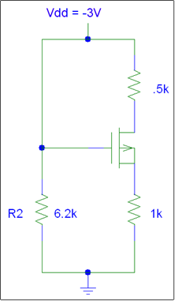

**6.8k**

**1.5k**

**0.6k**

*Figure 1: PMOS circuit.*

PMOS Circuit Parameters:

K’p= 133.78uA/V2 (*derived, see conclusion)

W/L =1

VTP=-1V.

**Results:**

|  |  |  |  |
| --- | --- | --- | --- |
| **Element** | **Calculated** | **PSpice** | **Measured** |
| R2 | 6800 Ω | 6800 Ω | 6656 Ω |
| Rs | 600 Ω | 600 Ω | 599.899 Ω |
| Rd | 1500 Ω | 1500 Ω | 1485 Ω |
| Vg | -3.00 | -3.00 V | -2.992 V |
| Vs | -0.293 V | -0.2925 V | -0.289 V |
| Vd | -2.883 V | -2.8830 V | -2.876 V |
| Vds | -3.176 V | -2.59 V | -2.589 V |
| Vgs | -.2707 V | -2.71 V | -2.703 V |
| Ids | 195.3 µA | 195 µA | 194 µA |

*Table 1: Calculated, PSPICE, and measured values.*

**Conclusion:**

Manual calculations resulted in values that failed to meet normal transistor operations. After consultation with T.A., determined best solution was to take actual measurements, solve for K’p using those values, then verify values with pspice and manual calculations using new K’p value. Both manual and pspice results confirmed the value of K’p. This exercise provided for good practice in calculating PMOS transistor circuit values and in creating and running PSPICE circuit emulation.