ECE 321

Lab 4: ELVIS II

Brian Becker, Tony Mancuso, Jeremy McConaha

(Tuesday)

September 18, 2012

Purpose:

The purpose of this lab was to familiarize students with use of National Instruments’ ELVIS II (Educational Laboratory Virtual Instrumentation Suite) circuit simulation hardware and software. Selected circuits will be analyzed theoretically and hand calculations recorded. ELVIS II measurements will be made on each circuit and those measurements will be compared to hand calculations.

Reference ELVIS II Tutorial:

Procedure:

1. Review ELVIS II Tutorial at:

[*www.Clemson.edu/ces/departments/ece/document_resorce/undergrad/lab_manuals*](http://www.Clemson.edu/ces/departments/ece/document_resorce/undergrad/lab_manuals)

1. Circuit 1
   1. Build Circuit 1 on ELVIS II breadboard (see Figure 1).
   2. Manually calculate ideal values for the circuit
   3. Apply DC voltage using ELVIS II variable DC power supply.
   4. Measure each component using the ELVIS DMM.
   5. Manually calculate values indicated (V and I3k) using the ELVIS measured values.
2. Circuit 2
   1. Build Circuit 1 on ELVIS II breadboard (see Figure 1).
   2. Manually calculate ideal values for the circuit
   3. Apply AC voltage using ELVIS II function generator.
   4. Measure each component using the ELVIS II DMM and Impedance analyzer.
   5. Manually calculate values indicated [Vc(t)] using the ELVIS measured values.

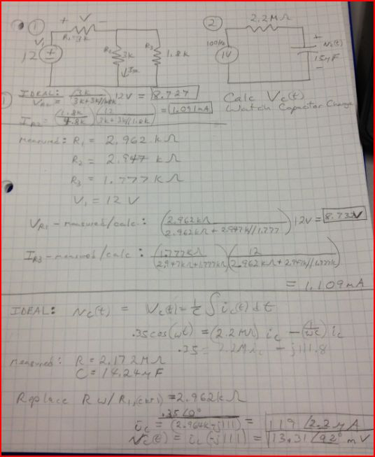

*Figure 1: Circuit 1 and Circuit 2 and hand calculations for each.*

Results:

Circuit 1 and circuit 2 hand calculations with ELVIS II measured values were very close to those measured with the ELVIS II instruments. In particular, the ELVIS II Impedance Analyzer measured 112 Ω for our capacitor in circuit and this was within 1.7% of our manual calculation.

Conclusion:

The National Instruments ELVIS II hardware and software performed quite well with respect to manual calculations. The small differences found between measurements and calculations can be attributed to parasitic inductance and capacitance in circuit wires, meter leads, and within the ELVIS II hardware system. Use of the ELVIS II was simple to understand and apply.