ECE 321

Lab 5: Circuit Simulation with PSPICE

Brian Becker, Tony Mancuso, Jeremy McConaha

(Tuesday)

October 2, 2012

**Purpose:**

This laboratory exercise is intended to provide students with familiarization in PSPICE circuit construction, emulation, and simulation.

**Procedure:**

1. For circuits 1 and 3 (see figures), manually calculate all voltages and currents.
2. For all circuits, create PSPICE circuit and run simulation.
3. For circuits 1 and 3, list calculated and PSPICE values in a table.
4. For circuits 2 and 4, attach simulation snapshot showing verified operation of circuit.

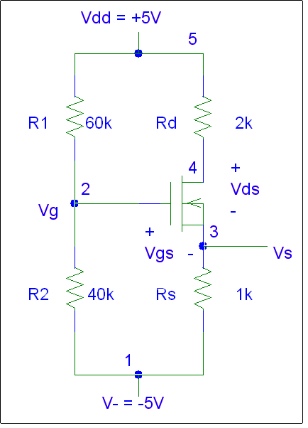

*Figure 1: Circuit 1 - NMOS circuit.*

Circuit 1 Parameters:

Kn = 500 μA/V2

W/L = 1

Vtn = 1V

|  |  |  |
| --- | --- | --- |
| **Element** | **Calculated** | **PSpice** |
| Vg | -1 V | -1 V |
| Vs | -4 V | -4 V |
| Vd | 3 V | 3 V |
| Vds | 7 V | 7 V |
| Vgs | 3 V | 3 V |
| Ids | 1 mA | 1 mA |

*Table 1: Circuit 1 calculated and PSPICE values.*

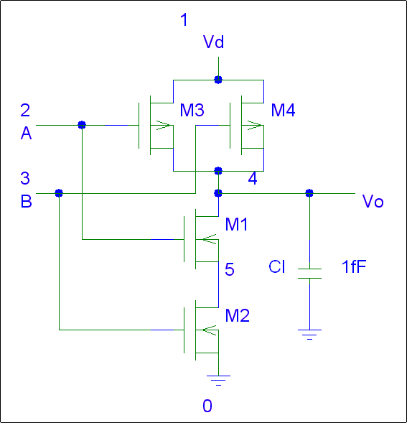

*Figure 2: Circuit 2 – 2 Input NAND circuit.*

Circuit 2 Parameters:

K’n = 50 μA/V2

l=2u, w=8u

Vtn = 0.6V

Vtp = -0.6V

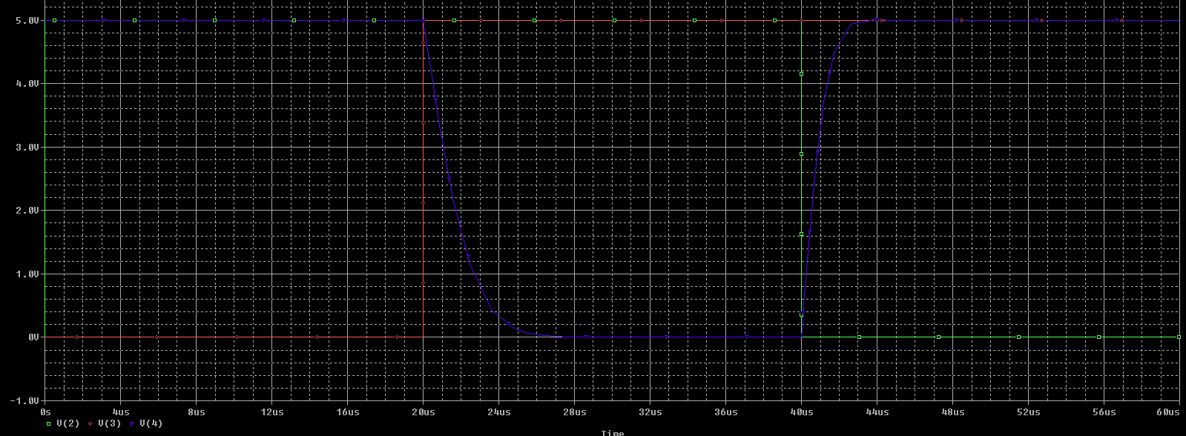

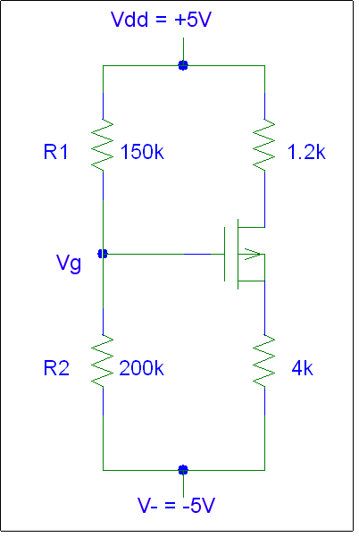

*Figure3: Circuit 3 - PMOS circuit.*

Circuit 3 Parameters:

K’p = 250 μA/V2

W/L = 1

Vtp = -1V

|  |  |  |
| --- | --- | --- |
| **Element** | **Calculated** | **PSpice** |
| Vg | 714.3 mV | 714.3 mV |
| Vs | 4.1268 V | 4.1269 V |
| Vd | -2.089 V | -2.089 V |
| Vds | -6.216 V | -6.22 V |
| Vgs | -3.412 V | -3.41 V |
| Ids | 727.69 mA | 728 mA |

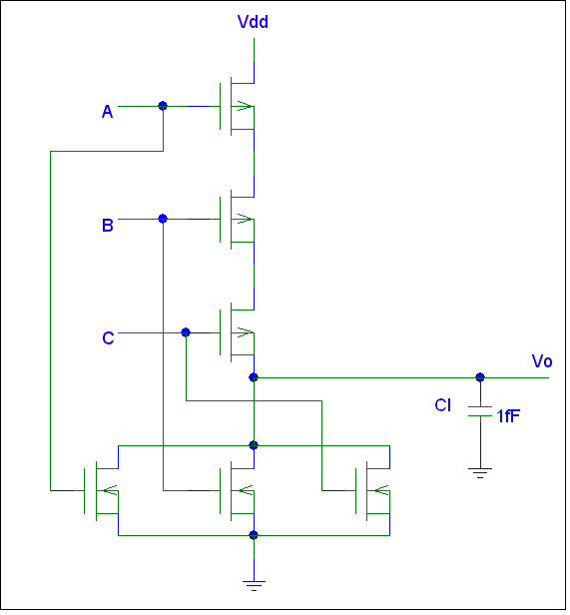

*Figure 4: Circuit 4 – 3 Input NOR circuit.*

Circuit 2 Parameters:

K’n = 50 μA/V2

l=2u, w=8u

Vtn = 0.6V

Vtp = -0.6V

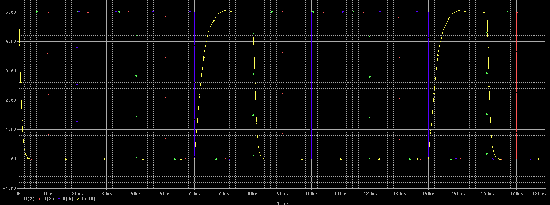

**Conclusion:**

This exercise was effective in introducing PSPICE circuit creation and simulation. Calculated values matched PSPICE values nearly identically and the only discrepancy was found in that PSPICE rounding was less precise than our calculations. There may be an option in PSPICE for setting the precision of its calculations or displayed results but we did not locate it yet. We also found that the Kn and Kp values were actually K’n and K’p values as we use in class work. There were some interesting limitations that we do not yet clearly understand with regard to circuit simulation/modeling output. One example of the unclear conditions is the time scale limitation. For one circuit we were able to adjust that parameter but for the other modeled circuit we were not able to adjust the parameter. Another “anomaly” was in that we (and other teams) were unable to get a current source to work in the previous lab’s practice run but there was at least one team that did get their current source to run. This experiment has shown that, in order for us to make more effective use of the capabilities of PSPICE, we will have to investigate options and work more examples.