ECE 321

Lab 6: NMOS Transistor Introduction

Brian Becker, Tony Mancuso, Jeremy McConaha

(Tuesday)

October 9, 2012

**Purpose:**

This laboratory exercise is intended to provide students practice in NMOS transistor circuit calculations, PSPICE emulation, and circuit construction and measurement.

**Procedure:**

1. Manually calculate all circuit (see figure 1) voltages and currents.
2. Create PSPICE circuit and run simulation.
3. Measure resistors and power supply level then construct circuit and measure all voltages and currents.
4. In a table, list results for values obtained in steps 1-3.

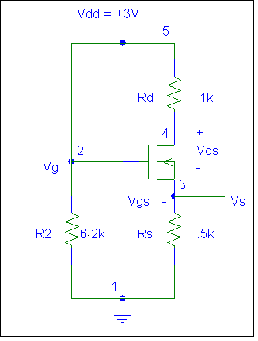

**6.8k**

**1.5k**

**0.6k**

*Figure 1: NMOS circuit.*

NMOS Circuit Parameters:

K’n= 1.825 mA/V2

W/L =1

VTN=1V.

**Results:**

|  |  |  |  |
| --- | --- | --- | --- |
| **Element** | **Calculated** | **PSpice** | **Measured** |
| R2 | 6800 Ω | 6800 Ω | 6803 Ω |
| Rs | 600 Ω | 600 Ω | 599.749 Ω |
| Rd | 1500 Ω | 1500 Ω | 1488 Ω |
| Vg | 3 V | 3 V | 3 V |
| Vs | 6835 mV | 6835 mV | 663 mV |
| Vd | 1.305 V | 1.305 V | 1.347 V |
| Vds | 621 mV | 621 mV | 682 mV |
| Vgs | 2.317 V | 2.317 V | 2.33 V |
| IR2 | 441.18 µA | 441.18 µA | 440.98 µA |
| Ids | 1.139 mA | 1.139 mA | 1.106 mA |

*Table 1: Calculated, PSPICE, and measured values.*

**Conclusion:**

This exercise provided for good practice in calculating NMOS transistor circuit values and in creating and running PSPICE circuit emulation. PSPICE values were identical to calculated values and measurements were very close to calculated and emulated values.