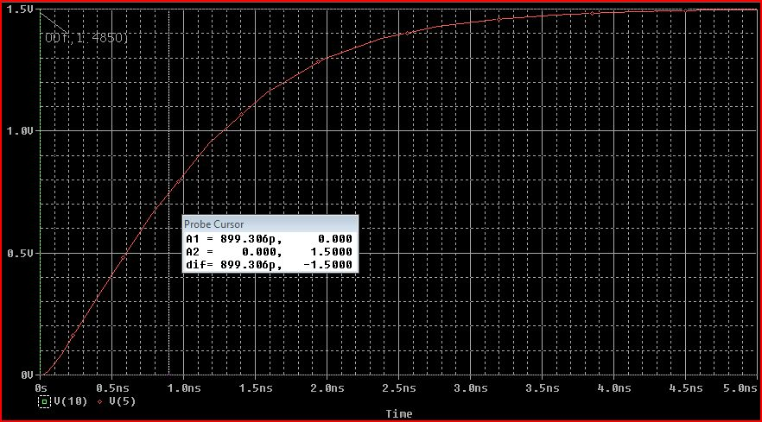

HW10: Calculated $t_{PLH}$ = **869.06 ps**

PSPICE Measured $t_{PLH}$ = **899.306 ps** (displayed below)

% error = 877.082-899) $\frac{899.306-869.06}{869.06 }$**x 100 = 1.03%**

*Anthony P Mancuso*

*ECE321, HW-11, PSPICE Verification of HW-10 tplh*

*HW-10 calculation: tplh = 869.06ps*

m1 12 10 0 0 cmosn l=.25u w=2.5u

m2 12 10 9 9 cmosp l=.25u w=4.25u

.model cmosp pmos level=2 vto=-0.4 kp=60u

.model cmosn nmos level=2 vto=0.4 kp=100u

r1 12 1 120

c1 1 0 75e-15

r2 1 2 165

c2 2 0 100e-15

r3 2 3 80

c3 3 0 95e-15

r4 2 4 105

c4 4 0 65e-15

r5 4 5 220

c5 5 0 200e-15

r6 1 6 100

c6 6 0 15e-15

r7 6 7 150

c7 7 0 45e-15

r8 7 8 90

c8 8 0 50e-15

vdd 9 0 dc 1.5V

vin 10 0 pulse(1.5 0 0ps 1ps 1ps 5ns 10ns)

*.DC Vin 0 5 0.01*

.op

.probe

.tran 100ps 20ns

.end