|  |  |  |
| --- | --- | --- |
| الجامعة الإسلامية – غزة  كلية تكنولوجيا المعلومات  ماجستير تكنولوجيا المعلومات |  | Islamic University – Gaza  Faculty of Information Technology  Department of Information Technology |
|  | شعار الجامعة.bmp |  |

**Using Hypothesis Testing**

**as Exploratory Data analysis Technique**

*A Case Study Using the Iris Dataset*

By:

*Abeer Yousef Abu Mosameh -220232641*

*Supervised By*

Dr. Iyad Husni Alshami

*Dec, 2024*

# Introduction

**Exploratory data analysis (EDA)** is used by data scientists to analyze and investigate data sets and declare main characteristics. For example, EDA use data visualization techniques to provide a clearer understanding of the data. Hypothesis testing plays an important role in EDA by validating patterns statistically.

**Hypothesis testing** is a structured approach or statistical method to validate or reject assumptions and claims about a dataset/population “It evaluates two mutually exclusive statements about a population to determine **which statement is best** supported by the sample data”. Therefore, it helps us make decisions based on data and evidence rather than intuition or assumption.

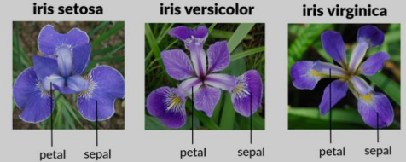So we will explore the application of hypothesis testing as an EDA technique using the Iris dataset- data sets consists of 3 different types of irises’ (Setosa, Versicolour, and Virginica) petal and sepal length.

# Hypothesis Testing Techniques Steps

1. **Defining Hypotheses:**

* ***Null Hypothesis (H0):***This represents the assumption to be tested. It typically states that there is *no effect, no difference between groups, or no relationship in the data*.
* *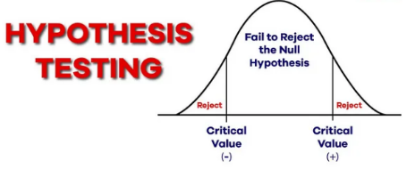****Alternative Hypothesis (H1):***This represents the opposite/complement of the null hypothesis. It suggests there is *an effect, a difference, or a relationship in the data can expect to find*

So The null hypothesis is the claim we test for possible rejection, while the alternate hypothesis is accepted when there's evidence against the null.

1. **Choose Appropriate Test Tool**

There is many tool can used in Hypothesis Testing:

* **Z-Tests**: used If population means and standard deviations are known.
* **T-Tests:** used If population standard deviations are unknown. and sample size is small
* **Chi-Squared Tests:** Assess the association between categorical variables.
* **F-test "Analysis of Variance (ANOVA)":** Compare the means of three or more groups .. used if has multiple groups.

1. 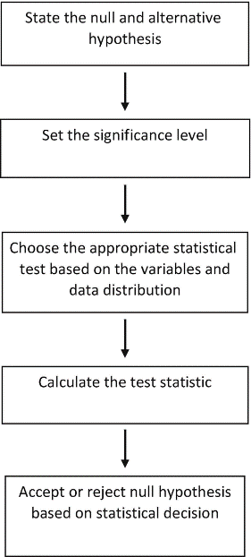**Decide Significance Level (Alpha):** it refers to the degree of significance in which we accept or reject the null hypothesis

Common alpha values are **0.05** “which means output should be 95% confident to give a similar kind of result in other sample” and **0.01**.

1. **Calculate Test Statistic and P-value**

* Test Statistic: is a numerical value calculated from sample data during a hypothesis test, used to determine whether to reject the null hypothesis.
* P-value: is the probability of obtaining test results when the null hypothesis (H0) is true.

1. **Take Hypotheses decision:**

Based on the test results, decide to reject the null hypothesis or not.

If the p-value is less than alpha” significance level”, then reject the null hypothesis. If it’s greater, we usually accept the null hypothesis.

# Apply Hypothesis Testing Technique in Iris Dataset using Python code

### **Z-Tests not preferred because the sample size is relatively small**

1. 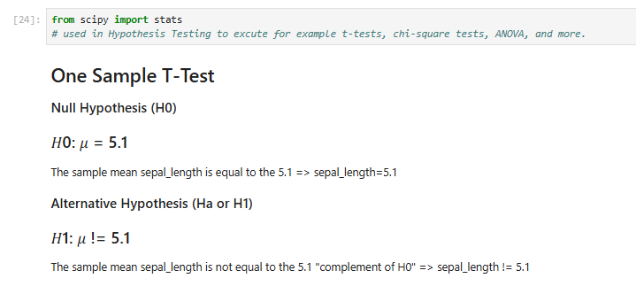**T-Tests can used**

t = Test statistic

x̄ = sample mean

μ = population mean

s = standard deviation of the sample

n = sample size

$$mathematical equation:$$

$$t= \frac{\overline{x}-μ}{\frac{s}{\sqrt{n}}}$$

Using Equation:

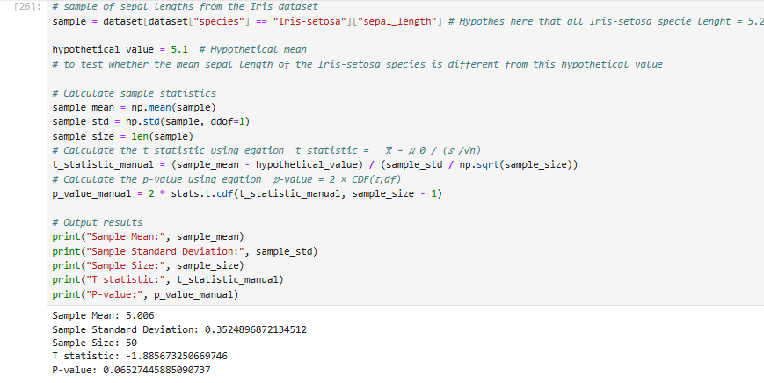or using ttest_1samp directly from scipy library

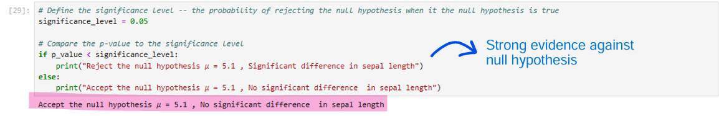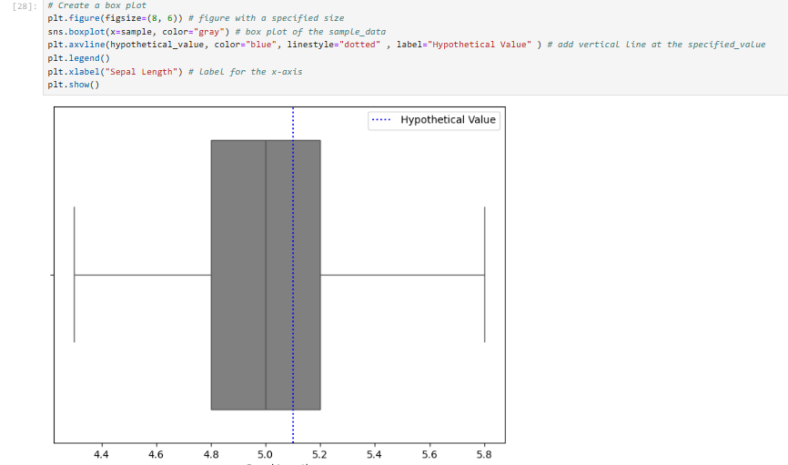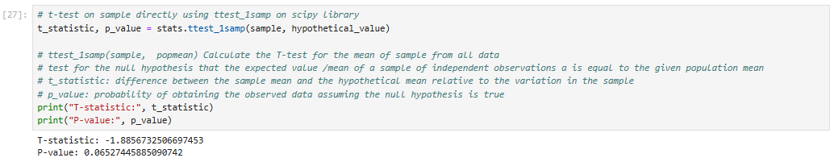

* 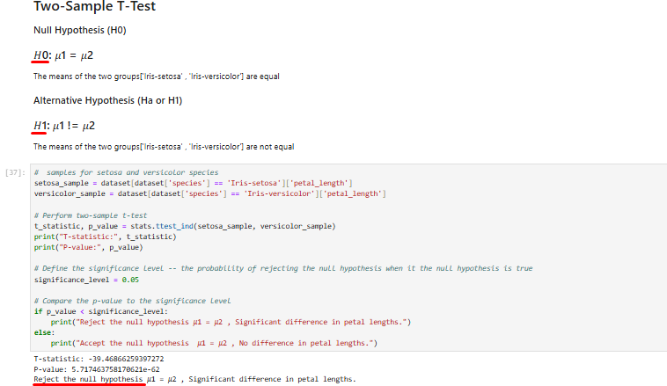 **Two sample T-Test $$t= \frac{\overline{x_{1}}-{\overline{x}}_{2}}{s_{p}\sqrt{\frac{1}{n_{1}}+\frac{1}{n_{2}}}}$$**
* $\overline{x_{1}}-{\overline{x}}_{2}$ are the sample means of the two groups
* $s_{p}$ is the pooled standard deviation

$$s_{p}=\sqrt{\frac{\left(n_{1}-1\right){s_{1}}^{2}+(n_{2}-1){s_{2}}^{2}}{n_{1}+ n_{2 }-2}}$$

$s_{1} , s_{2}$ standard deviations of the two samples

* $n_{1}$ and $n_{2}$ are the sample sizes of the two groups.

1. **Chi-Square Test can used but I will not mentioned**
2. **Analysis of Variance (ANOVA) :** suit for iris database because it’s 3 group ['Iris-setosa' , 'Iris-versicolor',’ Iris-virginica’]

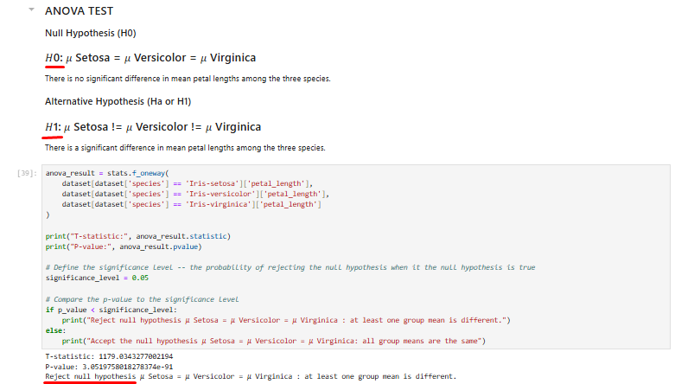

Video Link

<https://youtu.be/eIhFP4xzQ3M>

References

* GeeksforGeeks. (2024a, May 16). *What is Exploratory Data Analysis?* GeeksforGeeks. [https://www.geeksforgeeks.org/what-is-exploratory-data-analysis/](%20https:/www.geeksforgeeks.org/what-is-exploratory-data-analysis/)
* GeeksforGeeks. (2024c, October 8). *Understanding hypothesis testing*. GeeksforGeeks. <https://www.geeksforgeeks.org/understanding-hypothesis-testing/>
* Slidescope. (2023, February 22). *ANOVA Example using Python Pandas on Iris Dataset*. Slidescope. <https://slidescope.com/anova-example-using-python-pandas-on-iris-dataset/>
* GeeksforGeeks. (2024, September 23). *Exploratory data analysis on IRIS Dataset*. GeeksforGeeks. <https://www.geeksforgeeks.org/exploratory-data-analysis-on-iris-dataset/>