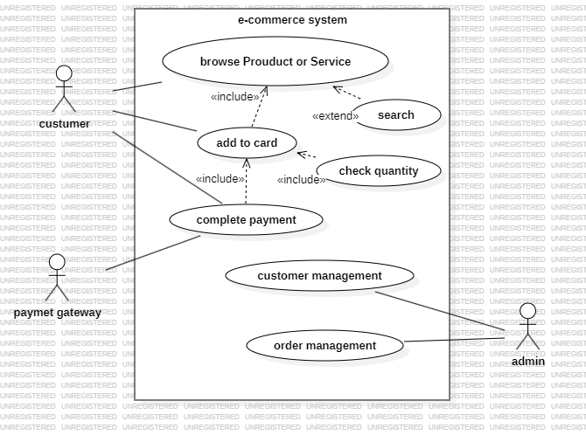

Assume the first page has product and I can search for the product

Use case brows product or service:

|  |  |  |
| --- | --- | --- |
| Use Case | Case Name | |
| Goal | When the customer accesses the system item can be found in the first page or by search | |
| Preconditions | The customer logged in the system by user name and password | |
| Success End Condition | The customer can view the items either in the first page of the system or by searching of them using the product name | |
| Failed End Condition | When the customer opens the first page there is no product found or be searching fails by shows a wrong product | |
| Primary Actors | customer | |
| Trigger | Press the search button | |
| Description / Main Success Scenario | Step | Action |
|  | Customer log in to the site/app using the username and password |
|  | Customer view product form the first page or search for it by click on the search button and enter a keyword of the product |
|  | The system displays the correct product after searching |
|  | The customer can view the product and may choose from them |
| Alternative Flow | Step | Branching Action |
|  | Customer cannot log in because he doesn’t have a username, first need to register. |
|  | Customer cannot find product because the system doesn’t have them, the system displays no result found |
|  | Customer cannot add product because the check quantity = 0, then the system displays this product out of stock |
|