

AIR UNIVERSITY E-9 ISLAMABAD

OBJECT ORIENTED PROGRAMMING

SEMESTER PROJECT

GROUP MEMBERS:

- ZEESHAN NASIR (232483)
- ABEERA ZAINAB (232997)
- MAHEEN FATIMA (232510)

Submitted To:
Maam Iqra Ali

Class: BSCS-EV-2B

Date:19/5/2024

Project Name:
“HANGMAN”

This word file contain documentation of project and screenshot of code and its output

- Description Of Project:

The Hangman C++ OOP Project is a console-based implementation of the classic Hangman game using Object-Oriented Programming principles in C++. The project is designed to showcase fundamental OOP concepts such as classes, objects, encapsulation, inheritance, and polymorphism. The game involves guessing a hidden word by suggesting letters within a certain number of attempts.

Features:
Object-Oriented Design:Class Structure: The project is structured around several key classes, such as Game, Word, Player, and Hangman. Each class encapsulates specific functionalities and responsibilities, promoting modularity and code reuse.Encapsulation: Data members are kept private, with public methods provided for interaction, ensuring data integrity and security.Inheritance and Polymorphism: Potentially extendable to include different types of players (e.g., human vs. computer).
Gameplay Mechanics:Random Word Selection: The game randomly selects a word from a predefined list, ensuring a new challenge each time.User Interaction: Players interact with the game through a simple text-based interface, making guesses one letter at a time.Attempts Tracking: The game tracks the number of incorrect guesses and provides feedback to the player, displaying the partially guessed word and remaining attempts.Win/Loss Conditions: The game ends when the player either successfully guesses the word or exhausts their attempts, with appropriate win/loss messages displayed.
- User-Friendly Interface:Input Validation: Ensures that players enter valid characters and handles invalid inputs gracefully.
Clear Instructions and Prompts: Provides clear instructions and prompts to guide the player throughout the game.Implementation DetailsLanguage and Libraries: Implemented in C++ using standard libraries. No external dependencies are required, ensuring easy compilation and execution on any standard C++ development environmentThe libraries that are included in code:
#include <iostream>
#include <cstdlib>
#include <ctime>
#include <string>
#include<fstream>

Code Structure:Main Function: Initializes the game and manages the game loop.Game Class: Manages the overall game flow, including word selection, tracking attempts, and checking win/loss conditions.Word Class: Handles word-related operations, such as revealing letters and checking if the word is fully guessed.Player Class: Manages player-specific operations, such as taking guesses and updating the game state.Hangman Class: Optionally could represent the hangman figure for graphical representation in a console environment.If we have entered 6 letter word then 2 words for hint is give and if 5 letter word is given then q hint is given for guess.
ScreenShots Of Code: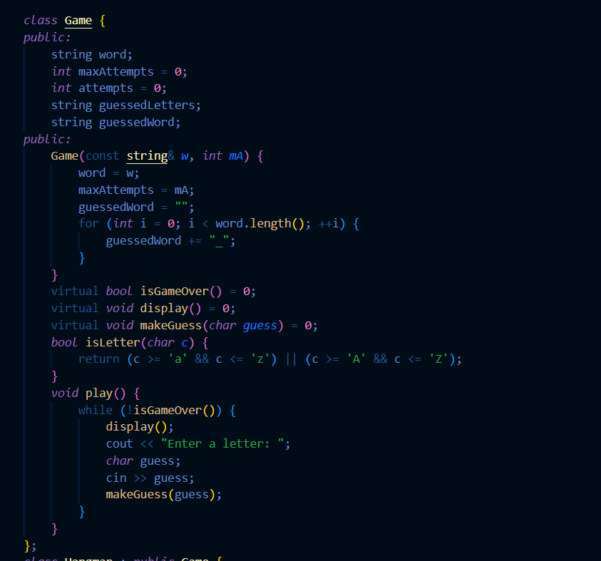

The code defines a class named Game.The class has several member variables:word: A string to store the word that needs to be guessed.maxAttempts: An integer representing the maximum number of attempts allowed.attempts: An integer to keep track of the current number of attempts made.
guessedLetters: A string to store the letters guessed by the player.guessedWord: A string representing the current state of the guessed word (with dashes for unguessed letters).The constructor initializes the word, maxAttempts, and guessedWord.Virtual Functions:The class declares three virtual functions:isGameOver(): Determines if the game is over (implementation not provided here).display(): Displays the current game state (implementation not provided here).makeGuess(char guess): Handles the player’s guess (implementation not provided here