How to build your virtual machine

<https://linuxmint.com/edition.php?id=250>

download Mint 18.3 “Sylvia” – Xfce (64 bit)

sha256 verify

a78be201c766133d35a39b0555e00503f5fe47ff2bb17d6e27953397f44dcf09 *linuxmint-18.3-xfce-64bit.iso

Oracle VM VirtualBox 5.2.6

<https://www.virtualbox.org/wiki/Downloads>

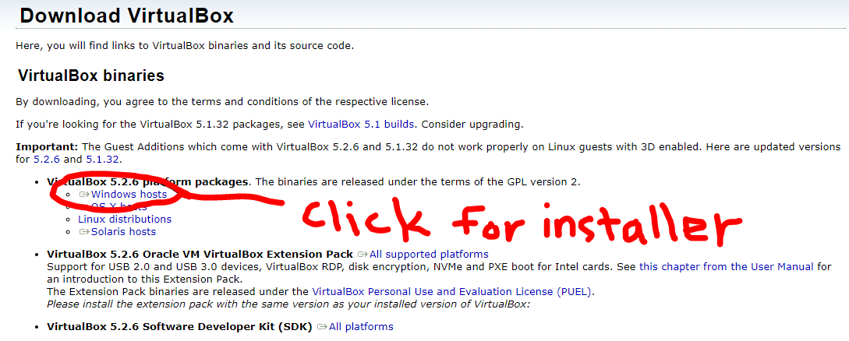

launch oracle virtual box

click new;

name: Django_Server

select: type = linux, version= Ubuntu(64)

select memory = 2048MB

leave “Create a virtual hard disk now”

click next;

first select Hard disk Type; I use VHD (Ive had problems with VDI, but many people leave it as the default)

next select file location

file location: I put my virtual machines in <user>/documents/virtual_machines/

you probably will never visit this file location

leave dynamically allocated selected

raise file size to 20.0 GB

*on the network tab it defaults to NAT. This allows your VM out to the internet but incoming connections cannot route to it. This is fine, but understand you will only be able to visit your Django website from the browser inside the virtual machine. If you want your other home computers to be able to view the robot waitress change this setting to bridged. Late make note of the ip address your router gives the VM. You will still be firewalled by the router but have access from home.

* you should be fine with the display default of 16MB as your host machine will be the one actually doing the work of rendering the desktop.

Next we are going to set the VM to boot to the linux ISO we downloaded earlier

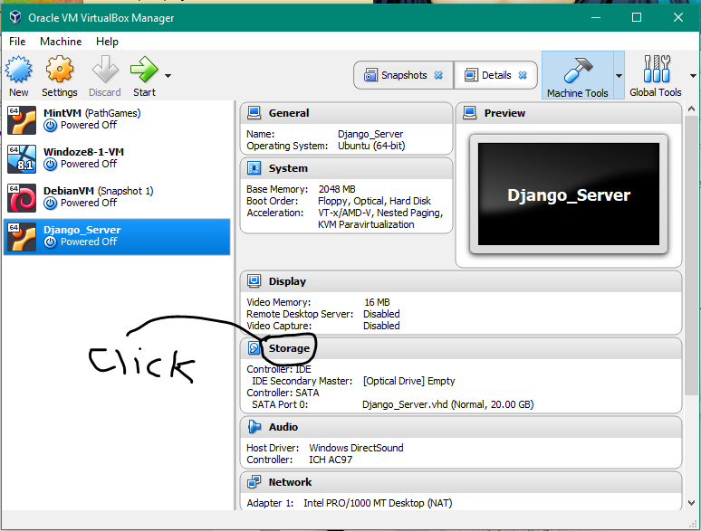

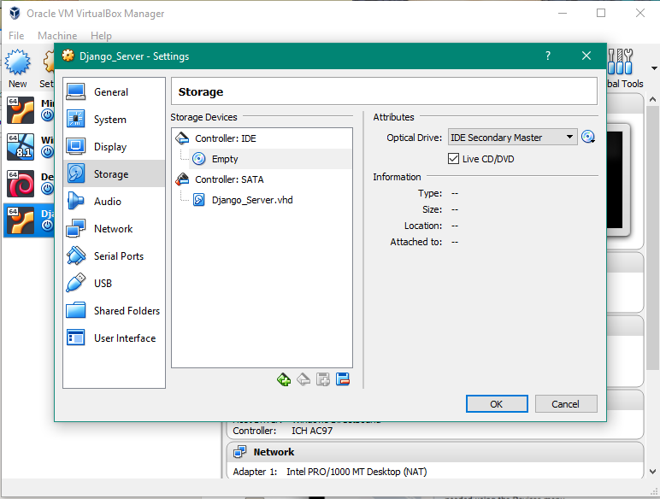

click on Empty underneath controller:IDE in the center window labeled Storage Devices

then mark the box “live CD/DVD”

then click the CD picture in the Attributes section

choose “choose virtual optical disk file”

navigate to where you saved the mint 18.3 download

select that file

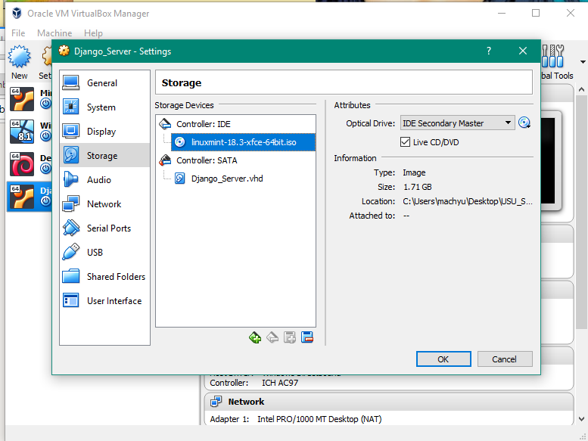

press ok;

press start;

[now you are bootinh into the mint virtual machine]

in about 30 seconds you should land on the mint desktop

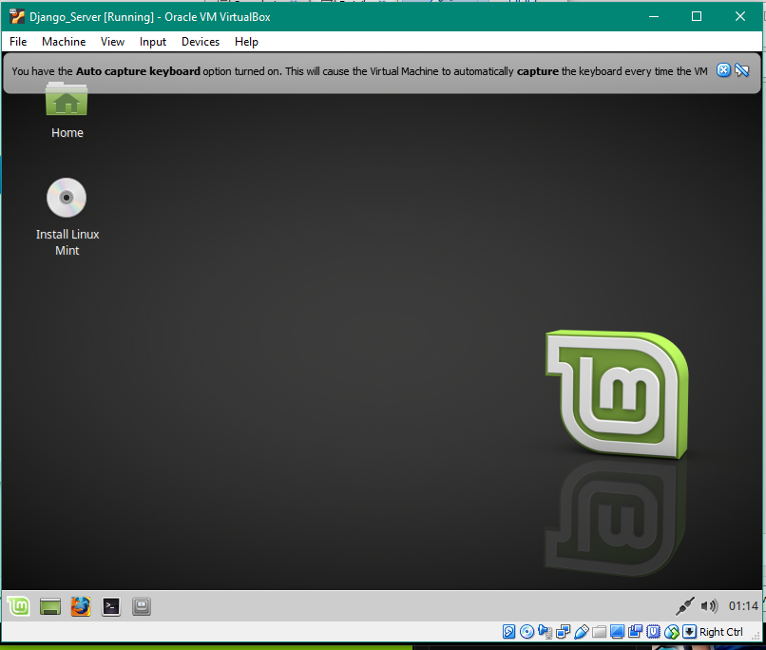

you can ‘x’ the capture warnings.

then click on the Install Linux Mint

[don’t worry, it will install in the 20GB space you created for it and not over you file system]

answers to install questions;

1. English
2. check to include third party software.
3. Erase disk and install Linux Mint

[you do not need to select Encryption or LVM *that’s to create snapshots on metal installs, virtual box will do our snap shots.]

1. accept the partitioning scheme by clicking continue

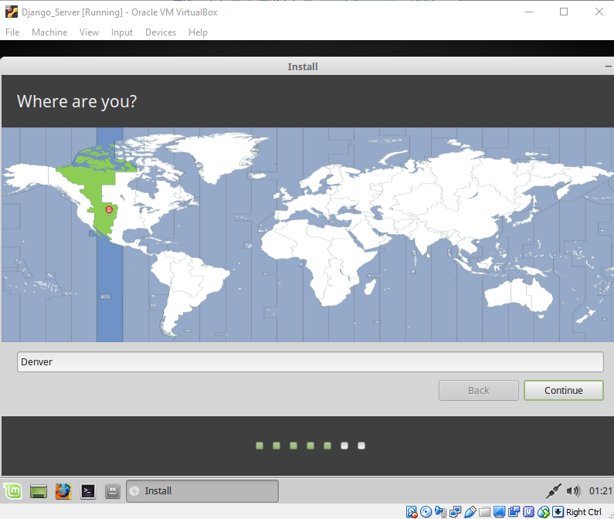

1. select Denver if not done already
2. English(US) and English(US) for keyboard. click continue
3. set up passwords (its just a demo machine so write down username and PW if you think you might forget

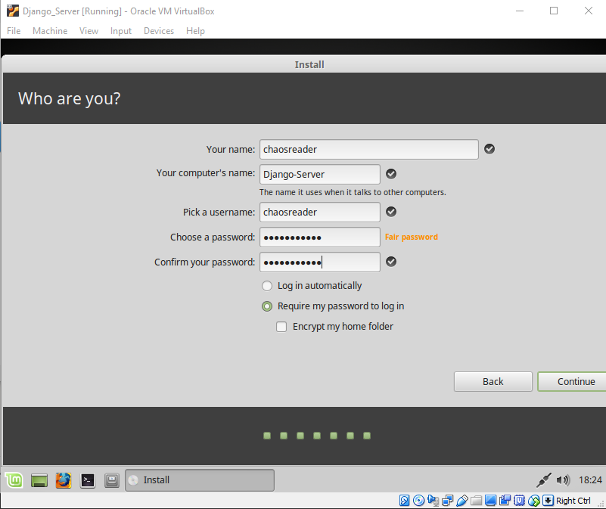

1. it will finish installing and ask you to restart
2. 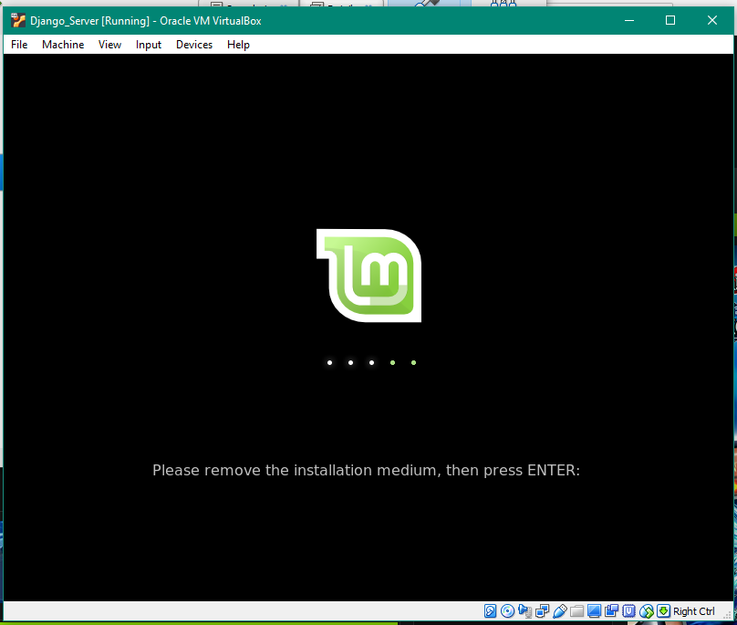
3. click devices -> Optical drives -> remove disk from virtual drive
4. then click on mint again and get you mouse captured. press enter.
5. congratulation you have built a virtual machine. next we will configure it for our evil purposes.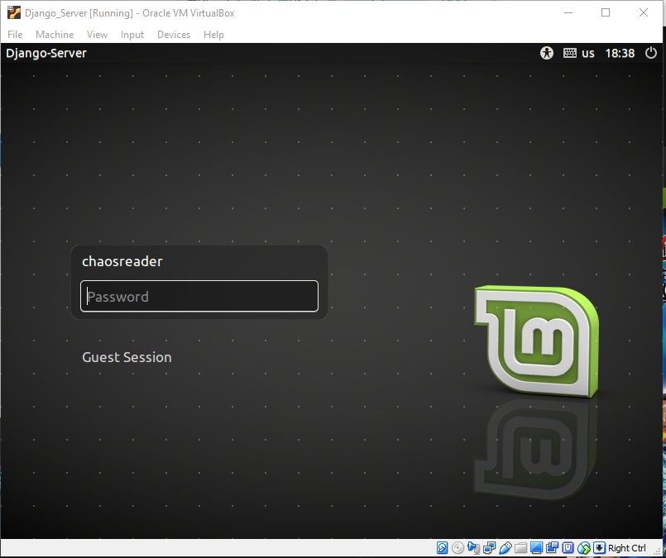

enter the following commands from inside the VM using the terminal

press yes for anything the next few commands ask

$ sudo apt update

$ sudo apt upgrade

$ sudo apt install python3-pip

$ sudo apt install git

inside mint open firefox and go to:

<https://code.visualstudio.com/Download>

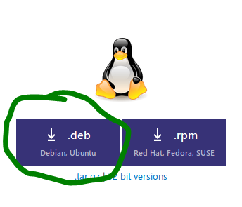

save file. it should end up in your download folder

you can close firefox

$ mkdir Builds

$ mv Downloads/code_1.20.0<tab complete> Builds/

$ cd Builds

$ sudo dpkg -i code_1.20.0.blah.blah.deb

these instructions assume you start in your home folder and are relative to that.

you should have a new program (click leaf (its like start) and hover over development)

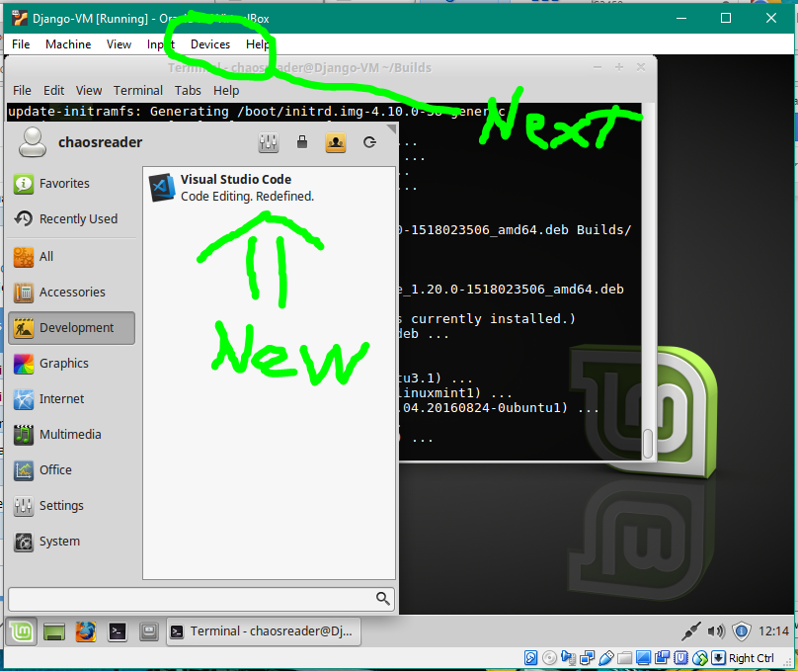

next click devices and select “insert guest additions CD”

in a second it should pop a notice that guest additions CD was mounted

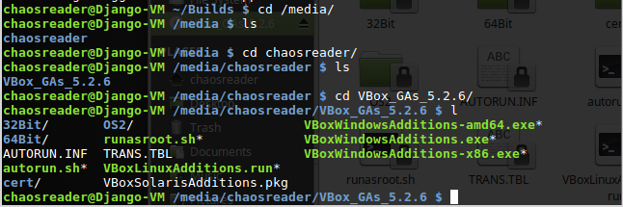

navigate to /media/<username>/VBox_<tab>/

run

$ sudo ./VBoxLinuxGuestAdditions.run

$ sync

close everything and shutdown the VM

I took a snapshot at this point:

on virtual box manager -> machine tools drop down -> snap shots -> then click take (camera with a + icon)

when you reboot, you should be able to get a full screen view of mint. I had to toggle back and forth twice to get it to start going full screen.

$ sudo –H pip3 install Django==2.0.2

* ignore the pip 8.1.1 warning

~ $ mkdir Server

~ $ cd Server

~/Server $ django-admin startproject robotwaitress

~/Server $ cd robotwaitress

~/Server/robotwaitress $ python3 ./manage.py runserver

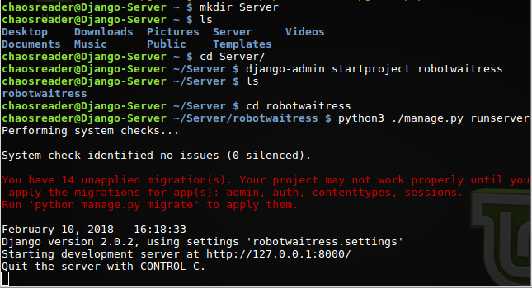

open firefox (in mint) and go to where the server is running. make sure to use the port number after the :

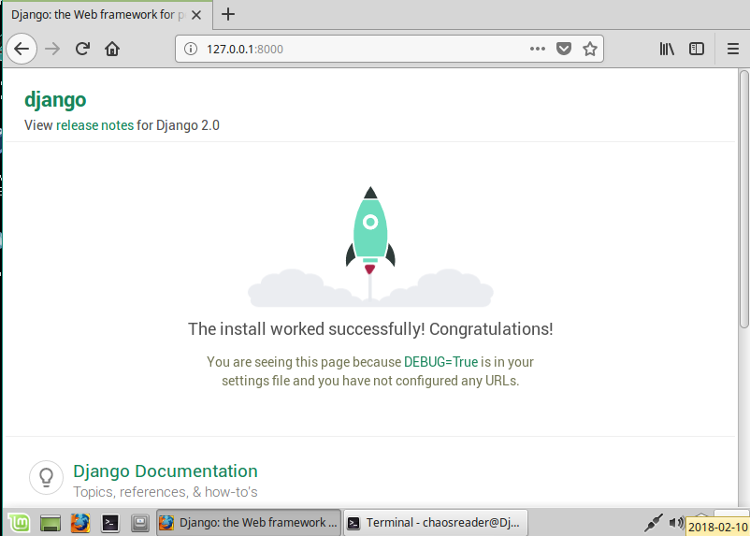

Shutdown the VM and make a snapshot. Mine is titled “Project-Start”