PGP User Manual
- PGP – What is it?
PGP is a computer program that enables you to scramble email messages so that they can only be read by the people that you chose to send them to.
Sending normal emails is like using postcards instead of letters - anyone can read them en-route. When you send an email to someone else, the contents may pass through a dozen other computers. Anyone in control of these could easily see what you have written.
The PGP software will provide you 2 keys. A private key which will be used to decrypt messages you receive and a public key that you need to give to the people you want to receive messages from and they will use it to encrypt the messages they send you.
Let’s say YOU want to send US a message:
First, you need OUR Public Key in order to encrypt your message. We will decrypt your message using OUR private key.
Note: you can also sign your message with a digital signature in order to ensure that the message came from you.
The Process in 3 Steps:
  - Using OUR Public Key, you encrypt the message.
Using YOUR own Private Key you generate a Digital Signature.
Note: In case you digital sign the message, we must have your public key in order to verify the signature. (There is an explanation how to use it, further in this document)
  - Send the Signed Encrypted Message to us by any mail server you like.
(The Digital Signature is actually placed inside the Encrypted Message)
  - Using OUR Private Key, we decrypt the message.
Using Your Public key we then verify the Digital Signature and ensure that it is you behind the message.
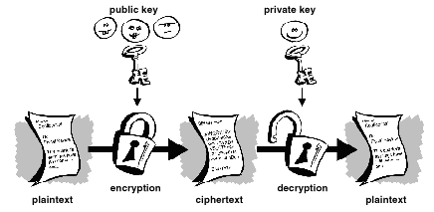
PGP session – Encrypt and Decrypt a message
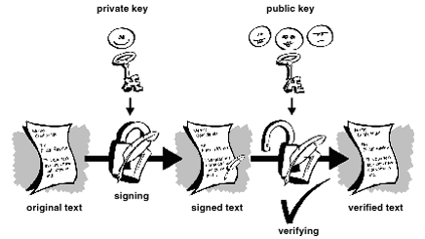
Digital Sign verification
This guide will take you through the basic steps necessary to install and use PGP on a computer running Windows 95, 98, ME, NT, 2000, or XP. This won't work on a computer running an older version of Windows, like Windows 3.1. There is a version of PGP for Apple Macs, but the installation procedure will be slightly different and this document doesn't describe it.
If you don't have a PGP program yet, you can use the several PGP programs available on the web. Some are free and some are not. We recommend you to use "GNU Privacy Guard" freeware also known as "GnuPG" or "GPG". It is an application where you need to manually Encrypt or Decrypt your messages.
It can be used for both:
  - Web Based Mail like Hotmail, Yahoo, Gmail etc.
  - Desktop Email Clients like Outlook.
This is possible because GnuPG operates directly on the text, regardless of the application.
You can download the program gpg4win-1.1.3 from: http://www.gpg4win.org/download.html
- Installation
  - Run the application file.
  - The following window will appear:
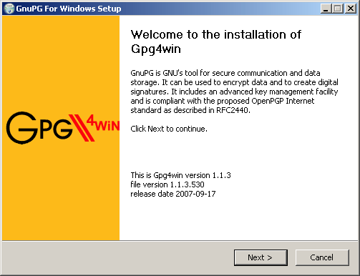
  - Click Next.
  - The following window will appear:
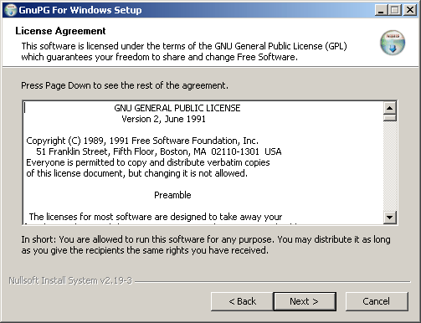
  - Click Next.
  - The following window will appear:
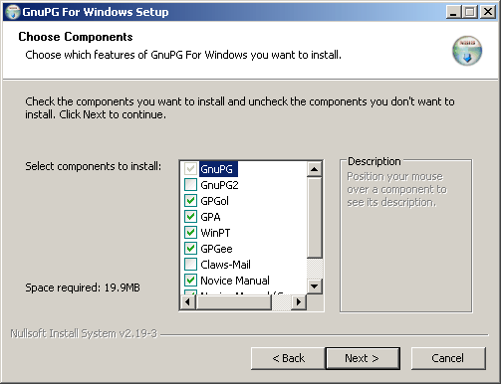
  - We recommend the default installation.
  - Click Next.
  - In the following window choose your preferred installation folder.
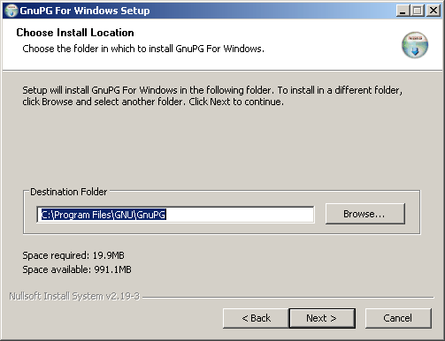
  - Click Next.
  - In the following window choose your preferred start links and click Next and then Install.
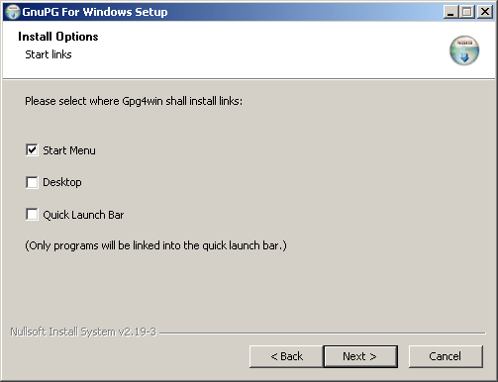
  - The installation will take a few seconds.
  - After the installation completed click Next and then Finish.
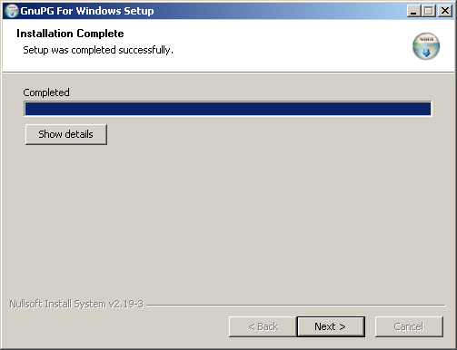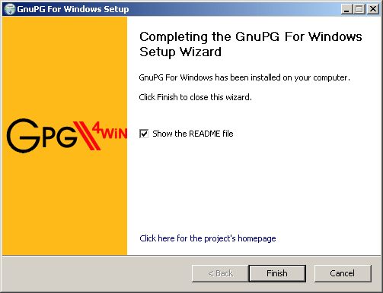
- First Use
  - Run the GPA program in order to create your own private and public keys.
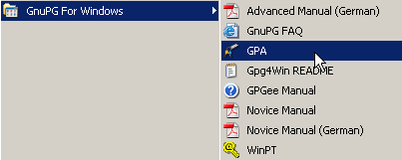
  - The following window appear:
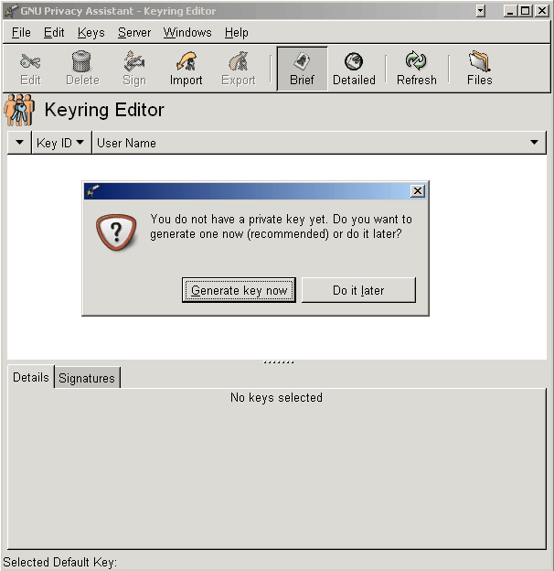
  - Click on Generate key now.
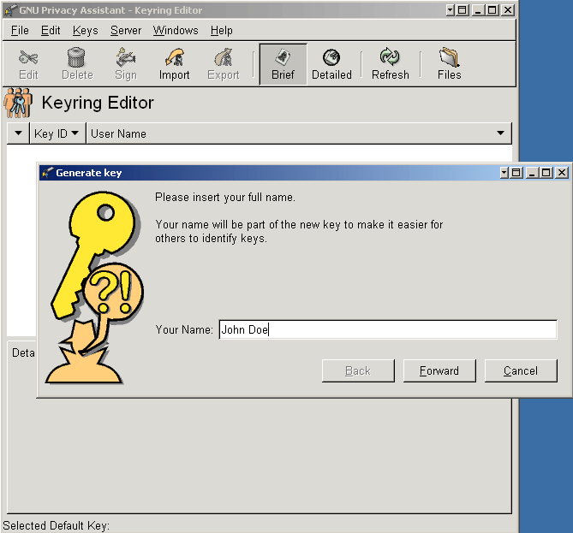
  - Fill in a name which will be attached to your private and public keys.
  - Click Forward.
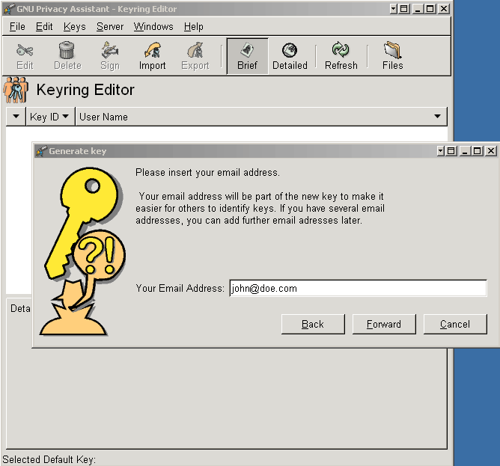
  - Fill in your email address which will be attached to your private and public keys as well.
  - Click Forward.
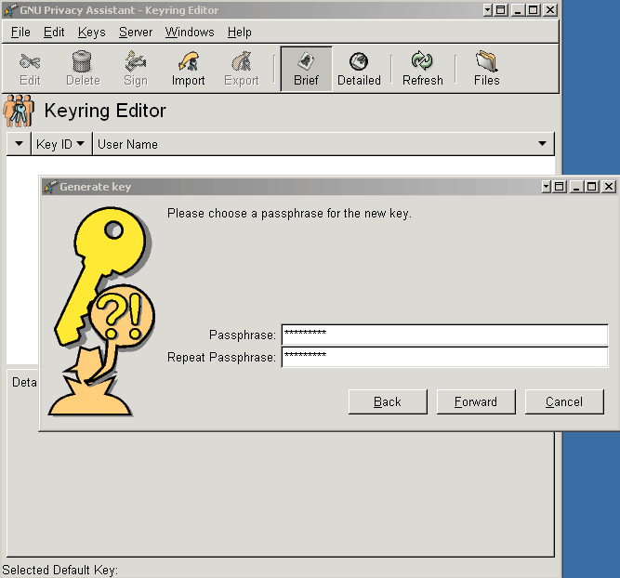
  - Enter your preferred password – twice.
Note: in case you received the following warning window:
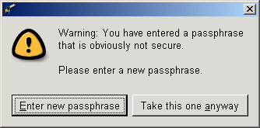
It is recommended to change your password into one that includes 13 characters in a combination of capital and non capital letter and numbers too.
  - Mark the Create backup copy option and click Apply.
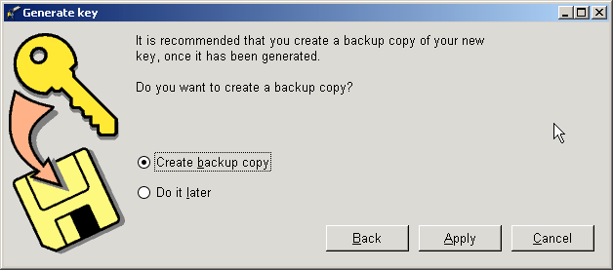
  - In the Backup Keys window, browse to the designated folder which you want to save the backup in, chose a desired file name and click ok twice
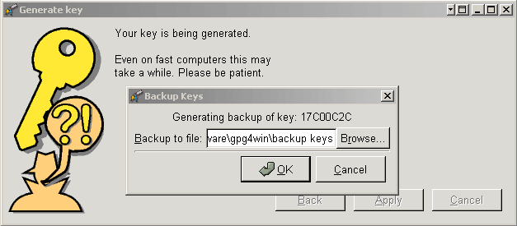
  - Creating keys process end.
  - In the following window you can see your keys (public and private).
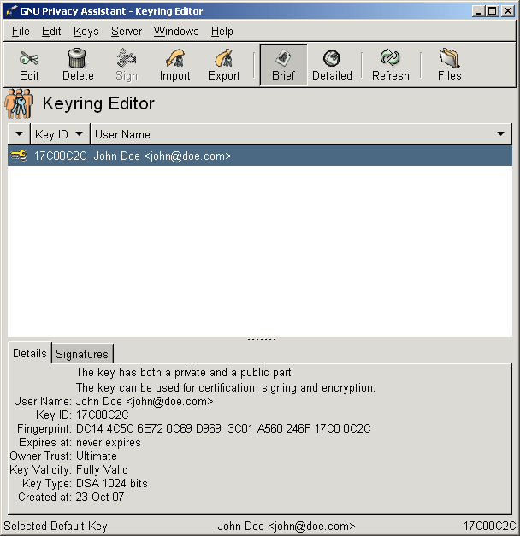
- SENDING encrypted MESSAGE
First you need to import the public key of the addressee.
For example you downloaded our public key from here and want to import it in order to send us an encrypted email
  - Click on the Import button.
  - Browse your drive and choose the public key you wish to import
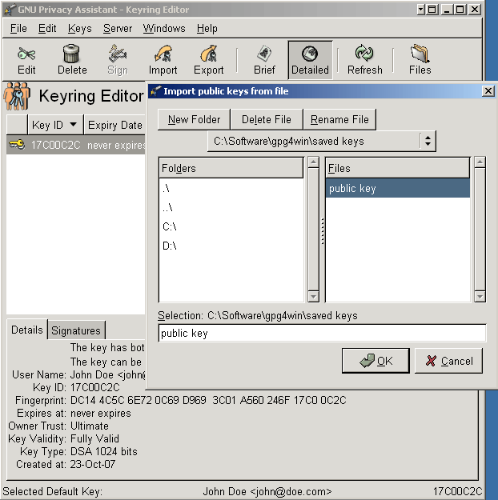
- Encrypting a text message
  - In case WinPT is not running (shown on your taskbar) run it from GnuPG program folder.
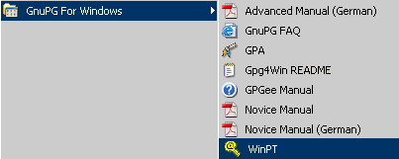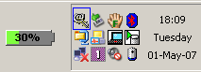
  - Write your massage with your favorite text editor (for example notepad).
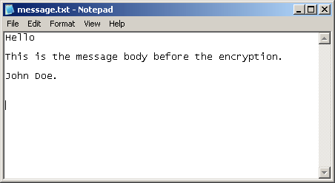
  - Mark and copy your massage then right click on the WinPT icon on your windows taskbar and select Clipboard -> Encrypt. (in case you want to sign the message as well, chose Sign & Encrypt.
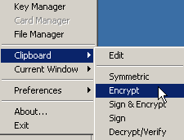
  - A window with optional keys will popup.
  - Select the addressee public key and press ok.
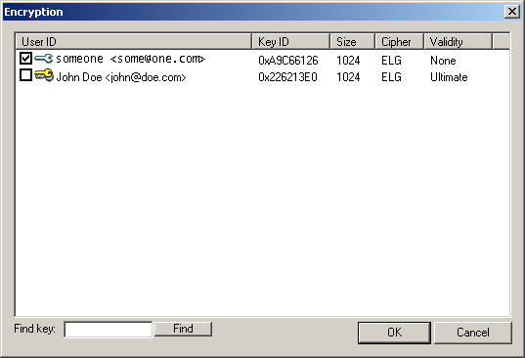
The encrypted message is now on your clipboard, you can paste it to your message window and send it with no worries.
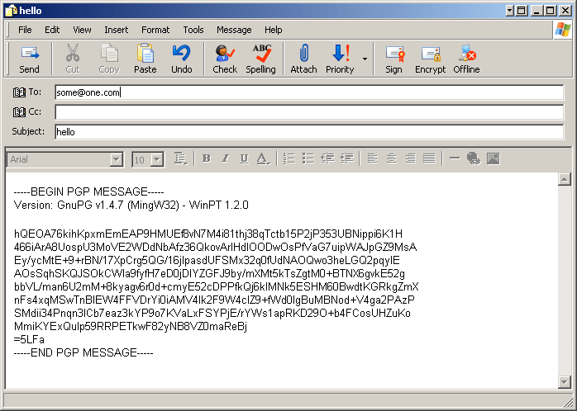
Important:
the encrypt message should include the PGP header -----BEGIN PGP MESSAGE----- and PGP footer-----END PGP MESSAGE-----

