UD24 – SPRING REST

1. 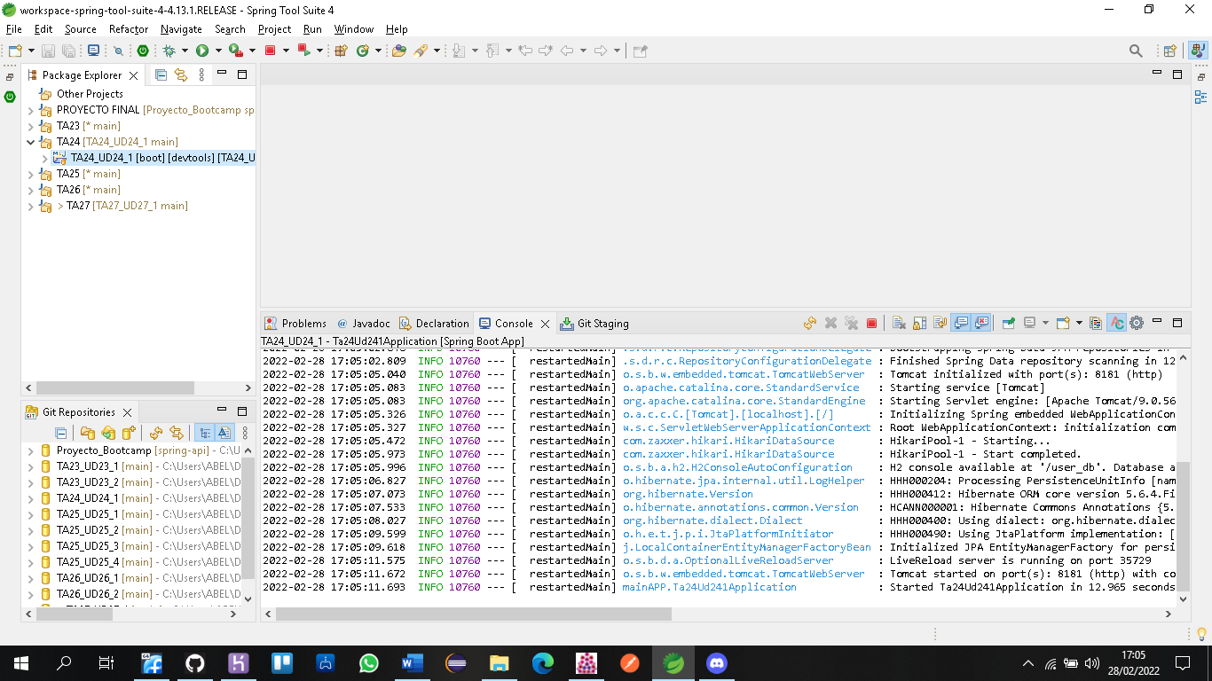<https://github.com/Abel-Git2103/TA24_UD24_1.git>

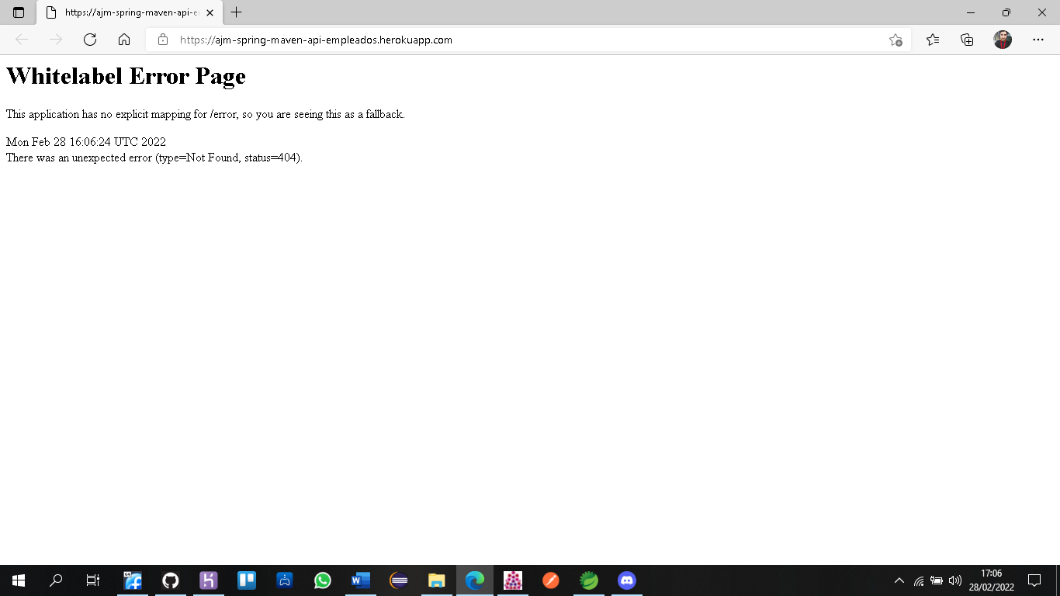HEROKU APP MAVEN: <https://ajm-spring-maven-api-empleados.herokuapp.com/>