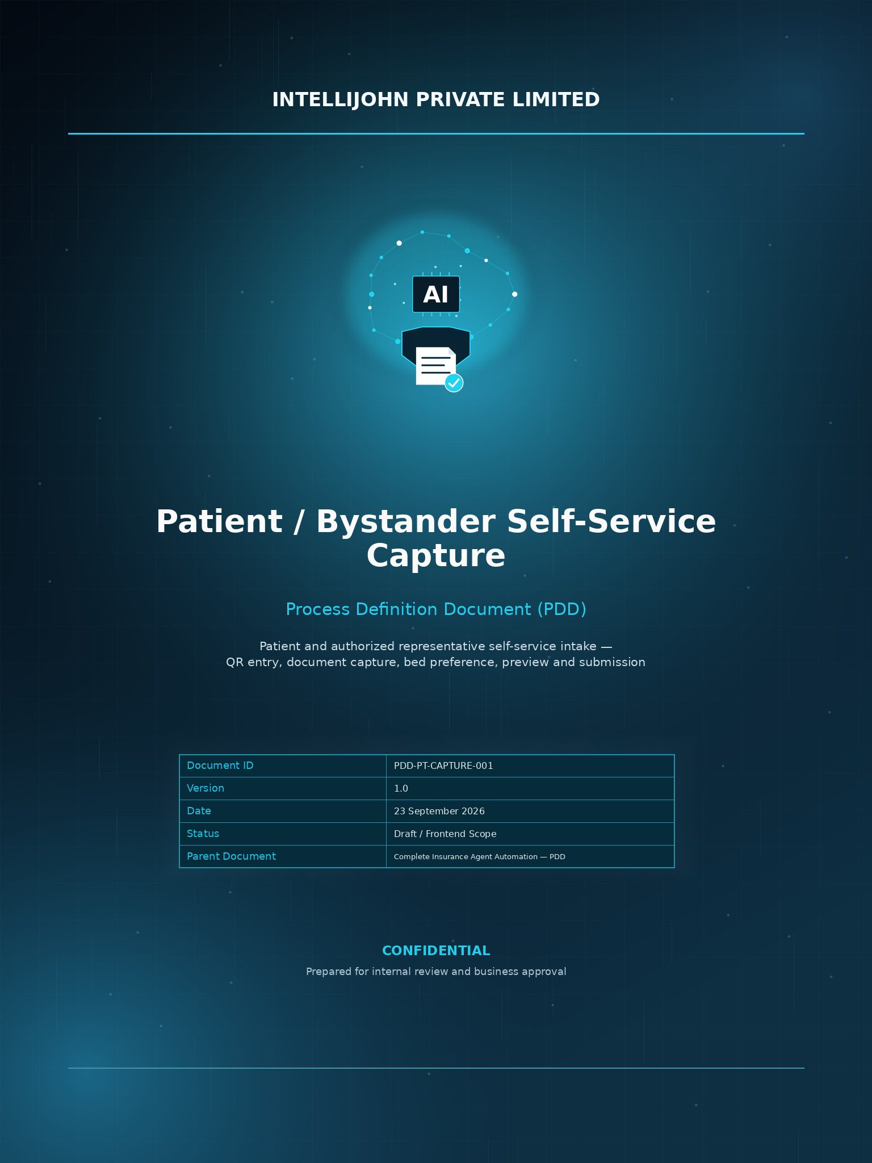

TABLE OF CONTENTS
1 Purpose 3
2 Scope 3
3 Out of Scope for the Frontend 3
4 End-to-End User Workflow 3
5 Detailed Functional Requirements 4
6 Screen List 5
7 Session and State Requirements 6
8 Error and Recovery Requirements 6
9 Security and Privacy Requirements 6
10 Non-Functional Requirements 6
11 Acceptance Criteria 7
12 UAT Scenarios 7
13 Data Captured by the Frontend 8
14 Backend / SDD Dependencies 8
15 Business Decisions / Open Items 8
16 Solution Design Boundary 9
17 Parent PDD Alignment 9
18 Alignment with the Overall PDD — Implementation Decisions 9
19 Final Agreed Frontend Workflow 10

PATIENT / BYSTANDER SELF-SERVICE CAPTURE
PROCESS DEFINITION DOCUMENT
Frontend-focused PDD

1. Purpose
This PDD defines the patient/bystander-facing web workflow for collecting documents, capturing bed preferences, presenting a final preview, and submitting the intake. It is derived from the parent insurance automation PDD and the previously defined patient/bystander self-service capture scope. Detailed technical implementation remains part of the Solution Design Document (SDD).

2. Scope
The frontend workflow covered by this PDD is:
- Open the web application by scanning a hospital QR code.
- Select Malayalam or English.
- Complete the document upload checklist.
- Capture/upload Hospital ID, Aadhaar, Insurance Card, Policy Document, PAN, and an outside-hospital Lab Report.
- Select and rank all four bed preferences.
- Review the complete submission on a final preview page.
- Submit the confirmed intake.
- Display submission success or an appropriate error/recovery state.

3. Out of Scope for the Frontend
- OCR/vision model implementation.
- Document extraction model development.
- Insurer/TPA portal automation.
- Clinical diagnosis or medical-necessity decisions.
- Insurance eligibility or approval decisions.
- Hospital-side final room allocation.
- Backend database implementation.
- Exact OCR/camera technology and quality thresholds.
- Final retention period unless approved by the relevant owners.

4. End-to-End User Workflow
QR Code → Language Selection → Document Upload Checklist → Document Capture/Upload → Bed Preference Ranking → Final Preview → Submit → Success

5. Detailed Functional Requirements

5.1 QR Code Entry
- The patient/bystander enters through the hospital-provided QR code.
- The QR flow opens the web application in a supported mobile browser.
- A session identifier must be associated with the intake.
- If an existing recoverable session is supplied, the application should resume safely without creating duplicate document sets.

5.2 Language Selection
- Display exactly two supported choices: English and Malayalam.
- The selected language must remain active throughout the session.
- All user-facing labels, instructions, errors and buttons must use the selected language.
- Language selection should be retained as part of the session.

5.3 Document Upload Checklist
The checklist for this workflow contains six document items:
Document | Capture / Upload | Required UI State
Hospital ID | Camera capture / upload | Not uploaded → Processing → Accepted / Retake
Aadhaar | Camera capture / upload | Not uploaded → Processing → Accepted / Retake
Insurance Card | Camera capture / upload | Not uploaded → Processing → Accepted / Retake
Policy Document | Camera scan / upload | Optional → Not uploaded → Processing → Accepted / Replace
PAN | Camera capture / upload | Not uploaded → Processing → Accepted / Retake
Outside-hospital Lab Report | Camera scan / upload | Optional → Not uploaded → Processing → Accepted / Replace
The business PDD notes that exact mandatory-document rules can depend on the approved insurer checklist. The six document items above are the current frontend workflow agreed for this implementation; Policy Document and Outside-hospital Lab Report are optional.

5.4 Document Capture and Quality Boundary
- For image documents, provide camera capture and/or device upload as approved by the implementation.
- The interface should guide the user to position the complete document inside the capture area.
- Unreadable, severely blurred, heavily cropped or glare-obscured captures must not be treated as accepted.
- A failed capture must provide a clear reason and a Retake action.
- Exact image-quality thresholds and camera technology are SDD decisions.

5.5 Extraction / Validation State
- After an accepted document is submitted, show a processing state.
- The frontend consumes extracted/validated values returned by the backend.
- Critical low-confidence or conflicting values must not be silently accepted.
- Where review is required, display an appropriate review/pending state rather than inventing or silently modifying a value.
- A replaced document must re-enter processing without creating a duplicate document set.

5.6 Bed Preference
The user must rank all four available bed preferences. All four options are preferences only; they do not represent confirmed hospital allocation.
Rank | Bed Preference
1 | Sharing
2 | Single
3 | Deluxe
4 | Super Deluxe
The user must be able to reorder the four options. The final rank order is stored with the intake session.
Example:
1. Super Deluxe
2. Deluxe
3. Single
4. Sharing

5.7 Final Preview / Review
The final page should present a consolidated view before submission:
- Selected language.
- Document checklist and status for all six document items.
- Key extracted patient/insurance information returned by the backend.
- The final preview displays the extracted Aadhaar and PAN details without masking.
- The four ranked bed preferences.
- Edit / Replace actions for documents where permitted.
- A clear Submit button.

5.8 Submission
- Submission is allowed only after the required workflow checks are satisfied.
- The confirmed document set and four ranked bed preferences are submitted together.
- Submission records the session reference and timestamp.
- A successful submission displays a confirmation page.
- A submission timeout must be reconciled before retrying so that duplicate submissions are not created.

5.9 Success Page
Display:
- Submission successful.
- Reference/session number if supplied by the backend.
- A concise instruction that the intake has been received.

6. Screen List
Screen | Purpose
1. QR / Session Entry | Open or resume the intake session.
2. Language Selection | Choose English or Malayalam.
3. Document Checklist | Show six required document items and their states.
4. Document Capture / Upload | Capture or upload an individual document.
5. Processing / Validation | Show extraction and validation status.
6. Bed Preference | Rank Sharing, Single, Deluxe and Super Deluxe.
7. Final Preview | Review documents, extracted information and preferences.
8. Submission Success | Confirm successful submission.
9. Error / Recovery States | Handle capture, network, processing and session failures.

7. Session and State Requirements
State | Meaning | Frontend Behavior
New | QR session created | Start language selection.
Language Selected | Language recorded | Proceed to checklist.
Awaiting Documents | Required documents incomplete | Allow capture/upload.
Processing | Document being validated/extracted | Show progress; prevent duplicate submission.
Review Required | Low confidence/conflict | Show pending/review state.
Preferences Recorded | All four ranks saved | Allow final preview.
Ready to Submit | Workflow complete | Enable Submit.
Submitted | Submission accepted | Show success and reference.
Failed / Recoverable | Technical failure | Allow safe retry/recovery.

8. Error and Recovery Requirements
Scenario | Expected Behavior
Camera permission denied | Explain permission requirement and allow retry.
Wrong document | Tell the user which document is expected and allow replacement.
Blur / glare / incomplete capture | Reject and request retake.
OCR/extraction failure | Keep the accepted capture and allow retry or replacement.
Low-confidence value | Do not silently accept; route to review/pending state.
Network interruption | Preserve recoverable session state where supported.
Session expiry | Resume or restart safely without duplicate records.
Submission timeout | Reconcile submission status before retry.

9. Security and Privacy Requirements
- Use HTTPS in production.
- Patient documents must be stored in controlled/private storage.
- Do not expose full Aadhaar/PAN in URLs, QR codes, filenames, browser logs or routine notifications.
- The final preview displays the extracted Aadhaar and PAN details without masking.
- Do not place privileged database or service credentials in frontend code.
- Validate uploaded file type, size and content before processing.
- Maintain traceable events for capture, replacement and submission.
- Use deidentified/sample documents during development and testing where possible.
- Retention and deletion periods must be approved; the frontend must not assume a fixed seven-day deletion period.

10. Non-Functional Requirements
Area | Requirement
Mobile-first | Optimized for smartphone browsers and camera interaction.
Responsive | Usable across common mobile screen sizes.
Performance | Show clear progress and immediate validation feedback.
Accessibility | Readable text, sufficient contrast and accessible controls.
Localization | All user-facing text comes from English/Malayalam translation resources.
Reliability | Network/API failures must not create duplicate document sets.
Security | Sensitive data protected in transit and handled with least privilege.
Maintainability | Document rules and translations should be extensible.

11. Acceptance Criteria
AC-01: A patient/bystander can open the application from the hospital QR code.
AC-02: The user can select English or Malayalam and the selection persists through the session.
AC-03: The checklist displays Hospital ID, Aadhaar, Insurance Card, Policy Document (Optional), PAN and Outside-hospital Lab Report (Optional).
AC-04: The user can capture/upload each applicable document.
AC-05: Poor-quality image captures are rejected with a retake/replacement path.
AC-06: Accepted documents are associated with the current session.
AC-07: Low-confidence or conflicting extracted values are not silently accepted.
AC-08: The final preview displays the extracted Aadhaar and PAN details without masking.
AC-09: The user can rank all four bed preferences.
AC-10: The final preview shows the document set, relevant extracted details and the four ranked preferences.
AC-11: The user can replace a document without restarting the complete session.
AC-12: Successful submission produces a traceable intake-session record.
AC-13: Technical failures can be recovered without silently duplicating the submission.

12. UAT Scenarios
ID | Scenario | Expected Result
UAT-01 | Scan valid QR | Web app opens and session starts/resumes.
UAT-02 | Select Malayalam | Malayalam remains active throughout the session.
UAT-03 | Select English | English remains active throughout the session.
UAT-04 | Checklist display | All six document items are displayed: Hospital ID, Aadhaar, Insurance Card, Policy Document (Optional), PAN and Outside-hospital Lab Report (Optional).
UAT-05 | Blurred document | Capture is rejected and retake is offered.
UAT-06 | Incomplete/cropped document | Capture is rejected.
UAT-07 | Valid document | Capture proceeds to processing.
UAT-08 | Policy Document upload | Policy Document can be scanned/uploaded when provided and is associated with the session.
UAT-09 | Low-confidence extraction | Value is not silently accepted; review/pending state is shown.
UAT-10 | Replace document | Replacement re-enters processing without duplicate document set.
UAT-11 | Rank bed preferences | All four options can be ordered 1–4.
UAT-12 | Preview | Documents, relevant extracted data and 1–4 bed ranks are shown.
UAT-13 | Submit | Confirmed intake is submitted with session/timestamp.
UAT-14 | Network failure | Recoverable state is preserved and duplicate submission is prevented.
UAT-15 | Session resume | Existing document set is restored without duplication.

13. Data Captured by the Frontend
Data | Purpose
Session ID | Associate all intake actions with one session.
Selected Language | Maintain UI language.
Document Metadata | Document type, status, capture time/version and processing state.
Document Reference | Reference to controlled/private document storage.
Extracted Values | Display backend-returned values in the final review.
Bed Preferences | Store all four preferences with ranks 1–4.
Audit Events | Trace capture, replacement and submission actions.

14. Backend / SDD Dependencies
- Session creation/resume API and session identifier.
- Document upload API and accepted file constraints.
- Image-quality validation response and exact thresholds.
- OCR/extraction API and confidence/review states.
- Document replacement/version behavior.
- Final submission API.
- Submission status/reference response.
- Approved masking rules and permitted Aadhaar/PAN fields.
- Approved retention/deletion policy.
- Exact hospital-specific room/bed terminology if it changes from the four agreed categories.

15. Business Decisions / Open Items
ID | Decision / Dependency | Owner
OPEN-01 | Confirm hospital name/branch and session or patient identifier rules. | Hospital IT / Admissions
OPEN-02 | Confirm the five-document checklist against the applicable insurer workflow. | Insurance Desk
OPEN-03 | Approve English and Malayalam translations. | Process Owner
OPEN-04 | Approve exact image-quality thresholds and capture behavior. | IT / Process Owner
OPEN-05 | Approve OCR/vision provider and processing location. | IT / Security
OPEN-06 | Approve Aadhaar/PAN permitted fields and masking. | Privacy / Security
OPEN-07 | Approve document retention/deletion period. | Privacy / Security / Process Owner
OPEN-08 | Confirm the four bed preference categories and their display descriptions. | Admissions
OPEN-09 | Approve patient/bystander consent and privacy notice wording. | Process Owner / Privacy
OPEN-10 | Finalize frontend/backend API contracts. | Integration Team

16. Solution Design Boundary
This PDD defines the business workflow and user-facing behavior. Framework versions, frontend architecture, API schemas, database tables, OCR provider, camera library, deployment topology and exact validation thresholds belong in the SDD. The frontend should therefore consume approved backend contracts rather than hard-code backend implementation details.

17. Parent PDD Alignment
The parent PDD defines the patient/bystander interface as an additional intake channel covering language selection, guided document capture with a scanning-quality boundary, room preference, extraction preview and submission. It also states that this channel does not replace extraction, validation or reviewer controls. The current PDD narrows that flow to the agreed frontend workflow and the finalized four bed-preference categories.

CONFIDENTIAL — Patient / Bystander Self-Service Capture PDD
Optional document rule: Policy Document and Outside-hospital Lab Report are optional in this frontend workflow. The user may continue without either item when they are not available. If provided, each must pass the same capture-quality and processing controls as other uploaded/scanned documents.

18. Alignment with the Overall PDD — Implementation Decisions
The frontend workflow follows the parent PDD terminology and business controls, with the following implementation decisions explicitly finalized for this version:
- Policy input is presented as “Policy Document” and supports both camera scanning and file upload.
- An “Outside-hospital Lab Report” is included in the checklist. It is for a lab/investigation report from a test performed outside the hospital that is available with the patient or authorized representative; it can be scanned or uploaded.
- Document capture retains the parent PDD scanning-quality boundary: edge detection/cropping, blur and glare rejection, minimum resolution and multi-page consolidation where applicable. Exact thresholds remain an SDD decision.
- Extraction, confidence scoring, normalization and reconciliation remain downstream controls. The frontend displays processing and review states rather than implementing the extraction model.
- Document replacement from the preview without restarting the session remains supported.
- The final preview displays the extracted Aadhaar and PAN details without masking.
- Bed selection remains a ranked preference only, not confirmed allocation. This implementation uses four ranked preferences: Sharing, Single, Deluxe and Super Deluxe.
- Patient-side submission closes the intake session; it is not the insurer/TPA preauthorization submission.
- The parent PDD's requirement that outside-test reports are supplied by the patient is implemented here through the explicit scan/upload Lab Report step.

19. Final Agreed Frontend Workflow
QR Code → Language Selection (English / Malayalam) → Document Checklist → Scan/Upload Documents → Bed Preference Ranking (1–4) → Processing/Extraction → Final Preview / Review → Submit → Success
Final document checklist:
- Hospital ID — scan/upload
- Aadhaar — scan/upload
- Insurance Card — scan/upload
- Policy Document — optional — scan/upload
- PAN — scan/upload
- Outside-hospital Lab Report — optional — scan/upload
Final bed preference ranking:
- 1. Sharing
- 2. Single
- 3. Deluxe
- 4. Super Deluxe

