Task Management System

Introduction to Programming  
CMPT 120L

Team Purple

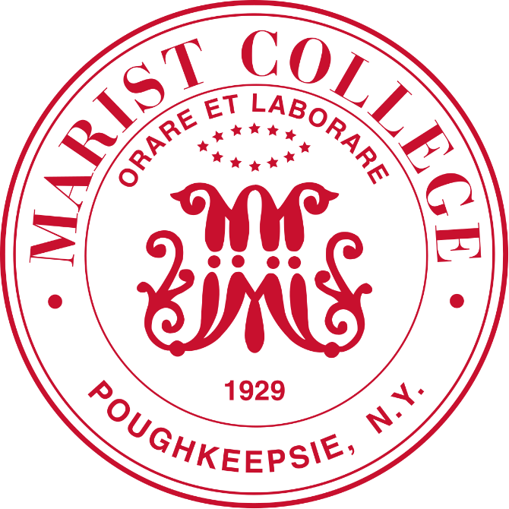

Marist College  
School of Computer Science and Mathematics

Submitted To:  
Dr. Reza Sadeghi

Fall 2022

CMPT 120L Project_Phase_01_TeamPurple

Project Progress Report 01 of Task Management System

Team Name

Team Purple

Team Members

1. Abel Scholl [Anna.Scholl1@marist.edu](mailto:Anna.Scholl1@marist.edu) (Team Head)

2. Christelle Bernardin   [Christelle.Bernardin1@marist.edu](mailto:Christelle.Bernardin1@marist.edu) (Team Member)

3. Sydney George         [Sydney.George1@marist.edu](mailto:Sydney.George1@marist.edu) (Team Member)

Description of Team Members

1. Abel Scholl

I am a freshman from Wilkes-Barre, Pennsylvania, and am majoring in Computer Science. I have taken four programming courses previously and have learned Python and Java. My interests include art, animation, video games, crocheting, sewing, and general creation of things. I like programming, because there is always something tangible that gets created that is interactive, personalized, and serves a purpose. I chose my group based on people in my class I thought seemed nice and wanted to connect to more. I took on the role as team head, because I have the most programming experience. I am excited to work with everyone, and I think we will work well together.

2. Christelle Bernardin

I’m Christelle, I like it pronounced Crystal, and I’m a freshman at this lovely college. This is my first time taking a Computer Science class. I like listening to music, sleeping, sesame chicken, and I really want to become the best student I can be. I haven’t known my group members for long, but I already know we’re going to work successfully together. I get an easy-going vibe from them, which I really like. It was clear the team head would be Abel, as they have had experience with GitHub before, and I don’t doubt they are an excellent student.

3. Sydney George

Hello, I’m Sydney! Some of my favorite things include reading, art, plants, and tennis. I’m a freshman, so I don’t have any programming experience, but I am dedicated to learning and excited about this project. I wanted to work with my team members because they seem like they are team players who are willing to solve issues together and are good communicators. In the brief times we have talked, everyone seems personable and flexible, so I think we will work well together. We selected Abel as our team head because the rest of us weren’t as confident using GitHub, and I think having someone with more experience/knowledge as our leader is wise.

CMPT 120L Project_Phase_01_TeamPurple

Table of Contents

Project Descriptions ...................................................................................................5  
GitHub Repository Address ...................................................................................... 6

CMPT 120L Project_Phase_01_TeamPurple

Project Description

Objective:

The purpose of the Task Management System project is to create a graphical user interface using python that is an interactive calendar for a logged in user to create, edit, and organize tasks on their schedule. It will include administrative and normal user logins that have different permissions available for the user to edit the interface. It will have a login window that requests a username and password, allowing the user to log in to the interface, add an account, and remove accounts, a welcome page where a user can request to view their calendar by day, week, month, or year, as well as edit, add or remove tasks, and search. It will also include an exit feature to log out of the interface.

CMPT 120L Project_Phase_01_TeamPurple

GitHub Repository Address

<https://github.com/Abel-Scholl/CMPT102L_TaskManagementSystem_TeamPurple#cmpt102l_taskmanagementsystem_teampurple>