Task Management System

Introduction to Programming

CMPT 120L

Team Purple



Marist College

School of Computer Science and Mathematics

Submitted To:

Dr. Reza Sadeghi

Fall 2022

CMPT 120L Project_Phase_02_TeamPurple

Project Progress Report 02 of Task Management System

Team Name

Team Purple

Team Members

1. Abel Scholl Anna.Scholl1@marist.edu (Team Head)

I am a freshman from Wilkes-Barre, Pennsylvania, and am majoring in Computer Science. I have taken four programming courses previously and have learned Python and Java. My interests include art, animation, video games, crocheting, sewing, and general creation of things. I like programming, because there is always something tangible that gets created that is interactive, personalized, and serves a purpose. I chose my group based on people in my class I thought seemed nice and wanted to connect to more. I took on the role as team head, because I have the most programming experience. I am excited to work with everyone, and I think we will work well together.

2. Christelle Bernardin Christelle.Bernardin1@marist.edu (Team Member)

I’m Christelle, I like it pronounced Crystal, and I’m a freshman at this lovely college. This is my first time taking a Computer Science class. I like listening to music, sleeping, sesame chicken, and I really want to become the best student I can be. I haven’t known my group members for long, but I already know we’re going to work successfully together. I get an easy-going vibe from them, which I really like. It was clear the team head would be Abel, as they have had experience with GitHub before, and I don’t doubt they are an excellent student.

3. Sydney George Sydney.George1@marist.edu (Team Member)

Hello, I’m Sydney! Some of my favorite things include reading, art, plants, and tennis. I’m a freshman, so I don’t have any programming experience, but I am dedicated to learning and excited about this project. I wanted to work with my team members because they seem like they are team players who are willing to solve issues together and are good communicators. In the brief times we have talked, everyone seems personable and flexible, so I think we will work well together. We selected Abel as our team head because the rest of us weren’t as confident using GitHub, and I think having someone with more experience/knowledge as our leader is wise.

CMPT 120L Project_Phase_02_TeamPurple

Table of Contents

Table of Figures ...........................................................................................................4

Project Description.......................................................................................................5

GitHub Repository Address ....................................................................................... 6

Graphical User Experience Design.........................................................................7-13

1. Login Page
2. Main Window
3. Action Pages
   1. Add Page; Search Page; Edit Page; Remove Page; Settings Page

Graphical User Interface Design...........................................................................14-29

1. Login Page
2. Main Window
3. Action Pages
   1. Add Page; Search Page; Edit Page; Remove Page; Settings Page

References..................................................................................................................30

CMPT 120L Project_Phase_02_TeamPurple

Table of Figures

1. Figure 1: Login Page Flowchart………………………………………………...………….7

2. Figure 2: Main Page Flowchart………………………………………………...……….….8

3. Figure 3: Add Page Flowchart.…………………………………………………………..…9

4. Figure 4: Search Page Flowchart………………………………………………….………10

5. Figure 5: Edit Page Flowchart……………………………………………….……………11

6. Figure 6: Remove Page Flowchart……………………………………………….……….12

7. Figure 7: Settings Page Flowchart…………………………………………………...……13

8. Figure 8: Login Page Layout Idea…………………………………………….….……….14

9. Figure 9: Main Page Layout Idea……………………………………………....…………16

10. Figure 10: Add Page Layout Idea..…………………………………………….……..…20

11. Figure 11: Search Page Layout Idea……………………………………………...……..22

12. Figure 12: Edit Page Layout Idea………………………………………….……..……..24

13. Figure 13: Remove Page Layout Idea..…………………………………..……….…….26

14. Figure 14: Settings Page Layout Idea…………………………………….…..……..….28

CMPT 120L Project_Phase_02_TeamPurple

Project Description

Objective and Module Descriptions:

The purpose of the Task Management System project is to create a graphical user interface using python that is an interactive calendar for a logged in user to create, edit, and organize tasks on their schedule. It will include administrative and normal user logins that have different permissions available for the user to edit the interface. It will have a login window that requests a username and password, allowing the user to log in to the interface, add an account, and remove accounts, a welcome page where a user can request to view their calendar by day, week, month, or year, as well as edit, add or remove tasks, and search. It will also include an exit feature to log out of the interface.

CMPT 120L Project_Phase_02_TeamPurple

GitHub Repository Address

<https://github.com/Abel-Scholl/CMPT102L_TaskManagementSystem_TeamPurple#cmpt102l_taskmanagementsystem_teampurple>

CMPT 120L Project_Phase_02_TeamPurple

Graphical User Experience Design

*Login Page*

This page functions by requiring the user to input text corresponding to a username and password in entry boxes. A valid username and password will grant a user access to the main page of the task management system. An invalid username or password will output a warning statement and require the user to retry.

*Figure 1: Login Page Flowchart*

CMPT 120L Project_Phase_02_TeamPurple

Graphical User Experience Design

*Main Window*

The main window allows the user to view their calendar and saved tasks. The user can cycle through comboboxes of months and years that change the layout of the calendar as necessary for that specific month and year combination. Upon opening the window, the user can also view their tasks for the current day. By selecting a day on the calendar, the tasks for that day will be visible. The user can also select a task and press buttons to edit or remove the selected task. The user can add a new task by pressing the “Add” button which will open the Add window, search for a task by pressing the ”search” button which will open the Search window, and go to the Settings window through the “Settings” button.

*Figure 2: Main Page Flowchart*

CMPT 120L Project_Phase_02_TeamPurple

Graphical User Experience Design

*Add Page*

This page allows the user to add a task by manually inputting the title, duration, time, and

description of the task. The user will have to click a save button for the task to save. There is no physical output, instead, the task data gets stored for future reference. Or, the user can press (input) an exit button and the window will close (output).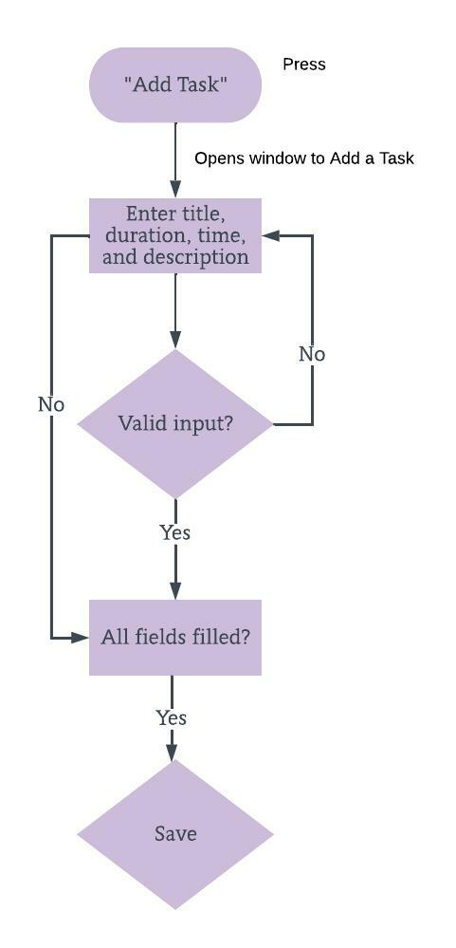

*Figure 3: Add Page Flowchart*

CMPT 120L Project_Phase_02_TeamPurple

Graphical User Experience Design

*Search Page*

The search page allows users to search for a task(s) by using the categories of title, time, and duration in a drop-down menu. The user will have to pick a selection from the drop-down and enter text before pressing the search button in order for the input to be valid. This page will output a list of any tasks that match the inputted information. 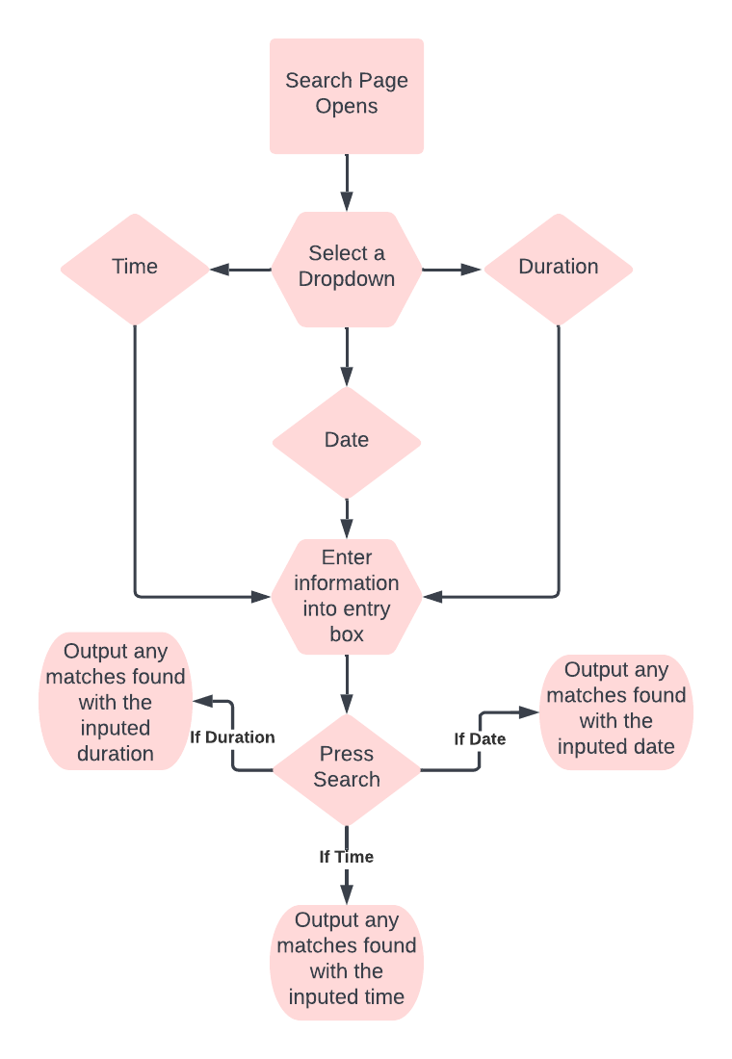

*Figure 4: Search Page Flowchart*

CMPT 120L Project_Phase_02_TeamPurple

Graphical User Experience Design

*Edit Page*

This page allows a user to change their previous inputs of title, duration, time, and description for a task by altering the characters in the input fields. The user must hit a save edit button for the input changes to save. There is no physical output, instead, the updated task data gets stored for future reference. Or, the user can press (input) an exit button and the window will close (output).

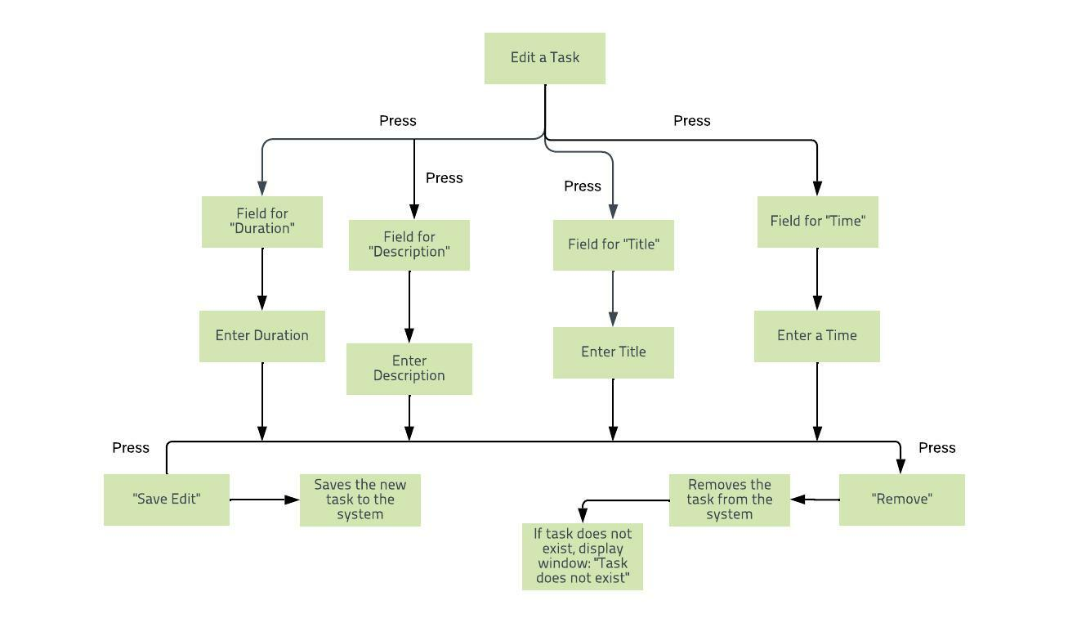

*Figure 5: Edit Page Flowchart*

CMPT 120L Project_Phase_02_TeamPurple

Graphical User Experience Design

*Remove Page*

The function of this page is to remove a task. The input will be a button press, yes or no. The output will either be the task is deleted or the task remains. After both output possibilities, the window will close.

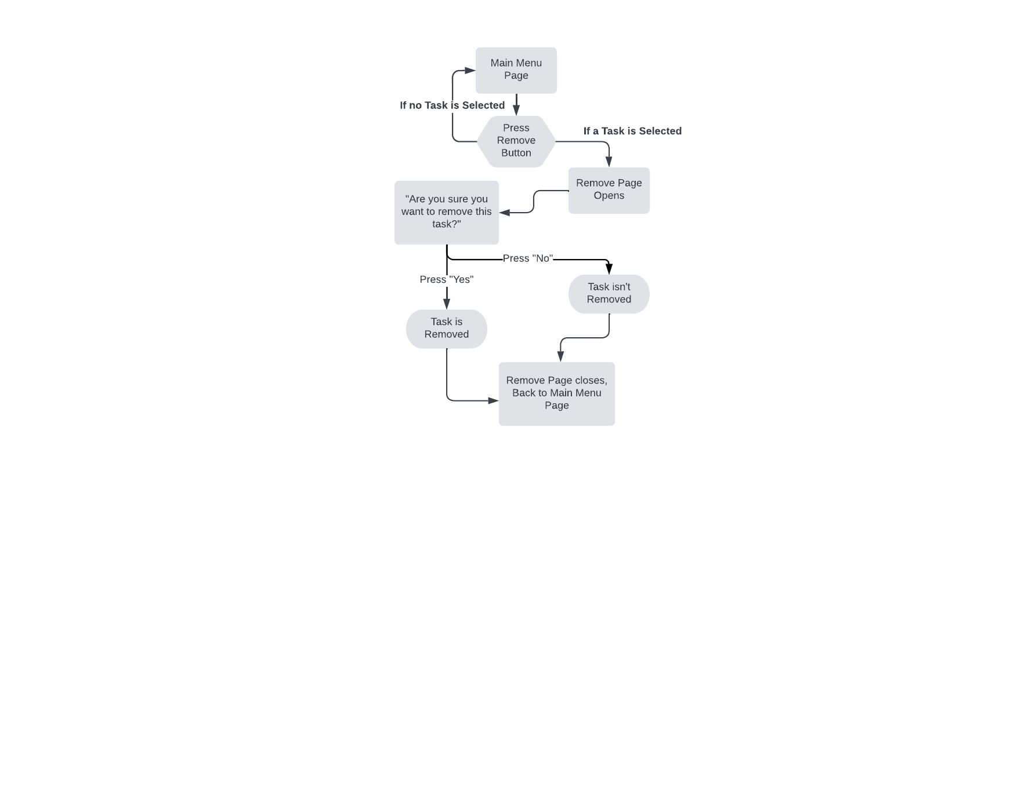

*Figure 6: Remove Page Flowchart*

CMPT 120L Project_Phase_02_TeamPurple

Graphical User Experience Design

*Settings Page*

This page requires users to input a username and password. The user must then provide a secondary input which is a button press from the options of ‘add user’, ‘remove user’, and ‘change admin details’. If the username/password is valid, the output will vary based on the button input. The inputted username/password will either be entered into the system, removed, or changed (if admin).

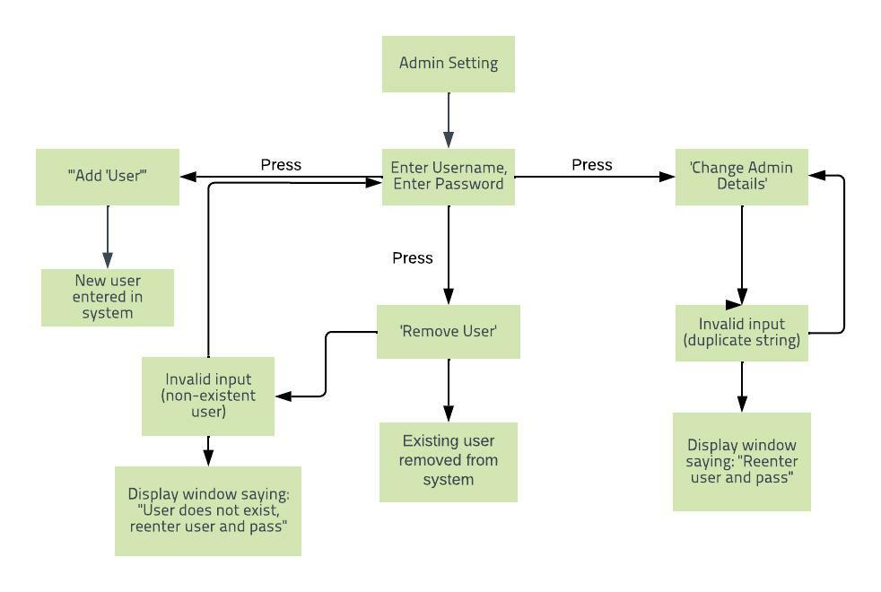

*Figure 7: Settings Page Flowchart*

CMPT 120L Project_Phase_02_TeamPurple

Graphical User Interface Design

*Login Page*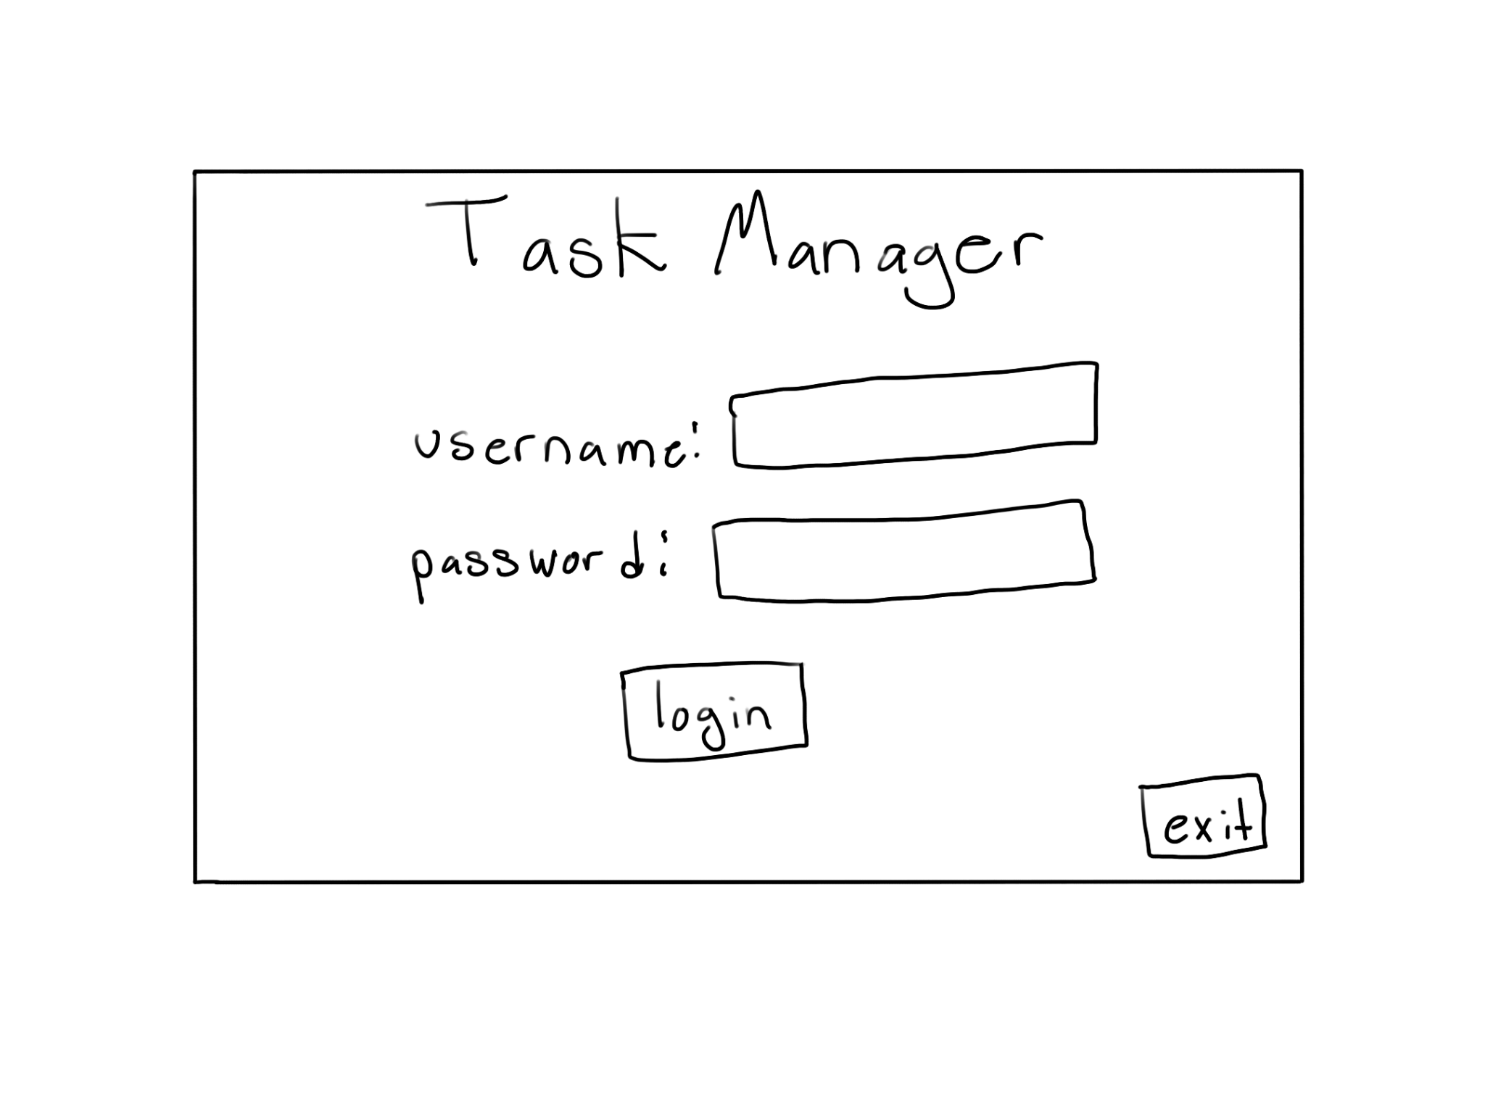

**Initial Shape of Page:**

Figure 8: Login Page Layout Idea

**Implementation in Python:**

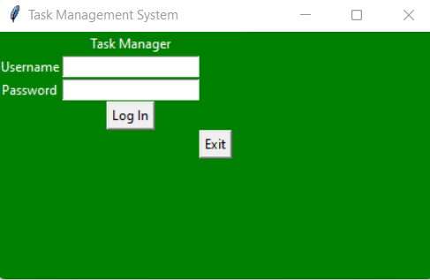

CMPT 120L Project_Phase_02_TeamPurple

Graphical User Interface Design

*Login Page*

**Python Code for the Implementation:**

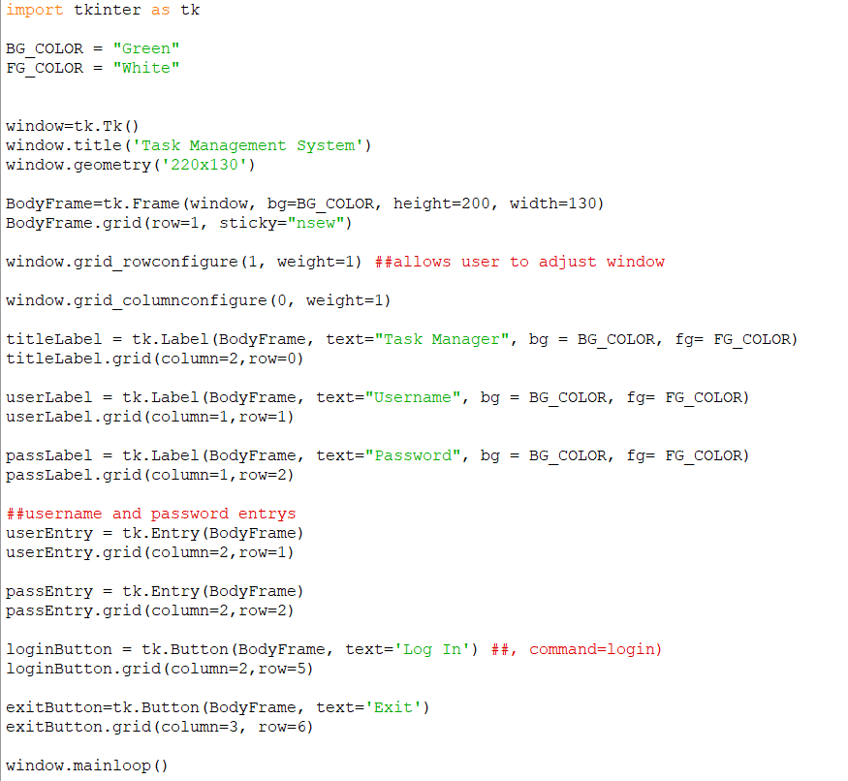

CMPT 120L Project_Phase_02_TeamPurple

Graphical User Interface Design

*Main Window*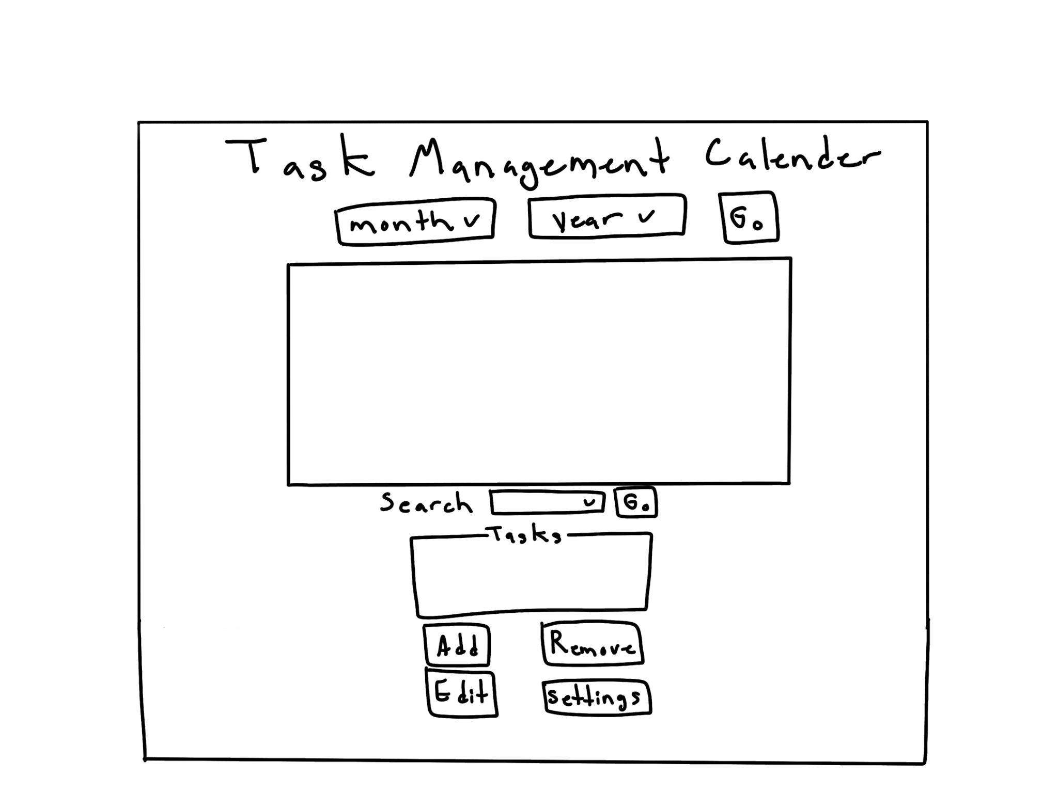

**Initial Shape of Page:**

Figure 9: Main Page Layout Idea

**Implementation in Python:**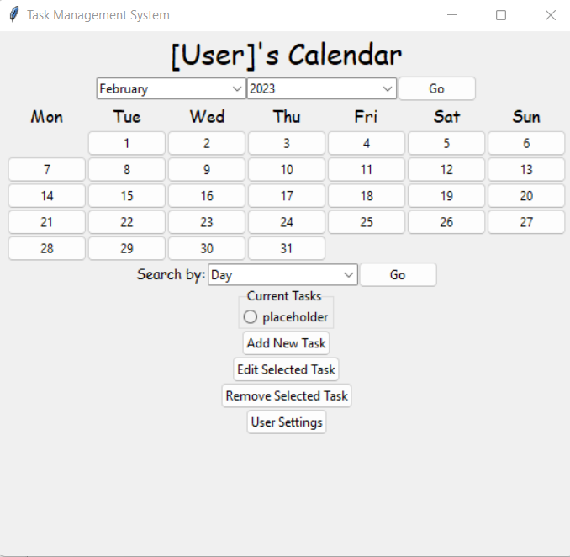

CMPT 120L Project_Phase_02_TeamPurple

Graphical User Interface Design

*Main Window*

**Python Code for the Implementation:**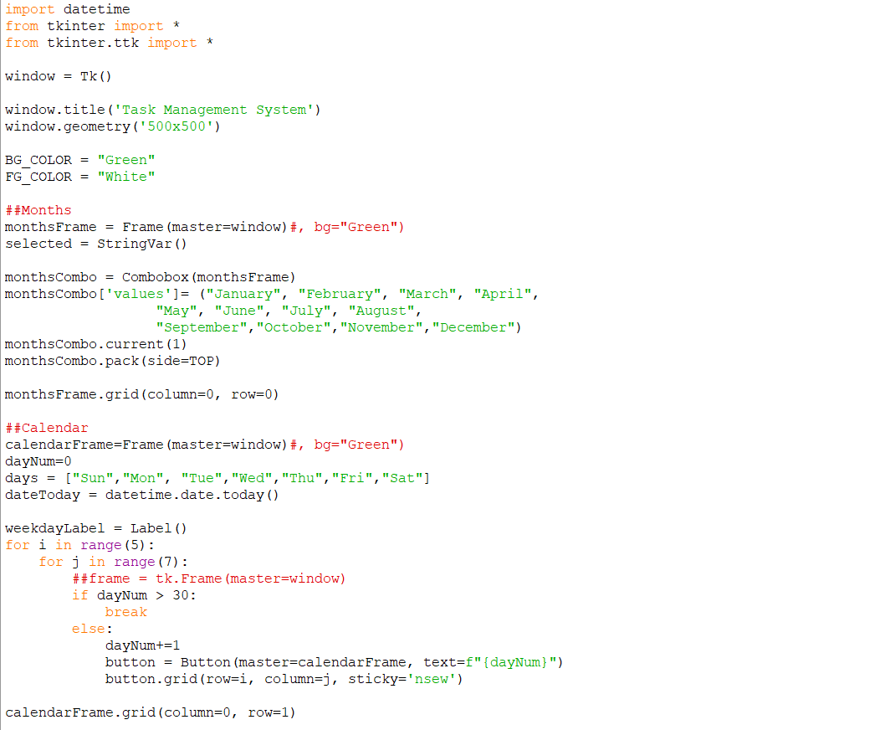

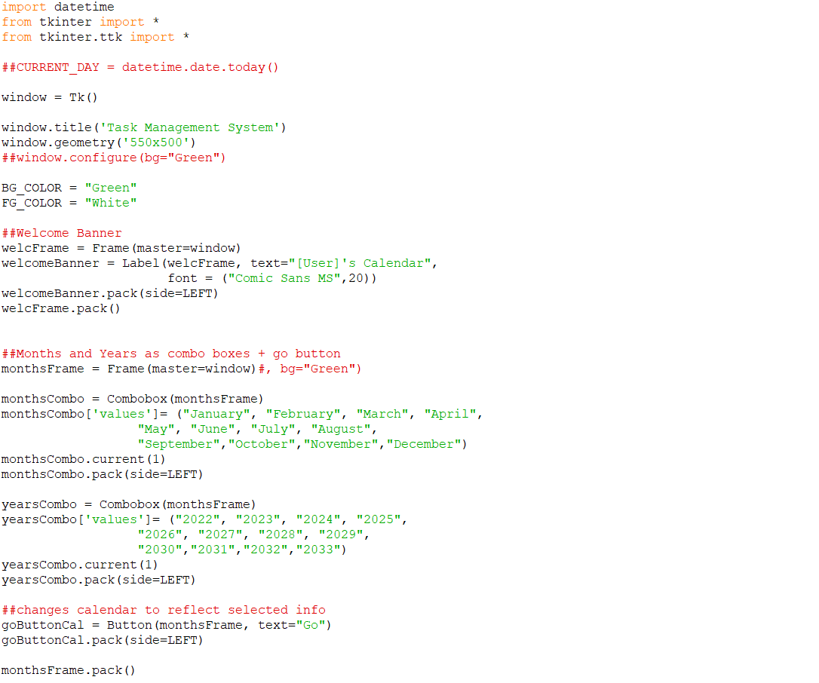

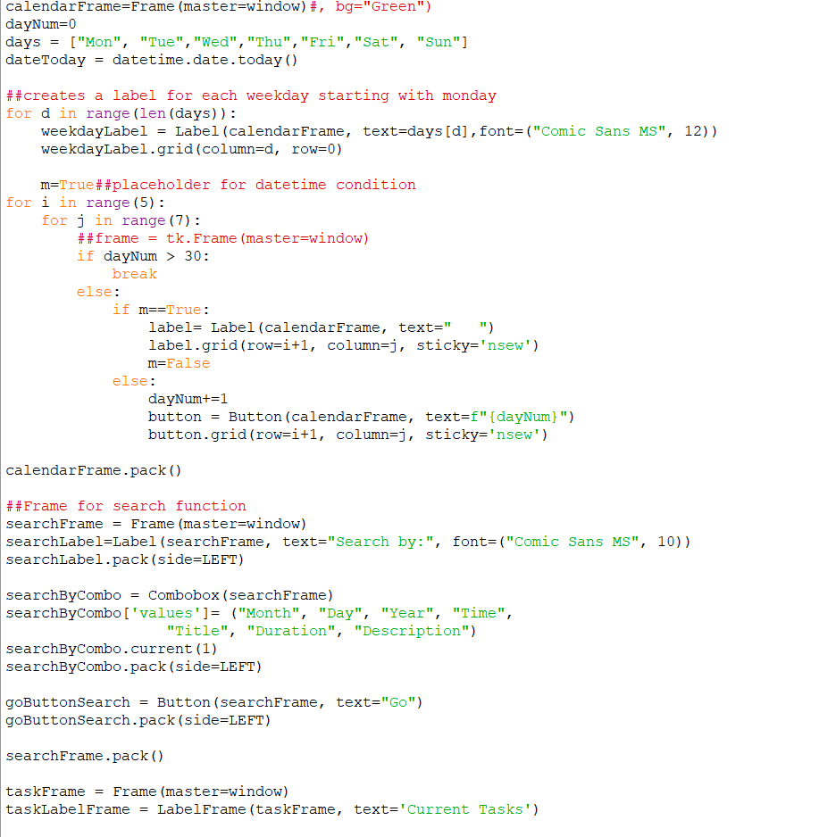

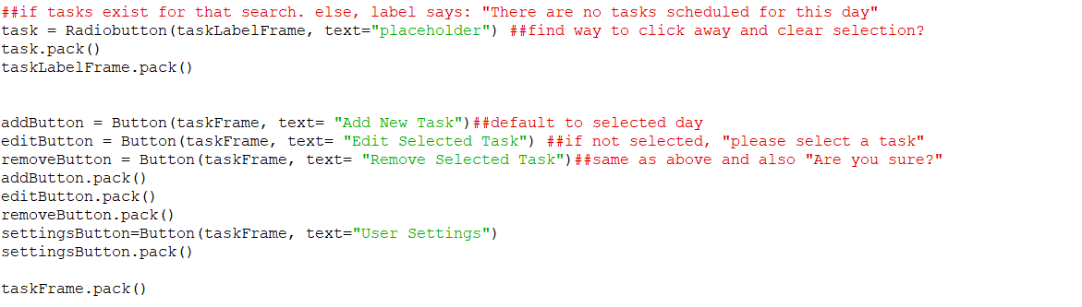

CMPT 120L Project_Phase_02_TeamPurple

Graphical User Interface Design

*Add Page*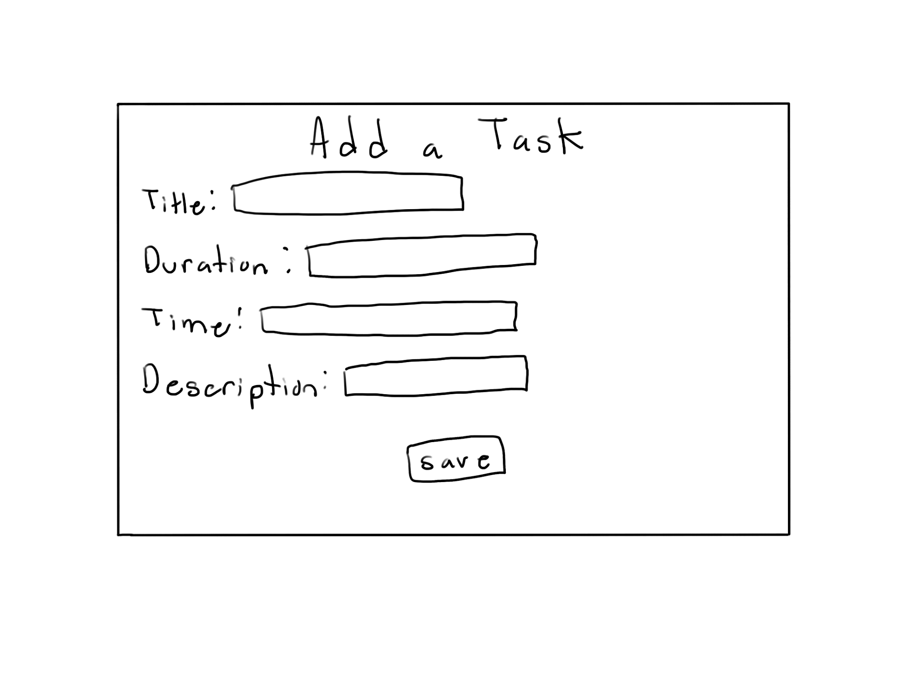

**Initial Shape of Page:**

Figure 10: Add Page Layout Idea

**Implementation in Python:**

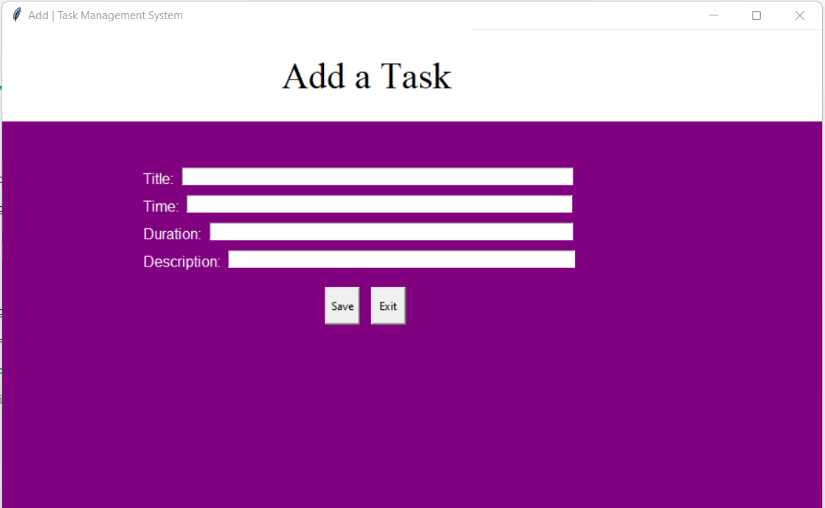

CMPT 120L Project_Phase_02_TeamPurple

Graphical User Interface Design

*Add Page*

**Python Code for the Implementation:**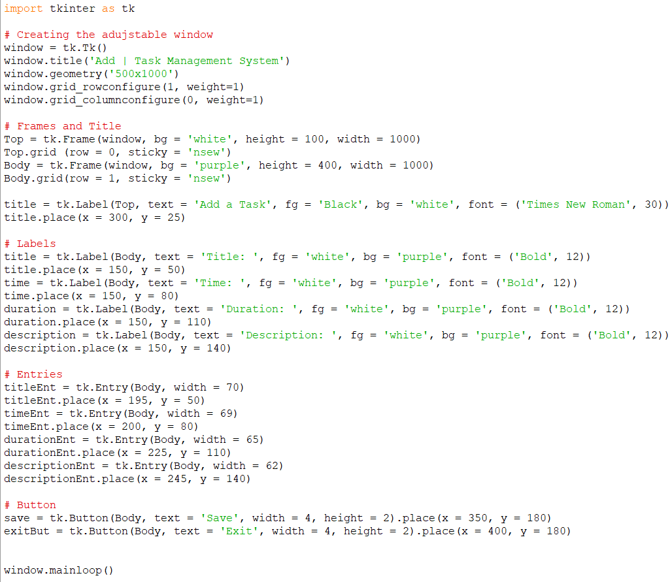

CMPT 120L Project_Phase_02_TeamPurple

Graphical User Interface Design

*Search Page*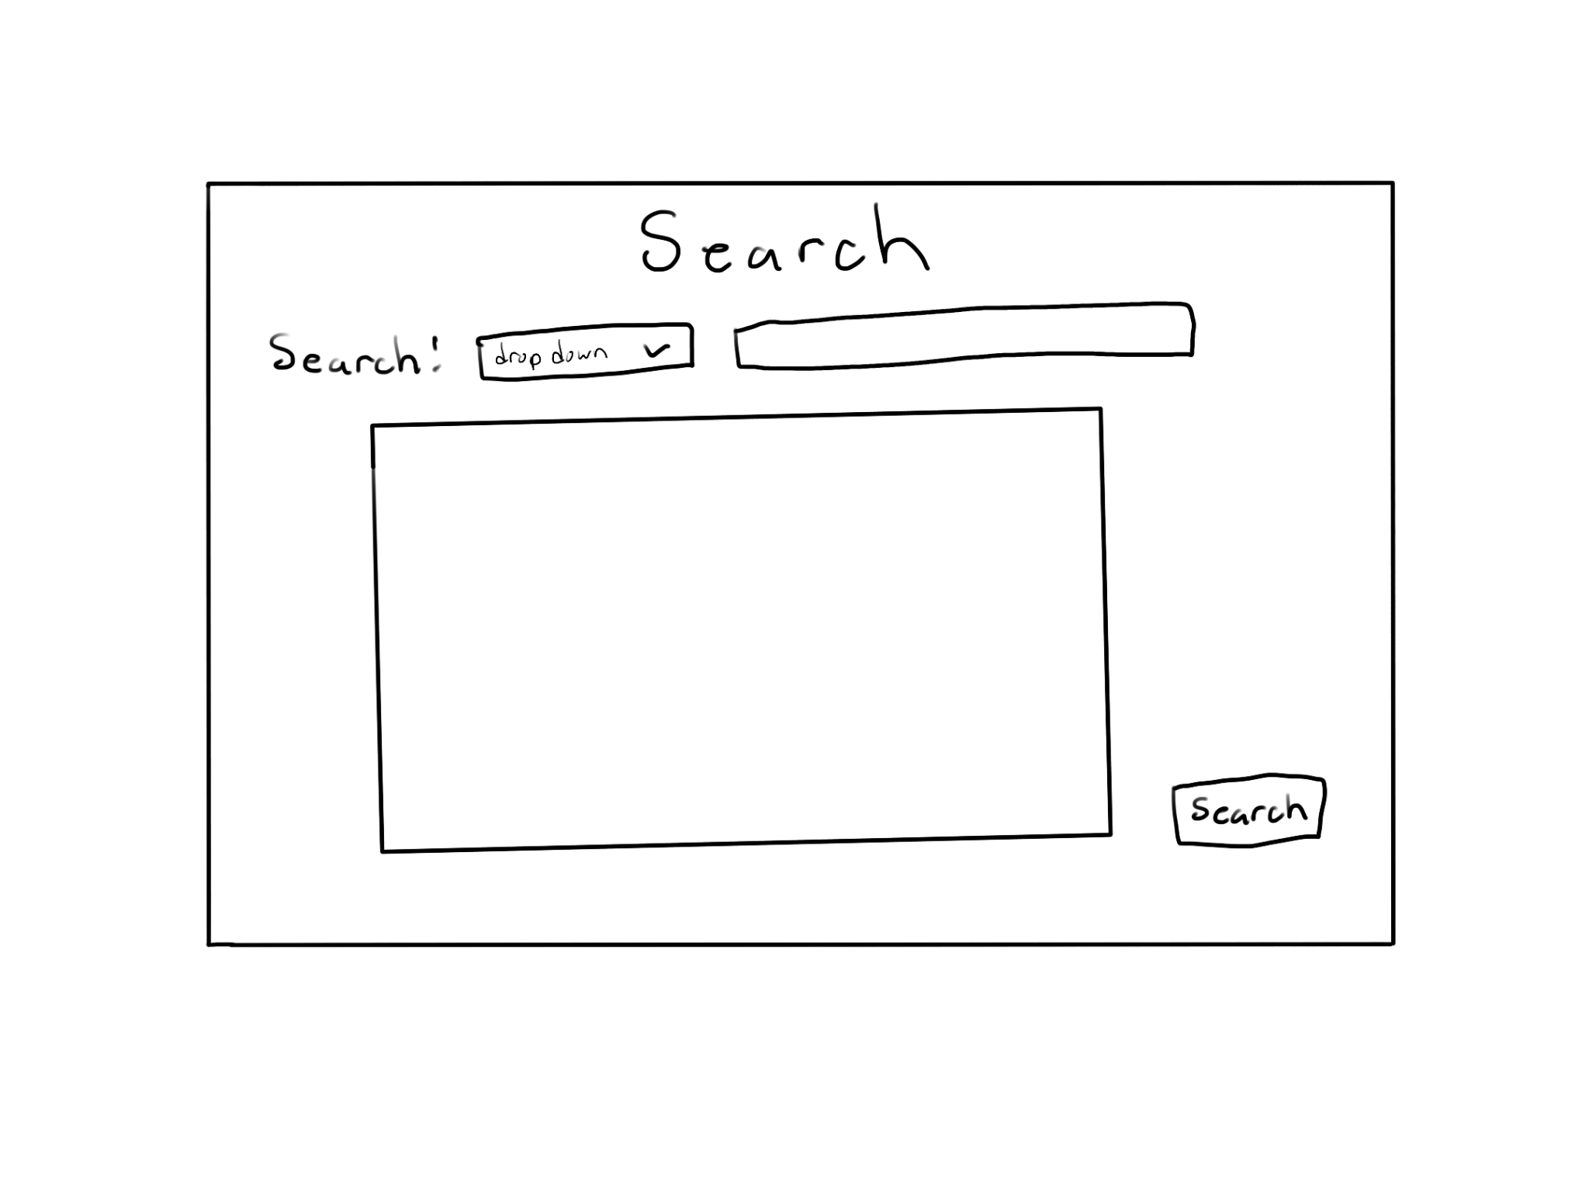

**Initial Shape of Page:**

Figure 11: Search Page Layout Idea

**Implementation in Python:**

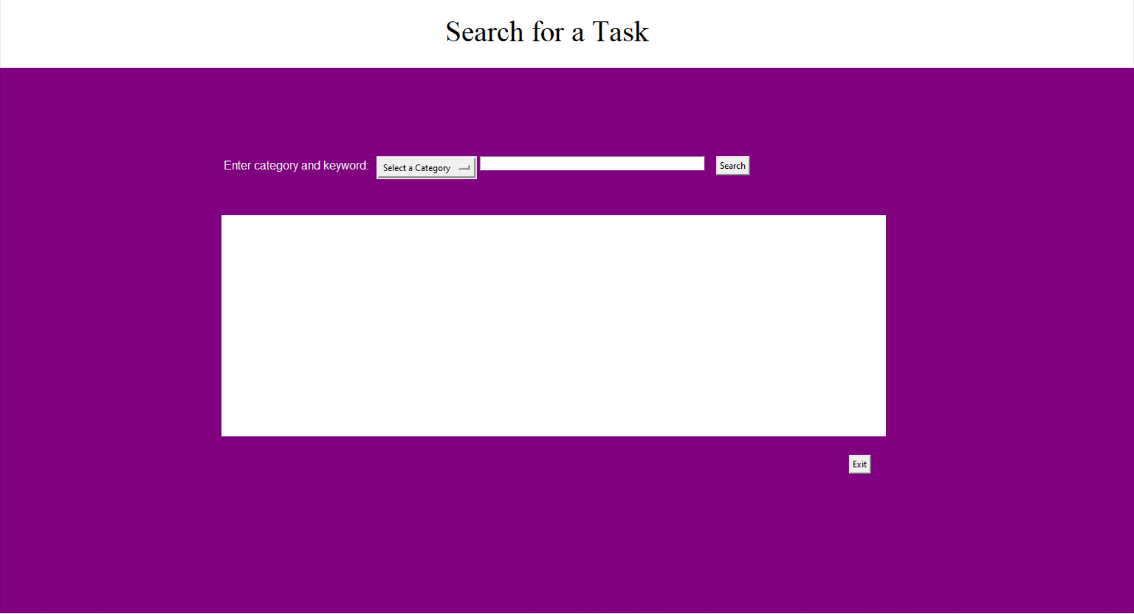

CMPT 120L Project_Phase_02_TeamPurple

Graphical User Interface Design

*Search Page*

**Python Code for the Implementation:**

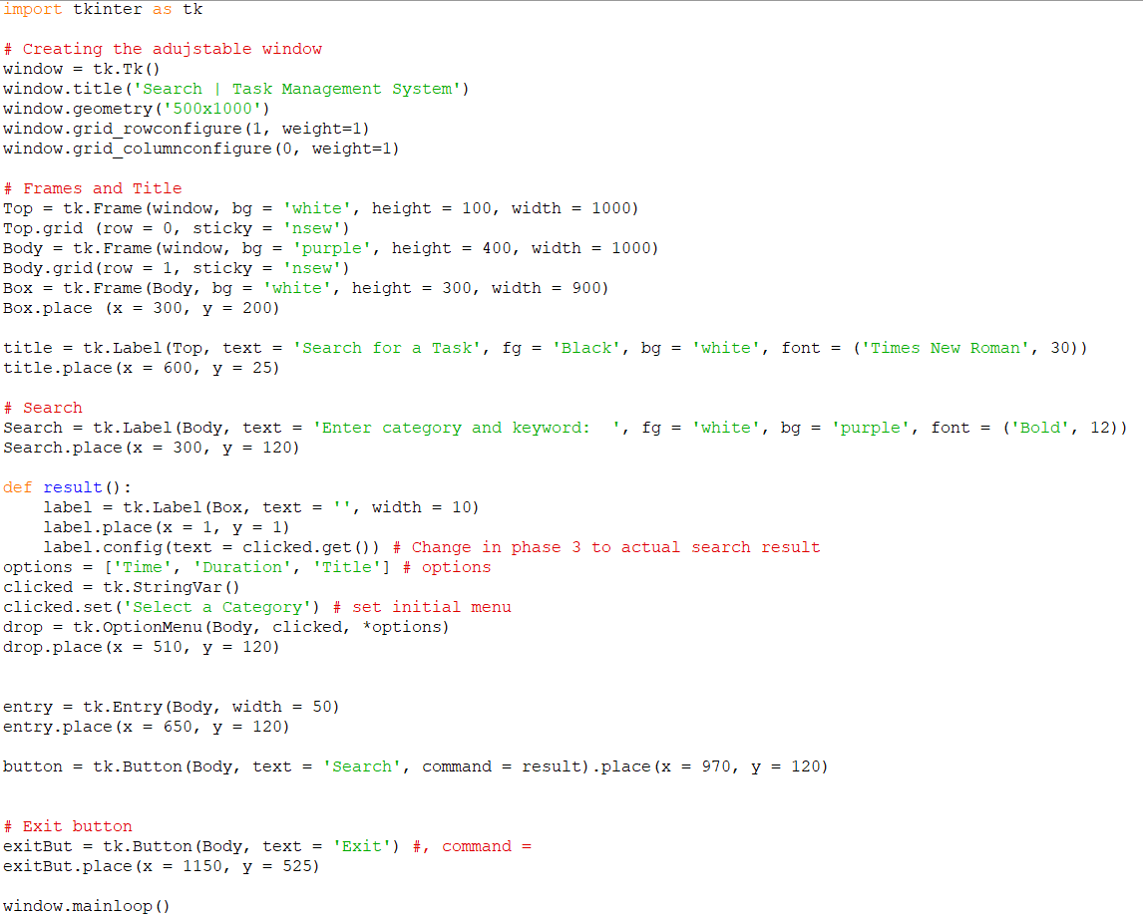

CMPT 120L Project_Phase_02_TeamPurple

Graphical User Interface Design

*Edit Page*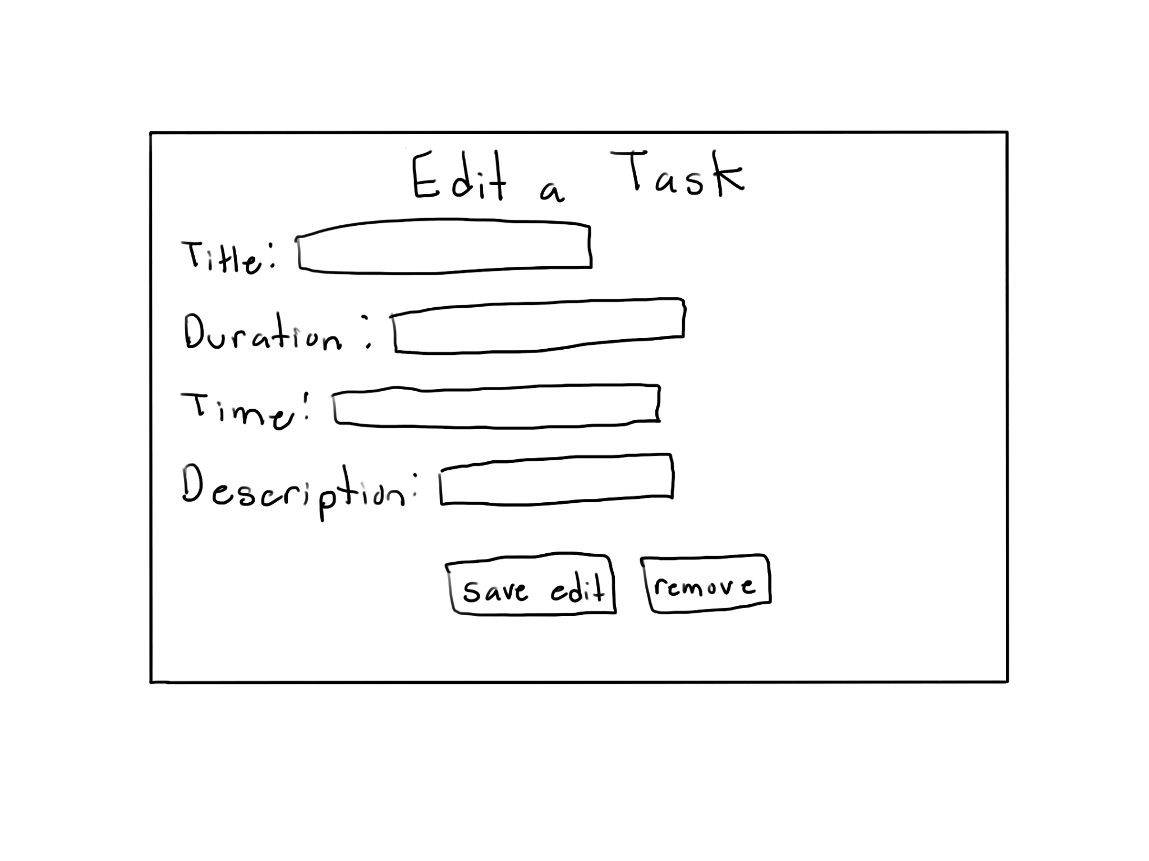

**Initial Shape of Page:**

Figure 12: Edit Page Layout Idea

**Implementation in Python:**

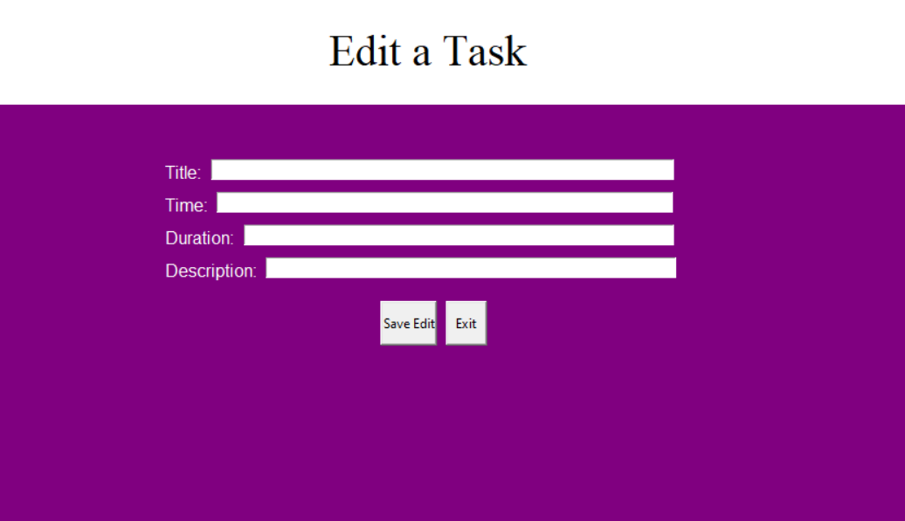

CMPT 120L Project_Phase_02_TeamPurple

Graphical User Interface Design

*Edit Page*

**Python Code for the Implementation:**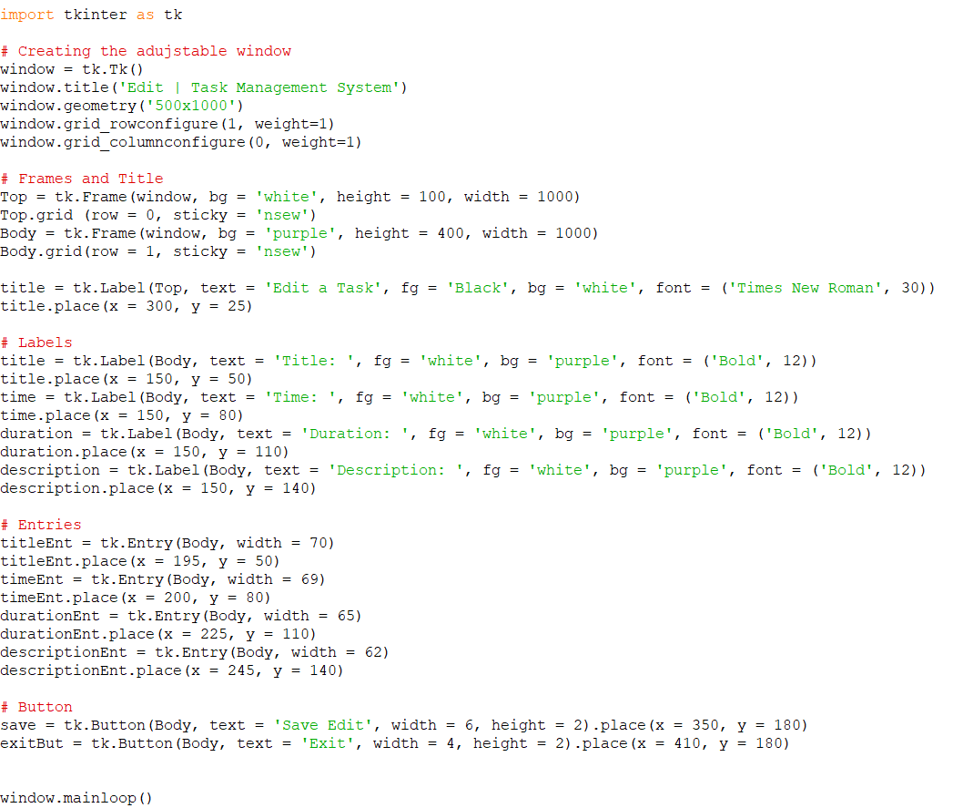

CMPT 120L Project_Phase_02_TeamPurple

Graphical User Interface Design

*Remove Page*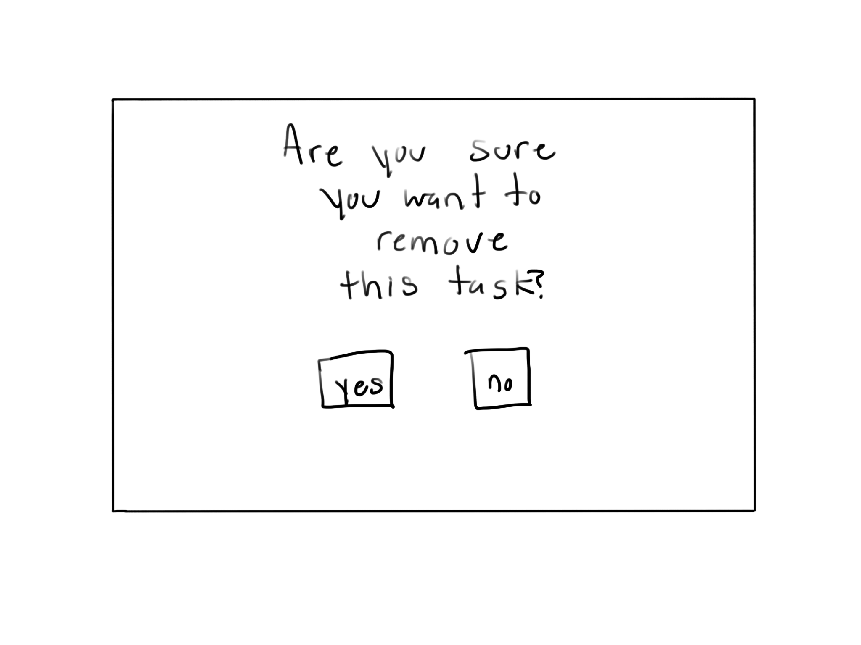

**Initial Shape of Page:**

Figure 13: Remove Page Layout Idea

**Implementation in Python:**

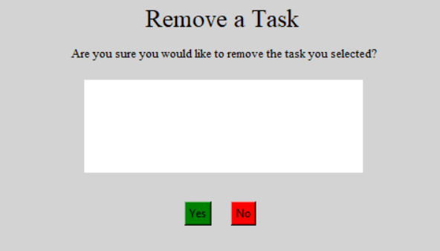

CMPT 120L Project_Phase_02_TeamPurple

Graphical User Interface Design

*Remove Page*

**Python Code for the Implementation:**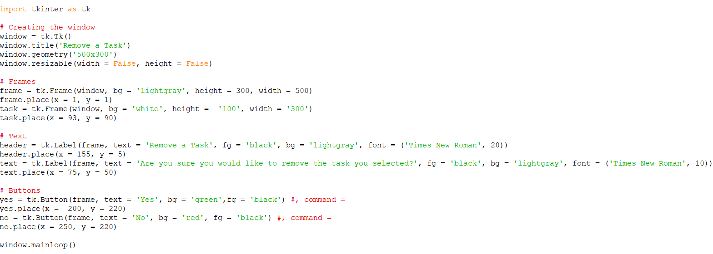

CMPT 120L Project_Phase_02_TeamPurple

Graphical User Interface Design

*Settings Page*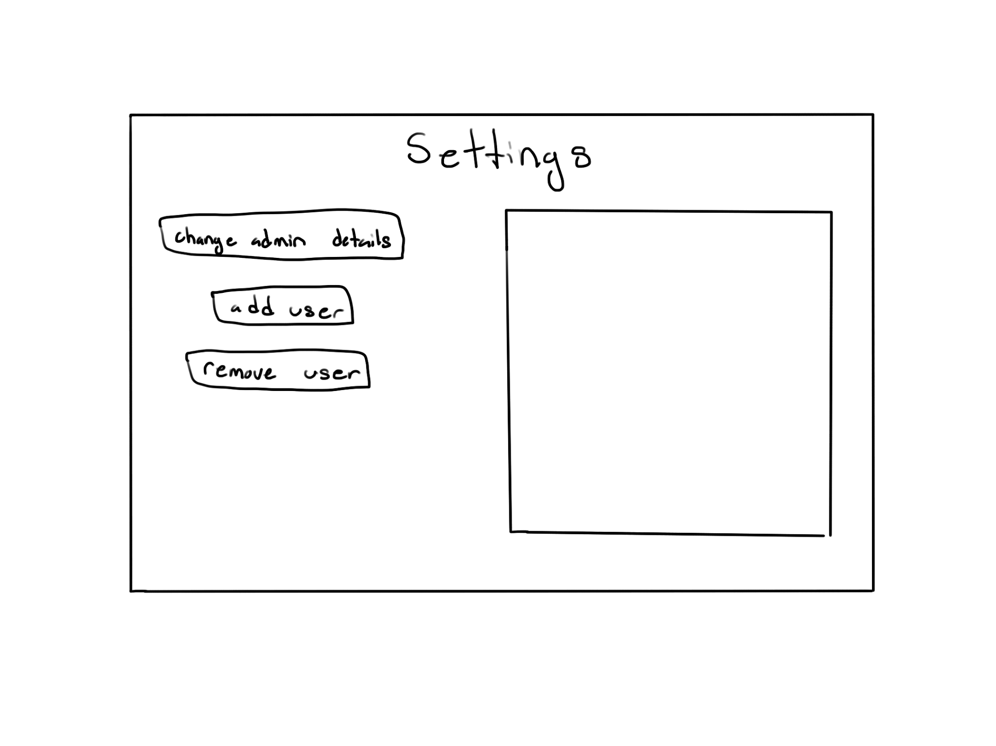

**Initial Shape of Page:**

Figure 14: Settings Page Layout Idea

**Implementation in Python:**

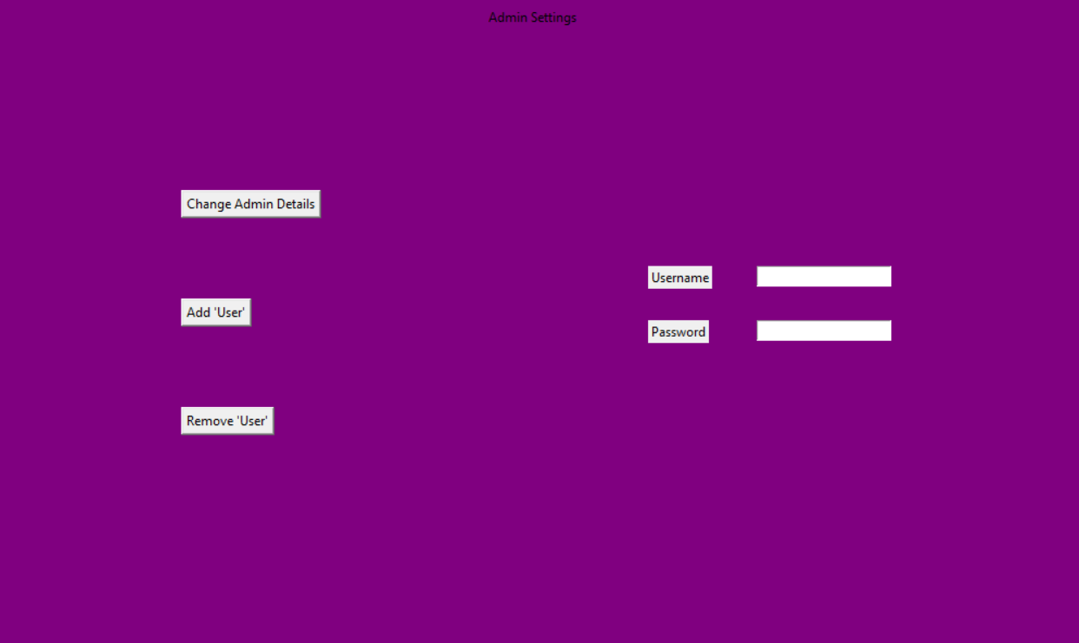

CMPT 120L Project_Phase_02_TeamPurple

Graphical User Interface Design

*Settings Page*

**Python Code for the Implementation:**

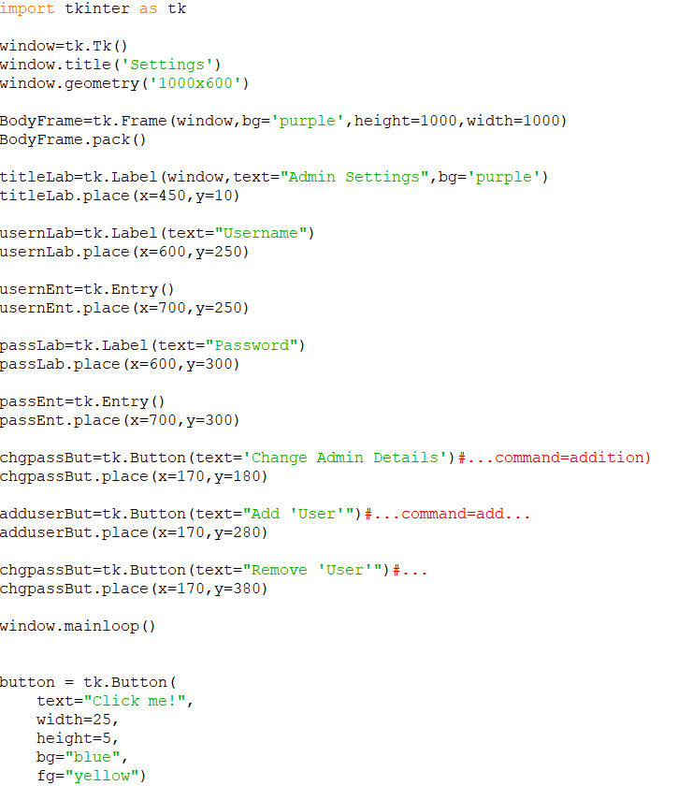

CMPT 120L Project_Phase_02_TeamPurple

References

<https://pythongeeks.org/gui-programming-in-python/>

<https://docs.python.org/3/library/calendar.html#module-calendar>

<https://www.plus2net.com/python/tkinter-rowconfigure.php>

<https://pythonguides.com/python-tkinter-listbox/>

<https://realpython.com/python-gui-tkinter/>

<https://www.plus2net.com/python/tkinter-rowconfigure.php>

<https://www.tutorialspoint.com/python/tk_relief.htm>

<https://likegeeks.com/python-gui-examples-tkinter-tutorial/>

<https://pythonguides.com/python-tkinter-radiobutton/>

<https://coderslegacy.com/python/python-gui/python-tkinter-combobox/>

<https://stephenallwright.com/python-month-number/>

<https://pythonguides.com/python-tkinter-grid/>

<https://docs.python.org/3/library/datetime.html#>

<https://likegeeks.com/python-gui-examples-tkinter-tutorial/#Add_radio_buttons_widgets>