Abel Antonio Aguilar Aguirre

WDD 230 FALL 2022

11/30/2022

Term Website Planning Document

Site Name & domain:

Bountiful Foods – www.bountifulfood.com

Site Purpose:

Our purpose is to provide a simple and manageable way to eat more locally grown fruits and vegetables. Our site will have a user-friendly interface that allows users to see what is new in the world of fruits and veggies as well as place orders online for pickup. You will be able to order fruit drink mixes and fruit and veggie bags.

Target Audience:

Our target audience is those looking to eat healthier. Ages 18-100. Our main base is walk-in customers orders are expected through mobile phone.

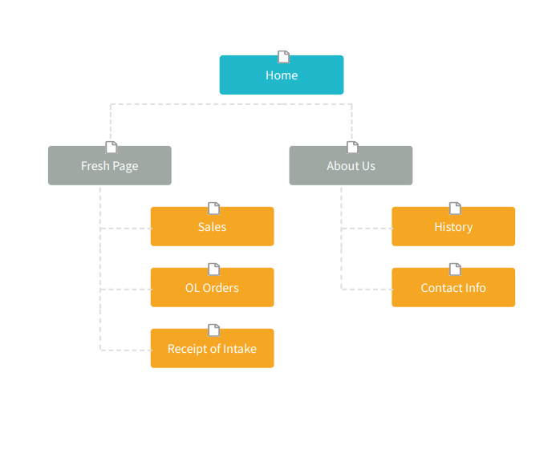Site Map:

Color Scheme:

|  |  |  |  |
| --- | --- | --- | --- |
| Primary | Secondary | Accent 1 | Accent 2 |
|  |  |  |  |
| #FFC6D9 | #000036 | #7B5E7B | #85FF9E |

Typography:

|  |  |  |  |  |
| --- | --- | --- | --- | --- |
| Site Header | Felix Titling | 40px | #FFC6D9 | Sample |
| Primary Navigation | Felix Titling | 30px | #000036 | Sample |
| Footer Navigation | Felix Titling | 20px | #85FF9E | Sample |
| Heading 1 | Felix Titling | 30px | #7B5E7B | Sample |
| Heading 2 | Felix Titling | 25px | #7B5E7B | Sample |
| Heading 3 | Felix Titling | 20px | #7B5E7B | Sample |
| Paragraph Text | Calibri | 16px | #000036 | Sample |

Wireframe Sketches:

MEDIUM

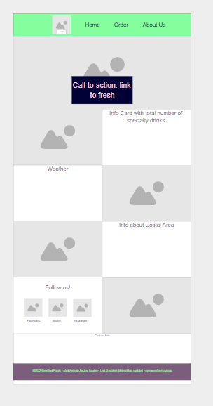

LARGE

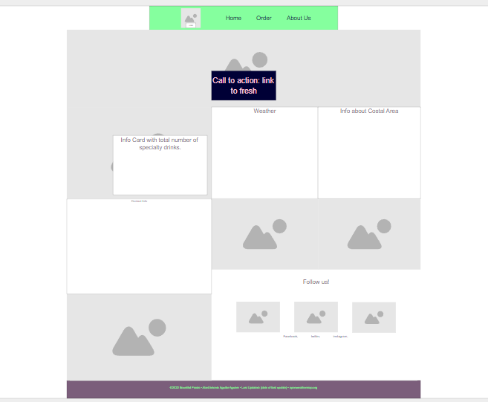

SMALL

