|  |  |  |  |  |
| --- | --- | --- | --- | --- |
| http://design.canonical.com/wp-content/uploads/2011/10/juju-464x252.png |  | |  | | --- | | Installing Ubuntu Juju  **Formal Proposal** | | 3/30/2015 | |
|  |  |  |
| By: ABel delgado |  | Additional information |

# Project Scope

What is Juju used for? Ubuntu Juju is highly regarded as one of the best solutions to maintain and organize your different applications and services in a UNIX environment. This is normally done through the default GUI, but Ubuntu Juju uses cloud services to allow you to remotely make changes to your service anywhere.

Tools Assuming that we are allowed to use Ubuntu (since this application can be installed on iOS and Windows as well), we will be using VMWare player to emulate a working Ubuntu environment. We will be using standard computer equipment, such as a home desktop or laptop, to run the actual program.

Techniques There are many resources we can use to help setup and run Ubuntu Juju. We have already located a video tutorial that explains how to set up and manage the service. We also found helpful commands on the Juju homepage. In the end, it doesn’t appear to take much time to actually set up the service. The issue here will be to actually get it to run with the additional services it provides. Since we are relatively new to most of its services, we will have to look extensively into the guides and pages mentioned already.

Technology Used Inside the Ubuntu environment, we will use the terminal commands to run, configure and install Juju onto the OS. Ubuntu juju also uses a unique tool called a charm. Charms are a collection of scripts that Juju already has prepared, and is usually a description of how the service works. Juju also comes with a visual representation that allows you to see your network visually, which makes it easier to manage you work.

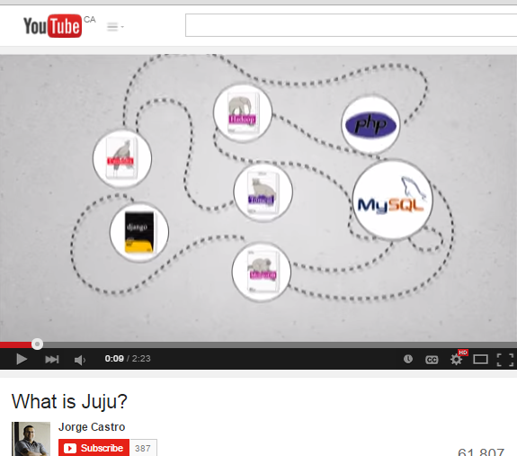

YouTube Guides

There are many guides online that will help us get started on running Juju. We will also look into cloud computing as that is Jujus main feature.

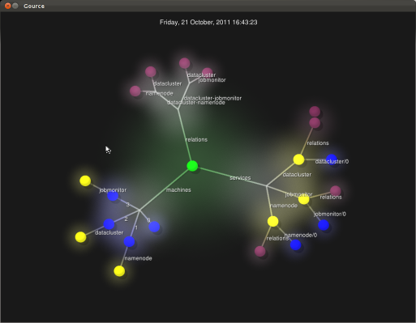

Gource

Juju uses Gource to visually represent what modules you currently have active. It is very convenient as it allows you to see your entire network in one place

### Project Planning

We aim to complete this project by the end of this course, and we plan on doing this by completing these tasks.

* Obtain all the required commands and tools needed to perform the installation and configuration

**DUE BY: April 6th**

* Utilize tools from the terminal such as Quickstart to allow quick and easy installation of Juju

**DUE BY: April 13th**

* Determine which type of job Juju we will perform and acquire the bundles needed for that job

**DUE BY: April 17th**

* Bootstrap the bundle to the computer environment

**DUE BY: April 20th**

* Configure cloud environment on public cloud or deploy locally

**DUE BY: April 24th**

* Bootstrap Juju and deploy GUI

**DUE BY: April 27th**

### Hardware/Software Specs

We will use different machines to test out whether our installation and setup works. Here are the specs for 2 machines we will use. For our project, you will require at least a functional Windows 7 operating system. You will also need an Ubuntu installation ISO and an internet connection.

**Recommended**

Processor: AMD A8-5600K APU with Radeon(tm) HD Graphics 3.60 GHz

Installed Memory (RAM): 8 GB

System Type: 64-bit Operating System

**Minimum**

Processor: AMD Athlon II P340 Dual Core processor 2.20 GHz

Installed Memory (RAM): 4 GB

System Type: 64-bit Operating System