class-04.R

Abel Demoz

2024-10-11

# My first Rscript   
x <- 1:50   
plot(x)

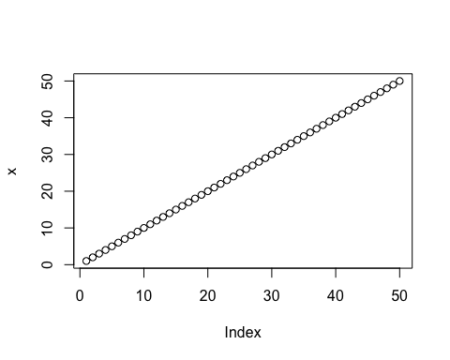

plot(x, sin(x), typ="l",col="blue")

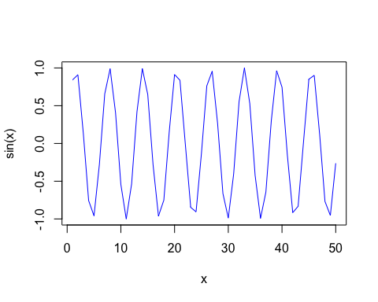

plot(x=x, y=sin(x), typ="l",col="red", lwd=3)

