Question Mathias – Fitting Weibull DBH Distributions
Amasson
2025-09-23

Problem presentation

My project aims to correct a significant bias in our forest growth simulators. These simulators are competition-driven, meaning a tree’s predicted growth depends heavily on its neighbors. The problem starts with our data: to save costs, forest inventories often apply a diameter at breasthight- threshold and only measure trees above a certain size (e.g., 5 or 10 cm diameter at breast hight). When we feed this “censored” data to the model, it sees the smallest measured trees, assumes they have no smaller competitors, and therefore overestimates their growth. My goal is to model the missing small trees to give the simulator a realistic picture of the competition.
This is where I’ve run into a classic “tale of two systems” problem, where the predictability is completely different depending on the forest structure.
My idea is to train a model based on a number of sample plots were all trees were measured, than artificially remove some trees (by applying a diameter at breastheight threshold at 12cm) and see if I can reconstruct the number of censored trees and their distribution.
System 1: Simple, Even-Aged Forests
Here, our approach was very successful. We used a Random Forest model to predict the parameters of the entire Weibull DBH distribution (k and λ). The model is highly predictable, with an R2>0.90. No problems here.
System 2: Complex, Uneven-Aged Forests
This is where it gets interesting. The same modeling approach failed completely (negative R2). We then switched to a hybrid method:
- First, predict only the number of missing trees due to the DBH-thresholds (N_missing).
- Then, distribute them using an average, empirically-derived Weibull shape that was fitted by using the data from all the plots.
Even with this new approach, the model for Nmissing has very low predictive power (R2≈0.35). This suggests that about 65% of the variance is just stochastic noise that our predictors (even fine-scale ones like light) can’t explain.
My main question for you is about our approach for this complex system. Does this hybrid method seem reasonable from a modeling perspective? And more generally, what are your thoughts on tackling systems with such a high degree of inherent randomness? Is the main scientific finding simply to quantify this limit of predictability?

Method for fitting a complete Weibull distribution based on a truncated empirical distribution of DBH
The method presented here follows the approach of McGarrigle et al. (2011) and consists in fitting, for each plot, a left-truncated Weibull DBH distribution—that is, the conditional distribution of DBH given that it exceeds a threshold $t$,
$$f\left(x∣x≥t\right).$$
Overall, McGarrigle et al. (2011) report that this method performs well. Here, we first develop it using a theoretical example based on simulated data, which allows us to introduce the key steps of model calibration and prediction, along with the metrics used to assess model performance (R², Q-metric, Relative Error, and Kolmogorov–Smirnov tests) and the visualisations produced (DBH distributions and Pearson residual distributions).
We then apply the method to an empirical dataset retrieved from Dryad - Schwarzmann & Waller (2025) - which has the simple advantage of providing DBH distributions for multiple forest plots. More precisely, these distributions correspond to multi-species, uneven-aged stands, which we artificially truncate in order to evaluate the robustness of the method.

Infering parameters of the truncated Weibull DBH distribution
The method developed by McGarrigle et al. (2011) is based on an empirical observation by Merganič & Sterba (2006), namely that the parameters of a left-truncated Weibull distribution are very similar to those of the full Weibull distribution. Thus, one can fit the truncated Weibull on the measured portion of the DBH distribution, and then treat the resulting parameters (scale and shape) as equal to those of the full Weibull. In a second step, using the cumulative distribution function of the full Weibull, one can estimate the number of missing small trees and their distribution across the DBH classes.
Starting from the density of a standard Weibull distribution, denoted $f\left(x\right)$, and its cumulative distribution function $F\left(x\right)$, the density of a left-truncated Weibull distribution for DBH values greater than a threshold $t$ can be written as:
$$f\left(x∣x>t\right)=\frac{f\left(x\right)}{1-F\left(t\right)}.$$
Accordingly, the likelihood associated with $n$ observations of DBH $>t$ under the assumption of a left-truncated Weibull corresponds to the likelihood of a full Weibull multiplied by $1/{\left(1-F\left(t\right)\right)}^{n}$. The resulting log-likelihood (denoted $LL_{W}$ for the complete Weibull and $LL_{TW}\left(t\right)$ for the truncated Weibull) is therefore:
$$LL_{TW}\left(t\right)=LL_{W}-n log\left(1-F\left(t\right)\right).$$
It is then possible to fit the truncated Weibull DBH distribution using maximum likelihood estimation. The following function allows fitting the truncated Weibull DBH distribution:
Application Example on simulated data (see code) :
Here we simulate a complete Weibull DBH distribution, using parameter values that are broadly consistent with those reported in the literature. We then left-truncate this distribution below DBH = 12 cm and attempt to recover the original parameter values using the calibration function fit_weibull_trunc_mle().
## shape scale logLik
## 1 1.871329 29.03234 -1250.929
Nothing to celebrate just yet, but the fit provided by the method for the simulated distribution parameters appears accurate and reliable (the predicted shape and scale are close to the values used for the simulation – 1.9 and 30).

Predicting the number of small (missing) trees based on predicted parameter values
Based on the parameters of the truncated Weibull and the total number of observed trees, one can predict the number of small trees that are missing, denoted $N_{\text{missing}}$. Assuming that the shape of the truncated Weibull is identical to that of the full Weibull McGarrigle et al. (2011), we can estimate the probability $P\left(DBH>t\right)$ that the DBH of a randomly selected tree in the plot exceeds the threshold $t=12\text{ cm}$. This probability is
$$P\left(DBH>t\right)=1-F\left(t\right),$$
where $F$ is the cumulative distribution function of the Weibull.
The total number of trees in the stand can then be estimated as the number of observed trees divided by this probability. Consequently, the number of missing trees is
$$N_{\text{missing}}=N_{\text{obs}} \frac{1-P\left(DBH>t\right)}{P\left(DBH>t\right)}=N_{\text{obs}} \frac{F\left(t\right)}{1-F\left(t\right)}.$$
The function predict_N_missing() below performs this calculation :
Application Example on simulated data (see code) :
## N_tot N_missing p_dbh_over_threshold
## 1 398.4054 69.40537 0.8257921
In our example, the probability that DBH exceeds the threshold $t$ is estimated at 0.85, and the resulting number of missing small trees is estimated at 58. The quality of this prediction is assessed later, in the section on metrics.
Note: The prediction here relies solely on the distribution of trees above the DBH threshold and does not use any environmental predictors (e.g., light availability, as mentioned earlier). It is possible to predict the number of missing trees $N_{\text{missing}}$ using alternative approaches, or to use the value of $N_{\text{missing}}$ predicted by this method as a predictor in another model—including environmental covariates—to obtain an even more accurate prediction.

Predicting the complete Weibull distribution
We can now distribute the total number of observations $N_{\text{obs}}$ across each DBH class (here using 2-cm classes by default), weighting each class by the difference F(DBH_{}) - F(DBH_{}), where $DBH_{\text{sup}}$ and $DBH_{\text{inf}}$ denote the upper and lower bounds of the DBH class.
This is what the function predict_weibull_full_counts() below implements:
Application Example on simulated data (see code) :
dbh_classes <- seq(0, 200, 2)
pred <- predict_weibull_full_counts(params = fit, N_obs, dbh_classes, t = dbh_threshold)
head(pred, 10)
## class_lower class_upper N_pred under_t
## 1 0 2 2.658674 TRUE
## 2 2 4 6.982626 TRUE
## 3 4 6 10.666267 TRUE
## 4 6 8 13.847343 TRUE
## 5 8 10 16.533231 TRUE
## 6 10 12 18.717233 TRUE
## 7 12 14 20.397709 FALSE
## 8 14 16 21.583546 FALSE
## 9 16 18 22.295333 FALSE
## 10 18 20 22.564675 FALSE
This table reports the number of trees (N_pred) in each DBH class (defined by its lower and upper bounds, class_lower and class_upper). The column under_t is included simply to facilitate the selection of classes with DBH values below the threshold $t=12\text{ cm}$.

Assessing the quality of the predictions
To assess the overall quality of the fitted Weibull DBH distribution, we calculated an $R^{2}$ using all trees (both above and below the threshold). In addition, because prediction quality depends both on correctly estimating the number of missing trees and on properly allocating these trees among the small DBH classes, we also evaluated these two aspects separately.
To assess the quality of the prediction of $N_{\text{missing}}$, we computed the mean relative error (in %) of the prediction compared with the true value. Indeed, $R^{2}$ (in its strict definition) measures the explanatory power of a model relative to a null model (a constant model in which $Y$ equals the mean of the observations). Thus, an $R^{2}$ of 0 means that the model performs no better than the null model—which is undesirable when trying to explain $N_{\text{missing}}$, but already quite good when the goal is to predict its value. The relative error is likely more appropriate here.
To evaluate the correctness of the allocation of trees among the small DBH classes, independently of differences in total tree number, we calculated the predicted and observed proportions of trees in each DBH class (Prop$​_{\text{pred}}$ and Prop$​_{\text{obs}}$), and then computed Pearson residuals for each class:
$$r=\frac{{\text{Prop}}_{\text{pred}}-{\text{Prop}}_{\text{obs}}}{\sqrt{{\text{Prop}}_{\text{obs}}}}.$$
We then computed a metric $Q=1-\frac{\text{mean}\left(r_{\text{under}}^{2}\right)}{\text{mean}\left(r_{\text{over}}^{2}\right)}$ to quantify differences in variability between residuals below and above the threshold. A value of $Q$ around zero indicates no meaningful difference in variability, whereas strongly negative values (approximately $Q<-1$) may indicate a substantial difference.
Finally, we performed a Kolmogorov–Smirnov test comparing the distributions of residuals above and below the threshold. The resulting p-value, denoted $KS_{p}$, indicates whether any difference between the two distributions is statistically significant. As usual, values below $KS_{p}=0.05$ indicate that the two distributions differ significantly.

Application Example on simulated data (see code) :
## Q R2_all RE_missing KS_p
## 1 0.2577233 0.87125 -2.245951 0.6820621
The overall $R^{2}$ is 0.91, indicating that, in general, the full Weibull provides a good fit to the data. For the predicted number of missing trees, we obtain an error of +5% relative to the true value, which is reasonably satisfactory.
A value of $Q=0.9$ indicates that the mean error in the distribution below the threshold is lower than the variance of the distribution above the threshold; however, $KS_{p}=0.22>0.05$ indicates that the residual distributions above and below the threshold are not significantly different.

Vizualising results
Vizualization of the observed and predicted distributions
plot_weibull_hist_curve(pred, n_obs, t = dbh_threshold, metrics)
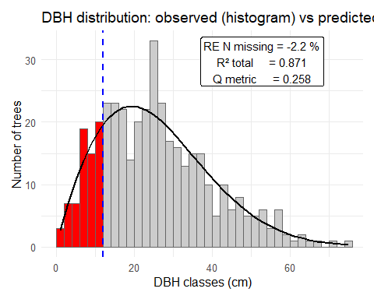
Figure 1 – DBH distribution: observed (histogram) and left-truncated Weibull fit (curve).
The histogram shows the observed number of trees in each DBH class, either above (grey) or below (red) the DBH threshold (dashed blue line at 12 cm). The black curve represents the Weibull distribution fitted using only trees above the threshold (all trees in the grey classes). The inset reports the Relative Error (RE N missing) in predicting the number of missing small trees (all trees in the red classes), the overall goodness of fit (R² total), and the Q metric.
The Weibull curve predicted by the model matches the observed (simulated) distribution well. Metrics values and interpretation are the same as above.
Vizualization of the distribution of residuals
plot_residuals_by_class(df_res, Q, KS_p, t = dbh_threshold)
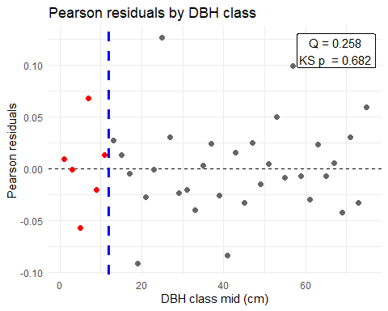
Figure 2 – Pearson residuals by DBH class. Pearson residuals (points) comparing observed and expected proportions for each DBH class, either above (grey) or below (red) the DBH threshold indicated by the dashed blue line. The inset reports the Q metric and the Kolmogorov–Smirnov goodness-of-fit test p-value (KS p).
On the graphic, the residuals below the DBH threshold (in red) do not appear to be overdispersed. This is also what the the p-value of the KS test (Ks p = 0.22) indicates.

Application to empirical data

The dataset of Schwarzmann and Waller
We now test our approach on real data to evaluate its robustness across the range of Weibull parameter values observed in actual forest stands, using a dataset from Schwarzmann & Waller (2025) with multi-species uneven-aged stands. Although our method assumes that DBH distributions are reasonably well approximated by a unimodal Weibull, this assumption may be violated in such heterogeneous stands. Furthermore, trees under 12 cm DBH appear not to have been measured so we had to truncate the DBH distributions below 20 cm to assess the quality of our method for trees in the 12–20 cm DBH range. This setup is not ideal, but it was difficult to find a more suitable dataset. Nevertheless, the method appears to perform reasonably well on this dataset …
Importing the dataset
df <- read_excel("Tree-DBH-BA_and_BM_Growth-Data-BySps.xlsx", sheet = 1)
head(df, 10)
## # A tibble: 10 × 24
## STAND_ID ACTIVITY_ID PLOT_ID `Tree ID` Species `Stand Av DBH cm`
## <chr> <dbl> <dbl> <dbl> <chr> <chr>
## 1 236010222-02 2005018 2 3 Abies balsamea 18.626666666666665
## 2 236022811-04 2005018 2 1 Abies balsamea 35.898666666666664
## 3 238010714-01 2006045 2 4 Abies balsamea 13.843000000000004
## 4 238010724-05 2006045 15 4 Abies balsamea 28.549599999999998
## 5 238010724-05 2006045 19 3 Abies balsamea 27.844750000000001
## 6 241123342-01 2006049 4 1 Abies balsamea 28.194000000000003
## 7 241123342-01 2006049 4 3 Abies balsamea 28.194000000000003
## 8 242030514-01 2006046 1 3 Abies balsamea 14.4145
## 9 242030514-01 2006046 1 1 Abies balsamea 14.4145
## 10 242030514-01 2006046 2 3 Abies balsamea 22.775333333333332
## # ℹ 18 more variables: `Stand BA m2/ha` <chr>, `RINGS / in` <dbl>,
## # `AveGrowth (cm/ yr)` <dbl>, DBH <dbl>, `DBH (in)` <dbl>,
## # `Adj DBH slope` <dbl>, NewGrowthRate <dbl>, `Tree BA (cm2)` <dbl>,
## # `OLD BA Increment (cm2/yr)` <dbl>, `OLD % BA Growth` <dbl>,
## # `Crtd BA Incr` <dbl>, `Crtd BA Incr %` <dbl>, CROWNCLASS <chr>,
## # DamageSev <chr>, `HEIGHT (ft)` <chr>, `Height (m)` <chr>,
## # `Biomass (kg)` <chr>, `Carbon (kg)` <chr>
Exploring DBH distribution within the dataset
# Choosing a PLOT_ID from 1 to XX to Display
PLOT_ID = 10
## Warning: Removed 28 rows containing non-finite outside the scale range
## (`stat_bin()`).
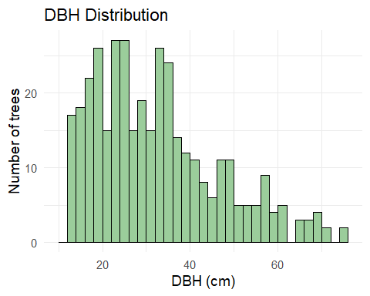
It appears that the DBH distribution in this dataset is already truncated at approximately 12 cm. We therefore truncate it further at $t=20$ cm and then evaluate the quality of our predictions for trees in the 12–20 cm DBH range.

Fitting a complete Weibull based on a truncated empirical distribution of DBH for each plot
Example on a single plot
First we have to choose a plot (a plot ID ‘pid’), and a declare dbh_threshold ‘t <- 20’ to truncate the observations.
Now let’s see how the method performs on that example :
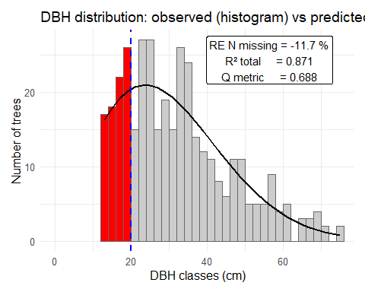
The overall $R^{2}$ is 0.81, indicating that, in general, the full Weibull provides a good fit to the data. For the predicted number of missing trees, we obtain an error of -11% relative to the true value, which is reasonably satisfactory.
A value of $Q=0.688$ indicates that the mean error in the distribution below the threshold is lower than the variance of the distribution above the threshold; however, $Q$ remains close to zero, and $KS_{p}=0.15>0.05$ indicates that the residual distributions above and below the threshold are not significantly different (see also the distributions of residuals below).
It looks like it works just as well on this empirical dataset than on the simulated one earlier.
Application on all plots in the dataset (see Code – hereafter is only the result)
head(results, 10)
## PLOT_ID shape scale Q R2_all RE_missing KS_p
## 1 1 1.858142 29.93716 -6.5993788 0.8071384 32.953558 0.780948890
## 2 2 1.769466 29.29993 -5.1197342 0.8361150 26.050804 0.936741695
## 3 3 2.004362 32.81126 -4.9506904 0.8662269 13.381118 0.028449502
## 4 4 2.023622 33.26928 -3.5913966 0.8526084 5.549078 0.602768544
## 5 5 1.780998 30.34452 -2.5006185 0.8166204 12.023279 0.171226771
## 6 6 2.009461 32.03501 -1.9123818 0.8404662 19.900961 0.032181915
## 7 7 1.851174 30.73227 -2.7224084 0.6937209 43.615087 0.103920181
## 8 8 2.226071 36.49071 -2.8453242 0.8360463 -27.639877 0.003530975
## 9 9 1.863459 32.25447 -0.8884033 0.7336660 27.243026 0.684060721
## 10 10 1.999769 33.59710 0.6880784 0.8134555 -11.660418 0.151056730
## N_tot_pred N_tot_obs N_missing_pred N_missing_obs
## 1 869.6198 809 252.61176 190
## 2 766.8593 720 231.93348 184
## 3 638.6246 621 155.33213 137
## 4 558.0333 552 131.93635 125
## 5 523.6661 508 150.11119 134
## 6 525.5283 504 133.09007 111
## 7 497.5999 458 139.30663 97
## 8 411.6669 441 76.70173 106
## 9 417.5196 397 108.15657 85
## 10 358.8592 371 73.32185 83

Predictive power of the approach
Displaying predicted vs. observed number of trees under the DBH threshold
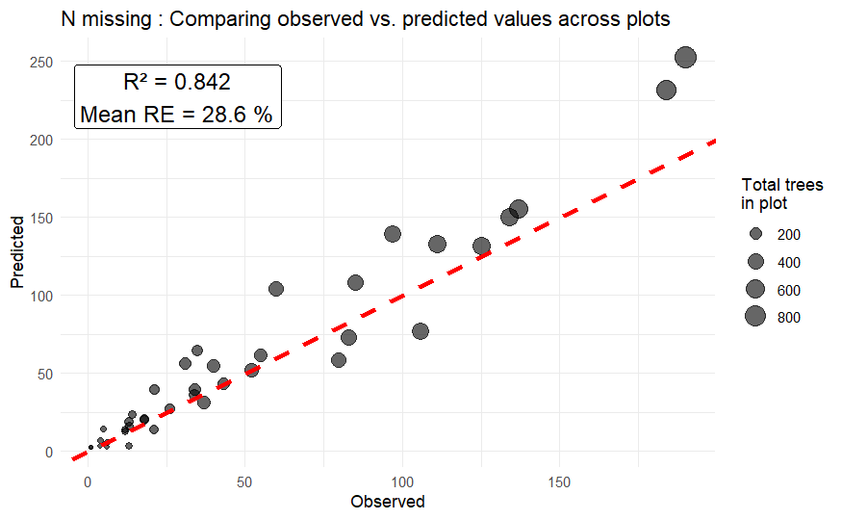
Figure 3 – Comparison between observed and predicted numbers of missing trees across plots. Each point represents the observed versus predicted counts of missing trees for a given plot. Point size is proportional to the total number of trees in the plot. The red dashed line represents the 1:1 relationship. The inset reports the R² and the mean relative error (Mean RE) across all plots.
The predictions of $N_{\text{missing}}$ are generally satisfactory, although a slight bias is evident: on average, predictions are 28.6% higher than the observed values.

Conclusion
My impression is that the method yields more satisfactory results than the $R^{2}=0.35$ mentioned in your email. Of course, I do not know the level of precision you require, and the method can certainly be improved if needed. In particular, the paper by McGarrigle et al. (2011) describes an approach that combines the Weibull-based prediction with environmental predictors to obtain even more accurate estimates.

