

**Assignment 1: Design, Implementation and Testing of a Single-Mode Biometric**

**Authentication System using Facial Recognition.**

**Abel Melinte**

**B00137882**

***Department of Informatics,***

***School of Informatics and Engineering,***

***Technological University Dublin,***

***Dublin 15***

**[Page Count: 7 Word Count: 1130]**

**Biometrics and Forensics Applications**

**Digital Forensics and Cyber Security**

**22/11/2023**

***Department of Informatics,***

***School of Informatics and Engineering,***

***Technological University Dublin,***

***Dublin 15***

**Declaration On Plagiarism**

I declare that the work we are submitting for assessment by the Institute examiner(s) is entirely our own work, except where the author or source has been duly referenced and attributed.

We confirm that this material has not been previously submitted for a degree or any other qualification at TUD or any at other institution.

We further confirm that we have read and understood the Institute policy on plagiarism in assignments and examinations (3AS08.doc) and that we are not, as far as we are aware, in breach of any of these regulations.

Names: Abel Melinte                                                                                           Student IDs: B00137882

Signed: Abel Melinte                                                                                                      Date: 22/11/2023

Course: Digital Forensics and Cyber Security                  Module: Biometrics and Forensics Applications

Table of Contents

1. Introduction 4

2. Training Set 4

How Database was implemented 5

Operating System 5

Software 5

3. Process 5

Threshold 5

Enrolments 5

Authentication 6

Circumvention 7

4. Conclusion 8

5. References 8

# Table of Figures

Figure 1 VeriLook Directory 5

Figure 2 7 Angles 6

Figure 3 Cuttout subject faces (pages) 7

Figure 4 Excel Sheets 8

# 1. Introduction

For this assignment you are required to test (Unit test) a biometric system for three distinct

categories: enrolment, authentication, and circumvention. The objective of this assignment is.

to write and carry out a physical test plan that you have written over a single mode biometric

authentication and testing system. This will enable you to reach an empirical decision as to

the worthiness and value of your chosen biometric model through concrete data. You may

choose any single biometric. The three tested values which are needed is “Failure to Enrol Rate”, “False Rejection Rate”, “False Acceptance Rate”.

# 2. Training Set

|  |  |
| --- | --- |
| Subject1 | Abel |
| Subject2 | Tudor |
| Subject3 | Attila |
| Subject4 | Luke |
| Face Database | 7,219 Faces https://www.kaggle.com/datasets/ashwingupta3012/human-faces/ |

This was the training set which I decided to go with, it was recommended to choose students from our module as being the subjects as we can remain on campus after classes which will give us the ability to Enrol, Authenticate and Circumvent throughout the rest of the week.

## How Database was implemented

The method which was used for importing the database in VeriLook was by downloading the ZIP file of the 7,219 faces then navigating over to the VeriLook tool, clicking on this drop-down menu, A screenshot of a computer error

Figure VeriLook Directory

Selecting “Directory” then clicking enrol and selecting which folder the faces were located in. It will then pass through each face and enrol them all in around 20 minutes depending on which system the user has.

## Operating System

The operating system which has been used throughout this entire process was Windows 11 Professional Version 10.0.22621 Build 22621.

## Software

The software which has been used to carry out this entire process was VeriLook version 13.0 which is created by Neurotechnology back in 2011.

# 3. Process

## Threshold

Throughout the entire process, the liveness threshold which was being used was “50%”. I decided to choose this threshold as it is set by default for face recognition, and it is also preferable as throughout the couple days/weeks something within the face could possibly change which will lead VeriLook to not being able to detect your enrolment image.

## Enrolments

When it came to enrolling each subject, the decision was enrolling each subject while looking in different directions, here is an example.

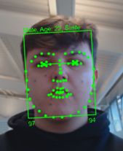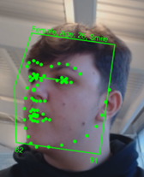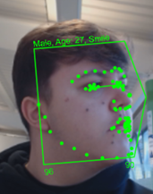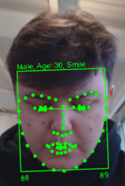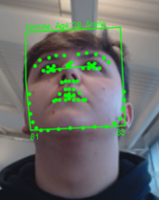

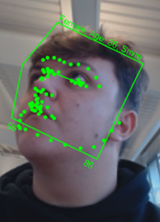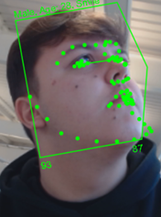

Figure 7 Angles

These were the 7 different angles which were taken, the reason for this was when it came to the FRR and FAR, it will have a higher chance of finding one of the above angles within the database. For example, when I was identifying myself, it returned the image in which I was looking left, this is because the camera caught me in a moment where I wasn’t facing the camera while it was identifying.

## Authentication

How I recorded the authentication, I decided to go ahead with 100 authentication attempts among all 4 subjects to get the best and most accurate result possible. I went with the “Active” liveness detection as on my system it performed better than “Passive” as it was smooth and not choppy. Over the authentications of 100 attempts among the subjects, the main results I have received was “Low” result, this means that the result was way lower than the average range, I went ahead and took note of it and labelled it as an “Anomaly”, I also received “Spoof Detected” a couple times, that has been taken note off, it means that it hasn’t recognised the subject because maybe the subject was leaned back and away from the camera or even only a portion of his face was captured in the camera or also while the active process was in action the subject moved rapidly causing the recognition to take it in as a Spoof attempt, finally I received “Liveness Check Detection”, this means that throughout the authenticating process, the subject has made an incorrect movement which didn’t lead him to follow the guided arrow on screen, that is the only way you can get Liveness Check Detection as a result.

## Circumvention

When it came to the Circumvention process, I had options to go ahead with,1) To take a picture of each subject and print each face out on a A4 page and then attempt to circumvent while Active liveness detection is one, 2) Record a video of each subjects face doing the same actions that has to be done for the Active process (look left blink, look centre blink, look right blink etc.)

The option I went with was option 1, I managed to print out each subject’s face and went out with cutting the eyes out from each A4 page as VeriLook needs to be able to see the eyes blink when it tells you to.

Figure Cuttout subject faces (pages)

Here is an image that shows the result after cutting out the eyes of the subject’s pages. Throughout the entire circumvention process, I was not able to detect one subject at all. I tried multiple times, but the result came back as “Spoof Detected” over and over, I figured out that this was happening as since the eyes were placed behind the cut-out paper, it created a shadow on the eyes which caused VeriLook to not be able to detect any eyes as it was complete darkness behind the pages. Another issue which I discovered was that when the page was turned left or right, it crumbled a little and caused a bright shine from the lighting in the room as soon as I was told to look left or right the system instantly detected a Spoof attempt.

The only remaining option was to go with option 2 which was to record videos of each subjects moving their heads and eyes the same way they needed to for Active liveness. The results overall were extremely surprising as I managed to circumvent VeriLook “23” times, more than the FRR. I managed to find out why it failed 377 times, this is because the subjects in the videos were moving their heads from left to right too slow and in the video, they were looking from left to right even if the Active process told them look from right to left. A plan I went along with was using an editing software and speeding up the video so the subject in the video can manage to reach the targets displayed on the screen. The scores overall were surprisingly like the FAR which I was totally not expecting as the liveness detection option is there for the reason to be more accurate in an attempt of a spoof attack.

## Notice

The excel file, which is part of this ZIP folder, when viewing the tables, there is 4 sheets which will have to be navigated through to view all the recorded data.



Figure Excel Sheets

# 4. Conclusion

To sum up, this assignment has been a big help in understanding the intricacies and applications of biometric systems. It has given me useful abilities for planning, carrying out, and assessing system testing and has highlighted the significance of empirical data in establishing the effectiveness and suitability of technical solutions. I have also learned how important it is for companies to have expensive equipment for recognition as in the assignment it clearly highlights on how easy it is to bypass and authenticate facial system.

# 5. References

Neurotechnology. (2011). VeriLook - Facial recognition technology [online]. Available from: https://www.neurotechnology.com/verilook.html [Accessed 22 November 2023].

Gupta, A. (2022). Human Faces Dataset [online]. Available from: https://www.kaggle.com/datasets/ashwingupta3012/human-faces/ [Accessed 23 November 2023].