**Abel Ngaliema 213094444**

E:\NewFolder\2.1.JPGQuestion 2.1

Question2.2

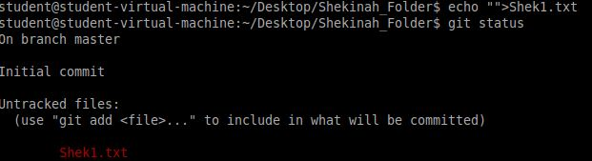

I whereby created a file named “Shek1.txt” in my newly initiated repository and by checking the status, it still shows as “untracked” because I have not set it to be track yet.

Question2.3

E:\NewFolder\2.3.1.JPG



Question2.4

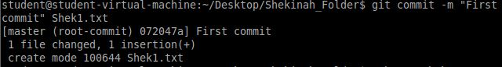

I’ve committed the “She1.txt”.

Question 2.5

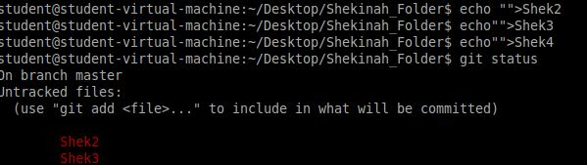

E:\NewFolder\2.5.1.JPG

These files are created but they remain in the “untrack” metho because it has not manipulated so that they can be become tracked, the git add does the work.

Question 2.6

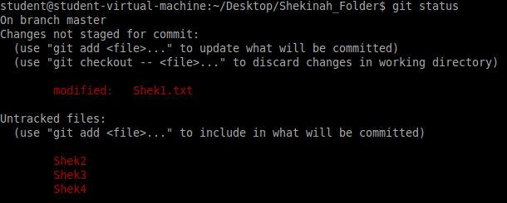

Question 2.7

E:\NewFolder\2.7.1.JPG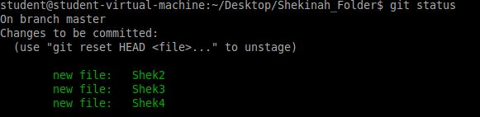

The created files are now comptable to be tracked. Thus the change in appearance.

Question 2.8

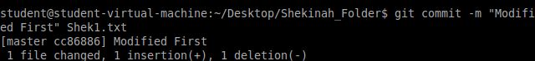

Question 2.9

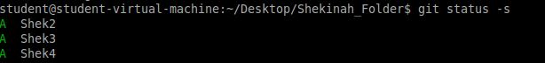

Question 2.10

E:\NewFolder\2.10.JPG

Question 2.11

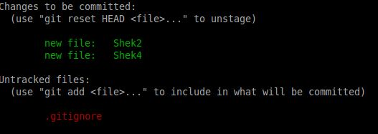

Question 2.12

E:\NewFolder\2.13.JPG

I have successfully removed the file from the local repo.

Question 2.13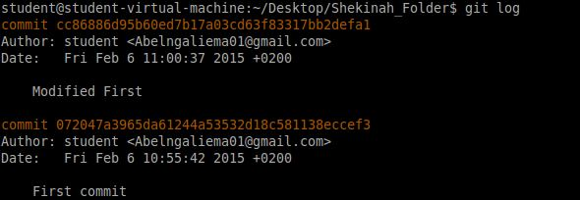

Question 3

Question 3.1

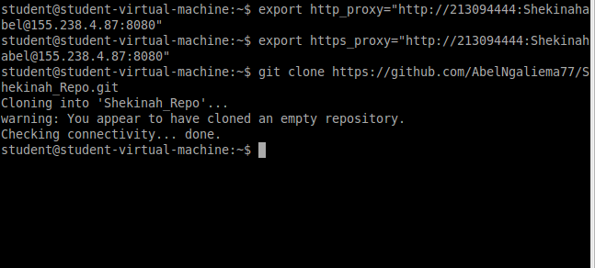

Question 3.2

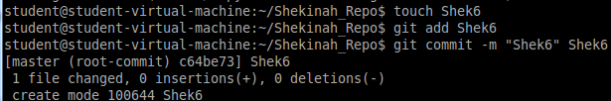

Question 3.3

H:\3.3.PNG



Question 3.4

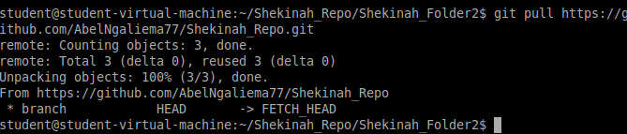

Question 3.5

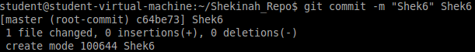

Question 3.6

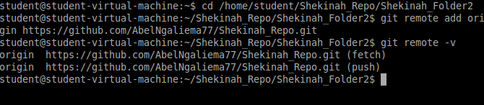

Question 3.7

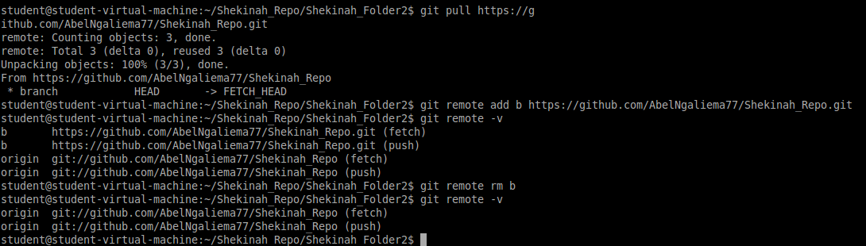

Question 4

Question 4.1

H:\4.1.PNG

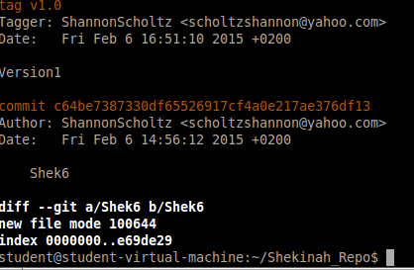

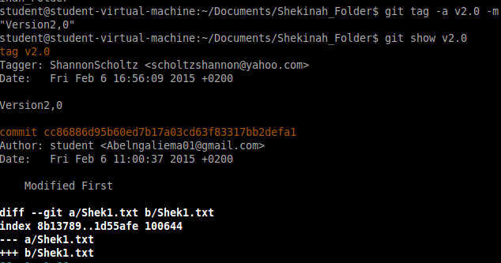

Question 5  
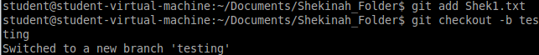

Question 6