**COLLEGE OF ENGINEERING CHENGANNUR**

**(Managed by IHRD, A Govt of Kerala Undertaking)**

Chengannur, Alappuzha Dist. PIN: 689121



**SOFTWARE REQUIREMENT SPECIFICATION**

**Mini Project**

**Group No.7**

**Group Members**

**Abdulla S CHN20CS001**

**Abel Raju CHN20CS002**

**Gouri G Varma CHN20CS050**

**Merin Mary Shibu CHN20CS069**

**Under the guidance of**

**Arathi U P**

**Assistant Professor**

**Department of Computer Science and Engineering**

**Project Details**

Project Title: E-Commerce website for college students

Objectives: To develop an online shopping website for students to buy

and sell second hand textbooks and lecture notes.

Supervised by: Arathi U P

Date started: 16-02-2023

Date completed: 02-06-2023

Technologies Used: HTML, CSS, NodeJS, MongodB

**Abstract**

The term “e-commerce” simply means the sale of goods or services on the internet. Through an e-commerce website, a business can process orders, accept payments, manage shipping and logistics, and provide customer service.

We aim to develop an e-commerce website of the sort but which is mainly centered around college students and their academics. Through this website students will be able to buy second hand books at a cheap rate and get access to lecture notes prepared by previous students as well as make money by selling the fore mentioned items of their own as well.

**Problem Definition**

* Students have always struggled in acquiring all the necessary textbooks for each semester.
* Available books may only be available at high prices.
* There are no convenient methods for students to acquire lecture notes.
* Student-centered e-commerce websites are non existent.

**Existing System**

* Students need to physically go to shops for buying academic books
* Lecture notes and other study materials may not be easily available
* Existing e-commerce websites are not student-friendly

**Proposed System**

* This website facilitates selling or buying second hand books mainly focusing on study materials and lecture notes.
* This provides a platform for students to get access to textbooks, notes etc. at cheap costs and on the flip side also allows them to earn money by selling their used books and self prepared notes.
* This will allow senior students to help younger ones with their academics and course work.

**Introduction**

The purpose of this document is to outline the requirements for developing an online shopping website specifically designed for college students to buy and sell second-hand textbooks and lecture notes. The website aims to provide an efficient and user-friendly platform for students to find affordable course materials and facilitate transactions between buyers and sellers.

**Scope**

The online shopping website will consist of the following main features:

* User registration and authentication: Students will be able to create accounts, log in, and manage their profiles.
* Product listing: Sellers can upload details and images of their textbooks and lecture notes through the admin, and buyers can browse for specific items.
* Product details: Each product listing will include information such as title, description, condition, price, seller details, and any additional notes.
* Shopping cart: Users will be able to add items to their shopping cart, view the cart, and proceed to checkout.
* Payment integration: The website will integrate with a payment gateway to securely process online transactions.
* Admin panel: An administrative interface will be provided to manage user accounts, resolve disputes, and monitor website activities.

**Functional Requirements**

**User Registration and Authentication**

* The system shall provide a registration form for new users to create accounts by providing their name, email, password, and other necessary details.
* Users shall be able to log in to the system using their registered email and password.
* The system shall implement password encryption for secure storage of user credentials.

**Product Listing**

* Sellers shall be able to create product listings by providing relevant information such as title, description, subject, course, author, condition, price, and uploading images to the designated admins of the website.
* Admin verifies the uploaded information and uploads the product to the website
* The system shall allow users to browse through the various products displayed on the website and choose the most appropriate one suited for their use.
* The products shall be displayed in a user-friendly and organized manner, showing relevant details and images.

**Product Details**

* Each product listing shall display detailed information such as title, description, subject, course, author, condition, price, seller details, and any additional notes.
* Users shall be able to view product images for a better understanding of the item's condition.

**Shopping Cart**

* Users shall be able to add products to their shopping cart.
* The system shall display the contents of the shopping cart, including quantities and prices.
* Users shall have the ability to modify the quantities or remove items from the cart.
* Users shall be able to proceed to checkout from the shopping cart.

**Payment Integration**

* The system shall integrate with a secure payment gateway to process online transactions.
* Users shall be able to enter their payment details and complete the purchase.
* The system shall provide appropriate feedback and confirmation upon successful or failed transactions.

**Non-Functional Requirements**

* The website shall have a responsive and intuitive user interface, compatible with desktop and mobile devices.
* The system shall ensure the security of user information, utilizing encryption and secure protocols.
* The website shall be scalable and capable of handling a large number of users and concurrent transactions.
* The website shall comply with relevant privacy regulations and protect user data.

**Constraints**

* The development of the online shopping website shall adhere to a predefined budget and timeline.
* The system shall be developed using technologies and frameworks suitable for web development.
* The website shall be compatible with modern web browsers and devices.

**Use-case diagrams**

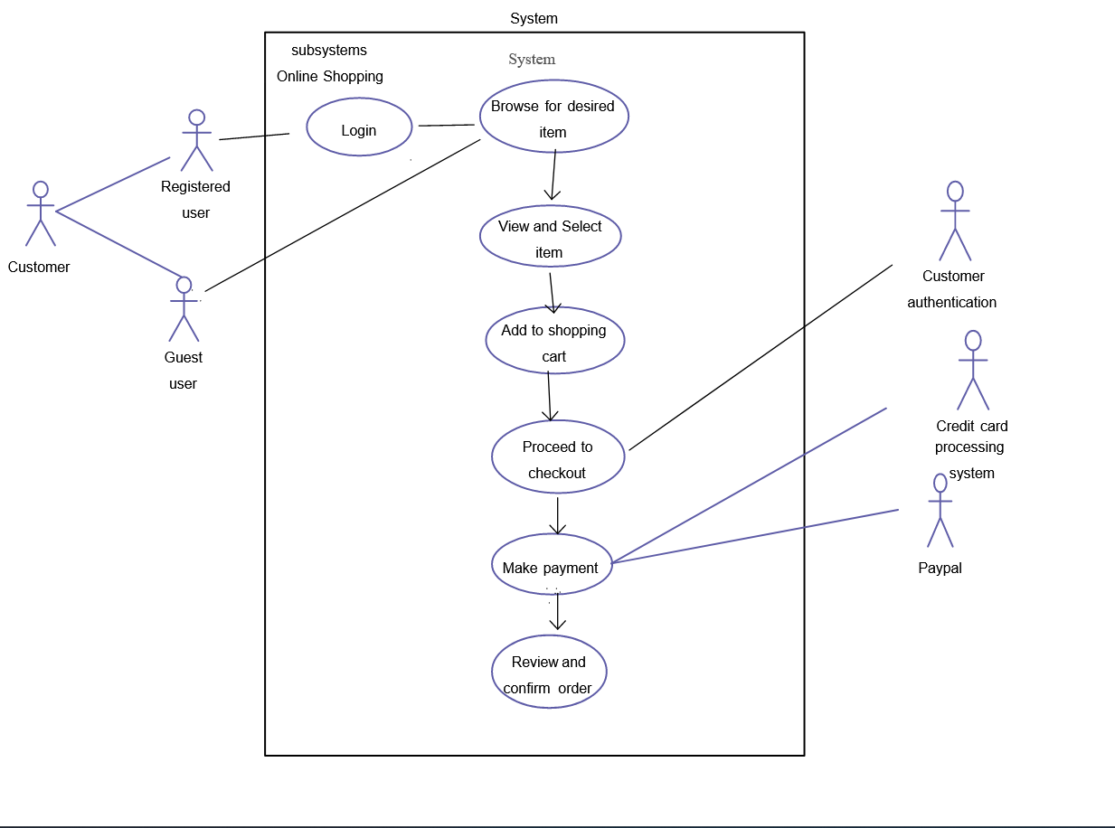

Confirm/Delete Orders

Add/Delete Products

View Orders

Logout

View Products

Admin

AdminPage

Login

**Login page**

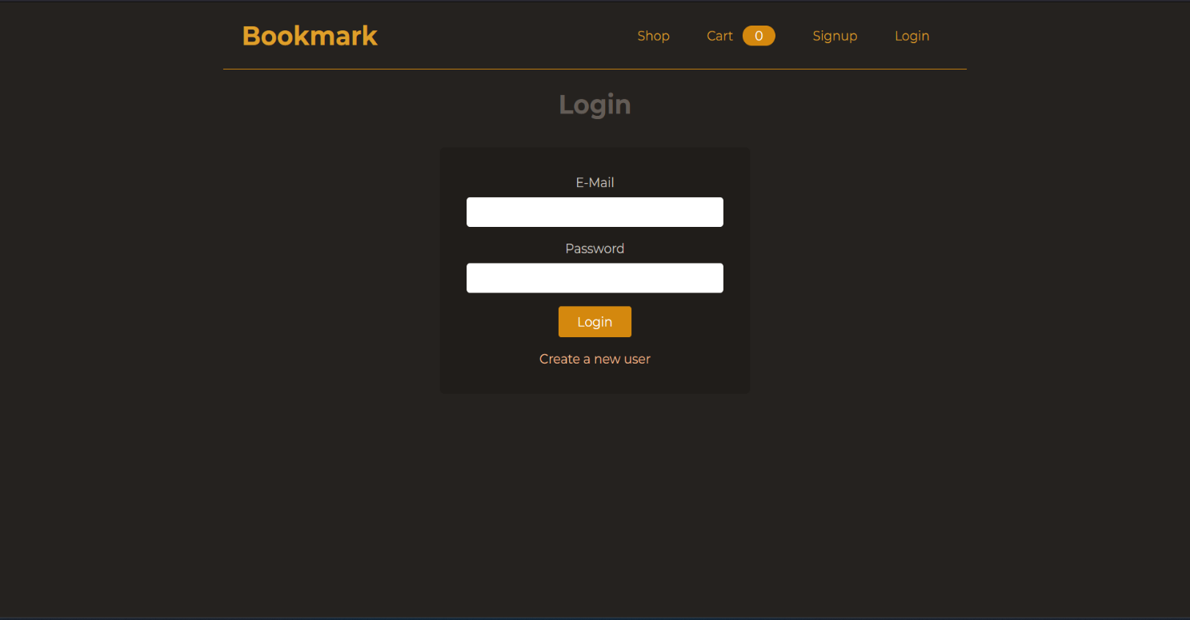

**Signup page**

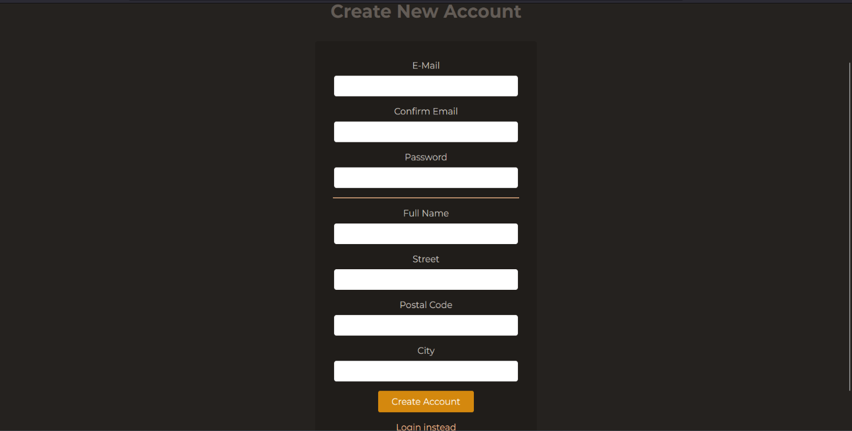

**Product Details**



**Adding a product**

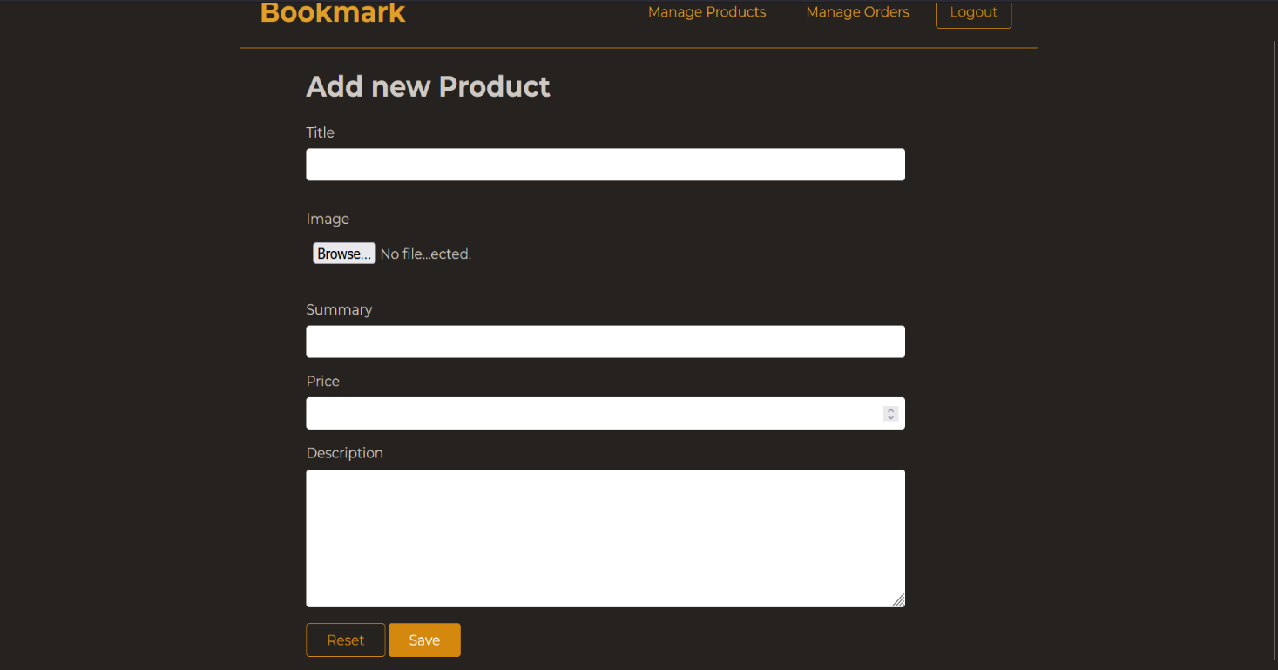

**Mobile View**

**