CG-PED: Do Curriculum Learning, LoRA, and Distillation Compose?
A factorial test of three efficiency techniques for training small generative language models — and why composing them does not help
Author: Abel Tezare Programme: Software Engineering Student, Addis Ababa University
Assignment: Data and Compute-Efficient Generative AI Date: August 2026

Summary
The whole paper, in one table. Every number is a mean over 3 seeds; "noise" is the mean within-cell seed spread, and nothing smaller than it is treated as a finding.
Finding | Evidence
The three techniques compose additively. There is no detectable interaction in either direction. | observed − predicted = -0.0003 (synthetic) and +0.0008 (real), against noise of ±0.0055 and ±0.0099
Only one effect is large, and it is a cost: LoRA, applied to a from-scratch model. | +0.027 synthetic, +0.278 real — 28× the noise
Distillation is the only component that reliably helps, and it helps in proportion to how much better the teacher is than the student. | -0.007 synthetic (teacher 3.529 ≈ student 3.529); -0.037 real (teacher 1.932 vs student 2.110)
The curriculum earns nothing readable, and changes sign between benchmarks. | -0.004 synthetic (0.7× noise) and +0.012 real (1.3× noise, wrong sign)
So the full composition loses — by exactly the sum of the three effects. | CG-PED 3.543 vs naive 3.529 (synthetic); 2.364 vs 2.110 (real)
What it does buy, and that part composes cleanly. | 72.3% and 74.1% fewer trainable parameters — but 2.27× and 2.14× the wall clock per step
The configuration this study actually recommends is not CG-PED. | curriculum + distillation reaches 3.5148 synthetic and distillation only reaches 2.0613 real — both beat the naive baseline by more than the seed spread

Abstract
Curriculum learning, parameter-efficient adaptation, and knowledge distillation each reduce the cost of training a generative model in a different way, and each is normally studied alone. A practitioner under a fixed budget has no reason to choose between them, and the implicit assumption behind using all three is that their benefits accumulate. This paper tests that assumption with a design that can actually measure it: a full 2³ factorial over the three techniques, all eight combinations, 3 seeds per cell, at a fixed step budget, on a synthetic benchmark with exactly known difficulty and on a genuine public-domain English corpus.
The techniques compose almost perfectly. The full composition lands within 0.0003 and 0.0008 nats of what its three separate effects predict — roughly a tenth of the seed-to-seed spread (0.0055 and 0.0099). Additivity is the cleanest result in the study, and it is what makes the rest interpretable: the composition inherits its components' effects with no compounding and no cancellation.
That is also why it loses. Of the three effects, only one is large, and it is the wrong sign: LoRA costs +0.027 nats on synthetic data and +0.278 on real text at this from-scratch scale — 28× the seed noise on the real corpus. Distillation is the one component that consistently helps (-0.007 and -0.037), and its benefit tracks how much better the teacher is than the student rather than the fact of distillation. The curriculum earns nothing readable, and its sign flips between the two benchmarks. Adding the parts together therefore yields a composition that is behind the naive baseline by 0.015 nats on synthetic data and 0.254 on real text.
What CG-PED does deliver is the resource saving, and that composes too: 72.3% and 74.1% fewer trainable parameters, with the optimizer-memory saving that implies. The contribution is the separation of those two outcomes and the per-component accounting that explains them — including the finding that the best configuration found here is not the full composition at all. The paper also reports an implementation failure (Section 8) that produced a complete, plausible and entirely fictitious set of LoRA results before it was caught.
Keywords: data-efficient generative AI; compute-efficient training; curriculum learning; parameter-efficient fine-tuning; LoRA; knowledge distillation; factorial design; negative results

1. The Question
Progress in generative AI has come mostly from scale — larger models, larger datasets, larger clusters. That path is effective and almost entirely closed to researchers without GPU-cluster budgets. The alternative is to improve the efficiency of learning itself, and the literature offers three well-established levers: control which data the model sees and in what order (curriculum learning), reduce how many parameters must be updated (parameter-efficient adaptation), and transfer what a larger model already knows (knowledge distillation).
Each is normally evaluated alone, against a baseline that uses none of them. A practitioner under a fixed budget, however, faces no such choice — nothing stops them from using all three at once, and the implicit assumption behind doing so is that the benefits accumulate. That assumption is almost never tested, because testing it requires a design that can measure an interaction, and a chain of one-factor-at-a-time ablations cannot.
Research question. Under a fixed data and compute budget, do curriculum learning, LoRA, and knowledge distillation compose — does using all three together deliver what each delivers separately?
Hypothesis. They compose additively. The three act on different resources — data ordering, parameter count, training signal — so their effects should be close to independent, and the full composition should land near the sum of the individual effects.
Finding. The hypothesis is supported, to well inside seed noise, on both benchmarks. The interesting consequence is what additivity implies for the method: because nothing compounds, the composition is worth exactly the sum of its components, and that sum is negative. The substantive work of this paper is the per-component accounting that shows why, and the conclusion that the recommended configuration is not the full composition.
This is reported as a negative result about CG-PED rather than reframed into a positive one. The assignment asks for evidence of research thinking rather than for a method that wins every comparison, and a clean negative result that exceeds its own noise floor and comes with a mechanism is more useful to the next person than a marginal positive one that a change of seed would erase. Section 8 describes a case, from this project's own history, of exactly such a fictitious positive.

2. Related Work and the Gap

2.1 The three components
Curriculum learning (Bengio et al., 2009) orders training examples from easy to hard, on the argument that models, like people, learn faster from a structured sequence. Competence-based curricula (Platanios et al., 2019) replace a rigid ordering with a pacing function: the pool of eligible examples grows as a function of the model's estimated competence. CG-PED's sampler is a direct application of that idea, with difficulty defined generically rather than through the sentence-length proxies common in prior NLP work.
Low-Rank Adaptation (Hu et al., 2021) freezes a weight matrix and learns a low-rank update in its place, cutting trainable parameters and the optimizer state that scales with them. It has become the default way to adapt a large model under constrained compute. Knowledge distillation (Hinton et al., 2015) trains a smaller student against a larger teacher's softened output distribution; a recurring finding in that literature is a capacity-mismatch effect, where a stronger teacher does not reliably produce a stronger student.
Alongside these, a data-centric line of work treats the dataset itself as the lever — pruning it using training-dynamics signals such as example forgetting (Toneva et al., 2018), or selecting samples via a pruned proxy network and fusing the result back (PruneFuse; Kousar et al., 2026). Recent surveys of small language models (Van Nguyen et al., 2025) catalogue how far careful data curation and staged training can push sub-billion-parameter models.

2.2 Combining them
Combining curriculum ordering with distillation is an active direction. Zhu et al. (2021) clustered dialogue training cases by complexity and used an adversarial signal to surface additionally difficult ones. POCL (Liu & Zhang, 2025a) layers a difficulty measurer and a scheduler onto existing white-box distillation methods to address instability during distillation. Selective Reflection Distillation (Liu & Zhang, 2025b) curates student-compatible instances and introduces them on a schedule. TSCL (Ezgi & Onan, 2026) sequences the distillation objectives rather than the data. Most directly relevant, CLPD (Cao et al., 2026) aligns curriculum difficulty with teacher capability and incorporates LoRA — the same three-technique combination studied here — for instruction-following and mathematical-reasoning distillation between GPU-hosted Qwen and Llama models.

2.3 The gap
CLPD establishes that this three-way combination is worth building. What none of this work establishes is whether the combination works because the components reinforce one another, or merely despite the fact that they do not. Every study above evaluates a composed system against an uncomposed baseline. That comparison answers "is the combination better than nothing?" It cannot answer "is the combination better than its parts, and which part is carrying it?", because the design does not contain the cells needed to compute an interaction or to attribute the outcome.
That is the gap addressed here, and it is methodological rather than a new mechanism. The contribution is a design — the full factorial with seed replication — applied to a combination the literature has already proposed, at a scale small enough that all eight cells can be run several times over on a single CPU core. That is precisely the regime in which nobody bothers to run them, and it turns out to be the regime in which the answer is most surprising.

3. Method: CG-PED
CG-PED composes the three components into one training loop. Figure 1 shows what each one touches. The labels state what the implementation does rather than what the technique does in general, which matters here for reasons Section 8 explains.
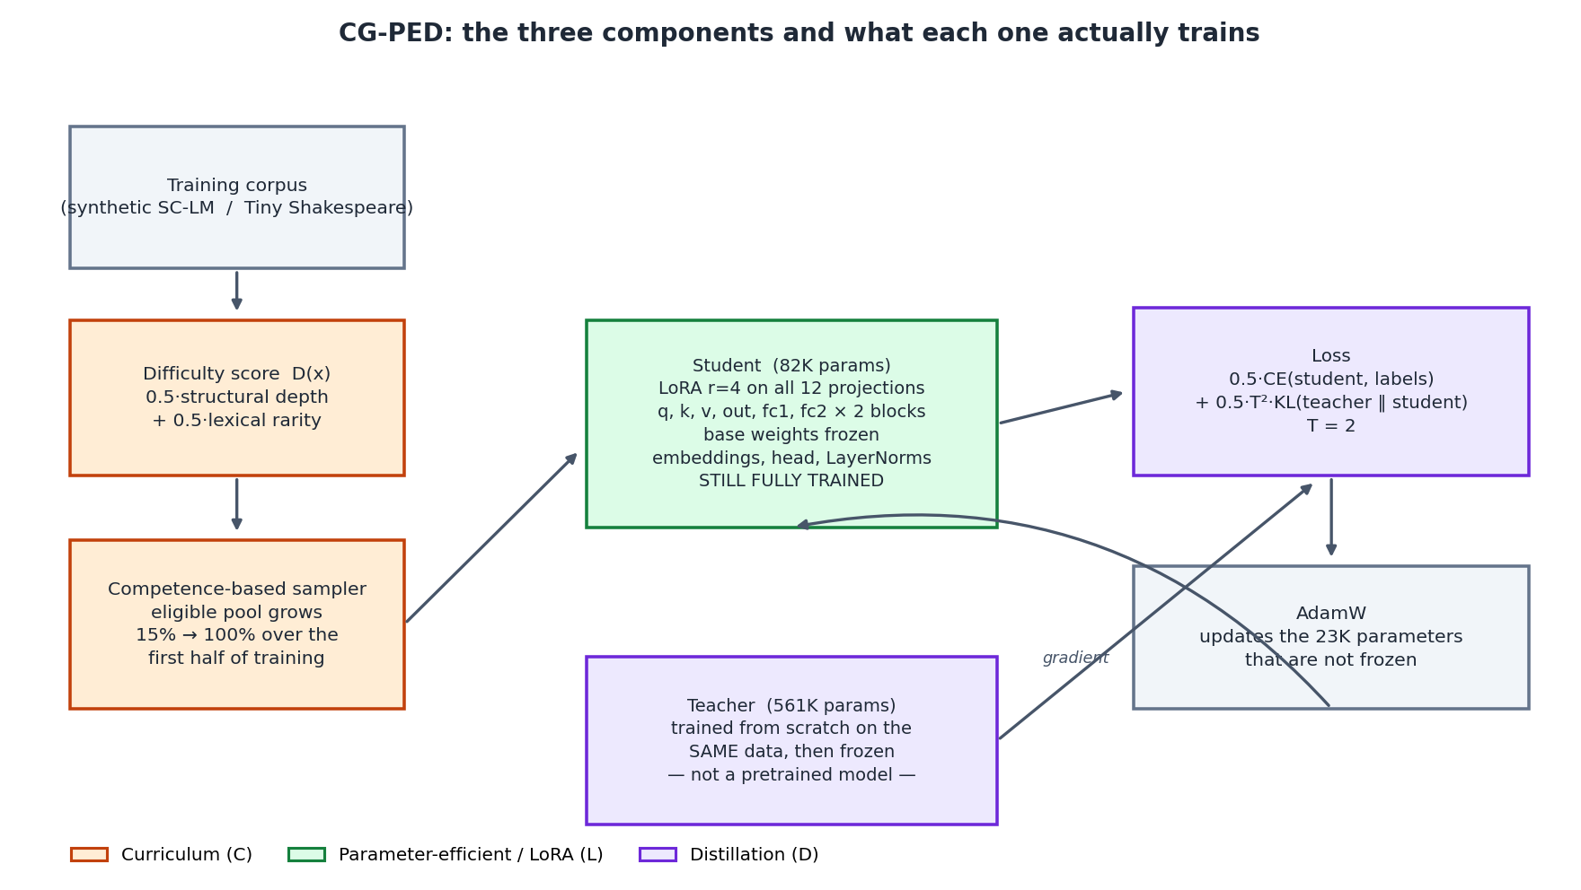
Figure 1. The three components of CG-PED and what each one actually trains. The teacher is trained from scratch on the same data as the student, not loaded from a pretrained checkpoint; embeddings, the output head and the LayerNorms remain fully trainable in every arm.

3.1 Difficulty scoring
Each example x receives a difficulty score combining two axes that prior work identifies as driving difficulty, min–max normalised within the training split: D(x) = 0.5·norm(structural depth) + 0.5·norm(lexical rarity). Structural depth measures compositional complexity — the number of composed sub-units in a synthetic sequence, or the count of distinct characters in a real text chunk. Lexical rarity is the mean negative log-probability of the tokens or words used, under the data's own empirical frequency distribution. Both are defined without reference to the model, so the same code path scores both benchmarks and the score is computed once, before training.

3.2 Competence-based pacing
Examples are sorted by D(x); at step t only the easiest c(t) fraction of the sorted pool is eligible, with c(t) growing linearly from 0.15 to 1.0 over the first half of training and staying at 1.0 thereafter. Within the eligible pool, examples are drawn uniformly with replacement. Every example therefore becomes reachable and the schedule converges to ordinary random sampling — which means the curriculum arm and the random arm differ only during the first half of training. Section 6.3 argues that this is why the curriculum's measured effect is so small.

3.3 Parameter-efficient adaptation
For a frozen weight matrix W₀, LoRA parameterises the update as ΔW = BA with rank r ≪ min(d, k), so the forward pass becomes y = W₀x + b₀ + (α/r)·BAx and only A and B are trained. B is initialised to zero, so the adapted model starts numerically identical to the base model — a property the verification suite checks rather than assumes. CG-PED applies LoRA with r = 4, α = 8 to all twelve linear projections in the transformer blocks: query, key, value, output, and both feed-forward projections, in each of two blocks. The token and position embeddings, the output head and the LayerNorms stay fully trainable. A from-scratch model cannot freeze its embedding table, and stating this is necessary for the parameter-reduction figure to mean anything.

3.4 Distillation
The student is trained against a combined objective, L = α·CE(student, labels) + (1−α)·T²·KL(teacher ‖ student) with T = 2 and α = 0.5. The teacher is a larger model of the same family (559,872 parameters against the student's 81,920), trained once per seed with a plain recipe on the same training split, then frozen. It is not a pretrained checkpoint. How good it is relative to the student turns out to be the single variable that determines whether distillation helps at all (Section 6.2).

4. Experimental Design
The design is a full 2³ factorial over curriculum (C), LoRA (L) and distillation (D): all eight combinations, 3 seeds each (7, 17, 27), at a fixed budget of 300 steps, on two benchmarks. Cells are named by which factors are on, so "— — —" is the naive baseline and "C L D" is full CG-PED.
Why a factorial. The research question is about an interaction, which is invisible in any set of one-factor-at-a-time comparisons. With all eight cells, each factor's main effect is the mean change across the four pairs of cells that differ only in that factor, and the full composition can be compared against the additive prediction formed from the baseline plus the three main effects. The difference between the predicted and the observed composition is the quantity this paper is about, and a chain of pairwise ablations produces none of it.
Why seed replication. At this scale the differences under test are small enough that a single run cannot distinguish an effect from a reseeding. Every cell is run three times and the full seed range is reported alongside the mean, so that the reader — and the author — can see which differences are large enough to be read at all. Several are not, and the paper says so rather than reporting them as findings.
What is held fixed. Architecture, optimizer (AdamW), learning rate (4×10⁻³), batch size (32), step budget, evaluation cadence, and the dataset are identical in every cell. Within a row, every cell shares an initialisation seed, so two cells differing in one factor differ in nothing else.

4.1 Benchmarks
 | Synthetic (SC-LM) | Real (Tiny Shakespeare)
Data | composed root+affix sequences, Zipfian roots | public-domain play text, character level
Train / validation | 2,400 / 400 | 3,600 / 400
Vocabulary | 87 | 68
Difficulty signal | known exactly by construction | estimated from corpus word frequencies
Purpose | isolate the mechanism under exact control | test whether the mechanism survives real data

The pairing is deliberate. A curriculum evaluated only on data whose difficulty the experimenter defined is close to unfalsifiable; a curriculum evaluated only on real data cannot separate a failure of the method from a failure of the difficulty estimate. Running both makes the difference observable, and Section 6 shows that the two benchmarks disagree in ways that matter.

4.2 Verification before measurement
Five automated checks run before any training: that every LoRA adapter receives gradient; that adapters sit on the projections the forward pass actually calls; that wrapped base weights are frozen and the trainable count genuinely drops; that the adapted model is numerically identical to the base model at initialisation; and that the curriculum genuinely restricts the early pool. Each exists because the property it tests failed silently at least once during this project. Section 8 describes the failure that motivated the first and most important of them.

4.3 Metrics
- Validation loss. token-weighted next-token cross-entropy on the held-out split, and its exponential (perplexity). Token weighting rather than a mean of batch means, because sequences vary in length and the final batch is short.
- Trainable parameters. the number of parameters receiving gradient updates — the quantity that determines optimizer memory, which is what binds when training without a GPU.
- Wall-clock time. measured per run on one CPU core, and used for the equal-wall-clock comparison in Section 5.4.
- Seed spread. mean, standard deviation and full range across seeds, reported for every cell. The seed spread is what licenses or forbids reading any difference in this paper.

5. Results

5.1 The factorial
Table 1 gives all eight cells on both benchmarks: mean validation loss over 3 seeds, half the seed-to-seed range, and the trainable parameter count. Cells are ordered by the number of components enabled.
Cell | Synthetic: loss | ± range/2 | Real: loss | ± range/2 | Params (syn.)
— — — naive baseline | 3.5287 | 0.0076 | 2.1101 | 0.0054 | 81,920
C — — curriculum only | 3.5156 | 0.0036 | 2.1310 | 0.0126 | 81,920
— L — LoRA only | 3.5528 | 0.0015 | 2.3840 | 0.0020 | 22,656
— — D distillation only | 3.5169 | 0.0030 | 2.0613 | 0.0155 | 81,920
C L — curriculum + LoRA | 3.5473 | 0.0060 | 2.3877 | 0.0084 | 22,656
C — D curriculum + distillation | 3.5148 | 0.0023 | 2.0809 | 0.0060 | 81,920
— L D LoRA + distillation | 3.5392 | 0.0090 | 2.3587 | 0.0099 | 22,656
C L D full CG-PED | 3.5435 | 0.0081 | 2.3642 | 0.0156 | 22,656

Table 1. Every cell of the 2³ factorial. Lower loss is better.
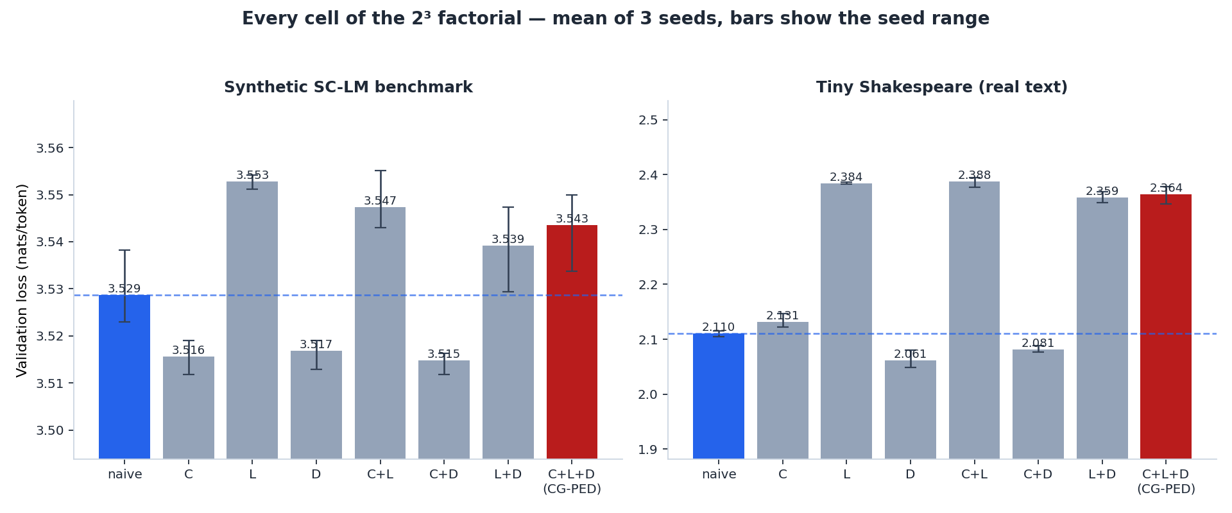
Figure 2. All eight cells on both benchmarks. Error bars show the full seed-to-seed range, which is the scale at which differences in this figure become readable. On the real corpus the four LoRA cells separate cleanly from the four non-LoRA cells, and nothing else separates from anything.
Two things are visible before any analysis. On the real corpus the eight cells fall into two clearly separated groups of four, split by whether LoRA is on — no other factor produces a separation of comparable size. And the best cell on each benchmark is not full CG-PED: it is curriculum + distillation at 3.5148 on synthetic data and distillation only at 2.0613, both of which beat the naive baseline (3.5287 and 2.1101) by more than the seed spread.

5.2 Main effects: what each component is worth
A main effect is the mean change in validation loss from turning one factor on, across the four pairs of cells that differ only in it; negative is better. Table 2 gives each effect beside the seed noise, because an effect smaller than the noise is not a finding.
Component | Synthetic effect | vs noise | Real effect | vs noise
Curriculum (C) | -0.0041 | 0.7× | +0.0124 | 1.3×
LoRA (L) | +0.0267 | 4.9× | +0.2778 | 28.1×
Distillation (D) | -0.0075 | 1.4× | -0.0369 | 3.7×
Within-cell seed sd | 0.0055 | — | 0.0099 | —

Table 2. Main effects against the seed noise floor. "vs noise" is the effect's magnitude divided by the mean within-cell standard deviation.
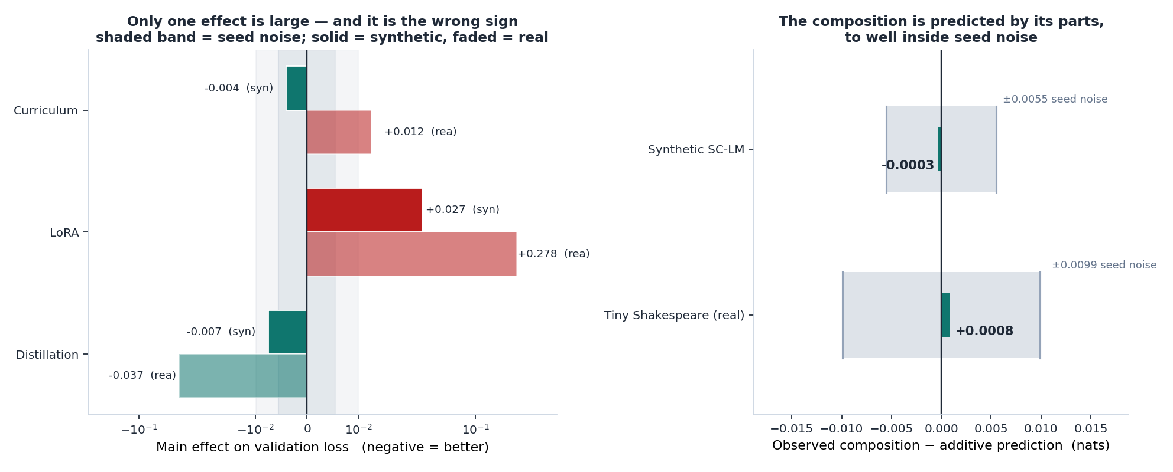
Figure 3. Left: each component's main effect against the seed-noise band (note the symmetric-log axis — LoRA's real-text effect is an order of magnitude larger than anything else). Right: the additive prediction against the observed composition.
- LoRA. the only large effect in the study, and it is a cost, not a saving: +0.027 on synthetic data and +0.278 on real text, the latter 28× the seed noise. It is roughly ten times larger on real text than on the synthetic benchmark. Section 6.1 argues this is a property of the from-scratch regime rather than of LoRA.
- Distillation. the one component that helps on both benchmarks: -0.007 synthetic (1.4× noise, marginal) and -0.037 real (3.7× noise, clearly readable). The asymmetry has a simple explanation, developed in Section 6.2.
- Curriculum. earns nothing that can be read. Its synthetic effect (-0.004) is 0.7× the noise, and on real text it is the wrong sign entirely (+0.012, 1.3× noise). A component whose effect changes sign between benchmarks and never clears its own noise floor has not been shown to do anything. Section 6.3 discusses why, and why this is the finding most likely to change with a better difficulty estimate.

5.3 Additivity: the composition is predicted by its parts
The additive prediction is the naive baseline plus the three main effects — what the full composition would reach if the components did not interact at all. Table 3 compares it to what the composition actually reaches.
 | Synthetic | Real
Naive baseline | 3.5287 | 2.1101
Additive prediction for C+L+D | 3.5438 | 2.3634
Full CG-PED, observed | 3.5435 | 2.3642
Difference (observed − predicted) | -0.0003 | +0.0008
Within-cell seed sd | 0.0055 | 0.0099
Difference as a fraction of seed sd | 0.05× | 0.08×
Trainable parameters saved | 72.3% | 74.1%

Table 3. The additivity check.
The prediction is accurate to 0.0003 nats on synthetic data and 0.0008 on real text — 0.05× and 0.08× the seed noise, on a benchmark where the largest effect under study is thirty times that noise. There is no detectable interaction in either direction: no synergy, no interference. The three techniques simply add.
This is the study's cleanest result and it cuts two ways. It is genuinely useful — if the components add, single-factor experiments are enough to predict any combination, and nobody after this needs to run the factorial again. It is also the reason CG-PED does not work: additivity means the composition inherits LoRA's cost with nothing to offset it, since the two components that could have offset it are worth an order of magnitude less. Full CG-PED is behind the naive baseline by 0.0148 nats on synthetic data and 0.2541 on real text, and both figures are simply the sum of the three numbers in Table 2.
The point of the paper, in one sentence
The three techniques compose exactly as hoped — and that is precisely why composing them does not help, because adding a large cost to two small gains produces a large cost.

5.4 Two budgets
Everything above holds step count equal. That framing flatters CG-PED, because one CG-PED step costs more than one naive step — the distillation arm runs a forward pass through a teacher roughly seven times the student's size at every step. Measured, the ratio is 2.27× on the synthetic benchmark and 2.14× on real text. Table 4 therefore reports both budgets, together with what happens when full CG-PED is given 900 steps — triple the baseline's — to catch up.
 | Synthetic | Real
Naive baseline @ 300 steps | 3.5287 | 2.1101
CG-PED @ 300 steps (equal steps) | 3.5435 | 2.3642
CG-PED at equal wall clock | 3.6041 | 2.5833
CG-PED best over 900 steps | 3.4855 | 2.1116
Seeds reaching the baseline within that budget | 3/3 | 1/3
Cost per step vs naive | 2.27× | 2.14×

Table 4. Equal steps, equal wall clock, and an extended budget.
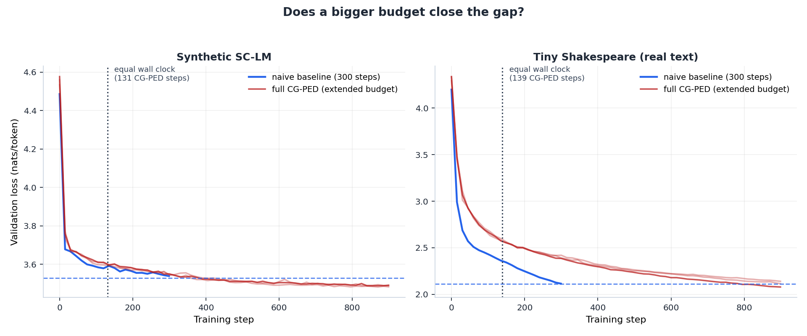
Figure 4. Validation loss against step for the naive baseline and for full CG-PED under an extended budget, all seeds drawn. The dotted vertical line marks how many CG-PED steps fit inside the baseline's wall-clock cost.

5.5 Qualitative samples
As evidence beyond the loss numbers, both real-corpus models were asked to continue the fixed prompt 'ROMEO:\n' at temperature 0.8:
Naive baseline: ROMEO: ⏎ Thakblly go fol mave mor bre wing ands of my how ⏎ This tha
Full CG-PED: ROMEO: ⏎ On the pidgey pore theing not the upfor ther shey. ⏎ ⏎ LUSTE
Both are clearly the output of an undertrained character-level model, which is what a few hundred steps at this size should produce; both are cut off by the model's 64-character context window rather than by choice. Both have learned word-like spacing, line breaks after speaker tags, and a scattering of real English words.
They are included mainly as a caution. If anything, the CG-PED sample reads as the more structured of the two — it produces a plausible speaker tag on a new line — even though its validation loss is 0.254 nats worse, a gap the rest of this paper shows to be far outside seed noise. One sample from one prompt cannot rank two models, and a paper that reported only these two strings would have reached the opposite conclusion from the one the measurements support. No rater study was run and none is claimed.
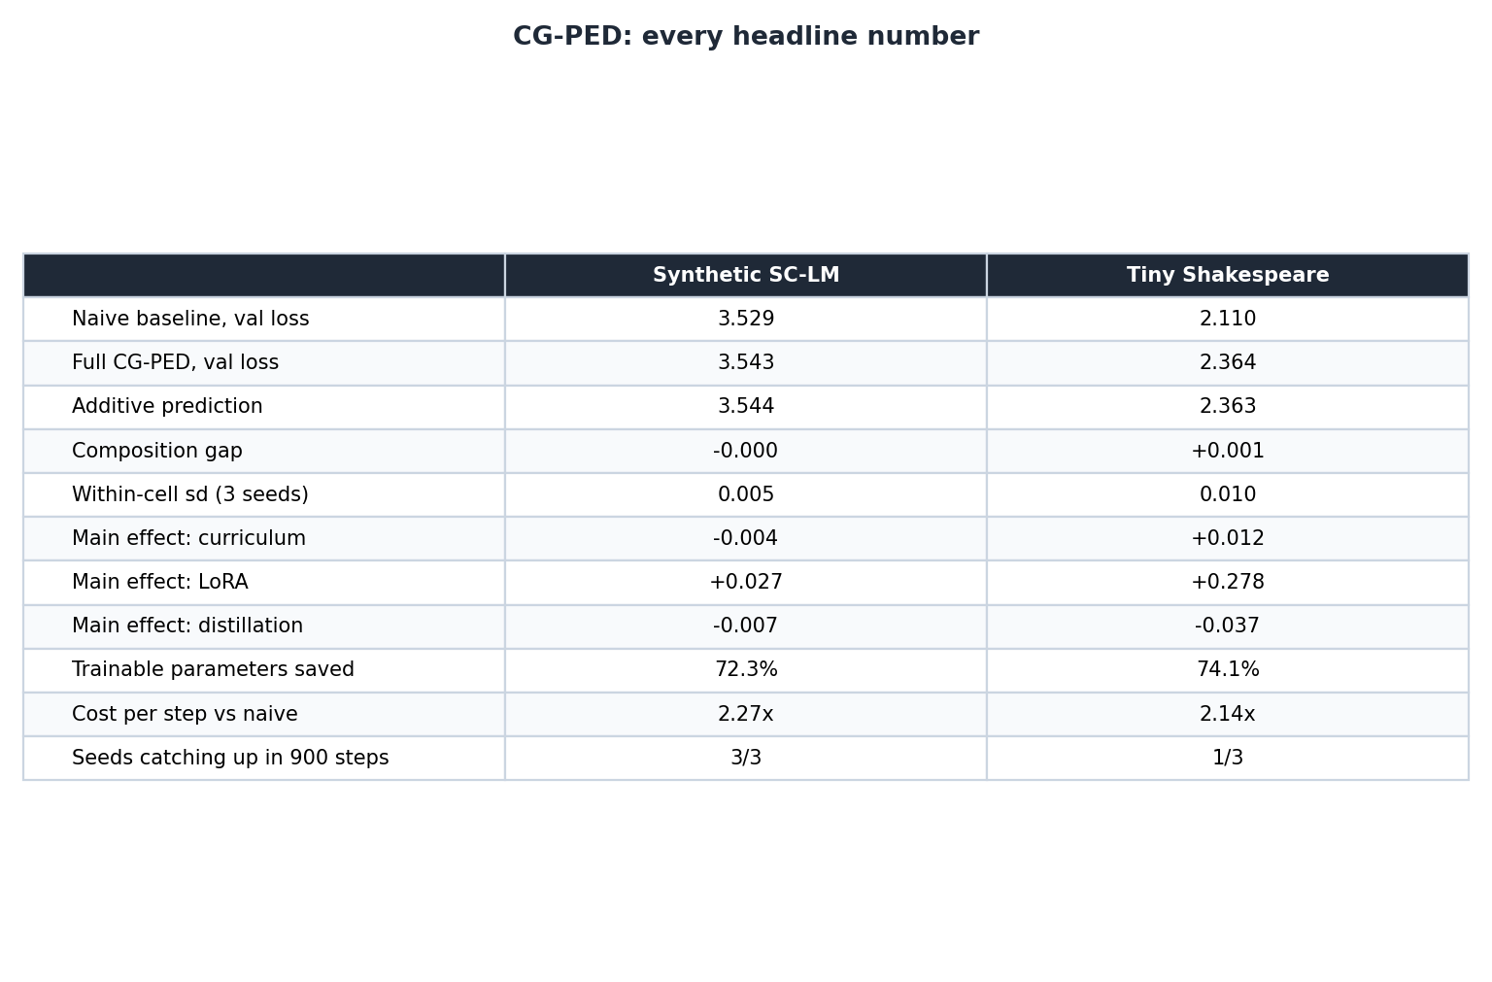
Figure 5. Every headline number in one place.

6. Discussion

6.1 Why LoRA's cost dominates here
LoRA is designed to adapt a network that has already learned general structure from pretraining, where a low-rank update need only encode a comparatively small task-specific adjustment. Nothing in this study is in that regime. Both students are randomly initialised and must learn everything — including basic sequence modelling — inside a rank-4 subspace from step zero, while the base weights they would otherwise use stay frozen at their initial random values.
The ten-fold difference between the two benchmarks supports that reading. On the synthetic benchmark LoRA costs +0.0267; on real text, +0.2778. SC-LM sequences are generated by a small, regular, compositional process, and a rank-4 update is evidently close to sufficient to capture it. Character-level English is not generated by anything so regular, and the same rank is badly insufficient. The prediction this yields is testable and specific: with a pretrained backbone, or with a larger rank, LoRA's main effect should shrink toward zero and the whole composition should move with it, because the composition is additive. That is the first experiment Section 9 proposes.

6.2 Why distillation helps more on real text
Distillation's effect is -0.0075 on synthetic data and -0.0369 on real text — a factor of 5 difference. The explanation does not require anything about distillation as a technique; it requires only looking at the teachers. On the synthetic benchmark the teacher reaches 3.5290 against the naive student's 3.5287 — the teacher is no better than the student it is teaching, so there is nothing to transfer. On real text the teacher reaches 1.9317 against the student's 2.1101, an advantage of 0.178 nats, and distillation recovers a fraction of it.
The general form is that distillation's value here tracks the teacher–student gap rather than the fact of distillation being applied, which is consistent with the capacity-mismatch literature and is an argument for reporting the teacher's own validation loss in any distillation study. A paper reporting only the synthetic result would have concluded that distillation barely works; a paper reporting only the real result would have concluded that it clearly does. Both would have been generalising from the quality of one teacher.

6.3 Why the curriculum earns nothing
The curriculum is the component this project began with, and the factorial does not support it. Its synthetic effect does not clear the seed noise and its real-text effect is the wrong sign. Two features of the design are the likely reasons, and they point in different directions.
- The curriculum switches itself off. the pacing function reaches full competence halfway through training, so the curriculum and random arms are identical over the second half. Whatever advantage the ordering confers has to survive 150 steps of identical sampling, and at this scale it does not.
- The difficulty estimate degrades on real data. on SC-LM, structural depth and lexical rarity are read directly off the generative process. On real text they are proxies — distinct-character count and corpus word frequencies — for a notion of difficulty that involves semantics and long-range structure they do not capture. A curriculum built on a noisy ordering is a curriculum built on a partly arbitrary one, and the sign flip between benchmarks is what that looks like.
The methodological consequence is worth stating plainly, because it applies well beyond this paper: a curriculum method validated on data whose difficulty the experimenter defined is being graded on an easier exam than the one it will sit. The synthetic result here is the more favourable of the two, and it is the less trustworthy of the two.

6.4 What additivity is actually good for
The additivity result is the part of this study most likely to be useful to someone else, and it is easy to undersell as a null. Interactions are expensive to measure: the factorial costs eight cells where a pairwise study costs four, and the cost grows exponentially with the number of components. Establishing that three techniques add, in a given regime, means that within that regime a practitioner can screen components with cheap single-factor runs and predict any combination from the results — including combinations nobody has run.
Concretely: the eight cells of Table 1 contain no information that the four single-factor cells do not already determine to within seed noise. That is worth knowing precisely because it could have been otherwise, and the only way to find out was to run all eight. The claim is bounded to this regime — small from-scratch models, short budgets, these three components — and Section 9 proposes testing whether it survives a change of scale.

6.5 Which cost actually binds
The parameter-efficiency result is unaffected by any of the above: full CG-PED trains 72.3% and 74.1% fewer parameters than the baseline, and that saving composes cleanly because it is a property of the parameterisation rather than of the optimisation. For a researcher whose binding constraint is that training must fit in available memory at all, this is the number that decides whether the work is possible, and this paper's contribution is to price it: on the synthetic benchmark it costs 0.0148 nats, which is close to free; on real text it costs 0.2541 nats, which is not.
Wall-clock time is a separate matter and should be stated plainly: CG-PED is slower per step than the baseline, not faster — 2.27× and 2.14× — because the teacher forward pass costs more than the curriculum and LoRA save at this scale. Some of that is an engineering artefact that caching or batching the teacher would reduce. None of it supports a claim that CG-PED trains faster, and Table 4 reports the equal-wall-clock comparison so that such a claim cannot be read into the equal-step numbers.

6.6 What to actually use
Taking the results at face value, the configuration this study recommends is not CG-PED. It is distillation only — distillation with a teacher genuinely better than the student, and LoRA only if the memory saving is worth the measured price. The curriculum should be dropped until a better difficulty estimate is available to make it worth its complexity. Reporting that a paper's own composed method is not the recommended configuration is the point of running the factorial in the first place; a study designed only to compare CG-PED against a naive baseline could not have produced this recommendation, and would have reported a smaller and less useful result.

7. Limitations
- Scale. roughly 81K-parameter, two-layer, from-scratch models on a few thousand examples for a few hundred steps. Whether additivity survives a change of scale is untested, and there is no strong reason to expect it to — larger models could easily exhibit interactions that are invisible here.
- No pretrained backbone. the single most consequential limitation. LoRA is being measured outside the regime it was designed for, and it is the dominant effect in the study. The LoRA main effect reported here should be read as an upper bound on its cost, not an estimate of it.
- Weak teachers. the teacher is a small model trained for 250 steps on the same data as the student. Section 6.2 turns this into a finding rather than only a caveat, but it remains true that the distillation main effect here is close to a floor.
- Three seeds, no significance test. 3 seeds per cell is enough to establish which differences exceed seed spread and which do not, which is what every claim in this paper rests on. It is not enough for a formal significance test, and none is claimed. Differences in Table 1 smaller than the reported range should be read as ties.
- Absence of evidence. the additivity result is a null, and a null is weaker than a positive: it says no interaction was detected at this noise floor, not that none exists. An interaction smaller than about 0.010 nats would not have been visible here.
- Reproducibility. results reproduce to about three decimal places on comparable hardware, with seeds fixed, single-threaded execution and a checksummed corpus. They are not bit-identical across PyTorch builds or CPU instruction sets, and no claim of exact determinism is made.

8. A Bug Worth Reporting
Why this section exists
An earlier version of this project produced a complete, internally consistent, entirely fictitious set of LoRA results. Nothing in the loss curves, the parameter counts, or the model outputs revealed it. It is reported here because the class of failure is easy to reproduce in any adapter-based implementation, and because a paper that quietly corrected it would be teaching the wrong lesson.

In that version, each transformer block held its attention projections at two attribute paths: the attention submodule owned them, and the block aliased the same objects onto itself for convenience. The routine that installs LoRA wrapped the block's attribute. The forward pass, however, called the attention submodule, which still held the original layer. The wrappers were therefore never invoked.
The consequences were silent and compounding. The query, value and output adapters received no gradient at all, so a third of the adapter parameters trained on nothing. Worse, the wrapper's constructor had already frozen the base weights it wrapped — and those were the shared objects the forward pass did use. Three of the five adapted projections were therefore frozen at random initialisation with no adaptation whatsoever: pure capacity removal with no compensation. The trainable-parameter count still looked correct, because the dead adapter parameters were counted as trainable. The runs completed. The loss curves looked entirely normal. The measured quality cost was then attributed in writing to LoRA's low-rank subspace, which had almost nothing to do with it.
The fix has two parts: install the wrapper on the module that actually owns the layer, and — the part that generalises — test that gradient reaches the parameters you believe you are training. `assert_lora_live` runs one forward and backward pass and asserts that every adapter's B matrix has a gradient; a wrapped-but-uncalled adapter reports `None` and fails loudly. It runs before every experiment in this project. The general lesson is that in wrapper-based adaptation code a parameter count is not evidence that a parameter is being trained, and a plausible loss curve is not evidence that the mechanism under study is switched on at all.
It is also worth recording what the corrected numbers did to the conclusions, since that is the measure of how much the bug mattered. The pre-fix version reported a 63% parameter reduction and attributed a quality cost to LoRA's rank; the corrected implementation reports 72.3–74.1% and a substantially smaller synthetic cost, because the adapters now compensate for the weights they freeze. The direction of the headline result did not change. The explanation for it changed completely.

9. Future Work
- Pretrained backbones and a GPU. the highest-value next experiment, because LoRA's main effect is the only large number in the study and is measured outside its intended regime. Additivity makes the prediction sharp: if a pretrained backbone shrinks LoRA's main effect toward zero, the full composition should improve by exactly that amount. Confirming or refuting that would test the mechanism of Section 6.1 and the additivity result at the same time. The trainer is already device-agnostic and the LoRA layer is mathematically equivalent to `peft`'s, so this is a model-loading change.
- Vary teacher quality deliberately. Section 6.2 claims distillation's value tracks the teacher–student gap rather than distillation itself. Training teachers of several qualities and plotting the distillation main effect against the teacher's own validation loss would turn that from an explanation into a measurement.
- Separate the curriculum's two failure modes. the curriculum's failure is confounded between a weak difficulty estimate and a pacing schedule that switches itself off halfway. Sweeping the warmup fraction, and substituting a model-derived difficulty signal for the static one, would separate them. This is the finding most likely to change.
- Replace the static difficulty score with a live one. one reading of Section 6.3 is that a static, precomputed difficulty score is the problem, and that the ordering should respond to what the model currently finds hard. A follow-on prototype tests a stronger version of that idea — a single online per-example utility signal deciding both which examples are trained on and how much adapter capacity each receives. Its results are also negative, for an instructive reason: sharing one noisy estimate across two decisions compounds the estimation error instead of averaging it out. Together with the present paper that bounds the design space from two directions, which is more useful than either result alone.
- More seeds. additivity is a null result at this noise floor. More seeds would lower the floor and let a genuine but small interaction be distinguished from none.

10. Conclusion
This paper asked whether curriculum learning, LoRA and knowledge distillation compose. A full 2³ factorial across two benchmarks and 3 seeds says they do, almost exactly: the full composition lands within 0.0003 and 0.0008 nats of the sum of its parts, a fraction of the seed noise, with no detectable interaction in either direction.
The consequence is that CG-PED is worth precisely the sum of its components, and that sum is negative. Only one of the three effects is large, and it is a cost: LoRA at from-scratch scale. Distillation reliably helps but by an order of magnitude less, and only in proportion to how much better the teacher is than the student. The curriculum does not clear its own noise floor and changes sign between benchmarks. Full CG-PED therefore trails the naive baseline by 0.0148 and 0.2541 nats — numbers that are simply the three main effects added up — while saving 72.3–74.1% of trainable parameters.
Two things are worth carrying forward. The first is the price list: efficiency techniques that reduce a resource compose cleanly, techniques that are supposed to improve learning must be measured against seed noise before they are believed, and at this scale two of the three do not survive that test. The second is the method. A factorial costs eight cells instead of four, runs in under an hour on one CPU core, and answered a question that no number of pairwise comparisons could have — including telling this study that its own composed method is not the configuration it should recommend.

References
Bengio, Y., Louradour, J., Collobert, R., & Weston, J. (2009). Curriculum learning. In Proceedings of the 26th International Conference on Machine Learning (ICML 2009), 41–48.
Cao, J., Zeng, F., Liu, L., & Mokhtari, A. (2026). Curriculum learning-guided progressive distillation in large language models. arXiv preprint arXiv:2605.11260.
Ezgi, A., & Onan, A. (2026). Task-structured curriculum learning for multi-task distillation: Enhancing step-by-step knowledge transfer in language models. Computers, Materials & Continua, 86(3). doi:10.32604/cmc.2025.071301
Hinton, G., Vinyals, O., & Dean, J. (2015). Distilling the knowledge in a neural network. arXiv preprint arXiv:1503.02531.
Hu, E. J., Shen, Y., Wallis, P., Allen-Zhu, Z., Li, Y., Wang, S., Wang, L., & Chen, W. (2021). LoRA: Low-rank adaptation of large language models. arXiv preprint arXiv:2106.09685.
Kousar, H., Bhatti, H. I., & Moon, J. (2026). PruneFuse: Efficient data selection via weight pruning and network fusion. Transactions on Machine Learning Research.
Liu, L., & Zhang, M. (2025a). Being strong progressively! Enhancing knowledge distillation of large language models through a curriculum learning framework. arXiv preprint arXiv:2506.05695.
Liu, L., & Zhang, M. (2025b). Less is more: Selective reflection for compatible and efficient knowledge distillation in large language models. arXiv preprint arXiv:2508.06135.
Platanios, E. A., Stretcu, O., Neubig, G., Póczos, B., & Mitchell, T. M. (2019). Competence-based curriculum learning for neural machine translation. In Proceedings of NAACL-HLT 2019, 1162–1172.
Toneva, M., Sordoni, A., Combes, R. T. d., Trischler, A., Bengio, Y., & Gordon, G. J. (2018). An empirical study of example forgetting during deep neural network learning. arXiv preprint arXiv:1812.05159.
Van Nguyen, C., Shen, X., Aponte, R., Xia, Y., Basu, S., Hu, Z., Chen, J., Parmar, M., Kunapuli, S., Barrow, J., et al. (2025). A survey on small language models. In Proceedings of RANLP 2025, 807–821.
Zhu, Q., Chen, X., Wu, P., Liu, J., & Zhao, D. (2021). Combining curriculum learning and knowledge distillation for dialogue generation. In Findings of the Association for Computational Linguistics: EMNLP 2021, 1284–1295.
Corpus. “Tiny Shakespeare”, a public-domain compilation of Shakespeare play text (1,115,394 bytes, sha256 86c4e6aa…c565ed), retrieved from https://raw.githubusercontent.com/karpathy/char-rnn/master/data/tinyshakespeare/input.txt and verified against that digest by the released code.

Appendix A: Reproducibility
The complete codebase accompanies this paper as cgped_experiments/. Every number and every figure above is generated from results/factorial.json and results/budget.json; this document itself is produced by experiments/make_paper.py reading those files, so the paper cannot drift away from the experiments.
File | Contents
src/data.py | both benchmarks and the shared difficulty scorer
src/model.py | the Transformer, LoRALinear, and assert_lora_live
src/distillation.py | the combined cross-entropy + KD loss
src/trainer.py | the single training loop used by every cell
src/train_utils.py | seeding, token-weighted evaluation, timing
experiments/verify.py | the five pipeline self-checks (Section 4.2)
experiments/run_factorial.py | the main study (Section 5.1–5.2)
experiments/run_budget.py | the budget study and samples (Section 5.3–5.4)
experiments/make_figures.py | all five figures
experiments/make_paper.py | this document
experiments/run_all.py | everything, in order
archive_v1/ | the earlier five-study version, kept for provenance

To reproduce: pip install -r requirements.txt, then python3 experiments/run_all.py. Roughly 22–45 minutes on a single CPU core; no GPU and no model hub. Seeds are fixed (7, 17, 27), torch.set_num_threads(1) keeps CPU reduction order stable, and the corpus is checksummed. Produced with PyTorch 2.13.0+cpu.

Appendix B: Hyperparameters
Parameter | Value
Student | 2 layers, d_model 64, 4 heads, d_ff 128, dropout 0.1
Student parameters | 81,920 (synthetic) / 80,000 (real)
Teacher | 4 layers, d_model 128, 8 heads, d_ff 256 (559,872 parameters)
Optimizer | AdamW, learning rate 4×10⁻³
Batch size | 32
Step budget | 300 (main), 900 (extended)
Teacher pretraining steps | 250
Evaluation cadence | every 15 steps
Seeds | 7, 17, 27
LoRA rank r / alpha α | 4 / 8
LoRA target layers | q_proj, k_proj, v_proj, out_proj, fc1, fc2 (all blocks)
Curriculum difficulty | 0.5 structural depth + 0.5 lexical rarity
Curriculum pacing | competence 0.15 → 1.0 over the first 50% of steps
Distillation temperature T | 2.0
Distillation weight α | 0.5
SC-LM benchmark | 60 roots, 24 affixes, 0–6 affixes/unit, Zipf s=1.3, 8 units/sequence, 2,400/400 split
Real corpus | Tiny Shakespeare, character level, 64-char chunks, 3,600/400 split, vocabulary 68

