## 1.Design

1.1. Introduction

The K-means function of opencv is used to segment the image first, and the iteration target is controlled to stop with an error less than 0.1. Secondly, due to the uncertainty of the k-value, the image features are obtained using the skimage.gabor filter, and in order to quantify the segmented image and the actual segmented image‘s likelihood, a column vector is obtained by the gabor filter, and then the column vectors of the two images are subjected to cosine similarity calculation to get the segmented image that is closest to the actual segmented image.

1.2. Output image

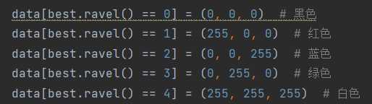

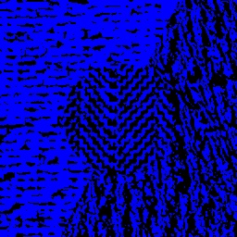 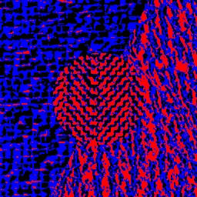

K=2 K=3

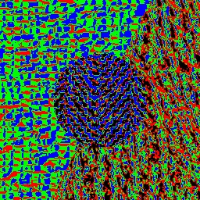 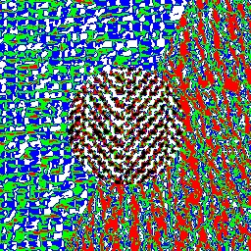

K=3 K=4

## 2.Numerical comparison

2.1 Calculate the eigenvalues of the original mapB.bmp by defining gaborcls function

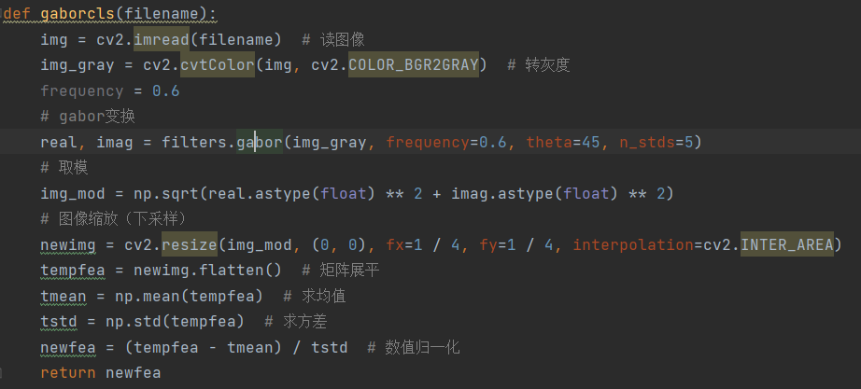

fea：[-0.17984725 -0.17984725 -0.17984725 ... -0.22221344 -0.22221344 -0.21162189]

2.2. Other vectors

And when the values of k are different, the vectors obtained through the gabor filter are different, respectively:

K=2：[ 0.73267837 0.30443477 -1.17912774 ... 1.4199589 -1.17573689 -1.18251859]

K=3：[ 0.73868207 -1.21578569 -0.21347139 ... 1.59228066 -0.87503863 -1.21447977]

K=4：[ 0.0701921 0.74032417 0.34913897 ... 0.02971572 0.9722030 -0.54724834]

K=5：[ 0.93322756 0.3121957 0.50523291 ... 0.20386518 1.56434839 -2.19622372]

2.3Take the minimum value of cosine similarity calculation：

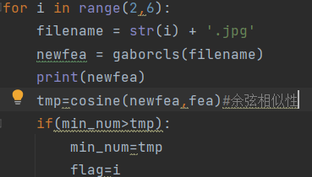

K=3：0.9119598573327653

2.4.The most similar image obtained in the end is 3.jpg：

 