jupyter notebook

import pandas as pd

**Creating data**

There are two core objects in pandas: the **DataFrame** and the **Series**.

A DataFrame is a table. It contains an array of individual *entries*, each of which has a certain *value*. Each entry corresponds to a row (or *record*) and a *column*.

pd.DataFrame({'Yes': [50, 21], 'No': [131, 2]})

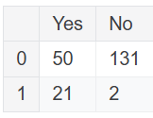

pd.DataFrame({'Bob': ['I liked it.', 'It was awful.'], 'Sue': ['Pretty good.', 'Bland.']})

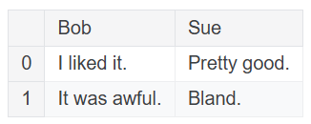

The list of row labels used in a DataFrame is known as an **Index**

pd.DataFrame({'Bob': ['I liked it.', 'It was awful.'], 'Sue': ['Pretty good.', 'Bland.']},

index=['Product A', 'Product B'])

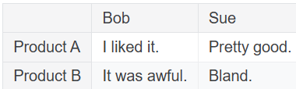

A Series, by contrast, is a sequence of data values

pd.Series([1, 2, 3, 4, 5])

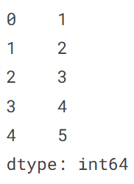

A Series is, in essence, a single column of a DataFrame

pd.Series([30, 35, 40], index=['2015 Sales', '2016 Sales', '2017 Sales'], name='Product A')

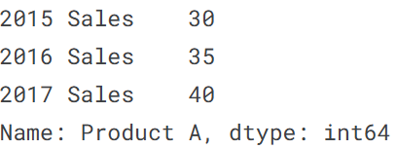

**Reading data files**

wine_reviews = pd.read_csv("../input/wine-reviews/winemag-data-130k-v2.csv")

We can use the shape attribute to check how large the resulting DataFrame is:

wine_reviews.shape

We can examine the contents of the resultant DataFrame using the head() command, which grabs the first five rows:

wine_reviews.head()

To make pandas use that column for the index (instead of creating a new one from scratch), we can specify an index_col.

wine_reviews = pd.read_csv("../input/wine-reviews/winemag-data-130k-v2.csv", index_col=0)

wine_reviews.head()

animals = pd.DataFrame({'Cows': [12, 20], 'Goats': [22, 19]}, index=['Year 1', 'Year 2'])

animals

In the cell below, write code to save this DataFrame to disk as a csv file with the name cows_and_goats.csv

animals.to_csv("cows_and_goats.csv")

import pandas as pd

1

fruits = pd.DataFrame({'apple':[30],'bananas':[21]})

2

Fruit_sales = pd.DataFrame({'apple':[35,41],'bananas':[21,34]},index = ['2017 Sales','2018 Sales'])

3

ingredients = pd.Series(['4 cups','1 cup','2 large','1 can'],index=['Flour','Milk','Eggs','Spam'],name='Dinner')

reviews = pd.read_csv('D:/Git/Kagle_File/winemag-data_first150k.csv',index_col=0)

animals = pd.DataFrame({'Cows': [12, 20], 'Goats': [22, 19]}, index=['Year 1', 'Year 2'])

animals

In the cell below, write code to save this DataFrame to disk as a csv file with the name cows_and_goats.csv

animals.to_csv("cows_and_goats.csv")

**Indexing, Selecting & Assigning**

In Python, we can access the property of an object by accessing it as an attribute. A book object, for example, might have a title property, which we can access by calling book.title. Columns in a pandas DataFrame work in much the same way.

Hence to access the country property of reviews we can use:

reviews.country

If we have a Python dictionary, we can access its values using the indexing ([]) operator. We can do the same with columns in a DataFrame:

reviews['country']

to drill down to a single specific value, we need only use the indexing operator [] once more:

reviews['country'][0]

**Indexing in pandas**

**Index-based selection**

Pandas indexing works in one of two paradigms. The first is index-based selection: selecting data based on its numerical position in the data. iloc follows this paradigm.

To select the first row of data in a DataFrame, we may use the following:

reviews.iloc[0]

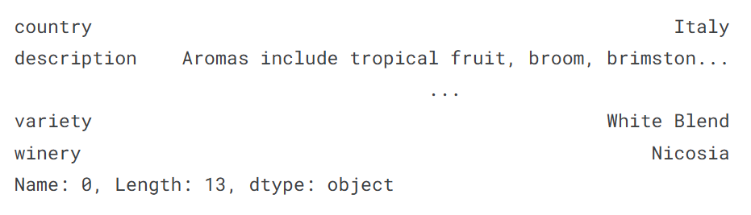

Both loc and iloc are row-first, column-second. This is the opposite of what we do in native Python, which is column-first, row-second.

This means that it's marginally easier to retrieve rows, and marginally harder to get retrieve columns. To get a column with iloc, we can do the following:

reviews.iloc[:, 0]

