Screenshots

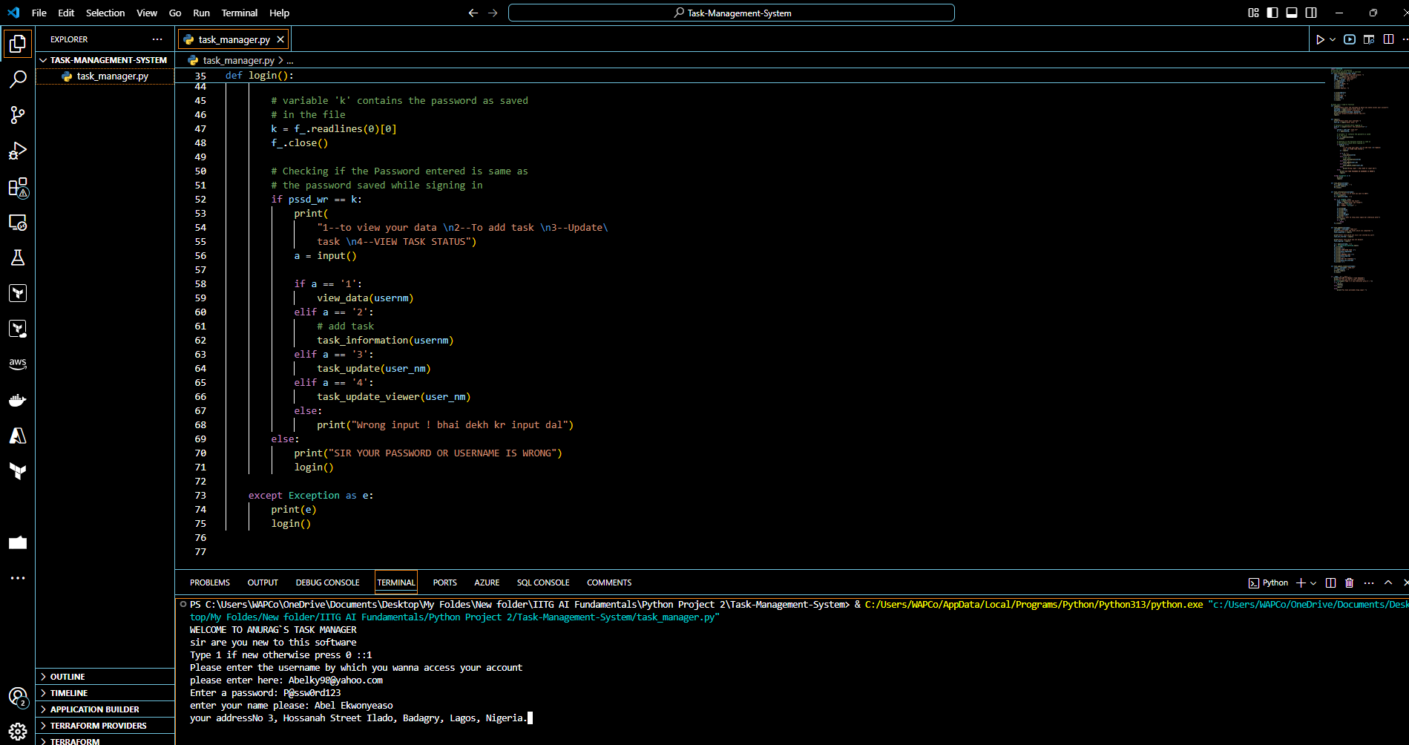

Figure 1. Signing up

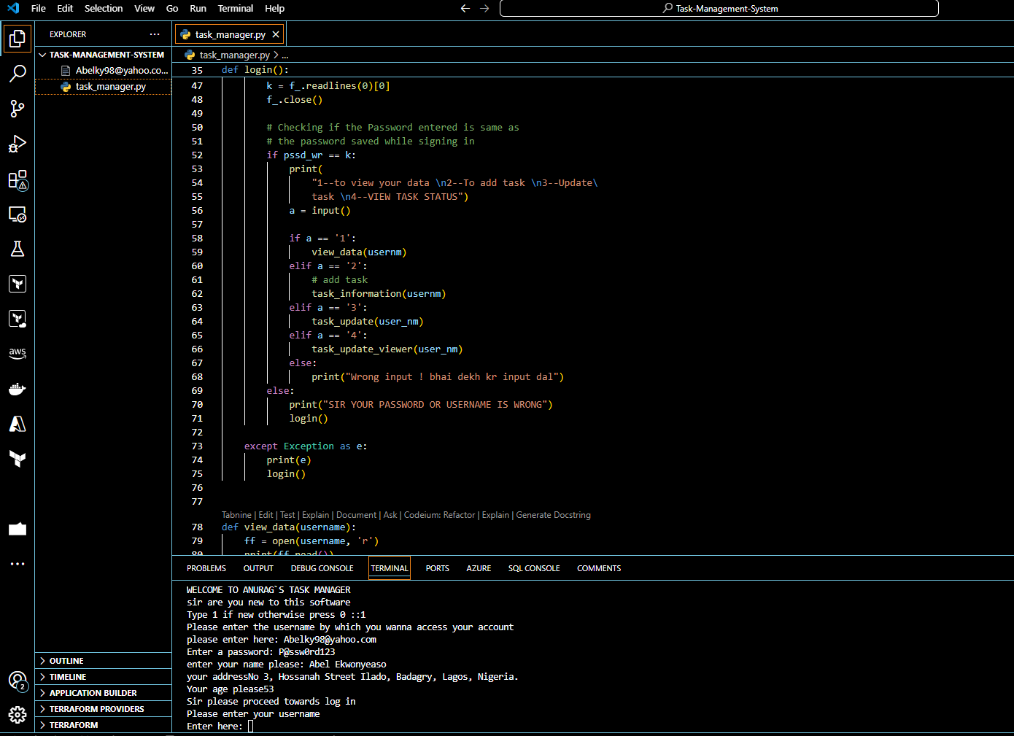

Figure 2. Creation of User’s Information.

Figure 3. Login request

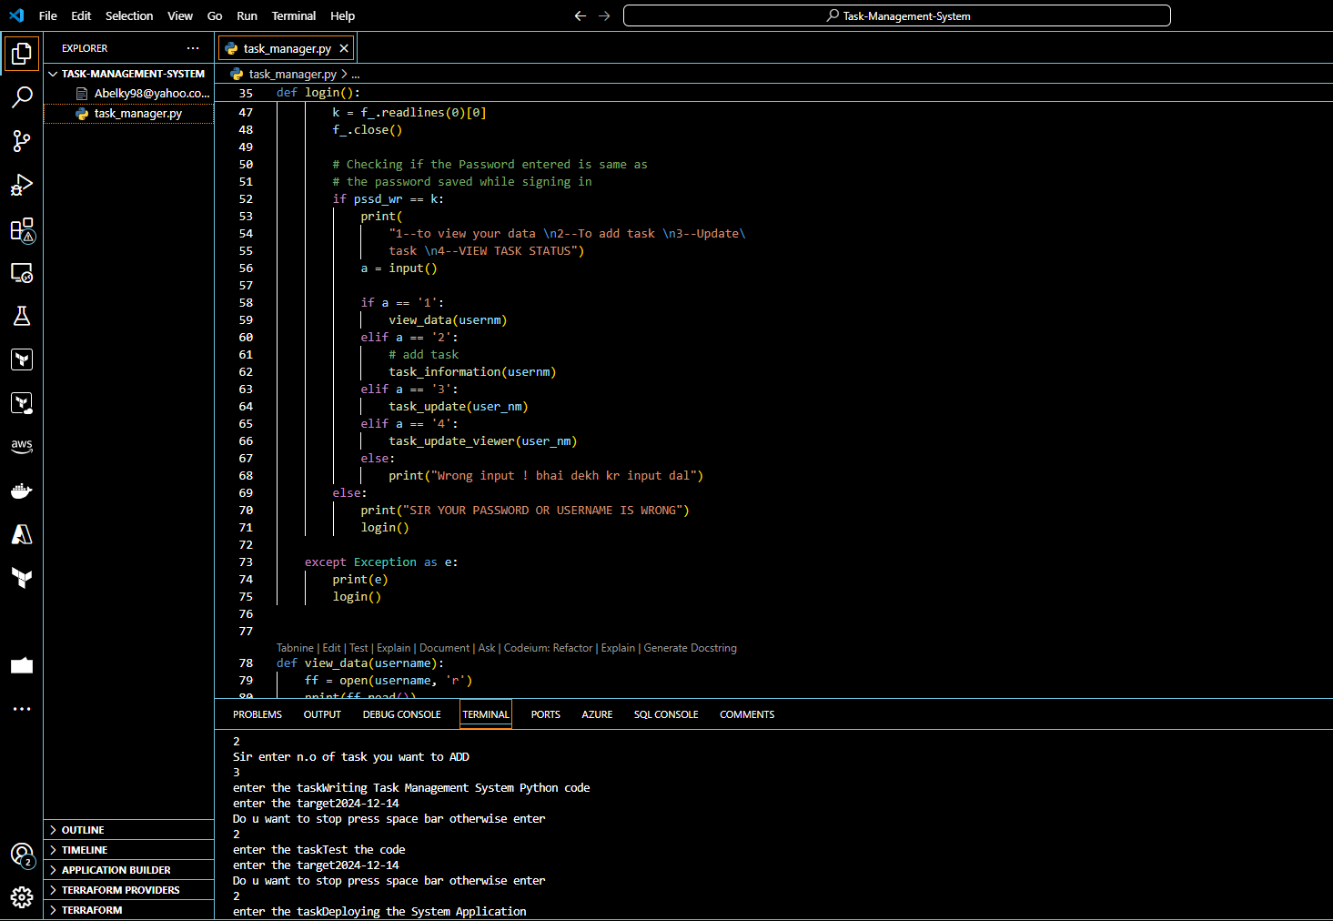

Figure 4. Inputting Tasks

