 |  |  |  |  | EQUIPEMENT DAMAGE REPORT |  |  |  |  | Vessel Name:
Equipment Type: |  |  |  |  | Equipment ID: |  |  |  |  | Date of Discharge: / /
Status: Full ☐ Empty ☐ |  |  |  |  |  |  |  |  |  | Time of Discharge: :
Equipment Damage Inspection (as Discharged):
-

Dent | ☐ | Bulged | ☐ | Crushed |  | ☐ | Cracked | ☐ | Scratched |  | ☐ | Missing Seal | ☐
Bent | ☐ | Broken | ☐ | Cut |  | ☐ | Distorted | ☐ | Leaking |  | ☐ | Electrical D. Opened | ☐
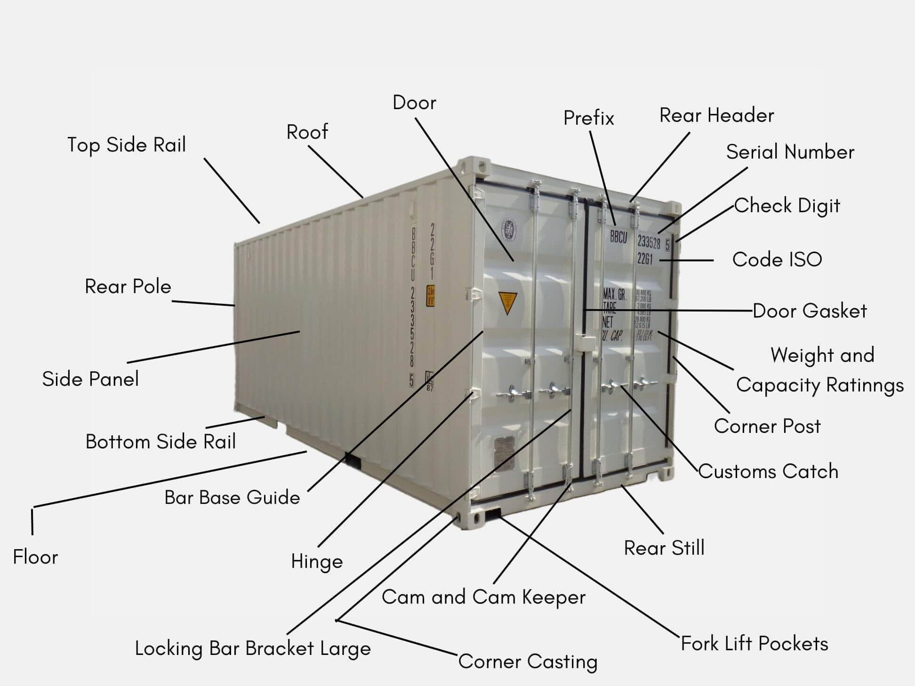
Advised loading position for the next vessel:
Above Deck Last Tier |  |  | ☐ | Above Deck First Tier |  |  |  | ☐ | Above Deck Outer Row |  |  |  | ☐
Under Deck Last Tier |  |  | ☐ | Under Deck First Tier |  |  |  | ☐ | Other Position: |  |  |  | ☐
On behalf of the Vessel’s Staff:  Name:  Position:  Stamp/ Signature: |  |  |  |  |  |  | On behalf of the Tangier Med Port staff:  Name:  Position:  Stamp/ Signature:

