**Abenezer Namaga**

**Mel Raganit**

CPE 403 – 1001

CC1350 LAB 03

Github root directory: https://github.com/Ayertena/AdvEmbededSys

Date Due: November 19th, 2018

**Task 00**: Labeled Launchpads

———————————————————————————————————

**Task 01**: SmartRF Studio ↔ SmartRF Studio

Successfully transmitted 100 packets and received packets In RF Studio.

———————————————————————————————————

**Task 02**: Importing and running the rfPacketTx

Imported build and ran the rfPacketTx example.

———————————————————————————————————

**Task 03**: Exporting and using RF configuration

Successfully changed the RF settings.

———————————————————————————————————

**Task 04**: Firmware TX → SmartRF Studio RX

Successfully received packets using CCS(Rx) and RF studio.

———————————————————————————————————

**Task 05**: Importing and Modifying rfPacketRx

Successfully imported, built and ran the rfPacketRx.

———————————————————————————————————

**Task 06**: Firmware TX → Firmware RX

Successfully reconnected the devices and transmitted and received packets.

———————————————————————————————————

**Task 07**: SmartRF Studio TX → Firmware RX

Successfully connected Tx launchpad to RF studio and transmitted and received packets.

Youtube Link: https://www.youtube.com/watch?v=iTtI7J1v1sc

Figure 1: RFStudio

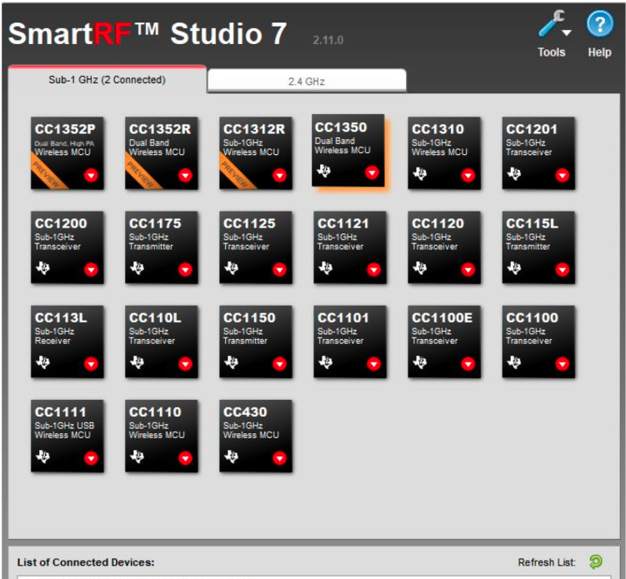

Figuer2: Rx

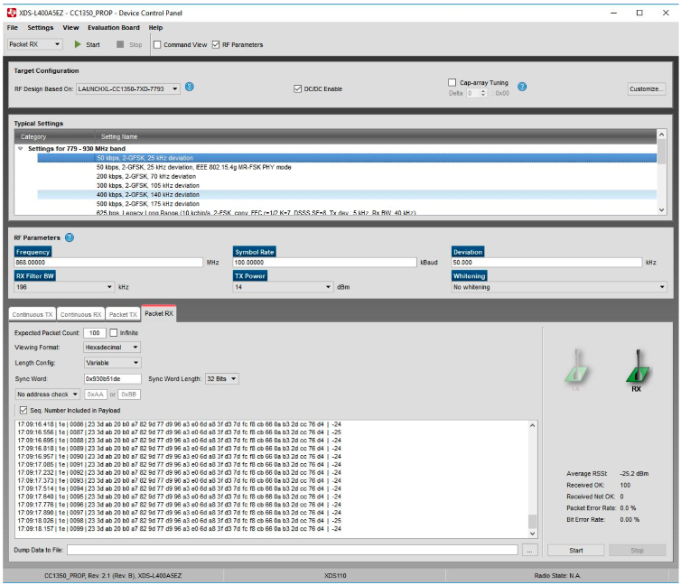

Figure3: Tx

