**Date Submitted: 11/16/2018**

**Task 01**: Replace the contents of hello.c

**#include** <xdc/std.h>

**#include** <ti/sysbios/BIOS.h>

**#include** <ti/sysbios/knl/Task.h>

**#include** <ti/drivers/GPIO.h>

/* Example/Board Header files */

**#include** "Board.h"

**void** **myDelay**(**int** count);

/* Could be anything, like computing primes */

**#define** FakeBlockingSlowWork() myDelay(12000000)

**#define** FakeBlockingFastWork() myDelay(2000000)

Task_Struct workTask;

/* Make sure we have nice 8-byte alignment on the stack to avoid wasting memory */

**#pragma** DATA_ALIGN(workTaskStack, 8)

**#define** STACKSIZE 1024

**static** uint8_t workTaskStack[STACKSIZE];

**void** **doUrgentWork**(**void**)

{

GPIO_write(Board_GPIO_LED1, Board_GPIO_LED_OFF);

FakeBlockingFastWork(); /* Pretend to do something useful but time-consuming */

GPIO_write(Board_GPIO_LED1, Board_GPIO_LED_ON);

}

**void** **doWork**(**void**)

{

GPIO_write(Board_GPIO_LED0, Board_GPIO_LED_OFF);

FakeBlockingSlowWork(); /* Pretend to do something useful but time-consuming */

GPIO_write(Board_GPIO_LED0, Board_GPIO_LED_ON);

}

**void** **workTaskFunc**(UArg arg0, UArg arg1)

{

**while** (1) {

/* Do work */

doWork();

/* Wait a while, because doWork should be a periodic thing, not continuous.*/

myDelay(24000000);

}

}

**int** **main**(**void**)

{

Board_initGeneral();

GPIO_init();

/* Set up the led task */

Task_Params workTaskParams;

Task_Params_init(&workTaskParams);

workTaskParams.stackSize = STACKSIZE;

workTaskParams.priority = 2;

workTaskParams.stack = &workTaskStack;

Task_construct(&workTask, workTaskFunc, &workTaskParams, NULL);

/* Start kernel. */

BIOS_start();

**return** (0);

}

/*

* ======== myDelay ========

* Assembly function to delay. Decrements the count until it is zero

* The exact duration depends on the processor speed.

*/

**__asm**(" .sect \".text:myDelay\"\n"

" .clink\n"

" .thumbfunc myDelay\n"

" .thumb\n"

" .global myDelay\n"

"myDelay:\n"

" subs r0, #1\n"

" bne.n myDelay\n"

" bx lr\n");

**Task 02**: Debugging Tools

a) Runtime Object View

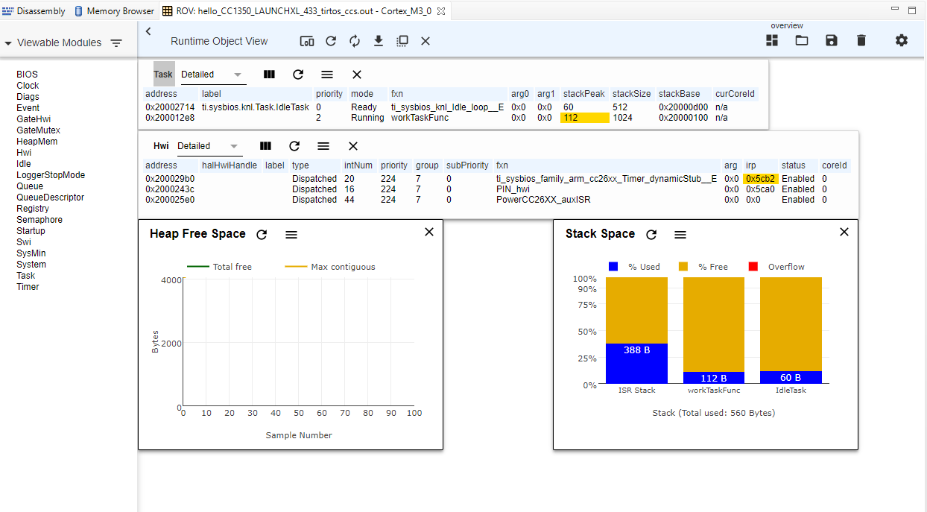

b) Execution Graph

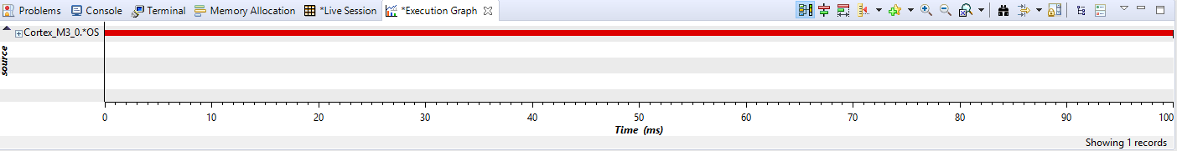

**Task 03**: Sleeping well

a) added Clock.h

**#include** <xdc/std.h>

**#include** <ti/sysbios/BIOS.h>

**#include** <ti/sysbios/knl/Task.h>

**#include** <ti/drivers/GPIO.h>

**#include** <ti/sysbios/knl/Clock.h>

/* Example/Board Header files */

**#include** "Board.h"

b) replaced myDelay with Task_sleep

**void** **workTaskFunc**(UArg arg0, UArg arg1)

{

**while** (1) {

/* Do work */

doWork();

/* Wait a while, because doWork should be a periodic thing, not continuous.*/

//myDelay(24000000);

Task_sleep(500 * (1000 / Clock_tickPeriod));

}

}

c) Execution Graph and priority list

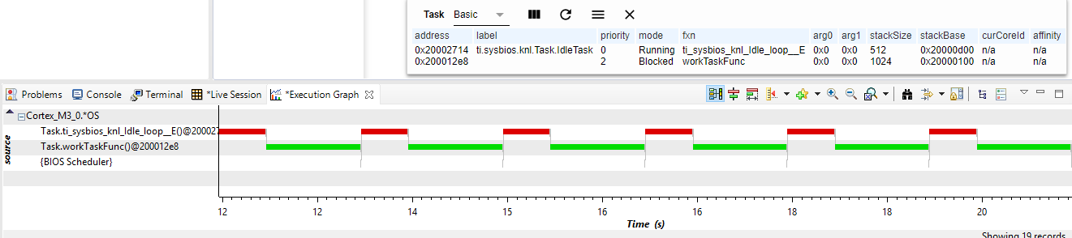

**Task 04**: Executing urgent work

a) added urgentWork parameters

Task_Struct workTask;

Task_Struct urgentWorkTask;

/* Make sure we have nice 8-byte alignment on the stack to avoid wasting memory */

**#pragma** DATA_ALIGN(workTaskStack, 8)

**#define** STACKSIZE 1024

**static** uint8_t workTaskStack[STACKSIZE];

**static** uint8_t urgentWorkTaskStack[STACKSIZE];

b) made function for urgentWork and Task_construct for urgentWork

**void** **urgentWorkTaskFunc**(UArg arg0, UArg arg1)

{

**while** (1) {

/* Do work */

doUrgentWork();

/* Wait a while, because doWork should be a periodic thing, not continuous.*/

//myDelay(24000000);

Task_sleep(50 * (1000 / Clock_tickPeriod));

}

}

**int** **main**(**void**)

{

Board_initGeneral();

GPIO_init();

/* Set up the led task */

Task_Params workTaskParams;

Task_Params_init(&workTaskParams);

workTaskParams.stackSize = STACKSIZE;

workTaskParams.priority = 2;

workTaskParams.stack = &workTaskStack;

Task_construct(&workTask, workTaskFunc, &workTaskParams, NULL);

workTaskParams.priority = 1;

workTaskParams.stack = &urgentWorkTaskStack;

Task_construct(&urgentWorkTask, urgentWorkTaskFunc, &workTaskParams, NULL);

/* Start kernel. */

BIOS_start();

**return** (0);

}

c) Execution Graph: urgentWork priority = 1

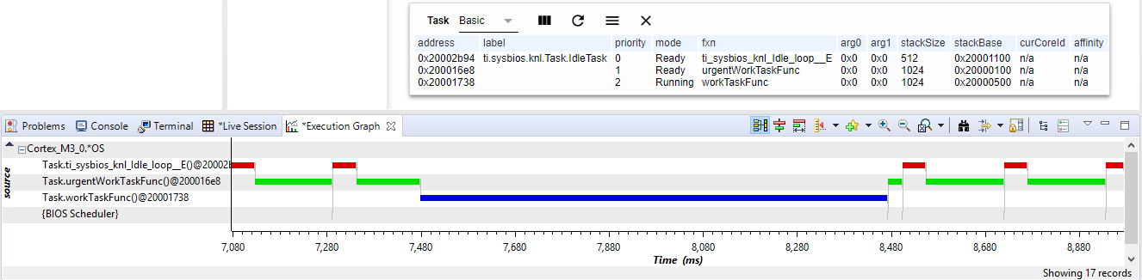

d) Execution Graph: urgentWork priority = 3

