Abenezer Namaga

CPE 403 – 1001

CC1350 LAB 04

Github root directory: https://github.com/Ayertena/CC1350-LABs

Date Due: November 21st, 2018

**Task 01**: Setup Project in SCS

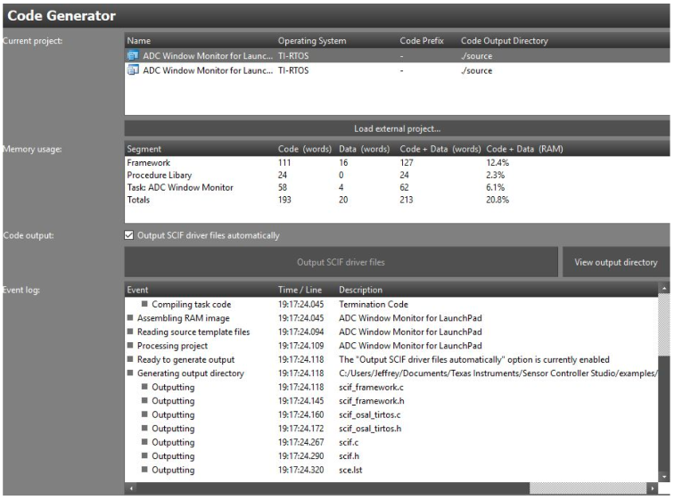

**Task 02**: Download and Debug with SCS

**Task 03**: Download and Debug with SCS

**Task 04**: Understand