10/06/25
Key concepts:
- Inference – metrics : latency – usually measured as time from image being input to model to its output. Ways of measuring .
- Methods for speeding up inference – quantization
Auxillary measurements – time it takes to move data from CPU to GPU
- Comparing different GPU models, some more optimized for batch offline
- Batching inference – can parallelize examples on different layers of the model, using specialized kernel functions to optimize calculations
- Quantization techniques – reduced precision while maintaining high accuracy. Used in post training usually, for model compresison
- Real time requirements – for real time applications
- Profilers – CUDA API's
- TensorRT - transforms model into real time engine for realtime applications

NVIDIA TensorRT is an SDK for deep learning inference.¹
Using it, you can deploy a deep learning application onto a GPU, for optimizing inference, specifically on latency and throughput metrics, doing so through powerful optimizations, use of reduced precision, and efficient memory use.
What it does, is it takes a deep learning model and, after converting it into ONNX format (format that is compatible with different deep learning frameworks), it creates a network object on the TensorRT software, that in turn generates a deep learning engine that is optimized for the target platform.
One optimization it provides is that given the optimum input, minimum and maximum tensor dimensions, it selects the kernel that results in the lowest runtime for the given profile.
It supports CUDA asynchronous inference, in which inputs are copied from CPU to GPU, and since it works asynchronously it allows for overlapping of GPU computer, which generally improves inference.
Another capability, is that when given a batch of inputs, rather than a single one, TensorRT makes use of special kernels and fully connected layers that leverage tensor cores.
The TensorRT will adapt the engine to the given batch sizes to choose the best algorithms that match the batch sizes, in terms of deploying the inputs onto the GPU.
The next step, once we have optimized the basic run, is to optimize it.
In general, quantization is a way to reduce the size of the model in memory, and speed up computations during inference.
The TensorRT framework provides ways to quantize the input, such as mixed precision (mixing together FP32 and FP16 computations), using INT8 for weights, activations, and execute layers.
The quantization to be used can be defined by the user, and the platform will decide during runtime to use lower precision kernels if they are deemed to perform better with the chosen configuration and target platform.
The framework also enables more control over the use of the GPU, such as demanding that more of it be used. The framework also knows to use the minimal memory required to perform the inference optimally. Based on the amount of memory allocated, TensorRT will choose between a set of algorithms to be used during inference.
Applications should consider giving the TensorRT ability to use as much GPU workspace as can be afforded.
Finally, the engine can be reused by serialzing the engine, which will save it with all the configurations for future use.
Bibliography:
- Speeding Up Deep Learning Inference Using NVIDIA TensorRT (Updated), Jul 20, 2021, By Josh Park, Sirisha Rella, Siddharth Sharma and Houman Abbasian

14/6
-Explaining the bottlenecks on inference.
-showing the existing research from articles
-showing the use case of inference.
-trying existing models on cpu. Feeling the bottlenecks
-preparing the schedules for todo project.

01/08/2025
Notes on Paper: A Comprehensive Study on Quantization Techniques for Large Language Models
The mathematical theory of quantization:
-goal is to quantize data
-assuming the full precision data range is [b,a]
-the equation behind the affine quantization:
- $x_{q}=\left(x*S+Z\right)$
-$x$ is the weight without quantization
-$x_{q}$ is the quantized weight
-S is the scaling factor, E.g, if converting from FP32 to FP16, would be 2.
-Z is the zero point.
-When mapping between two different data types, such as FP32 to INT8, need to determine an appropriate scaling factor for mapping the range of FP32 to INT8.
This technique is known as calibration.
$$s = \frac{2^{b}-1}{α - β}$$
Variation: quantization by scale only:
Eqn: $x_{q}=\left(x*S\right)$
Types of quantization:
- Per-Layer Quantization
All filters within the same layer share the same quantization parameters.
Simplifies quantization process but often reduces model performance
- Per-Channel quantization
Each filter is assigned customized quantization parameters
Quantization calibration
The max and min values from the full-precision data range are utilized to scale the data to a lower precision.
For ex, when scaling from Int16 to int8, the range of [-32767,32767] is evenly mapped onto the range of [-125,125] – this type of calibration is known as global calibration. This is the simplest method but can compromise accuracy, as not all values within the unquantized range are necessarily relevant or required for optimal performance.
Max calibration selects the maximum value from the unquantized data.
KL Divergence Calibration measures the difference between two probability distributions. Various scaling factors are tested to generate different distributions, and KL divergence is used to pick the scaling factor that minimizes information loss.
Percentile calibration. Rather than selecting the global maximum value, which might be on the tail end of the data, this picks a percentile that represents the important values, and determines the max from that. Optimal percentile is typically 99.99% or 99.999%.

Implementation on models
Different implementations of quantization of models.
Common one is post-training quantization. Two common approaches are static quantization (which is done before runtime), and dynamic quantization, which is done during runtime after each activation.
Another approach is Quantization-Aware training. This model accounts for quantization during training, and implements operators at each activation during the training phase. Enables to recognize and adapt to quant error throughout the backpropagation process.
Weight Quantization targets the weight matrices and leaves the activation values in their original precision.
Activation Aware Weight Quantization approach that recognizes that not all weights are equally important. It identifies critical weights based on activation magnitudes, keeping them in full precision.
Attention-Aware Weight Quantization technique that utilizes the Hessian trace to determine the importance of weight matrices. Leverages attention mechanisms. Weights are identified as more/less significant based on attention scores.
This approach adopts mixed-precision quantization.

Analyzing existing quantization techniques:
GPTQ:
-Tried on llm's
-Quantization technique utilizing PTQ (post training quantization)
-Can enable llm's to be run on single GPUs
-Speed improvements (3.25x, 4.5x)
-Specific study that implements layer-wise quantization
-objective is to find a matrix of quantized weights that minimizes the error in relation to the full-precision output of each layer
Can be formulated as a mathematical function as
$\arg{\min_{\hat{W}}{∥WX-\hat{W}X∥_{2}^{2}}}$
Specifically OBQ ("optimal brain quantization") builds upon this and quantizes each row w of W independently, and updates the rest of the unquantized weights (using the Hessian matrix).
Ie every time a weight undergoes quantization, a corresponding set of weights will be updated (not quantized).
Modification to speed up computation – instead of independently quantizing the weights of each row based on their corresponding errors, GPTQ quantizes the weights of all rows in the same order. This method reduces computation on the set of full-precision weights, since they remain the same for all rows. It can be likened to a sliding window approach (when implemented in a column-by-column way).

Analyzing GPTQ performance against existing quantization methods
- Analyzed on smaller as well as larger models
- Performance precision wise is comparable or slightly less accurate than the best quantization techniques, but time-wise it is highly competitive, as it can reduce processing times from hours to less than a minute
- Performance is evaluated across several tasks, including WikiText2, on BLOOM llm.
Accuracy is much higher compared to RTN (round to nearest) quantization technique, especially for 3 bit quantization, where RTN has notable drop in performance.
Quantization Aware Techniques
-more resource intensive, happends during training
-some methods quantizes specifically the key-value caches in the llm, rather than the weights or activations.
-needs to address challenge of limited access to training data (through synthetic data)

04.08.2025 – testing sample TensorRT code
-from TensorRT github repository.
-has a python folder, with sample modules to run.
-ran the "network api pytorch mnist" module.
-module includes a CNN (pytorch.nn) of four layers – 2 convolution layers
And 2 fully connected layers. The convolutional layers perform 2d convolution, with kernel size 5.

06.08.2025 – checking out TensorRT code repository.
-Different ways of using TensorRT
-Make some order –
Before using TensorRT, we should locate it correctly in the deep learning workflow, understand where it is, what it does and does not do, what input it expects to receive, and what it is supposed to output to us.
TensorRT builds a network of all the components that make up a model,

14.08.2025 - ways to use TensorRT
Model needs to be prepared for use with tensorRT
Models come in different formats: the weights, an exported version of the model, different architectures.
For some models there exit API's to make them work with TensorRT
For example, for the pytorch model for MNIST, there is no need to convert it to onnx format. There is a function that gets the models weights and its pytorch class, and then recreates a network that tensorRT can run on.
So even without onnx, tensorRT can be used on the model.
For Detectron model, conversion to ONNX is more complicated.
Pytorch has an onnx api that exports its models to onnx in one command.
Time it takes?
According to some sources, it is better to call the command on a model that is on the cpu/gpu. The reason for that is because the onnx command needs a simulation of the model to better export it. Therefore, the command should be placed after an eval command on the model.

-Convert model to ONNX (universal format for models) – simple option in terms of API
-Convert model into "network" yourself – requires expertise in making the conversion.

27/08/25
Task: convert a pytorch model into onnx – done
Load model onto tensorRT

Create a structured project that you can build on, with different classes built by SOLID principles. Classes for testing. Classes for setting up testing pipelines. Classes for setting up GPU testing pipelines. Classes for training and tracking in depth neural network models and neural network performance. Classes that can be easily expanded, inherited, built upon, (by solid principles), and dont need to be change completely every time we want to make a small edit.
Build good bases so you don’t have to repeat the same basic steps of training and evaluation every time. Don’t need to design the model itself at all. The testing should work on any model.
Try to gain access into every step of the learning process: dataloading from cpu to gpu, optimization techniques, quantization, create frameworks to be able to clearly see those things.

Split all the above into tasks, and make sure you can advance a little on each part of it.

TASK 1: Neural Network to be tested, Define parameters – data type
The first task is to be able to define a basic neural network to be tested. As we have read there are ways to quantize, and the different ways would require a different type of network object. We should try to implement some quantization methods ourselves, so that we better understand how the tensorRT works. Be able to graph it so that you can see it happen. Be able to measure it.
Classes to create:
- NeuralNetwork module
  - Initialize the layers of the network
  - Initialize the activation functions
- Thoroughly test the model, its speed, its classification, know it inside out.

- Hide all the ugly code that we don’t need to see
-create methods for plotting that can be reused – abstract all the inside code
-pack all necessary parts for trainings (loss fn? Optimizer?) into one high level module.

-quantify every part of the pipeline (use logging), in terms of time, resources used, accuracy
-remember to focus more on inference. – so perform logging especially for that part.

-double down on the evaluation method. Define an evaluation class maybe

-send a result to them

11.09.2025
Key things I learned today:
A guide on good usage of non_blocking and pin_memory() in PyTorch
https://docs.pytorch.org/tutorials/intermediate/pinmem_nonblock.html
Author: Vincent Moens

- Pytorch has functions to control the copying of a tensor from memory (that is in the CPU), to the Cuda device (GPU).

The default is that the data, containing the tensors, is pageable, meaning it is arranged in pages of memory, which are located both in the RAM and the disk.
Therefore, when tensors need to be sent to the GPU, all the pages will be brought to the RAM before being sent to the GPU.
This step of bringing the data to the RAM can be cut if the data is already required to be located in the main memory.

This is enabled by making the memory non pageable, or page-locked.
In that way, all data is accessed directly in the main memory.
This enables the functions that read this data to be accelerated.

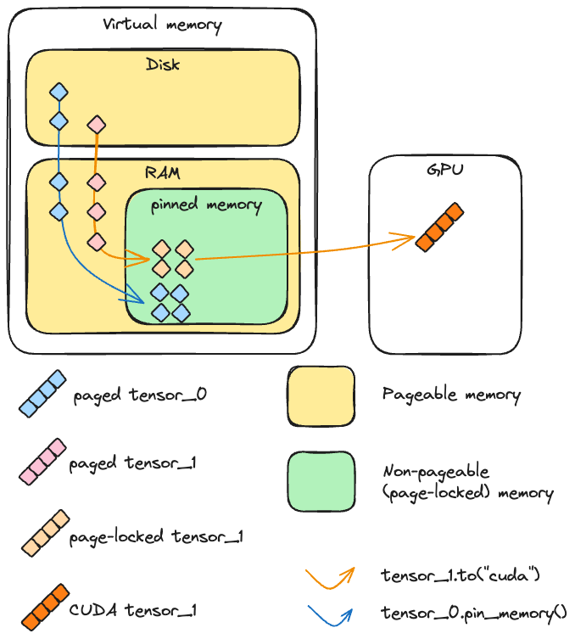

How does TensorRT work.

TensorRT builds an engine off the model.
The way it does it is by initializing a network and inputting the model's parameters into it.
If the model is already in ONNX format, then this step is more straightforward.
Otherwise, one has to populate the network manually by using the conventions of TensorRT for doing that.

Once this step is done, if the engine is to be used later, it can be serialized in the meantime, and deserialized when it will be used.

There are other steps that need to be done, such as allocating buffers, and creating an execution context.

Once done, one can call the function to do inference.

Overall, the process is clear and simple.

Since NVIDIA provides the GPU, you can imagine it will provide useful tools for analyzing its performance and for optimizing the runtime.

As an example, One optimization it provides is that given the optimum input, minimum and maximum tensor dimensions, it selects the kernel that results in the lowest runtime for the given profile.
The selection of the kernel is a command to the GPU, which is enabled through the cuda API's and tensorRT which is designed to communicate with them.

TODO tomorrow:
- Setup benchmark and profiling tools and use with tensorRT inference.
- Try quantization methods on the model and show the results
- One optimization it provides is that given the optimum input, minimum and maximum tensor dimensions, it selects the kernel that results in the lowest runtime for the given profile.
- It supports CUDA asynchronous inference, in which inputs are copied from CPU to GPU, and since it works asynchronously it allows for overlapping of GPU computer, which generally improves inference.
- Another capability, is that when given a batch of inputs, rather than a single one, TensorRT makes use of special kernels and fully connected layers that leverage tensor cores.
- The TensorRT will adapt the engine to the given batch sizes to choose the best algorithms that match the batch sizes, in terms of deploying the inputs onto the GPU.

13.09

Write few pages on deep learning:
-CNN – how tensors are organized
-loss function
-ReLU
-minimizing cost of loss function
-backpropagation
-normalizing data
-stacking examples

Write few pages on GPU:
-optimized for matrix and vector operations
-learning how to write code optimized for gpu's- less for loops more vector operations, show the speedup
-measurements for machine learning - TFLOPS

14.09
Experiment comparing speeds of GPU execution for different command of data transfer by CUDA from CPU to GPU.
Three tensors:
- One pinned (t1)
- One paged (t2)
- One on cuda
Exepriment:
-Perform a copy operation on one tensor, and a cuda operation (multiplication), and see if they happen at the same time or not.
Note: the command here used for copying is "to()"
Some terminology:
H2D – host to device
D2H – device to host
In the context of gpu's, we call the gpu the device, while the host is the cpu.
Both terms refer to the flow of data between the two points.

In the first run, we are copying the paged tensor and running the cuda operation.
The result: while the copy operation is taking place, the cuda operation waits.
Same for pinned memory if we do not start an additional cuda stream.
Only if we pin memory AND start an additional cuda stream (for copying) do we get overlap with another cuda kernel executed on the main stream.

A Pytorch perspective:
Pin_memory() – pytorch command that enables to cast cpu tensors to pinned memory.
This command is blocking on the host's main thread.
Result: sending a pinned memory tensor to gpu (aka casting), is much faster than a pageable tensor, as expected and explained in the introduction.
If we only have a single stream (the main one), then pin_memory() will cause a blocking operation of copying the information to memory.
Therefore, he advantage of using pin_memory is when we can start multiple threads and start the operation in parallel.
For that we have to make use of an argument, called non_blocking.
This argument, as its name implies, designates the operation it is called with to be executed asynchronously.
Note, that in terms of data integrity, when performing asynchronous operations we are more susceptible to operations on the same piece of data happening out of order. Therefore when making asynchronous calls, we need to call the synchronize() command in the end to ensure full and correct completion of the asynchronous operations, before proceeding.
For example, if we are performing a computation on data, asynchronously, we call synchronize to ensure the computation is fully finished before the function that wraps it returns.
This is also important for accurate profiling timing measurements.

When we set non_blocking = true. – ie transferring tensors from cpu to gpu asynchronously.

" Remember that profiling your code and keeping an eye on the memory consumption are essential to optimize resource usage and achieve the best possible performance."'

15.09.2025
Goal: optimize the program for the GPU.
Model: lightweight MLP
Dataset: MNIST digits
Functions:
In mnist_main:
train_epoch(dataloader, model, loss_fn, optimizer, device)
evaluate(dataloader, model, loss_fn, device)
In mnist_inference:
Non-recurrent commands:
    - NeuralNetwork().to(device)
    - Model.eval()
Recurrent commands:
    - Tensor.to(device)
    - Output=model(X)
    - Torch.softmax(output,dim=1)
    - Torch.argmax(probabilities,dim=1).item()

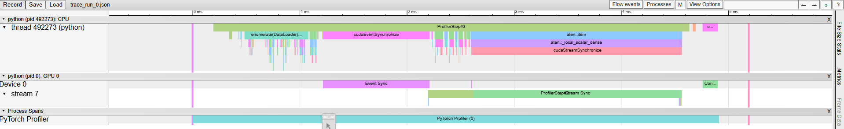
Profiling inference:
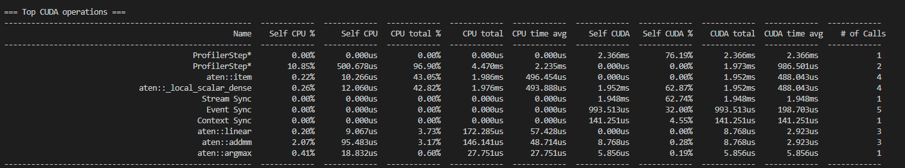

16.09.2025
First profiler run:
Code structure:
- Calling DataLoader on dataset, with pin_memory arg set to True.
- For-loop on examples in dataloader
- Sending example to cuda device (with arg non_blocking=True)
- Calling model(X) – expected to be run on Cuda
- Calling probabilities
- Calling predicted_class

Results:
- Order of operations in practice:
- CPU
- Cycle length (approx): 910 $μs$
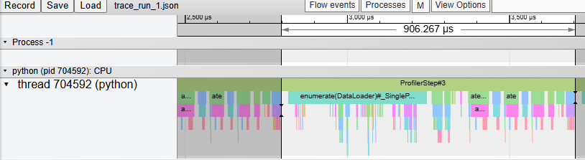

- High level breakup of the cycle:
  - First half: enumerate
    - Subprocesses: copy
    - No GPU activity
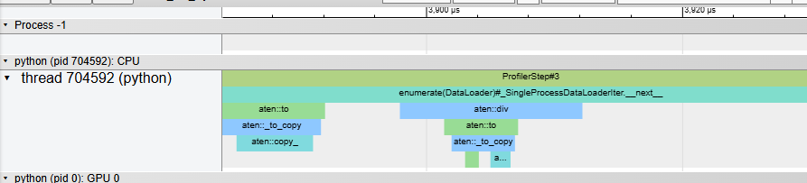
  - Second half: computations
    - Linear, relu, softmax, argmax
    - Calls to GPU – sparse and short, none parallelized.
      - Average exec time for GPU instr < 5 $μs$ , <10 calls per cycle

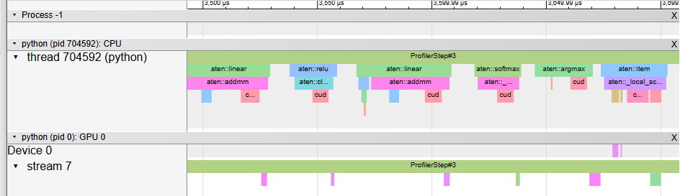
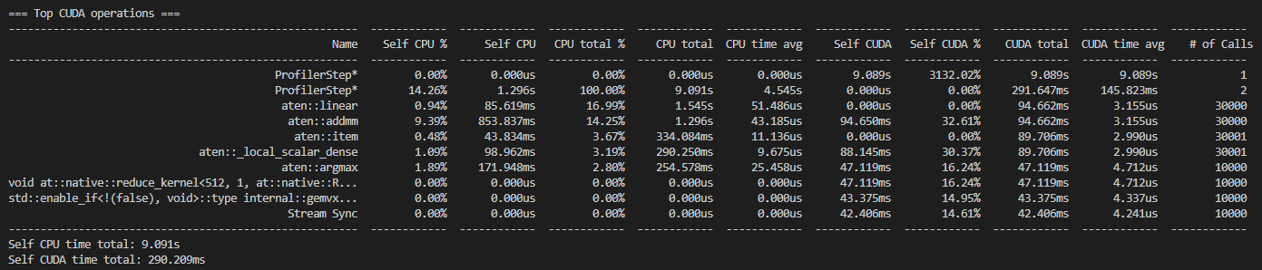
Inefficiencies:

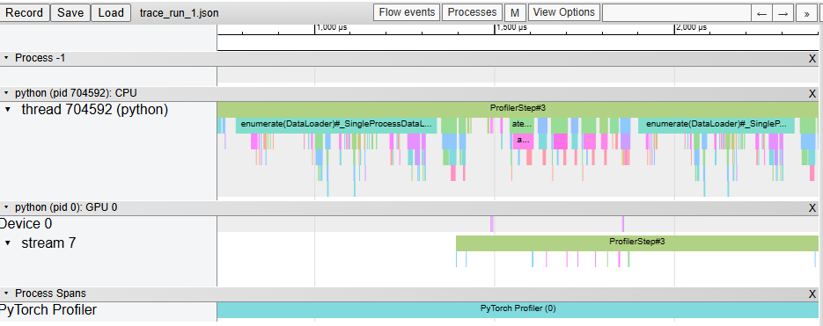

=== Top CUDA operations ===
------------------------------------------------------- ------------ ------------ ------------ ------------ ------------ ------------ ------------ ------------ ------------ ------------
Name Self CPU % Self CPU CPU total % CPU total CPU time avg Self CUDA Self CUDA % CUDA total CUDA time avg # of Calls
------------------------------------------------------- ------------ ------------ ------------ ------------ ------------ ------------ ------------ ------------ ------------ ------------
ProfilerStep* 0.00% 0.000us 0.00% 0.000us 0.000us 15.368s 211.59% 15.368s 15.368s 1
ProfilerStep* 7.91% 1.216s 100.00% 15.369s 7.685s 0.000us 0.00% 7.264s 3.632s 2
aten::item 0.28% 43.034ms 47.54% 7.307s 243.561us 0.000us 0.00% 7.083s 236.085us 30001
aten::_local_scalar_dense 0.55% 84.338ms 47.26% 7.264s 242.127us 7.082s 97.51% 7.083s 236.085us 30001
Stream Sync 0.00% 0.000us 0.00% 0.000us 0.000us 7.070s 97.34% 7.070s 707.016us 10000
aten::linear 0.57% 87.746ms 10.03% 1.541s 51.366us 0.000us 0.00% 83.066ms 2.769us 30000
aten::addmm 5.54% 850.810ms 8.37% 1.287s 42.896us 83.060ms 1.14% 83.066ms 2.769us 30000
aten::argmax 1.11% 170.915ms 1.63% 250.457ms 25.046us 48.474ms 0.67% 48.485ms 4.848us 10000
void at::native::reduce_kernel<512, 1, at::native::R... 0.00% 0.000us 0.00% 0.000us 0.000us 48.474ms 0.67% 48.474ms 4.847us 10000
std::enable_if<!(false), void>::type internal::gemvx... 0.00% 0.000us 0.00% 0.000us 0.000us 39.701ms 0.55% 39.701ms 3.970us 10000
------------------------------------------------------- ------------ ------------ ------------ ------------ ------------ ------------ ------------ ------------ ------------ ------------
Self CPU time total: 15.370s
Self CUDA time total: 7.263s

