Final notes:
Start from the basics of what you started doing in your part (going chronological):
Started by trying to execute code samples from tensor rt repository.
04.08.2025 – testing sample TensorRT code
-from TensorRT github repository.
-has a python folder, with sample modules to run.
-ran the "network api pytorch mnist" module.
-module includes a CNN (pytorch.nn) of four layers – 2 convolution layers
And 2 fully connected layers. The convolutional layers perform 2d convolution, with kernel size 5.
Ran simple modules. Tried to understand the other modules. To give some names:
Module about populating the network (very long):

Next task: convert a pytorch model into onnx and load it into tensor rt
Once we have a model converted into onnx, we can send it to neutron to have a schematic of it

Defined the first task:
TASK 1: Neural Network to be tested, Define parameters – data type
The first task is to be able to define a basic neural network to be tested. As we have read there are ways to quantize, and the different ways would require a different type of network object. We should try to implement some quantization methods ourselves, so that we better understand how the tensorRT works. Be able to graph it so that you can see it happen. Be able to measure it.
Classes to create:
- NeuralNetwork module
  - Initialize the layers of the network
  - Initialize the activation functions
- Thoroughly test the model, its speed, its classification, know it inside out.

- Hide all the ugly code that we don’t need to see
-create methods for plotting that can be reused – abstract all the inside code
-pack all necessary parts for trainings (loss fn? Optimizer?) into one high level module.

-quantify every part of the pipeline (use logging), in terms of time, resources used, accuracy
-remember to focus more on inference. – so perform logging especially for that part.

-double down on the evaluation method. Define an evaluation class maybe

- Setup benchmark and profiling tools and use with tensorRT inference.
- Try quantization methods on the model and show the results
- One optimization it provides is that given the optimum input, minimum and maximum tensor dimensions, it selects the kernel that results in the lowest runtime for the given profile.
- It supports CUDA asynchronous inference, in which inputs are copied from CPU to GPU, and since it works asynchronously it allows for overlapping of GPU computer, which generally improves inference.
- Another capability, is that when given a batch of inputs, rather than a single one, TensorRT makes use of special kernels and fully connected layers that leverage tensor cores.
- The TensorRT will adapt the engine to the given batch sizes to choose the best algorithms that match the batch sizes, in terms of deploying the inputs onto the GPU.

Running profiler on MNIST digit recognition:
Goal: optimize the program for the GPU.
Model: lightweight MLP (multi layer perceptron)
Dataset: MNIST digits
Functions:
In mnist_main:
train_epoch(dataloader, model, loss_fn, optimizer, device)
evaluate(dataloader, model, loss_fn, device)
In mnist_inference:
Non-recurrent commands:
    - NeuralNetwork().to(device)
    - Model.eval()
Recurrent commands:
    - Tensor.to(device)
    - Output=model(X)
    - Torch.softmax(output,dim=1)
    - Torch.argmax(probabilities,dim=1).item()

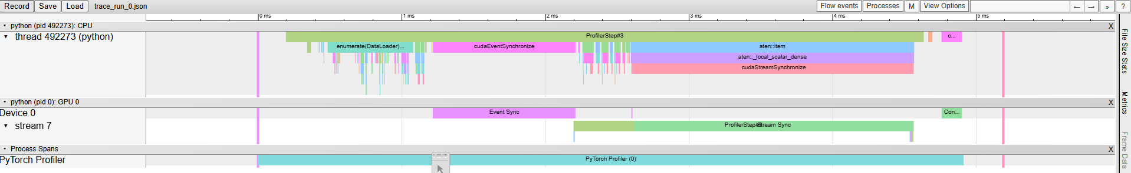
Profiling inference (single cycle):
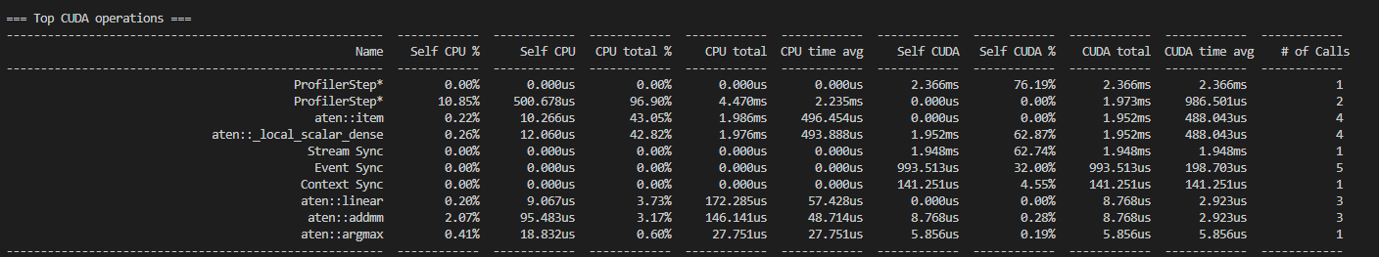
Conclusions:
In gpu only see a ProfilerStepStream Sync and Event sync.
Expected to see computations. In cpu stream also see that largest processes in terms of time are the sync processes.

16.09.2025
First profiler run:
Code structure:
- Initialize dataset into dataloader, with pin_memory arg set to True.
- Loop through examples in dataloader
- Sending example to cuda device (with arg non_blocking set to True)
- Calling model(X)
- Calling probabilities (softmax)
- Calling predicted_class (argmax)

Results:
- Order of operations in practice:
- CPU
- Commands repeat in a cycle
- Cycle length (approx): 910 $μs$
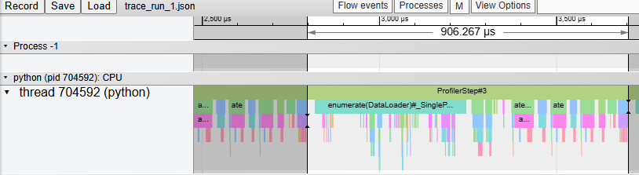
- Breakdown of the cycle:
  - First half: enumerate
    - Command type: copy
    - No GPU activity
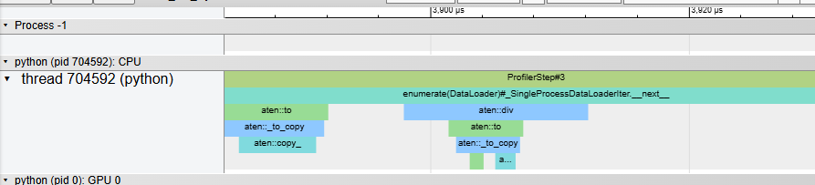
  - Second half: computations
    - Linear, relu, softmax, argmax
    - Calls to GPU – sparse and short, none parallelized.
      - Average exec time for GPU instr < 5 $μs$ , <10 calls per cycle
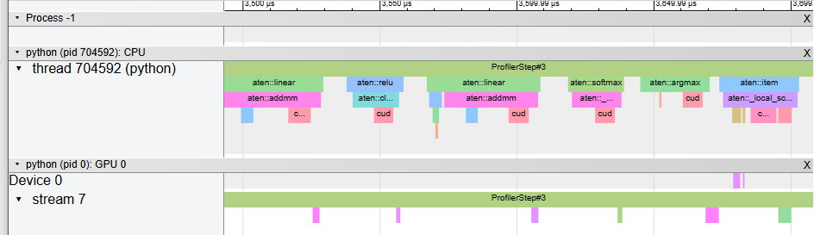

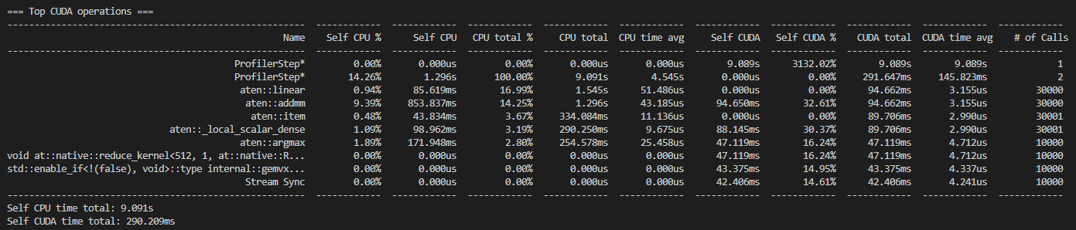
Results summary:

Longest overall CUDA operations (by time and percentage):
ProfilerStep is the reference length (runs 100% of time)
Linear (17% of cpu time)
Addm (14% of cpu time, cuda time says 32% but seems off because it runs much less time – says profiler step for cuda is 3000% which is wrong)
Local_scalar_dense (3% of cpu time)
Argmax (2.8% of cpu time, 16% of gpu time)
Note: Enumerate command (which is high percentage but parallelized does not appear in table)

Inefficiencies:
Most of the load is on the cpu.

Profiler run #2:
Settings:
Pin_memory set to true

Upon seeing with the profiler that most of the load was on the cpu, I suspected that there is a memory transfer bottleneck and that the data does not arrive fast enough to the gpu.
So I set up an experiment on jupyter notebook where I tested the memory transfer with different argument parameters (pinned memory, blocking/non blocking), and compared the runtimes of the functions.
For this I used a pytorch profiler timer that gets argument such as a command ("stmt"), and you can define for it how many times to run and it runs automatically and tests the runtime of the function. (see functions in appendix)
Note: the command here used for copying is "to()"
Some terminology:
H2D – host to device
D2H – device to host
In the context of gpu's, we call the gpu the device, while the host is the cpu.
Both terms refer to the flow of data between the two points.

In the first run, we are copying the paged tensor and running the cuda operation.
The result: while the copy operation is taking place, the cuda operation waits.
Same for pinned memory if we do not start an additional cuda stream.
Only if we pin memory AND start an additional cuda stream (for copying) do we get overlap with another cuda kernel executed on the main stream.

A Pytorch perspective:
Pin_memory() – pytorch command that enables to cast cpu tensors to pinned memory.
This command is blocking on the host's main thread.
Result: sending a pinned memory tensor to gpu (aka casting), is much faster than a pageable tensor, as expected and explained in the introduction.
If we only have a single stream (the main one), then pin_memory() will cause a blocking operation of copying the information to memory.
Therefore, he advantage of using pin_memory is when we can start multiple threads and start the operation in parallel.
For that we have to make use of an argument, called non_blocking.
This argument, as its name implies, designates the operation it is called with to be executed asynchronously.
Note, that in terms of data integrity, when performing asynchronous operations we are more susceptible to operations on the same piece of data happening out of order. Therefore when making asynchronous calls, we need to call the synchronize() command in the end to ensure full and correct completion of the asynchronous operations, before proceeding.
For example, if we are performing a computation on data, asynchronously, we call synchronize to ensure the computation is fully finished before the function that wraps it returns.
This is also important for accurate profiling timing measurements.

When we set non_blocking = true. – ie transferring tensors from cpu to gpu asynchronously.

" Remember that profiling your code and keeping an eye on the memory consumption are essential to optimize resource usage and achieve the best possible performance."'

Results:
Outline: comparing inference with asynchronous tensor to gpu vs synchronous tensor to gpu
Preparation:
Code:
-attach jupyter code: file name: inference_profiling.ipynb
File location: mnist_model
Results :
Asynchronous copy and inference time: 1.575929 seconds
Asynchronous copy and inference time: 1.468861 seconds
Asynchronous copy and inference time: 1.455780 seconds
Asynchronous copy and inference time: 1.457217 seconds
Asynchronous copy and inference time: 1.455045 seconds
Asynchronous copy and inference time: 1.455118 seconds
Asynchronous copy and inference time: 1.454524 seconds
Asynchronous copy and inference time: 1.456453 seconds
Asynchronous copy and inference time: 1.457391 seconds
Asynchronous copy and inference time: 1.457894 seconds
Asynchronous copy and inference time: 1.453143 seconds
Asynchronous copy and inference time: 1.452112 seconds
Synchronous copy and inference time: 1.483008 seconds
Synchronous copy and inference time: 1.477060 seconds
Synchronous copy and inference time: 1.485503 seconds
Synchronous copy and inference time: 1.485182 seconds
Synchronous copy and inference time: 1.482512 seconds
Synchronous copy and inference time: 1.485441 seconds
Synchronous copy and inference time: 1.485229 seconds
Synchronous copy and inference time: 1.484079 seconds
Add summary results from the jupyter notebook
No Noticeable improvement. – led me to question whether the problem has to do with meory transfer as I had thought.

Decided to run on a larger model. Found the resnet 18 model (add a neutron model picture and show its parameters)
- Test inference without TensorRT – see if you don’t already have some results
- Show the bottlenecks on inference with the profilers
- Use timers on operations that require computation on the data
Running Resnet 18 inference
=== Top CUDA operations ===
------------------------------------------------------- ------------ ------------ ------------ ------------ ------------ ------------ ------------ ------------ ------------ ------------
Name Self CPU % Self CPU CPU total % CPU total CPU time avg Self CUDA Self CUDA % CUDA total CUDA time avg # of Calls
------------------------------------------------------- ------------ ------------ ------------ ------------ ------------ ------------ ------------ ------------ ------------ ------------
ProfilerStep* 0.00% 0.000us 0.00% 0.000us 0.000us 3.554ms 228.35% 3.554ms 3.554ms 1
ProfilerStep* 30.38% 1.156ms 99.72% 3.796ms 1.898ms 0.000us 0.00% 1.548ms 773.823us 2
aten::conv2d 0.96% 36.430us 25.38% 966.036us 48.302us 0.000us 0.00% 1.391ms 69.555us 20
aten::convolution 1.74% 66.237us 24.42% 929.606us 46.480us 0.000us 0.00% 1.391ms 69.555us 20
aten::_convolution 2.53% 96.158us 22.68% 863.369us 43.168us 0.000us 0.00% 1.391ms 69.555us 20
aten::cudnn_convolution 13.45% 511.893us 20.15% 767.211us 38.361us 1.391ms 89.38% 1.391ms 69.555us 20
_5x_cudnn_volta_scudnn_winograd_128x128_ldg1_ldg4_re... 0.00% 0.000us 0.00% 0.000us 0.000us 795.806us 51.13% 795.806us 61.216us 13
void implicit_convolve_sgemm<float, float, 128, 5, 5... 0.00% 0.000us 0.00% 0.000us 0.000us 285.247us 18.33% 285.247us 95.082us 3
void cudnn::winograd::generateWinogradTilesKernel<0,... 0.00% 0.000us 0.00% 0.000us 0.000us 219.359us 14.09% 219.359us 16.874us 13
aten::batch_norm 0.99% 37.571us 27.27% 1.038ms 51.902us 0.000us 0.00% 75.201us 3.760us 20
------------------------------------------------------- ------------ ------------ ------------ ------------ ------------ ------------ ------------ ------------ ------------ ------------
Self CPU time total: 3.807ms
Self CUDA time total: 1.556ms

Input size: DOG – 297KB

Extrapolations for more data (where do we reach a limit):
Calculation:
Model size: $\sim 11 million parameters$
Input size: $\sim 300 KB$
Latency: CPU: $3.8 ms$, GPU: $1.5 ms$
Throughput: $\frac{1}{3.8×{10}^{-3}+1.5×{10}^{-3}}=188 units/sec$
Test for larger inputs:
Using cache found in /home/benilla/.cache/torch/hub/pytorch_vision_v0.10.0
Measuring inference latency...
Average inference latency: <torch.utils.benchmark.utils.common.Measurement object at 0x7fda0f6f8650>
ResNet18 Inference: Single Image
Using CUDA Stream
2.02 ms
1 measurement, 100 runs , 1 thread ms
Quantize model using TensorRT:

Now that we got proof of gpu perfroamcne we could consider the tensor rt as a tool to improve it
TensorRT can be used in several ways.
- Following the TensorRT exec command to analyze quickly

Trtexec is a keyword command that runs in the terminal.
It expects a model in onnx format.
Onnx is a universal format for model description which tensor rt uses.
It also expects the input dimensions (it feeds generated inputs based on those dimensions).
The command runs the model on thousands of different generated inputs, for a set number of runs, and prints the run time of the device on that input.
In our test, we ran the command on a resnet-18 model (add earlier info about the resnet 18 finetuning which we did, and why did we choose to use that model and not the smaller network which we used for mnist digit recognition)
Why we decided to use a larger model (and not the 3 layer model which was used for mnist digit recognition):
When we tried to test performance on the mnist digit recognition model, we saw using the profiler that most of the work was done on the cpu, and very little on the gpu. That got us scratching our heads.
This is what led us to profiling the data transfer, to see whether the bottleneck was caused by the cpu.
(fill in theory about memory transfer and pinning – from introduction)
So we ran functions comparing different data transfers on large quantities of data, and we did not experience the bottleneck that we expected to see.
So we realized that maybe the model isn't big enough. And actually sources say that if the gpu is not working enough it will delegate to the cpu (try to find that torch thread that says that)
So we went on a search for a big enough vision model, and fell on the resnet models.

Example output we got from trtexec running on resnet-18:

[I] Average on 10 runs - GPU latency: 0.344336 ms - Host latency: 0.344336 ms (enqueue 0.00661621 ms)

The information given is: the time it takes for the host and the gpu to process.
Note: the enqueue is the delay the gpu had to wait to process. (check later what the enqueue operation actually does)

If that delay is in the order of the time it takes for the gpu to run, then there is potentially a problem. Here we see that is is very low.

Then we get latency and throughput measures.

What we are doing now?

The trtexec command runs on a random input so it does not measure the accuracy of the model after quantization.
Since we need to know the accuracy of the model, we need to train a model and run accuracy test on it, and then run accuracy tests on the quantized version (don't need tensor rt for that).
Specify exactly which quantization was used
Note the strong points of tensor rt:
The tensor rt exec command runs thorough benchmarking
What if I want to use layer fusion?
You can see if layer fusion happened in the trtexec log?
"To investigate which fusions have occurred, the builder logs its operations to the logger object provided during construction. Optimization steps are at the kINFO log level. To see these messages, ensure you log them in the ILogger callback".
Using tensor rt with an existing model:
Tensor rt will have to create an engine based on the model.
The engine differs from the model in that it was optimized on several fronts for performance.
For example, layer fusion will fuse two layers so that they will be performed in a single kernel operation, when possible without altering the computations.
The engine is built by a TensorRT BUILDER object. The LOGGER object gives us information on which optimizations the builder did on the model, so that we actually know what was done to the model to optimize it.
In our case, we ran the TensorRT builder on the resnet_18 finetuned model which we trained, and got the following results:

For the tensorrt dataset, we wanted to test it on a large enough model.
One of the problems was finding a good dataset, that was large enough to actually put the gpu to the test.
We thought that using the imagenet dataset would be too large.
So we found a dataset in kagglehub of 120 classes and 20k examples of dogs.
That seemed to fit the requirements. However, that required finetuning the resnet 18 models imagenet weights.
We initially did try to use the Imagenet.
Lesson learned, know what you are trying to do.
Initially we tried to learn the dogs dataset with
We did not know that we were using mismatched images and labels, and therefore getting very low performance.
After finetuning the model, we started getting reasonable performance.
So since we needed to create a performance baseline for the model, we wanted to train it to a high enough accuracy.
Later we will want to quantize the model and test it against out baseline.
There are several tools.
The tensorrt has an exec tool, that can perform quantization on an onnx file.
But, it doesn't create the tensorrt engine, which comes with a whole set of advantages.
Think of it as follows, the tensorrt engine is for production, while the trtexec allows testing different configurations on the onnx file.
So that can include batching, quantization,
But once an engine is built, it is very specifically built to accept.
Which is why it is very specific on the input layers, even batches cannot be defined dynamically. Basically, the engine is more or less statically defined.
That means, if the TensorRT engine was built with a fixed batch size of 32, it always expects to process 32 images. If you provide fewer (like 16), it may still return a buffer sized for 32, or it may fail.
it uses Static Shapes to calculate memory. If your engine was built with a dynamic batch size (a -1 or None in the first dimension), your size calculation will fail or become negative.
The reason for that is because tensorrt allocates memory to the engine according to those parameters.
All these create conversions that are necessary for them to run properly. Note, this is how we did it, there may be some redundant conversions although we worked the default way for most of the way so take note that you may also encounter those discrepancies

This may also mean that the datasets and labels for measuring accuracy may be different.
Note that tensorrt outputs indexes of the correct class, and that may be different from what pytorch outputs, and that is important to note when running accuracy calculations, or else you may get 0% accuracy due to those mismatches.

Trt runtime:~130 it/s
Model runtime:~180 items/sec

Ran and got a 81% accuracy, which was higher than the 50% accuracy measured on the "normal" model.
So thought its maybe because its overfitting on the training data.
So made sure to give it the same test data.
Then moved the dataset preparation outside of the run_inference_trt function as a global variable.
Then since I am using the dataset's loader, didn't need to load files manually so took that out too.
Then ran again and got 0.5% accuracy.

Realized the problem was that I was using old labels (of the entire dataset), you can call them global labels, rather than the local labels, and this is what made this 0% accuracy.
Finally got the same accuracy across the tools.
Note that all this was done using the tensor rt engine. (ie not just on the onnx file, this can be used as a file to run things)

Explain what you just did now:
Trained a resnet 18 model and finetuned it and got it to a top 1 accuracy of 50% (for heavily augmented data), because earlier we were encountering overfitting – so the results were not reflective of good performance.
So we went on heavier transformations to take that into account , ran them for 60 epochs on the training data, and reached a plateau of 50%.
We saw that right from the outset we were getting very low accuracy and had to train it a while to improve the accuracy from 3% to 50%.
The reason we had such high accuracy before was probably because the data underwent less if any transformations.
However, we probably realized that for a class that only compares dogs, we needed to take into account more feature preservation, which was probably lost due to transformation, so that is something we will take into account in the future, although as a baseline it is good enough in order to compare performance with the tensor rt engine.

Once we had our finetuned model, we needed to properly compare it to tensor rt.
Since we also wanted to compare accuracy, we could not just run the trt exec function as we did before, which runs on a randomly generated input on an onnx file, and only gives performance indicators (good for high level, testing configuraitons on the go).
So our task was to compare inference on the tensor rt engine.
So we had to build the engine, which has some framework differences from simply loading a pytorch model and its weights.
The inference engine expects input and output buffers to allocate memories, and it runs asynchronously on the data.
Some important things to consider:
Important differences to consider when measuring on actual data:
-Make sure the transformation pipeline is the same as the transformation pipeline you used for training the model
-note the datatype differences (tensor rt uses np datatypes rather than torch tensors by default)
-install the required dependencies (such as cudart for memory allocation)
-you have to define the folder structure yourself to make sure it will work – it is not set up for you as in the torch hub environment
- when you load the dataset, you may have to load it differently than in pytorch (ie not using the torch.datasets loader

So we first set out to build the engine.
There are some things to take into consideration at this stage:
-there are some different ways of building the engine. In the tensor rt repository, some files which are called build_engine function create some problems.
Some also have an additional function dedicated to building the network, which is essentially the onnx file.
But we encountered some problems with some files that were buggy for us.
So finally we found a file that worked for us and built the engine.
Then we set up the inference function.
As noted earlier, there are some framework differences to take into account.
Finally, the inference function ran and gave identical accuracy results on the same dataset compared to the pytorch model.
It is important to keep the data almost the same, and the same dataset function for both the model and engine, because if not we might encounter a label mismatch.
A good rule of thumb is to get the data's true labels from the function itself as an object returned by the run inference function, so that we know we are getting both the engine's outputs and the labels of the data from the same source, and that way we avoid mismatch.
Then, the accuracy function can be the same for both models.
Results we got:
MODEL
Testing: 129/129 [00:14<00:00, 8.91it/s]
🧪 Test Loss: 1.9988 | Acc: 0.5158 | Precision: 0.5505 | Recall: 0.5158 | F1: 0.5135
ENGINE
[01/12/2026-18:21:50] [TRT] [I] Loaded engine size: 53 MiB
[01/12/2026-18:21:50] [TRT] [I] [MemUsageChange] TensorRT-managed allocation in IExecutionContext creation: CPU +0, GPU +5, now: CPU 0, GPU 58 (MiB)
TensorRT Inference: 4116it [00:31, 128.97it/s]
Overall Accuracy from TensorRT engine: 51.58%

