Assigment 1
Name: Yerkebulan Abenov
Discipline: Web technologies 1
Date: 20.09.2026
1 Task: 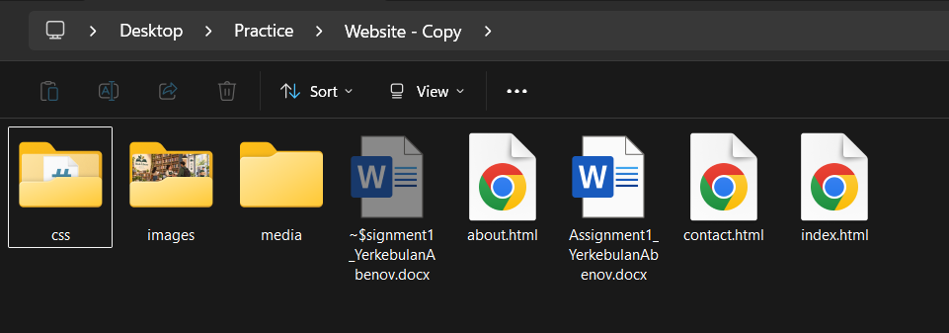
I had created the structer that was said in assigment as intext, about, contact htmls.
And also folders with the proper names for it.

- Write a valid HTML5 boilerplate in every page (with lang, charset and the viewport meta). Create css/style.css but leave it empty for now (you will fill it in Part 3).
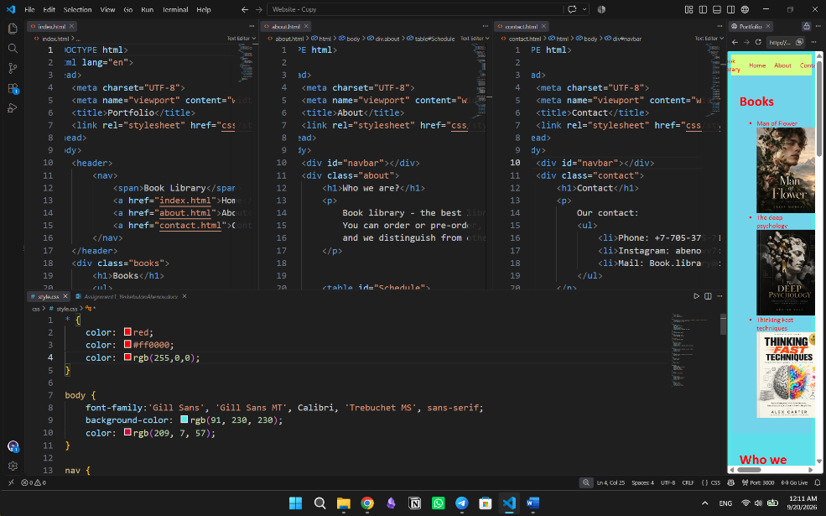
I wrote the DOCTYPE and metatypes, and also put css on its own folder.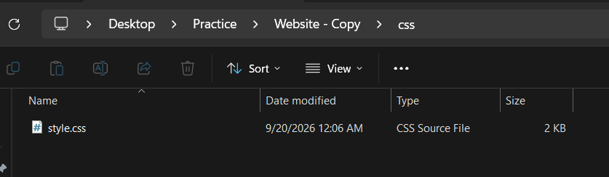

- Divide index.html into header, nav, main and footer.
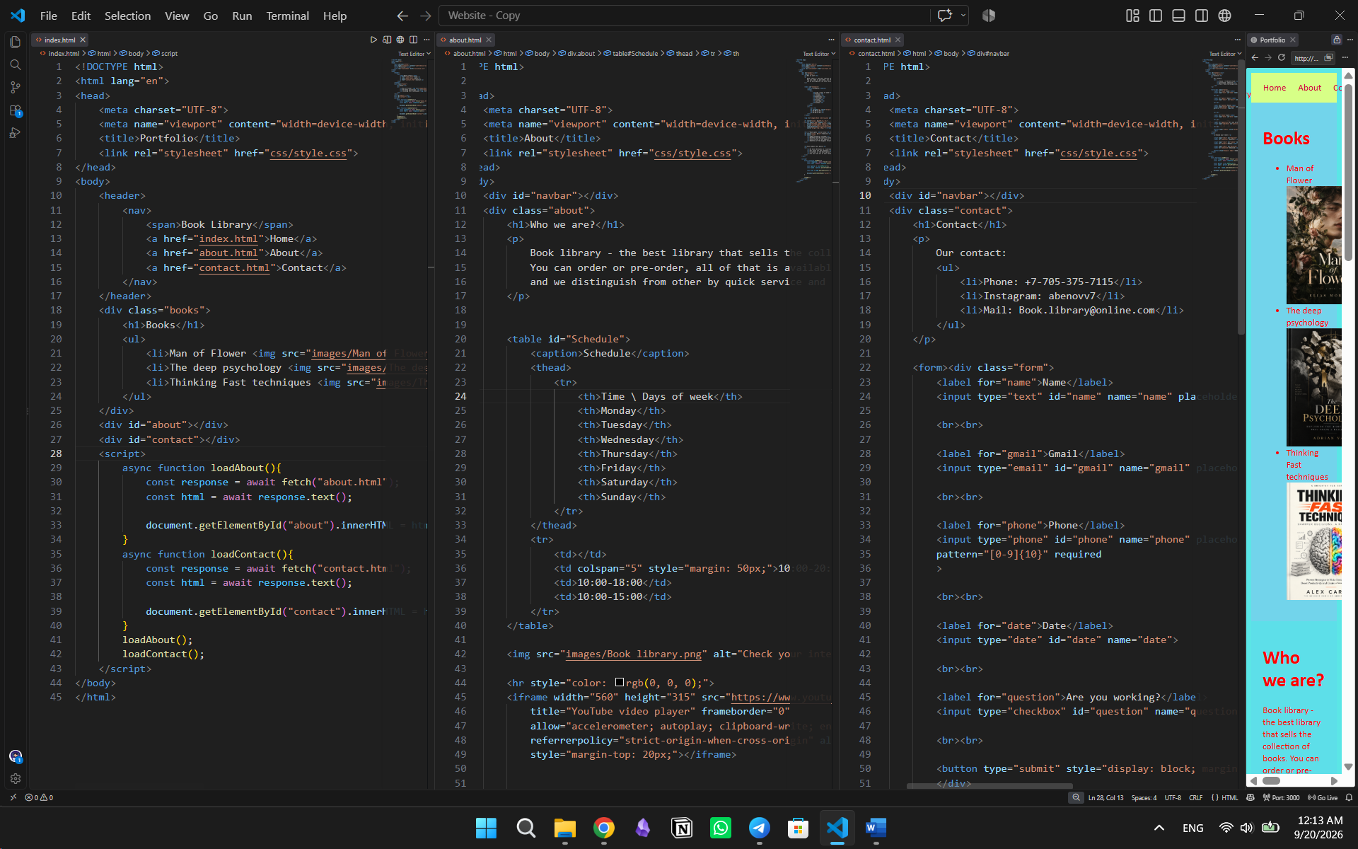
I divided into several main parts: nav, by div: headers, paragraphs and some sections.

- Inside main put one h1, two h2 sections with your own text, one unordered and one ordered list, and two images (from the images folder) with meaningful alt text.
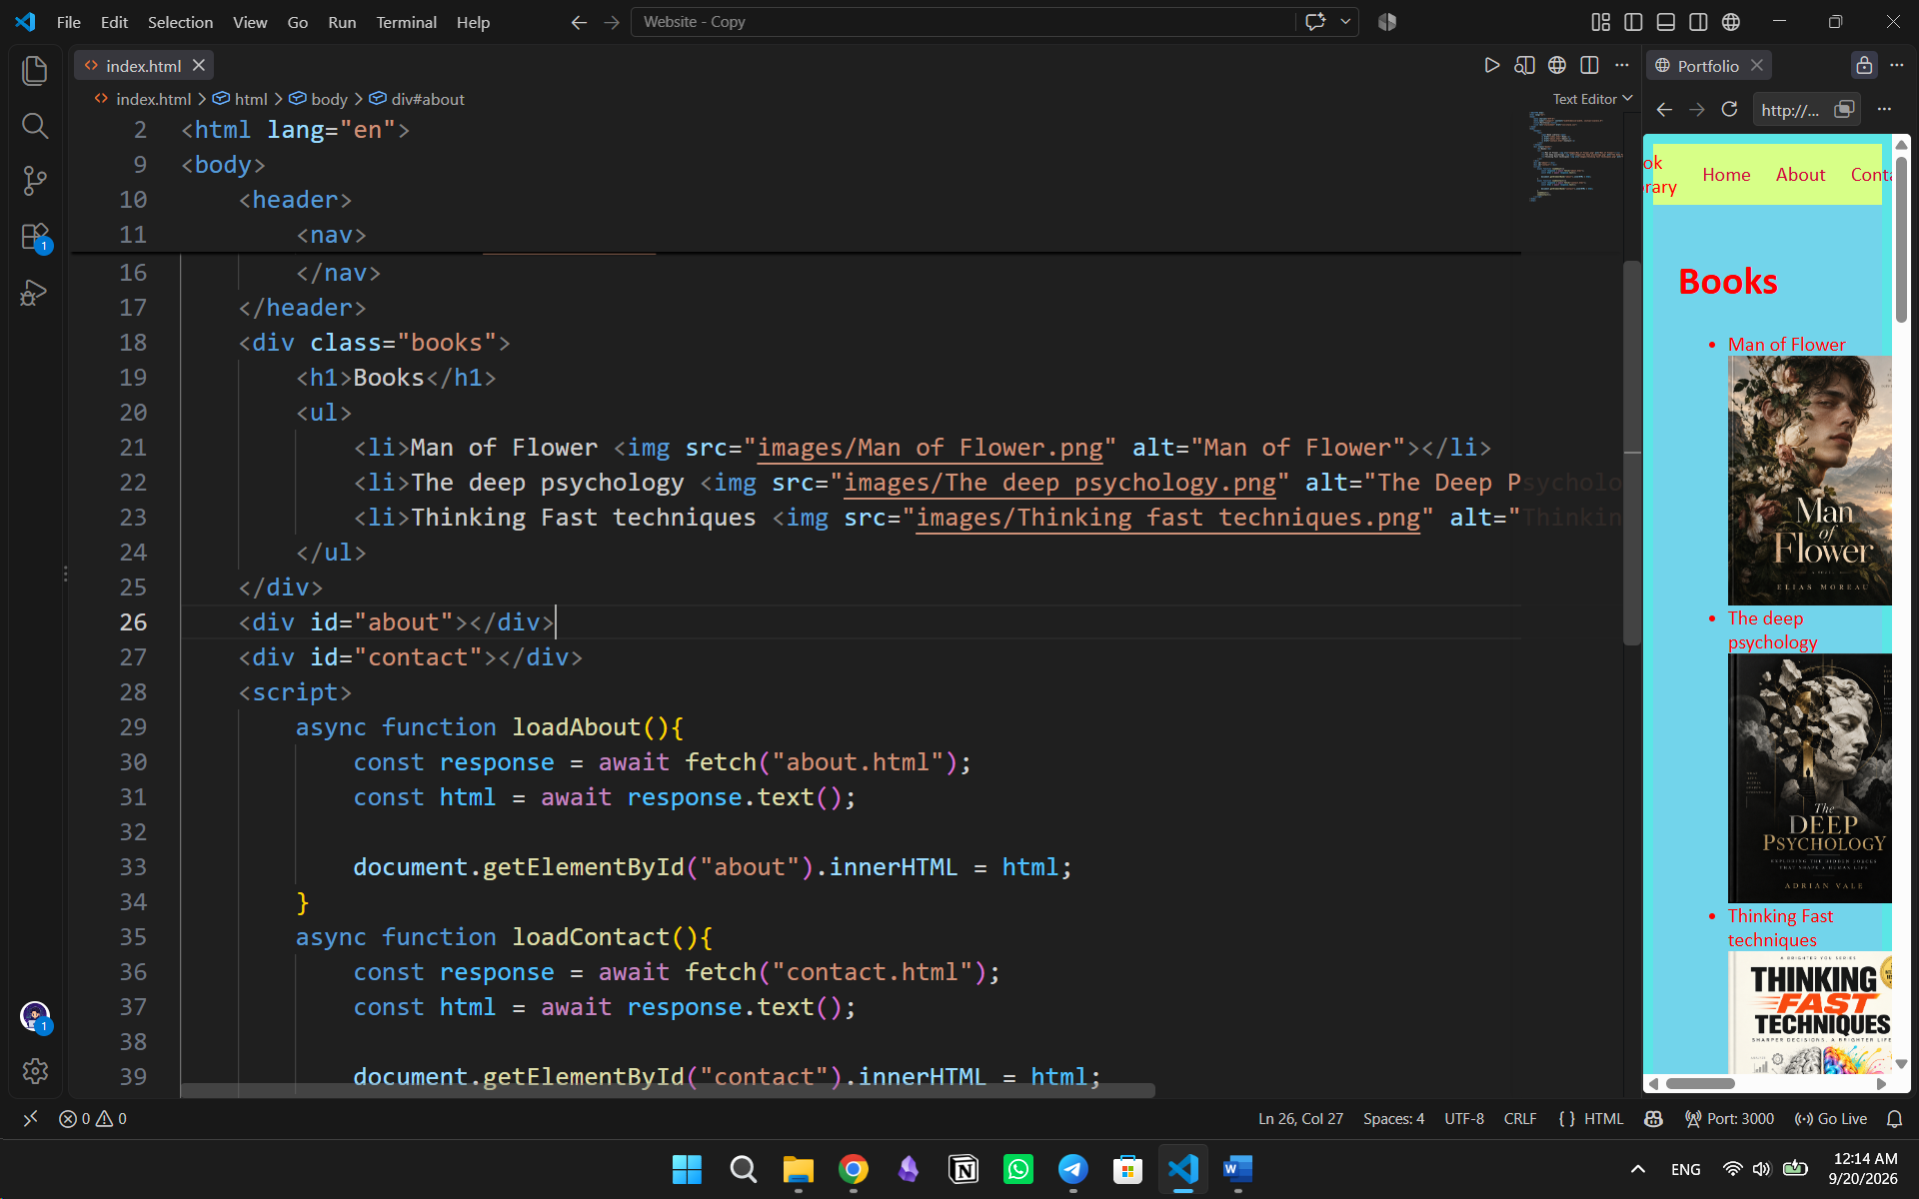

- Task 2. About page, media and navigation (20 points)
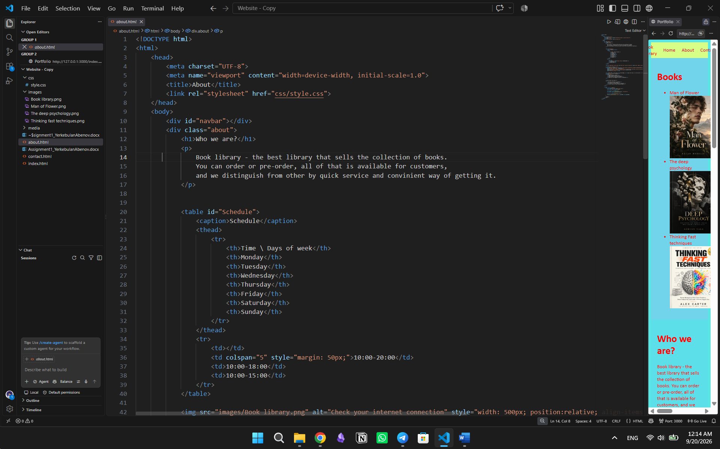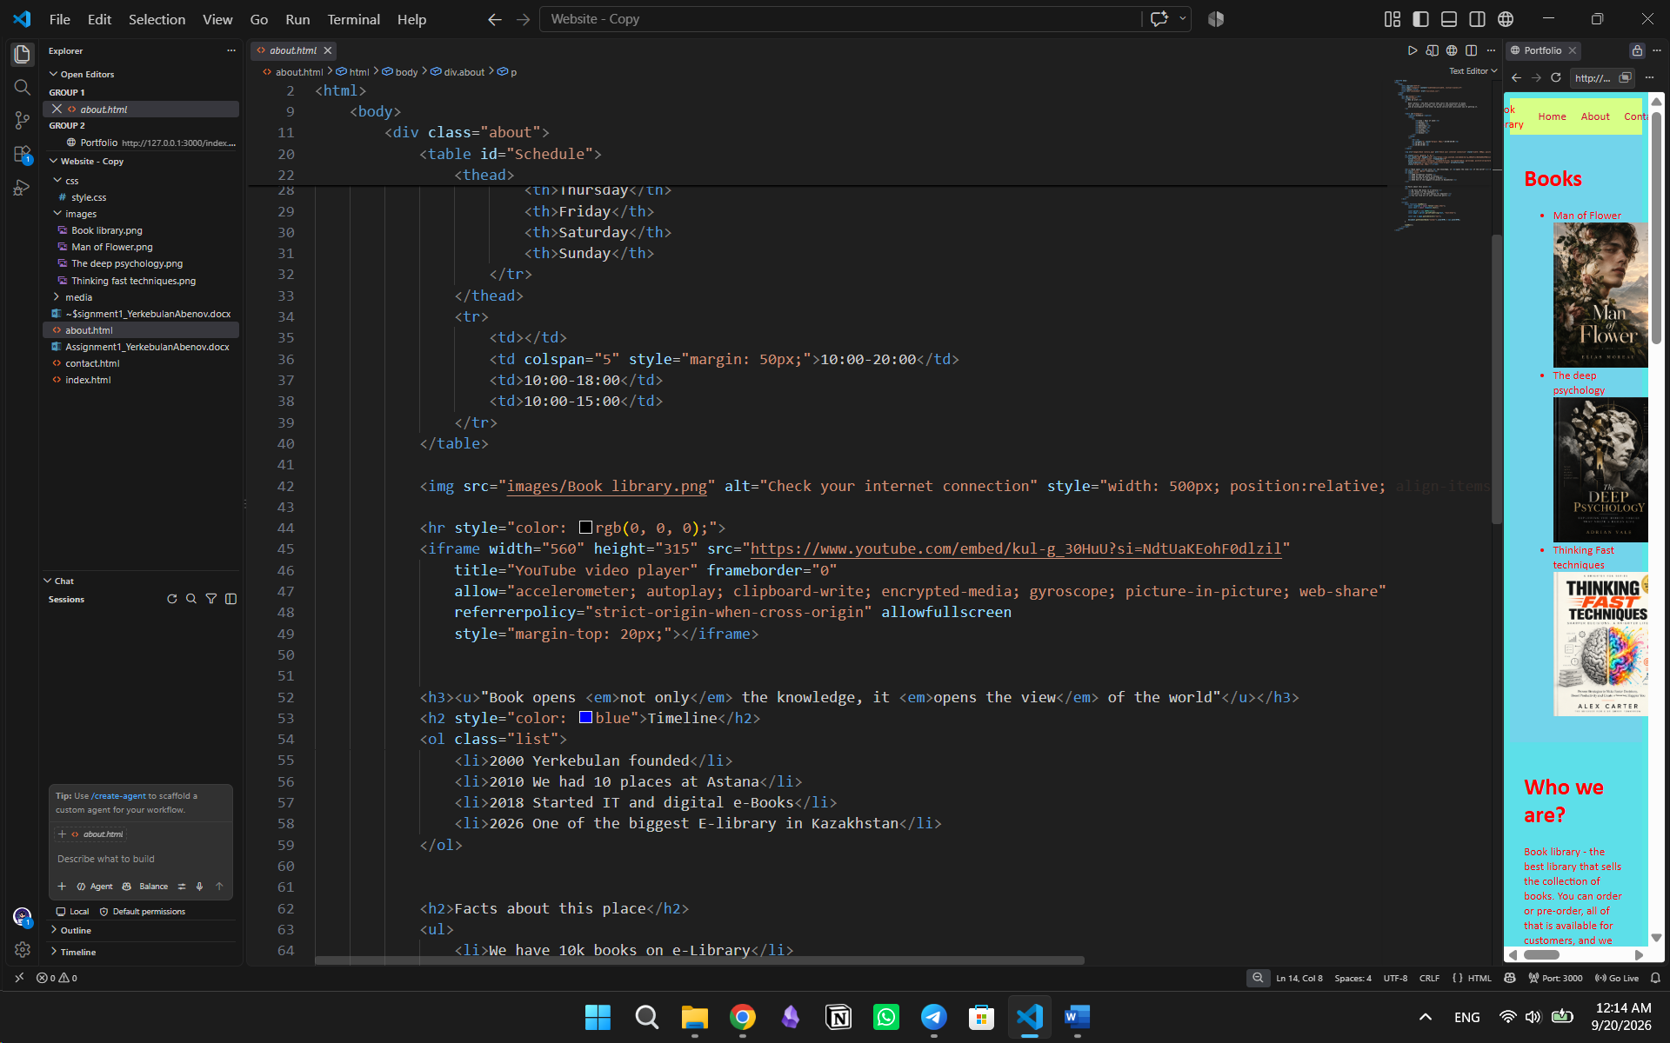
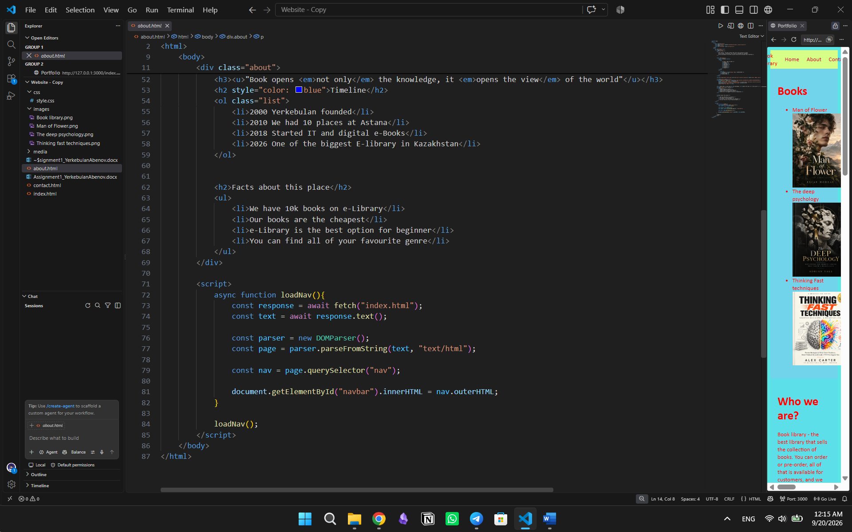

- Task 3. Data table and contact form (20 points)

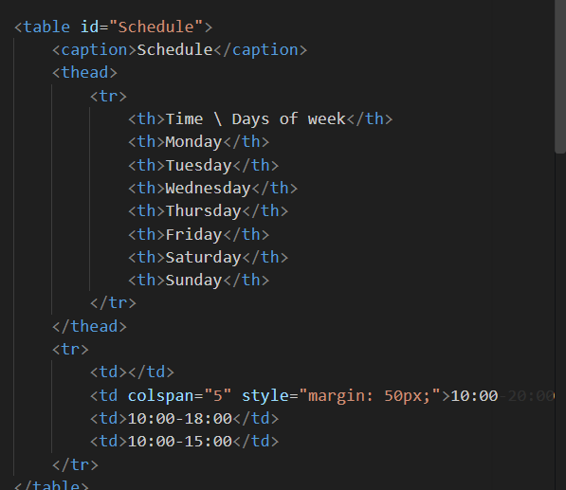
- Contact form
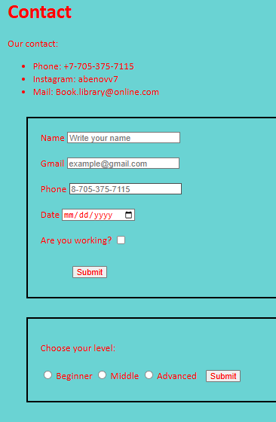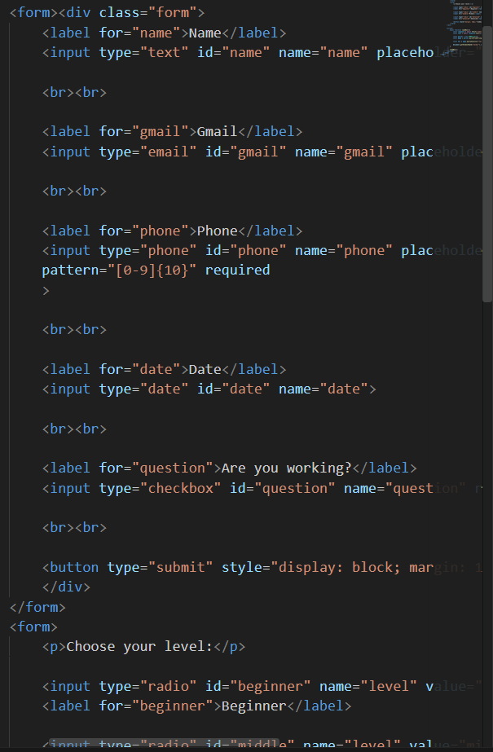
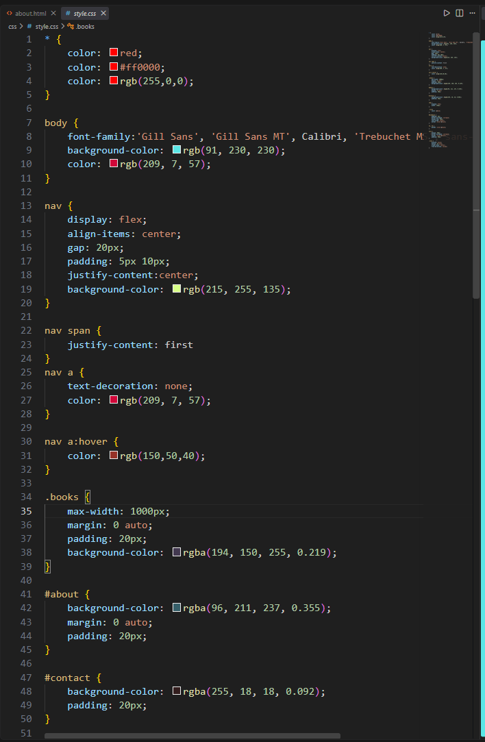
- Task 4. CSS styling (10 points)
- Task 5. Validate and publish (5 points)

