Assignment 4 — Forms and Validation
HTML + Bootstrap
Name: Yerkebulan Abenov
Group: [Add your group]
GitHub repository: [Add the GitHub repository URL after uploading the source]
This assignment has three forms made with HTML, Bootstrap and CSS. I used the browser’s built-in validation without JavaScript.

Task 1. Book a train ticket
I followed the picture using Montserrat, the given colours and rounded corners. From and To use floating labels. The form also has date inputs, radio buttons, a passenger list, a phone input group and an SMS switch.
The Bootstrap grid puts fields beside each other on a laptop and in one column on a phone. I used column-reverse to put Find trains above Clear on phones without moving the buttons in HTML.
Required fields cannot be left empty. Clear removes the entered details and restores the defaults: One way and 1 adult. Return is optional.

Task 1 — Laptop, 1280 px
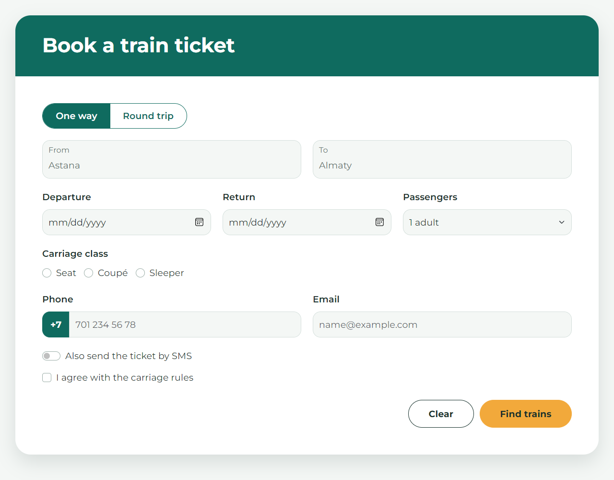
Laptop view — 1280 px.

Task 1 — Phone, 375 px
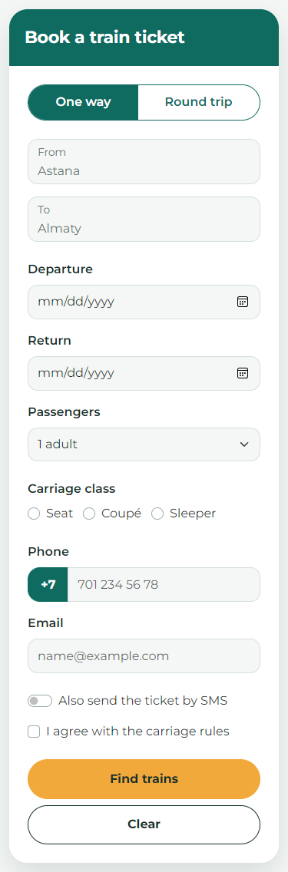
Phone view — 375 px.
There is no horizontal scrolling. Find trains appears above Clear.

Task 2. AITU Hack 2026 registration
I used required, minlength, maxlength, min, max and step for the rules. Age must be a whole number from 16 to 30. Check-in uses step=1800 because 30 minutes is 1800 seconds. The fee uses step=500.
Choose… has an empty value, so it cannot be submitted as a track. GitHub is optional, but a filled link needs https:// or another valid URL scheme. The email input checks the address format. No pattern attribute is used.
Errors are hidden when the page opens. After an invalid field is edited and left, :user-invalid shows its red border and error text.
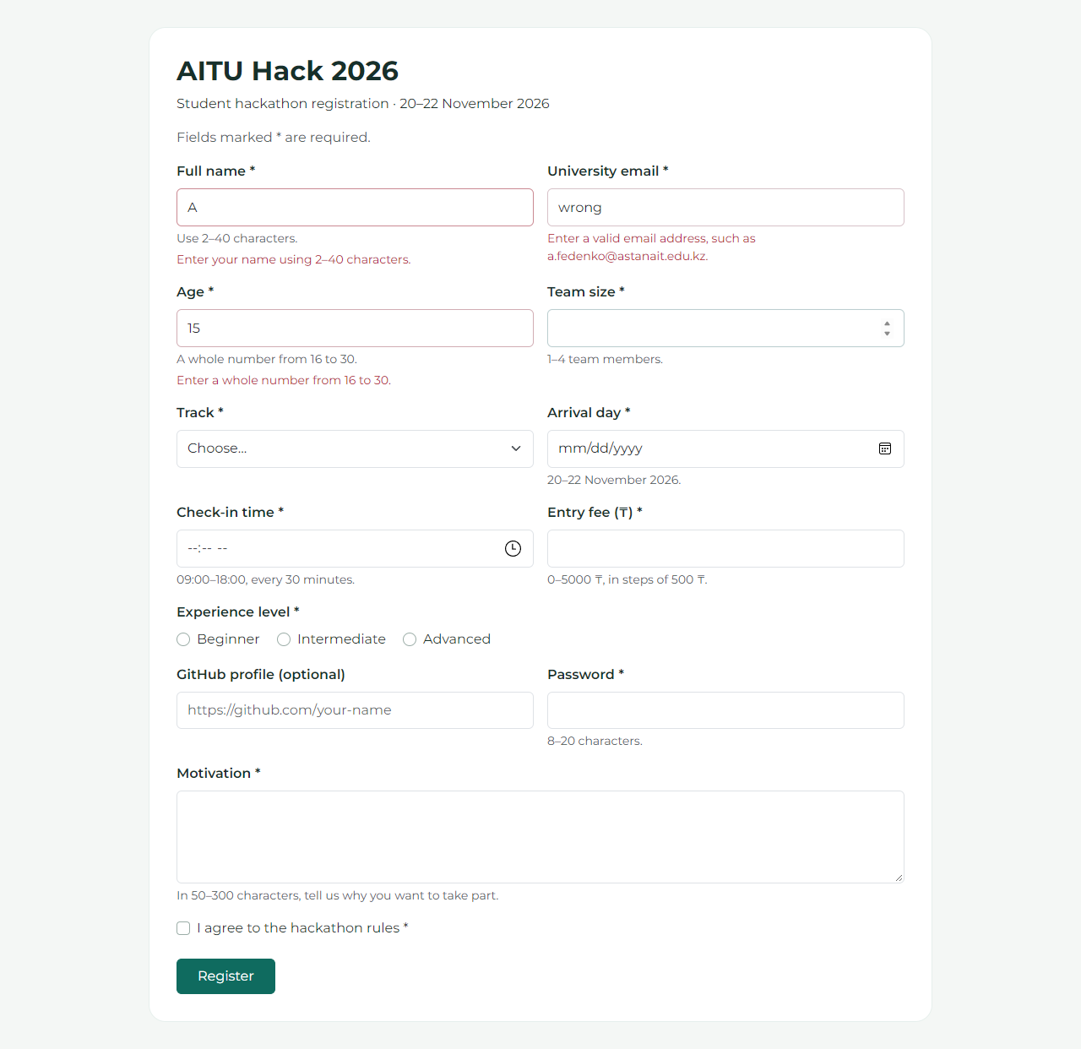
Invalid name, email and age after editing the fields.

Task 2 — Test results
The table shows the results for the assignment values. I also checked the limits and all four tracks. Dates are written as day.month.year.
Field | Test value | Observed result
Full name | Anna-Maria Lee | Accepted
Full name | A | Rejected
University email | a.fedenko@astanait.edu.kz | Accepted
University email | a.fedenko; a.fedenko@ | Both rejected
Age | 18; 15; 31 | Accepted; rejected; rejected
Team size | 4; 5; 2.5 | Accepted; rejected; rejected
Track | Web; Choose… | Accepted; rejected
Arrival day | 21.11.2026; 25.11.2026 | Accepted; rejected
Check-in time | 10:30; 10:15; 19:00 | Accepted; rejected; rejected
Entry fee | 1500; 1250; 6000 | Accepted; rejected; rejected
Experience | Beginner; nothing chosen | Accepted; rejected
GitHub profile | Empty; https://github.com/yerassyl-dev | Both accepted
GitHub profile | github.com/yerassyl-dev | Rejected
Password | Astana2026; short | Accepted; rejected
Motivation | 120 characters; 49 characters | Accepted; rejected
Rules agreement | Ticked; not ticked | Accepted; rejected
The browser also stops typing at the maximum text length: 40 characters for the name, 20 for the password and 300 for motivation. A completed valid form opens the confirmation page when the local server is running.

Task 3. Fix a bad form
I kept all the original fields and used Bootstrap for the layout. These line numbers refer to the original code in reference/task3-original.txt.
Original code / line | Problem for the user | My fix
3–4, 18: placeholders only | The field names disappear when I start typing. | Added visible labels for name, email and comments.
3–10, 14, 18–19: no name | Most field values are not included when the form is sent. | Added a name to each field.
4: type=text for email | The browser accepts an invalid email address. | Changed it to type=email.
5–6: Phone label | Clicking Phone does not select the input. | Added for=phone to the label.
7–8: guests / people | The Guests label points to the wrong id. | Used guests for the input id and label target.
8: type=text for guests | The user can enter words or half a guest. | Used type=number, min=1 and step=1.
10: type=text for date | The user can type a date that does not exist. | Changed it to type=date.
10, 12: id=date twice | The date label can point to the wrong control. | Gave the Inside radio its own id.
11: Seating paragraph | The radio group has no proper group label. | Used fieldset and legend for Seating.
12–13: radio names | Inside and Terrace can both be selected. | Gave both radios name=seating.
12–13: radio labels | Clicking Inside or Terrace does not select the radio. | Connected each option to a label.
14–17: select has no label | The user is not told what Lunch and Dinner refer to. | Added a Meal label and a Choose a meal option.
19: checkbox label | The terms text is not clickable. | Added a connected label and made agreement required.
20: div as a button | Tab skips it and it cannot submit the form. | Replaced it with button type=submit.

Two possible alternatives
For line 3, aria-label could name the input for a screen reader. I chose a visible label so the field name stays on screen while typing.
For line 20, input type=submit would also work. I chose button because its text is easy to change inside the tags.

Task 3 — Corrected reservation form
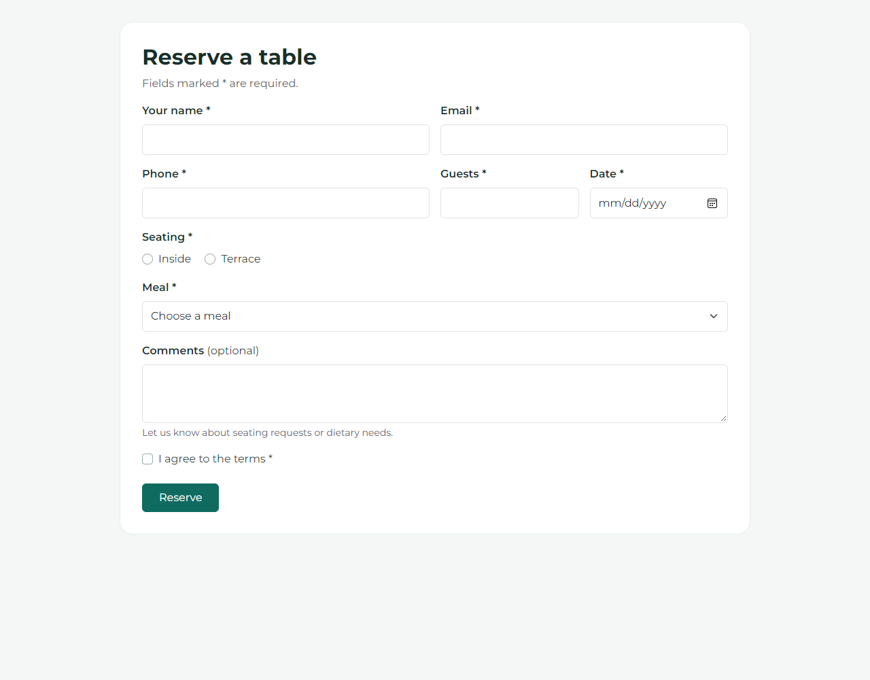
The corrected café form at 1280 px.
The form fits at 375, 768 and 1280 px. All nine field names are included in the submitted data. Tab moves between controls, the arrow keys change seating, Space checks the agreement and Enter submits the form.
The W3C validator found 0 HTML errors in the five pages.

Conclusion
I learned to validate forms with HTML attributes and arrange fields with Bootstrap. I also learned the difference between id and name: id connects the label, while name identifies the value sent by the form. Small details like these make a form easier to use.

References
Assignment 4.pdf — task requirements and reference design.
Bootstrap forms: https://getbootstrap.com/docs/5.3/forms/overview/
MDN time input: https://developer.mozilla.org/en-US/docs/Web/HTML/Reference/Elements/input/time
MDN :user-invalid: https://developer.mozilla.org/en-US/docs/Web/CSS/:user-invalid

