Assignment 3: Responsive Web Design
Name: Yerkebulan Abenov
Group: IT-2511
Project: Campus Study Club
GitHub repository: https://github.com/Abenovv/Web-technology-Assignment3
My page is about a study club for students. It has five sections: Home, Activities, Sessions, FAQ, and Contact. I used HTML, CSS, and Bootstrap 5.3.8. The club and schedule are examples for this assignment.

Task 1. Media queries by hand
For Activities, I used CSS Grid without Bootstrap classes. I started with one column for phones. The first media query adds two columns at 768px, and the second adds three columns at 992px. Both use min-width, so the layout starts with the smallest screen.
At 768px I also increase the heading size from 1.75rem to 2rem and the gap from 1rem to 1.5rem. The items have no fixed widths. The grid shares the available space between them.
Activities at 768px: two items in the first row and one in the second row.
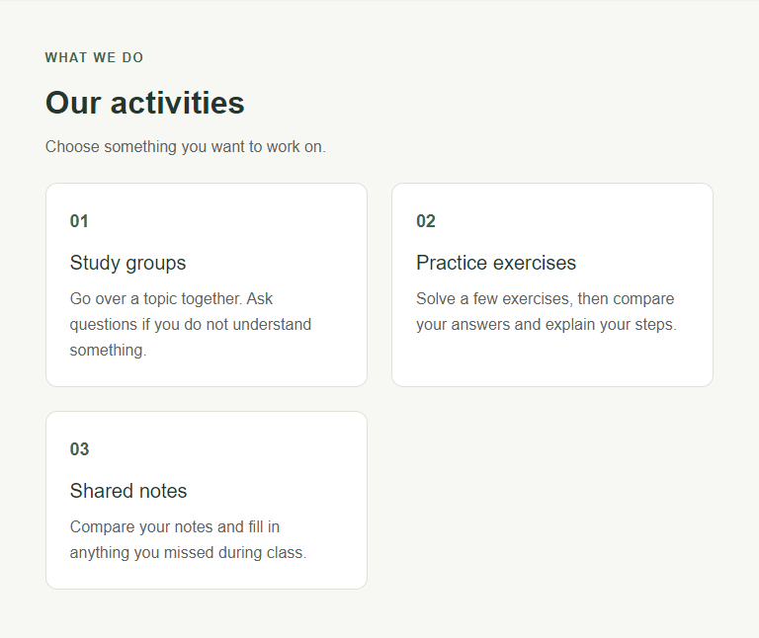

Task 2. Bootstrap grid and components
I added the Bootstrap CSS link in the head, followed by style.css. This lets my CSS change the default styles. I also added the viewport meta tag and the Bootstrap JavaScript bundle before the closing body tag.
For the session cards, I used container, row, and col-12 col-md-6 col-lg-4. The Bootstrap grid has 12 columns: col-12 takes the full row, col-md-6 takes half, and col-lg-4 takes one third. The cards show one per row at 375px, two at 768px, and three at 1280px. The g-4 class adds gaps, and h-100 keeps cards in the same row equally tall.
In the Home section, both columns use col-12 col-lg-6. The text has order-1 order-lg-2, and the image has order-2 order-lg-1. Below 992px the text is above the image. From 992px the image is on the left and the text is on the right.
The extra sentence uses d-none d-md-block. It is hidden below 768px and shown on wider screens. I used py-5 and mb-4 for spacing, text-secondary for the paragraph color, and d-flex to arrange the card content.
The navbar uses navbar-expand-lg, so it becomes a menu button below 992px. Its links go to the page sections. The FAQ uses a Bootstrap accordion: clicking a question opens its answer and closes the previous one. The JavaScript bundle makes both the menu and accordion work.
Menu opened at 375px.   | Second FAQ answer opened at 375px.  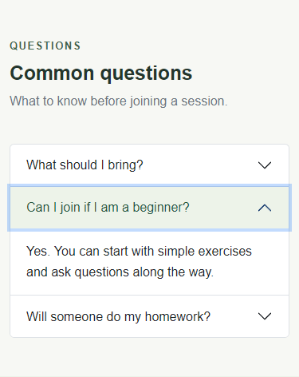
The screenshots at the end show the whole page at 375px, 768px, and 1280px.

Task 3. Comparison of the two ways
Point | My media queries | Bootstrap grid
Amount of code | I wrote the grid rules and two media queries in style.css. | I added col-12 col-md-6 col-lg-4 to each session column.
Control over design | I set the Activities heading size, gaps, and column changes in my CSS. | I used Bootstrap breakpoints for the columns and my CSS for the colors.
Time needed | I had to write the rules for each screen size. | The card layout took fewer steps because the column classes already exist.
Making changes | To change the Activities layout I edit the grid rules in style.css. | To change the session layout I edit the col-* classes in index.html.
Components | The grid only arranges the activity items. | I also used Bootstrap for the navbar, cards, and FAQ accordion.
I would use my own media queries when I want to choose exactly when a layout changes. I would use Bootstrap for a page with several rows of cards and a menu, because those parts are already available. For this page, CSS Grid was enough for Activities, while Bootstrap helped with the other sections.

Screen-size checks
Width | Activities | Session cards | Navigation
375px | 1 column | 1 column | Menu button
768px | 2 columns | 2 columns | Menu button
1280px | 3 columns | 3 columns | Visible links
The page was checked in Microsoft Edge at these widths. Both grids changed as expected, and nothing caused horizontal scrolling. The menu, FAQ buttons, and section links worked. The same checks passed at 320px, 1024px, and 1440px.

Conclusion
This assignment helped me understand how a layout changes with screen width. I practiced writing min-width media queries and using Bootstrap column classes. The main difference was where I made changes: in style.css for Activities and in the HTML classes for the Bootstrap sections.
References: https://getbootstrap.com/docs/5.3/getting-started/introduction/ and https://getbootstrap.com/docs/5.3/layout/grid/

Whole page at 375px: parts 1-3 of 5
I split the screenshot into parts so the text is large enough to read. Read each part from top to bottom, then move to the next part.
Part 1 of 5  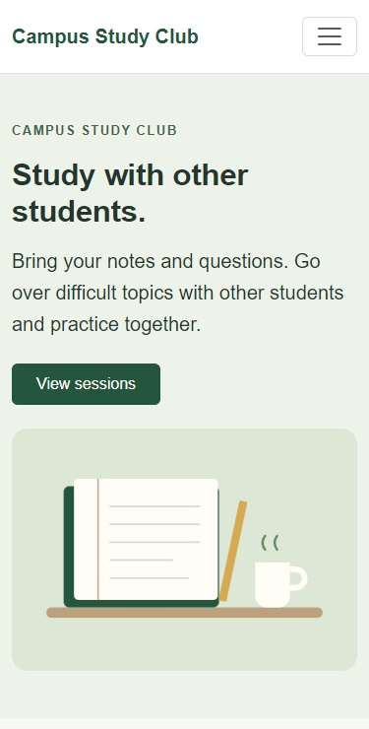 | Part 2 of 5  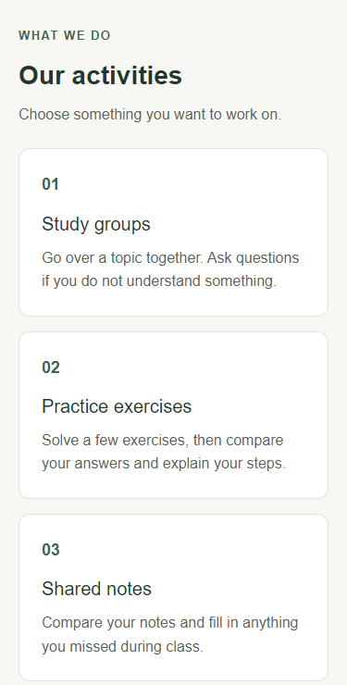 | Part 3 of 5  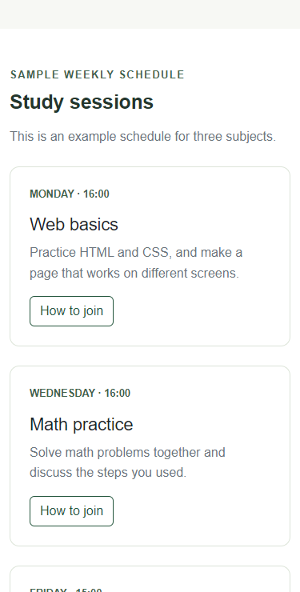

Whole page at 375px: parts 4-5 of 5
Part 4 of 5  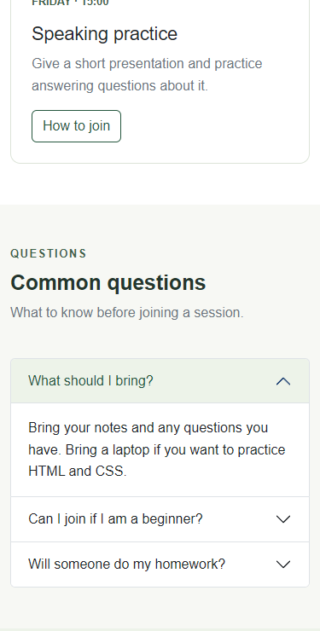 | Part 5 of 5  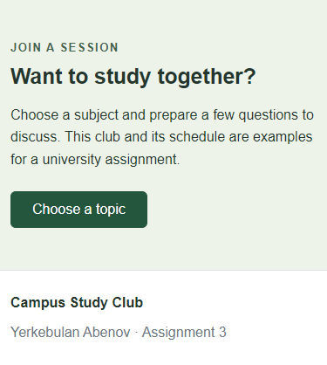

Whole page at 768px: parts 1-2 of 4
I split the screenshot into parts so the text is large enough to read. Read each part from top to bottom, then move to the next part.
Part 1 of 4  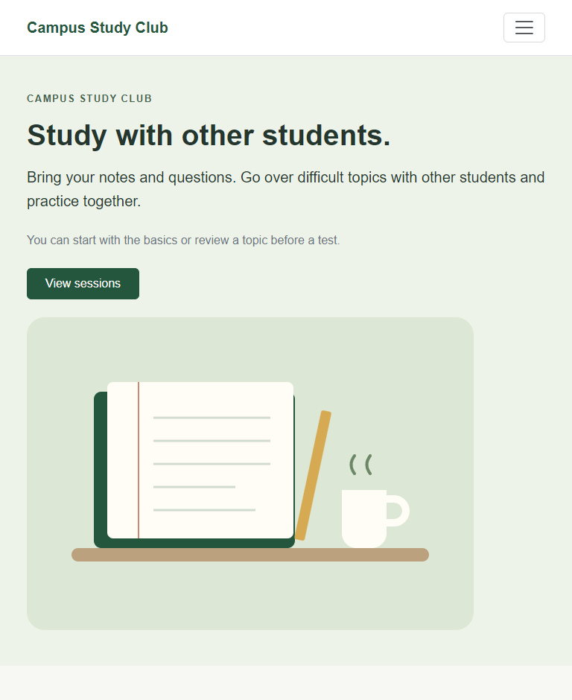 | Part 2 of 4  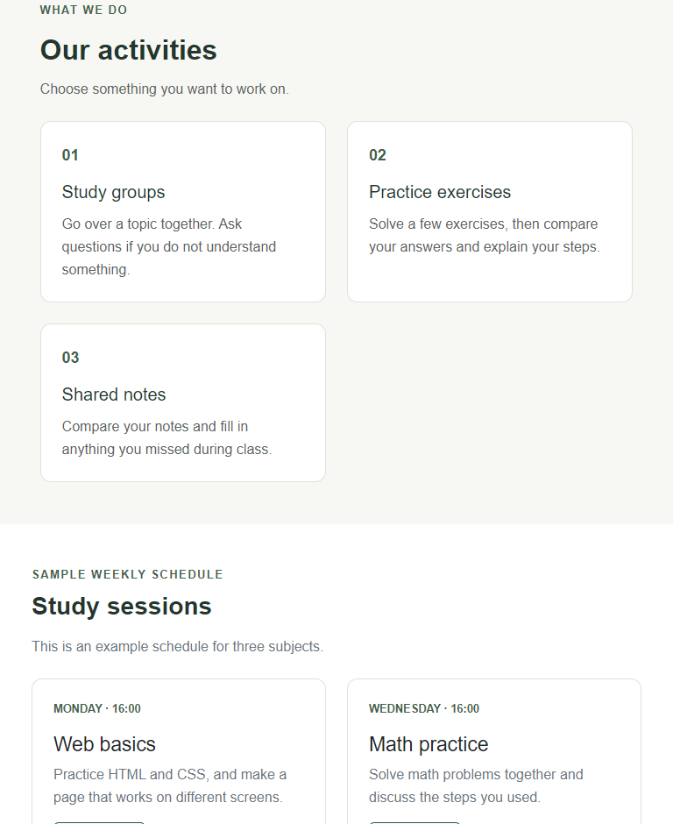

Whole page at 768px: parts 3-4 of 4
Part 3 of 4  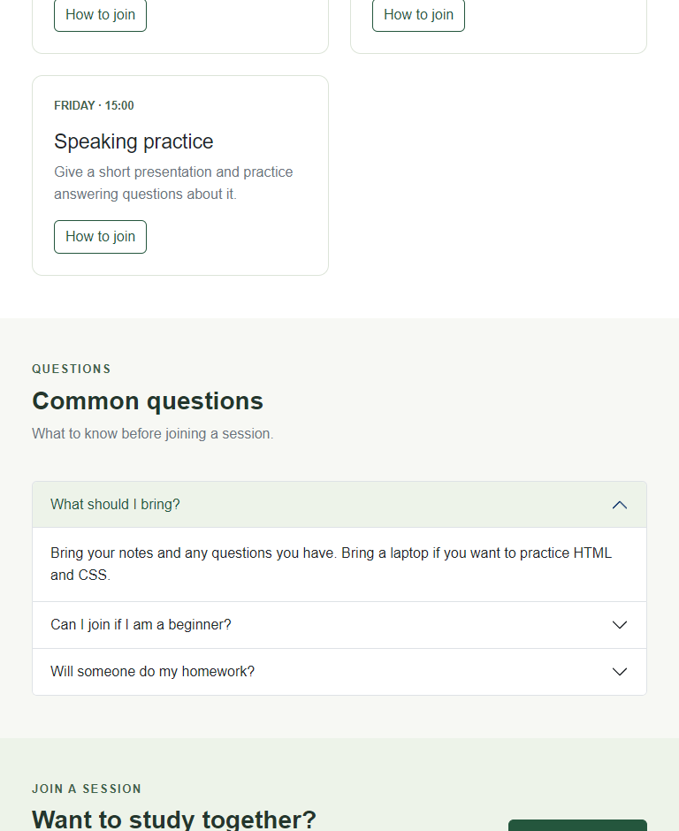 | Part 4 of 4  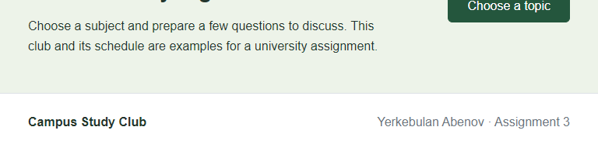

Whole page at 1280px: part 1 of 3
I split the screenshot into parts so the text is large enough to read. Read each part from top to bottom, then move to the next part.
Part 1 of 3
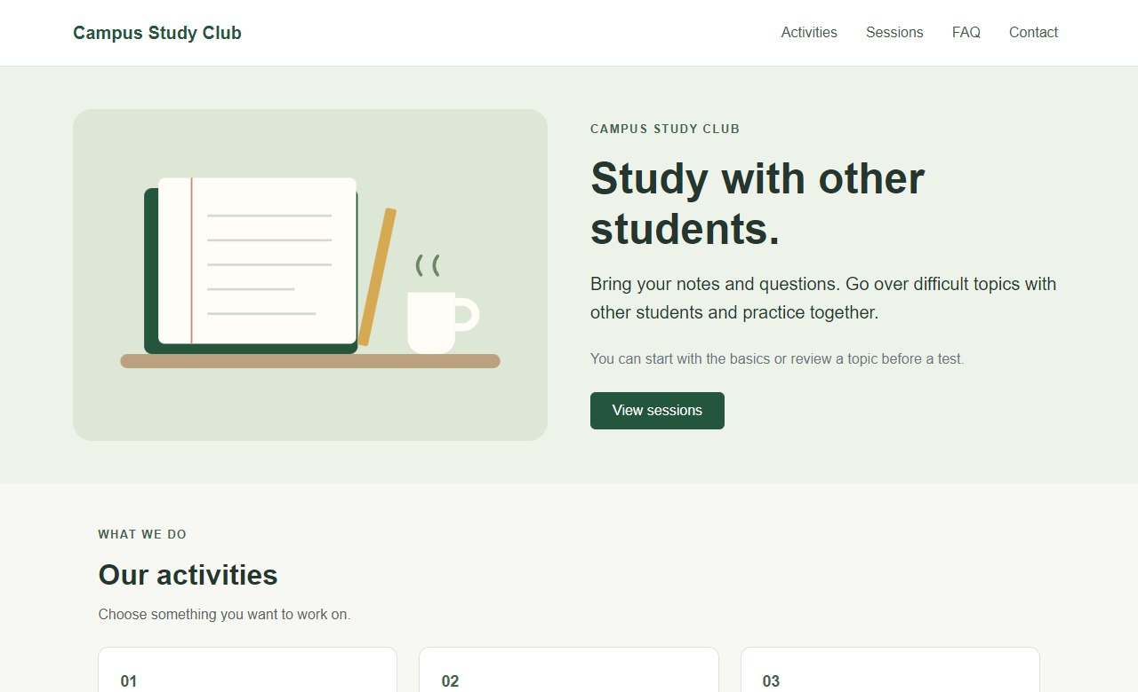

Whole page at 1280px: part 2 of 3
Part 2 of 3
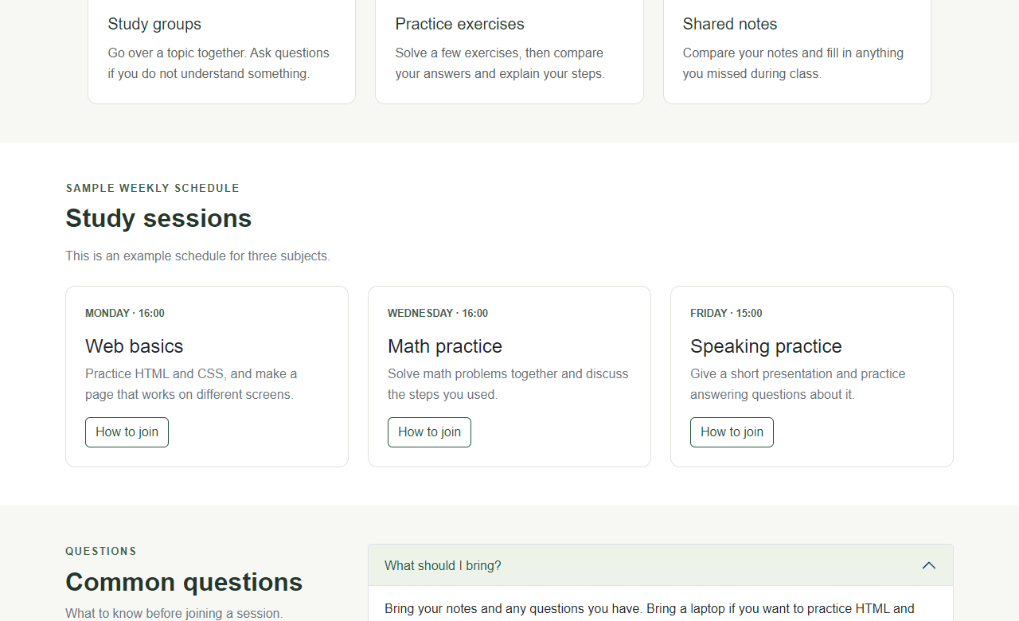

Whole page at 1280px: part 3 of 3
Part 3 of 3
