**FRENCH IMMERSION PROGRAM @ ABE**

**COMMUNICATION**

* [Power point information](http://schools.cbe.ab.ca/b829/aberhart/programs/french-immersion/general-information.pdf) for our registered French Immersion students **@ ABE**
* [French Immersion Expectations](http://schools.cbe.ab.ca/b829/aberhart/programs/french-immersion/frenchimmersion-expectations.pdf) **@ ABE**
* [10 good reasons to learn French](http://schools.cbe.ab.ca/b829/aberhart/programs/french-immersion/10-goodreasons.pdf)
* [Article fromFred Kreiner](http://schools.cbe.ab.ca/b829/aberhart/programs/french-immersion/butmom.pdf) “ BUT MOM…!!!”
* Important dates for 2014-15 (not yet posted)
* French Immersion in action – Newsletter
  + [June 2014](http://us8.campaign-archive1.com/?u=04fe293fdfd4e9e3bf3338344&id=d925c27b9a&e=%5BUNIQID%5D)

**French Language Arts**

Mme Nathalie Dunn – Learning Leader & Teacher (FLA & DELF) [nrdunn@cbe.ab.ca](mailto:nrdunn@cbe.ab.ca)

Mme Stéphanie Lavallée – Teacher (FLA) [sllavallee@cbe.ab.ca](mailto:sllavallee@cbe.ab.ca)

M. Ryan Mooney – Teacher – (FLA) [rrmooney@cbe.ab.ca](mailto:rrmooney@cbe.ab.ca)

Mme Caroline Tremblay – Teacher (FLA) [cctremblay@cbe.ab.ca](mailto:cctremblay@cbe.ab.ca)

Mme Jill Pettigrew – Teacher (FLA, FSL & AP French) [jepettigrew@cbe.ab.ca](mailto:jepettigrew@cbe.ab.ca)

**Mathématiques**

Mme Véronique Brunelle – Learning Leader [vebrunelle@cbe.ab.ca](mailto:vebrunelle@cbe.ab.ca)

Mme Fatima Hudda [fahudda@cbe.ab.ca](mailto:fahudda@cbe.ab.ca)

Mme Liane Reid [loreid@cbe.ab.ca](mailto:loreid@cbe.ab.ca)

Mme Fosti [mlfosti@cbe.an.ca](mailto:mlfosti@cbe.an.ca)

M. Power [tjpower@cbe.ab.ca](mailto:tjpower@cbe.ab.ca)

**Études Sociales**

M. Marc Moquin [mpmoquin@cbe.ab.ca](mailto:mpmoquin@cbe.ab.ca)

M. Eric Vaillant [ejvaillant@cbe.ab.ca](mailto:ejvaillant@cbe.ab.ca)

M. Ryan Mooney [rrmooney@cbe.ab.ca](mailto:rrmooney@cbe.ab.ca)

Mme Caroline Tremblay [cctremblay@cbe.ab.ca](mailto:CCTremblay@cbe.ab.ca)

**French Learning strategists - Stratégistes d’apprentissage**

Mme Andrée Belhumeur [anbelhumeur@cbe.ab.ca](mailto:anbelhumeur@cbe.ab.ca) Mme Shayda Cummings [secummings@cbe.ab.ca](mailto:secummings@cbe.ab.ca)

**French Immersion Assistant Principal** M. Sébastien Fournier [sefournier@cbe.ab.ca](mailto:sefournier@cbe.ab.ca)

**COURSE DESCRIPTIONS**

[**Mathématiques**](http://schools.cbe.ab.ca/b829/aberhart/departments/mathematics/mathematics.html)

[**Études Sociales**](http://schools.cbe.ab.ca/b829/aberhart/departments/social-studies/social-studies.html)

**FRENCH LANGUAGE ARTS 10-1, 20-1, 30-1 (5 credits each)**

*FOR IMMERSION STUDENTS ONLY*

The continued development of effective oral and written comprehension and production is the overall goal of these courses. The students should gradually feel at ease in a variety of communication situations. To achieve this aim, literary and non-literary sources, written texts, audio-visual and technology materials will be used. The use of vocabulary, verb tenses, orthography, syntax and style will be studied within the context of the various forms of communication. Students are expected to participate in a variety of oral projects as well as written productions. FLA 30 students have the opportunity to take the French Advanced Placement course and/or the DELF exam for an International Language Proficiency. FLA 30-1 students will write the FLA 30-1 diploma exam.

|  |  |  |  |  |
| --- | --- | --- | --- | --- |
| **FLA 10-1 & 20-1** | | | **FLA 30-1** | |
| **Travail en classe** | **(70%)** |  | **Travail en classe** | **(50%)** |
| Compréhension écrite  Production écrite | 40% |  | Compréhension écrite  Production écrite | 25% |
| Compréhension orale  Production orale | 30% |  | Compréhension orale  Production orale | 15% |
| **Examen final** | **(30%)** |  | Examen final – production orale | 5% |
| Examen compréhension écrite (CM) | 10% |  | Examen final – compréhension orale | 5% |
| Examen production écrite | 10% |  | **Examen de diplôme** | **(50%)** |
| Examen production orale | 5% |  | Production écrite (Partie A) | 25% |
| Examen compréhension orale | 5% |  | Compréhension écrite (Partie B - CM) | 25% |

**Useful links**

[Bon patron](http://aberhart.bonpatron.com/) (CODE= MORLEY) [REPSIT](http://www.ucalgary.ca/repsit/exercices-de-langue/) [Bescherelle](http://www.bescherelle.com)

**FRENCH LANGUAGE ARTS 30-2** (5 credits)

FOR IMMERSION STUDENTS ONLY with difficulties in written comprehension and production

The FLA-2 program is offered and highly recommended for students who experience challenges in French comprehension and production during previous FLA courses. The course is predominantly project based and follows the FLA-2 program of studies. In addition, this program offers further strategies from our learning strategist in the Learning Center. Students in FLA with a mark below 60% are highly recommended to register in this program and will be an asset for successful completion of the immersion program. This program is a non-diploma course and also leads to the completion of the student’s CBE - Certificate of Achievement in French Immersion.

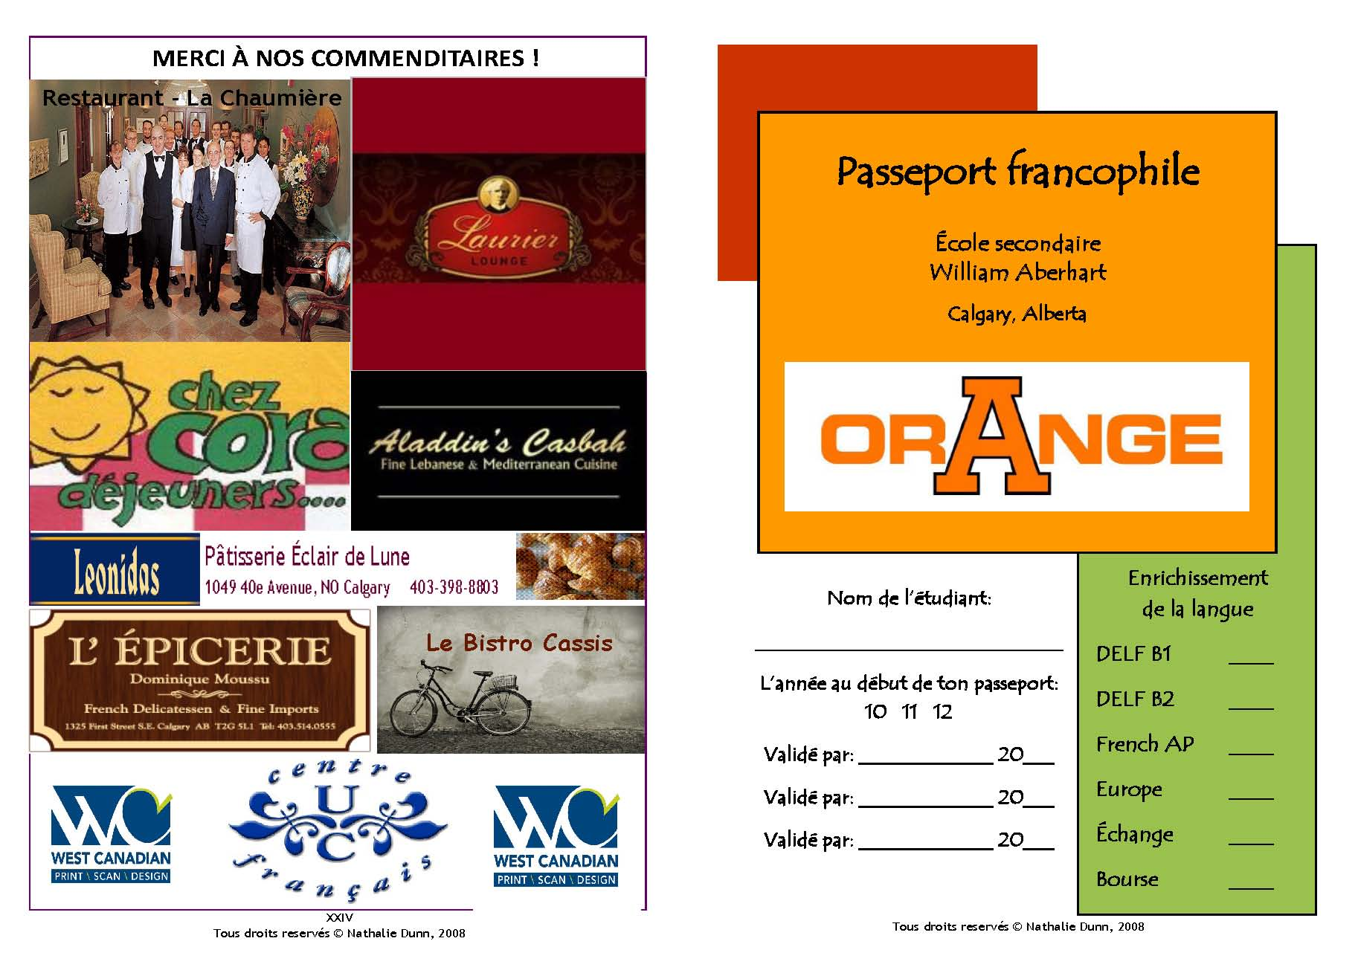

**ABE - Immersion en action !!!**

**LANGUAGE ENRICHMENT**

**D.E.L.F.** = Diplôme d’étude en langue française

**What is the DELF exam?**

The DELF *(Diplôme d'études en langue Francaise)* is an official French Language Diploma awarded by France Ministry of National Education.  It is recgnized around the world and is valid for life.

**Where is it from?**

"Founded in 1945 and National public institution since 1987, the CIEP is recognized both in France and abroad for its skills with regard to expert evaluation, training, assessment, and management of international projects."

[**CIEP**](http://www.ciep.fr/en) IN THE WORLD has more than 1,000 test centers in 167 countries, projects in over 50 countries, language assistants from 51 countries, expert missions in 85 countries.

[Language Portal of Canada](http://www.noslangues-ourlanguages.gc.ca/collaborateurs-contributors/articles/etudes-studies-eng.html)

[Le DELF au Canada](http://www.acpi.ca/ressources/delf-c-est-quoi/le-delf-au-canada-perceptions-des-parties-interessees-the-delf-in-canada-stakeholder-perceptions)

[FAQ (in French & English)](http://www.acpi.ca/ressources/delf-c-est-quoi/les-questions-souvent-posees-concernant-le-delf-au-canada)

[CBE language credentialing](http://www.cbe.ab.ca/programs/languages/credentialing.asp)

[CBE spotlight story](http://www.cbe.ab.ca/new/spotlights11-12/121511-delf.asp)

For more **information** please see Mme Dunn in room 221 or email[nrdunn@cbe.ab.ca](mailto:nrdunn@cbe.ab.ca)

**Projet collège Maurick - Pays-Bas et France – Europe Trip 2015-16**

In April 2014, French Immersion families hosted 7 students from the [Maurick College](http://www.maurickcollege.net/) of [Vught](http://en.wikipedia.org/wiki/Vught), Netherlands.  The 10 days was filled with authentic linguistic and cultural activities varied from a visit to the Glenbow Museum, line dancing, *cabane à sucre* to a trek in our beautiful Canadian Rockies.  Our FI students will be traveling to the Netherlands and Paris, France next October 2014.  This project includes a cultural, linguistic and Social Studies aspect of our French Immersion program.

For more **information** for 2015-16, please see Mme Dunn – [nrdunn@cbe.ab.ca](mailto:nrdunn@cbe.ab.ca)



**AP French Language and Culture Course**

This course is recommended to students with an average of 80% in grade 11 in their FLA 20-1 class. This course is for motivated and self-directed learners. Students **may earn** 1st year university credit for the course or receive advanced standing and enter the second year course directly.  The revised AP French Language and Culture Exam will assess student proficiency in the three modes of communication (Interpersonal, Interpretive, and Presentational) and will continue to feature multiple-choice and free-response questions. A thematic structure enables students to study a variety of concepts in interesting, meaningful, engaging contexts along with a focus on the learning objectives of the FLA 30-1 program of studies.  Students will develop an awareness and appreciation of aspects of the target culture, practices and perspectives. [AP Central College Board](http://apcentral.collegeboard.com/apc/public/courses/teachers_corner/2152.html?ep_ch=PR&ep_mid=7741149&ep_rid=30977275)

We offer a French AP course during the second semester out of the regular schedule of each calendar school year.

For more **information** please see Mme Pettigrew **–** [jepettigrew@cbe.ab.ca](mailto:jepettigrew@cbe.ab.ca)

**FRENCH COURSE CHALLENGE**

* **At Aberhart**, we prefer that all our students take the FLA 10-1 course.
* If a student receives a mark above 90% in FLA 10-1, he/she can register directly in FLA 30-1 and receive 5 credits and a “P” (for pass)” for FLA 20-1.
* If a student wishes to challenge FLA 20-1 and receive a mark and 5 credits, the application form must be submitted **to Mme Dunn.**

**FLA 20-1**

* [Regulation and Procedures](http://schools.cbe.ab.ca/b829/aberhart/programs/french-immersion/procedures-challenging-%20fla20-1415.pdf)
* [Application form](http://schools.cbe.ab.ca/b829/aberhart/programs/french-immersion/application-challenge-fla20-1.pdf)
* [Course Challenge Porfolio](http://schools.cbe.ab.ca/b829/aberhart/programs/french-immersion/portfolio-challenging-%20fla20-1415.pdf)

**FSL 30 -9Y – French as a Second Language**

Any ABE student s @ ABE will have the opportunity to challenge the FSL 30-9Y course to earn 15 additional credits. A 5 credits and a mark for the French 30 challenge, and retroactive 10 credits can be given for the FSL 20-9Y and FSL 10-9Y classes.   Grade 12 students registered in the French Language Arts 30-1 level are also encouraged to challenge this course. **These credits do not count toward the “CBE - French Immersion Certificate of Achievement”.**  The FSL 30-9Y challenge will be offered twice a year in January and June (during exam schedule) to all students who meet the previous requirements.  The FSL30 challenge exam not only awards 15 credits to students, but the mark awarded may be included in an overall average for most university entrance. Please see guidance for more details.

Students who wish to challenge FSL 30-9Y, MUST **submit, to Mme Dunn no later than December 15th or May 15th**, the application form ONLY.

The day of the exam student **MUST** print and bring the **course challenge evaluation package** and the **two evaluation sheets**.

* [FAQ](http://schools.cbe.ab.ca/b829/aberhart/programs/french-immersion/student-faq-application-challenge-fsl-30-9y.pdf)
* [Student Course Challenge Application Package](http://schools.cbe.ab.ca/b829/aberhart/programs/french-immersion/student-package-challenge-fsl-30-9y.pdf).
* [Student Evaluation Rubriques (spoken & written expression)](http://schools.cbe.ab.ca/b829/aberhart/programs/french-immersion/student-evaluation-challenge-fsl-30-9y.pdf)

**For any other language French challenges inquiries please see Mme Dunn.**

“More than **200 million** people speak French on the **five continents**. The *Francophonie*, the international organization of French-speaking countries, comprises **68 states** and governments. French is the **second most** widely learned foreign language after English, and the **ninth most widely spoken language in the world**.”

**REMEMBER - Ten top reasons to learn French**

1. A world language

2. A language for the job market

3. The language of culture

4. A language for travel

5. A language for higher education

6. The other language of international relations

7. A language that opens up the world

8. A language that is fun to learn

9. A language for learning other languages

10. The language of love and reason **☺**