Aberin,Jinky Mae October 11, 2019

BSTM191/HRO191 Activity #1

A Flowchart is a sort of chart that speaks to a calculation, work process or procedure. The flowchart demonstrates the means as boxes of different sorts, and their request by interfacing the cases with bolts. This diagrammatic portrayal delineates an answer model to a given issue. Flowcharts are utilized in breaking down, planning, reporting or dealing with a procedure or program in different fields. Each flow chart is concerned with one particular process or system. It begins with the input of data or materials into the system and traces all the procedures needed to convert the input into its final output form. Specialized flow chart symbols show the processes that take place, the actions that are performed in each step, and the relationship between various steps. Flow charts may include different levels of detail as needed, from a high-level overview of an entire system to a detailed diagram of one component process within a larger system. In any case, the flow chart shows the overall structure of the process or system, traces the flow of information and work through it, and highlights key processing and decision points.

Flow charts are an important tool for the improvement of processes. By providing a graphical representation, they help project teams to identify the different elements of a process and understand the interrelationships among the various steps. Flow charts may also be used to gather information and data about a process as an aid to decision making or performance evaluation. For example, the owner of a small advertising agency who hopes to reduce the time involved in creating a print ad might be able to use a flow chart of the process to identify and eliminate unnecessary steps. Though flow charts are relatively old design tools, they remain popular among computer programmers working on systems analysis and design. In recent years, many software programs have been developed to assist business people in creating flow charts.

Flow charts typically utilize specialized symbols. Some of the main symbols that are used to construct flow charts include:

* Round-edged rectangle to represent starting and ending activities, which are sometimes referred to as terminal activities.
* Rectangle to represent an activity or step. Each step or activity within a process is indicated by a single rectangle, which is known as an activity or process symbol.
* Diamond to signify a decision point. The question to be answered or decision to be made is written inside the diamond, which is known as a decision symbol. The answer determines the path that will be taken as a next step.

Flow lines show the progression or transition from one step to another.

Constructing a flow chart involves the following main steps: 1) Define the process and identify the scope of the flow diagram 2) Identify project team members that are to be involved in the construction of the process flow diagram; 3) Define the different steps involved in the process and the interrelationships between the different steps (all team members should help develop and agree upon the different steps for the process); 4) Finalize the diagram, involving other concerned individuals as needed and making any modifications necessary; and 5) Use the flow diagram and continuously update it as needed. <https://en.wikibooks.org/wiki/Programming_Fundamentals/Flowcharts>

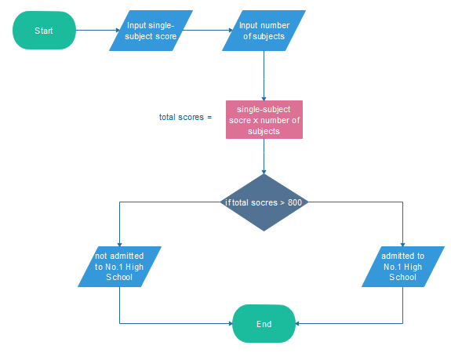

Pseudocode (pronounced SOO-doh-kohd) is a detailed yet readable description of what a computer program or algorithm must do, expressed in a formally-styled natural language rather than in a programming language. Pseudocode is sometimes used as a detailed step in the process of developing a program. It allows designers or lead programmers to express the design in great detail and provides programmers a detailed template for the next step of writing code in a specific programming language.

Because pseudocode is detailed yet readable, it can be inspected by the team of designers and programmers as a way to ensure that actual programming is likely to match design specifications. Catching errors at the pseudocode stage is less costly than catching them later in the development process. Once the pseudocode is accepted, it is rewritten using the vocabulary and syntax of a programming language. Pseudocode is sometimes used in conjunction with computer-aided software engineering-based methodologies.It is possible to write programs that will convert a given pseudocode language into a given programming language.

https://whatis.techtarget.com/definition/pseudocode