M1

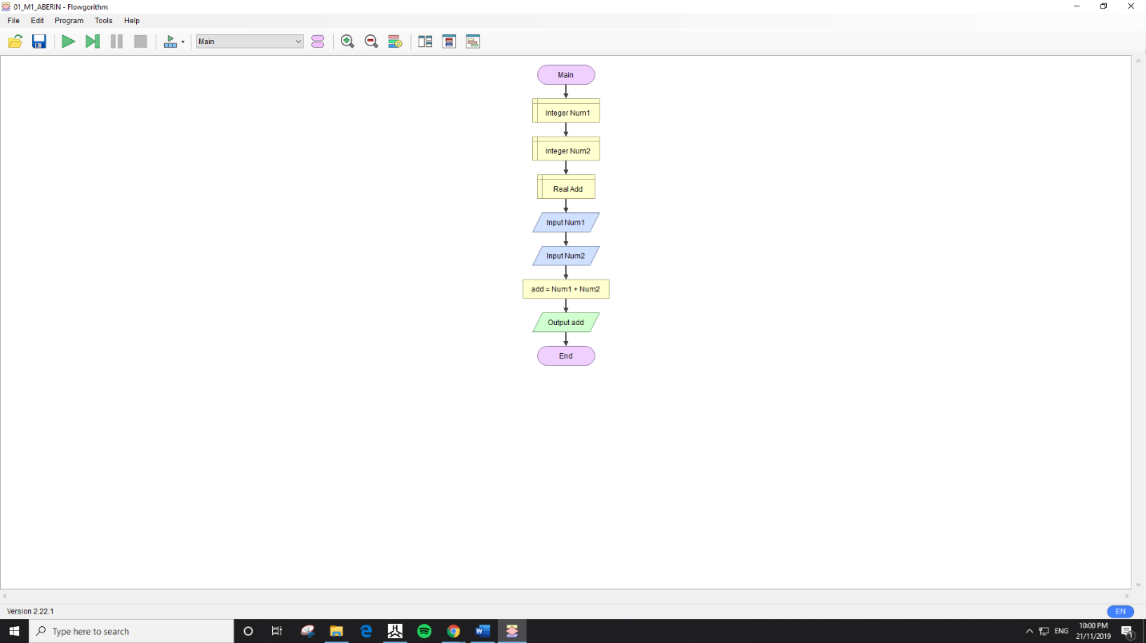

Discussion: In doing my flowchart by adding two numbers, I first put declare to give the integer Number 1 and Number 2, next is I put the Real add then put the input Number 1 and Number 2. And add the sum Number 1 and Num 2 and output and after you get the answer, it will end.

M2

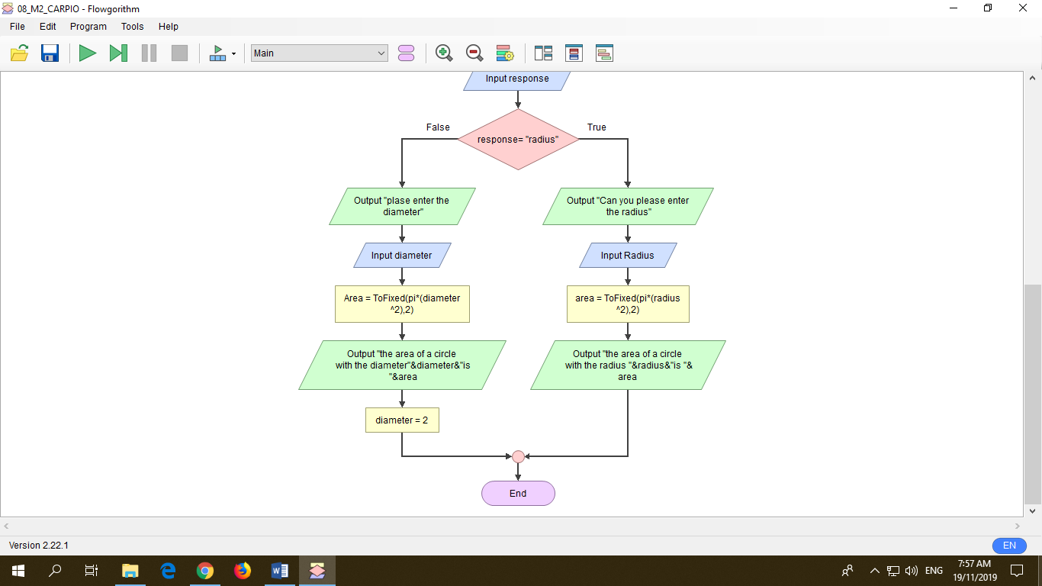

Discussion: In tackling the zone of a circle utilizing Radius and Diameter, First I embed announce and Real Radius, Real Variable, Real Diameter, and Real Answer. After that I Insert proclaim and put String Response and String yes. Next is embed Output and inquire as to whether "do you have an estimation of sweep and width?" and after that addition Input Response. What's more, next is make a choice on the off chance that it is valid or invalid. In the event that it is invalid you should utilize the measurement and on the off chance that it is genuine you need to utilize Radius and you will go into some advancement and you will get the yield, and that will be the end.