Applicant Day Games Programming Task

# Run application

Press F5 to run the application. The Left and Right Arrow keys will move the zombie left and right. However, the zombie does not animate. During this short task we will add code to enable and control the animation.

# How animation works

A typical animation of this type uses a Sprite Sheet (figure 1), a series of images of the zombie in different poses. That when put together form the animation.

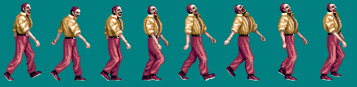

Figure 1 Zombie Sprite Sheet

# Adding animation code

Open the zombie.cpp file.   
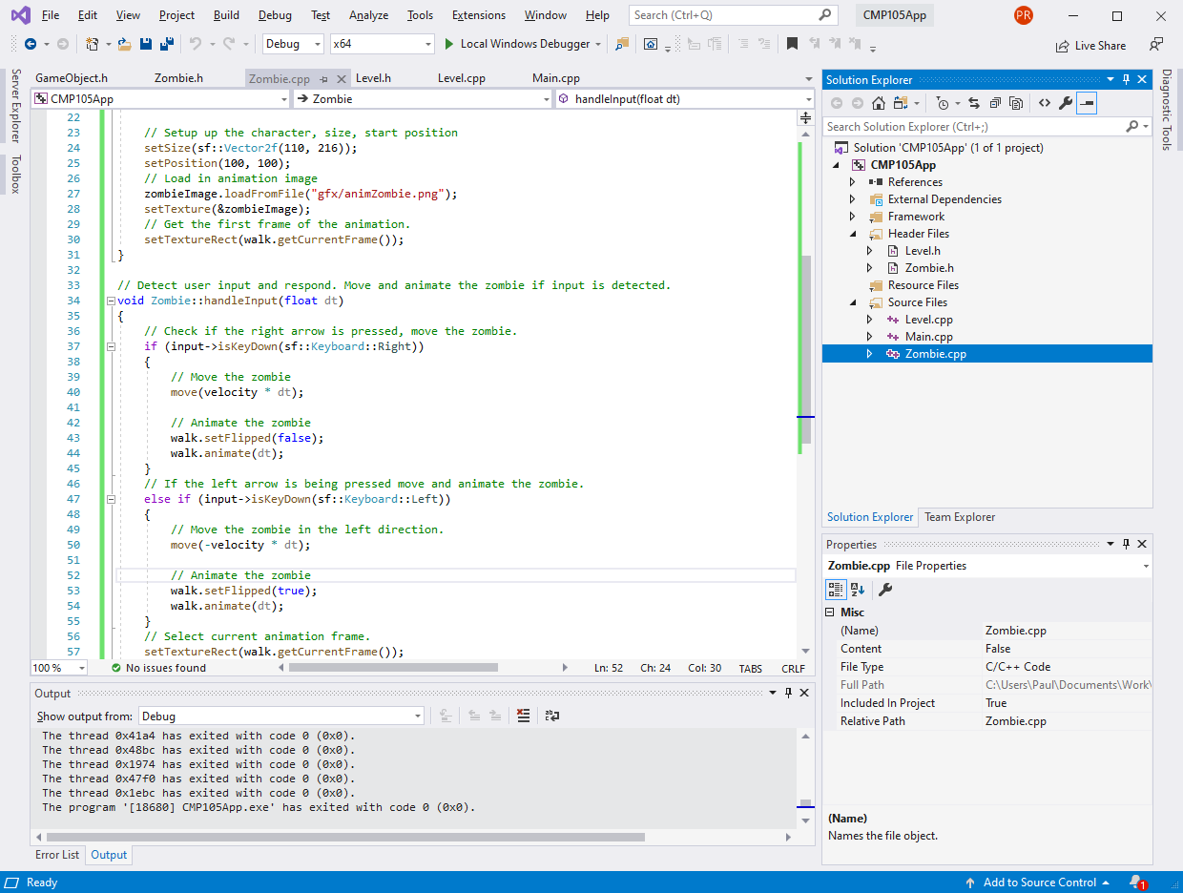  
This controls zombie movement and we will update it to add code for the animation. Find the following code section and add the highlighted lines of code.

|  |
| --- |
| void Zombie::handleInput(float dt)  {  // Check if the right arrow is pressed, if pressed move the zombie.  if (input->isKeyDown(sf::Keyboard::Right))  {  // Move the zombie  move(velocity * dt);  // Animate the zombie  walk.animate(dt);  }  // If the left arrow is being pressed move the zombie to the left.  else if (input->isKeyDown(sf::Keyboard::Left))  {  // Move the zombie in the left direction.  move(-velocity * dt);  // Animate the zombie  walk.animate(dt);  }  // Select current animation frame.  setTextureRect(walk.getCurrentFrame());  } |

Press F5 and run the project again. Now pressing left and right will move and animate the zombie. Only animating while the zombie is moving.

# Fix it

You will notice that the zombie doesn’t change direction when moving, so he animates walking forward while moving backwards. To fix this we can flip the sprite information depending on the direction the zombie is moving. Update the code adding the highlight lines of code.

|  |
| --- |
| void Zombie::handleInput(float dt)  {  // Check if the right arrow is pressed, move the zombie.  if (input->isKeyDown(sf::Keyboard::Right))  {  // Move the zombie  move(velocity * dt);  // Animate the zombie  walk.setFlipped(false);  walk.animate(dt);  }  // If the left arrow is being pressed move and animate the zombie.  else if (input->isKeyDown(sf::Keyboard::Left))  {  // Move the zombie in the left direction.  move(-velocity * dt);  // Animate the zombie  // Flip the walk animation to make the zombie animate the other way.  walk.setFlipped(true);  walk.animate(dt);  }  // Select current animation frame.  setTextureRect(walk.getCurrentFrame());  } |

Press F5 and run the project again. Now the zombie should move left and right and animate in the correct direction.