Follow the steps below to include a Twitter feed in the application:

- Edit your XML file

  - Add a <page> element
  - Inside, add a <twitter> element, with a title attribute
  - Next, add an <account> element, with an empty widgetId attribute
  - Save the file.
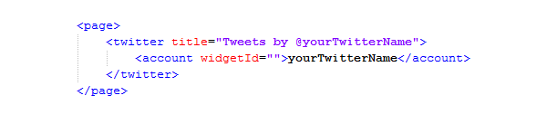
- Set up a timeline widget – this will show the latest tweets from @yourTwitterName

  - Go to http://twitter.com/yourTwitterName, e.g http://twitter.com/abertaysls
  - Log in and select Settings.
  - Select Widgets.
  - Click on Create New.
  - The details used to create the timeline widget will be pre-populated. No changes are necessary. Click on Create widget.
  - Under the preview on the right side is a box containing code. Find the 18-digit code found next to data-widget-id, as shown here:

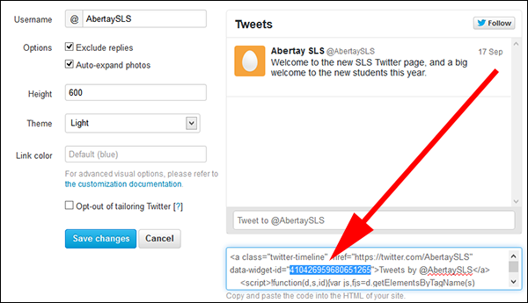
  - Copy and paste the highlighted code into the widgetId attribute in your XML file, as follows:

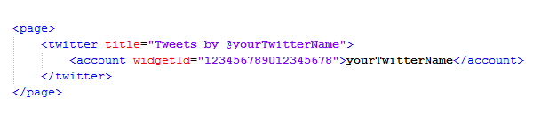
- Optionally, you may also include a hashtag, e.g #abertay. The application will display tweets using this hashtag in a tab alongside your timeline.

  - Edit your XML file to include a <hashtag> element with an empty widgetId attribute, as shown below:

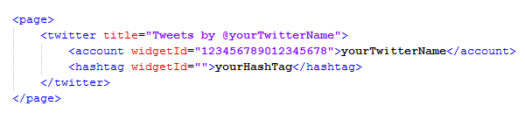
  - Log in to your Twitter account, and go to Settings.
  - Select Widgets.
  - Click on Create New.
  - Select the Search tab.
  - In Search query, enter the hashtag you wish to use. No other changes are required.
  - Click on Create widget.
  - As before, find the 18-digit widget code:

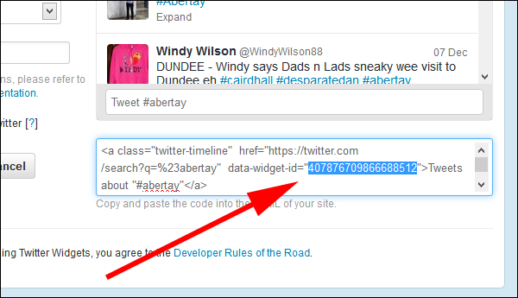

  - Copy the code into the empty widgetId attribute in your XML file:
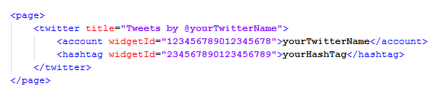
  - Save the file, and upload it to the server.

- The application is now set up to use your Twitter feed.

