**FLOWCHART**

According to the site Edraw max soft a flowchart is a graphic representation of how a process works, showing, at a minimum, the sequence of steps.

*Flowchart diagram “is a diagram that uses a set of standard graphic symbols to represent the sequence of coded instructions fed into a computer, enabling it to perform specified logical and arithmetical operations. It is a great tool to improve work efficiency. There are four basic symbols in program flowchart, start, process, decision and end. Each symbol represents a piece of the code written for the program.”*

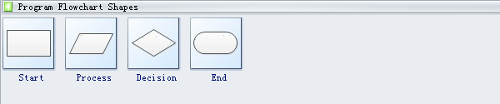

**Start** event symbol signals the first step of a process.

**Process** is a series of actions or steps taken in order to achieve a particular end.

**Decision** is the action or process of deciding something or of resolving a question.

**End** event symbol stands for the result of a process.

**Benefits of Program Flowchart**

The advantages of program flowchart are as follows (Edraw max. N.D):

* Program flowchart can help programmers to find the bug in the process before carrying out.
* It works as a blueprint when analyzing the systems and developing programs, which makes coding more efficient.
* It improves programmers’ efficiency in maintaining the operating program.
* With the help of program flowchart, communicating the logic of a system to all concerned gets much easier.

**PSEUDOCODE**

The definition of flowchart can be divided into the following two parts:

**Flow** - It is a representation of a series of logic operations to satisfy specific requirements. It can be irregular, naturally, unfixed or full of problems. For this reason, it may apparently be absent in some situations.

**Chart** - It is a presentation or a written description of some regular and common parts of the flow. A chart is conducive to communication and concentration and offers references for process engineering.