**ECE 6310**

**Introduction to Computer Vision**

**Fall 2022**

Lab 1

Harshal B. Varpe

In this lab the students were asked to implement three version of 7x7 mean filter. Each implementation was to be timed multiple times and average time values were to be considered to decide which implementation of the filter was faster. The three different version were: A standard 7x7 mean filter, a Separable 7x7 filter, and Separable – Sliding window 7x7 filter. The filters were written in C language with help of baseline code of 3x3 mean filter. The image format is “.ppm”. The output images files were supposed to have no differences.

Fig 1 - Input image (bridge.ppm)

The following table shows the how much time each run of each filter took in nanoseconds. Each version of filter was run 10 times.

|  |  |  |  |
| --- | --- | --- | --- |
|  | Standard 7x7 Filter | Separable 7x7 Filter | Separable – Sliding Window 7x7 Filter |
| 1 | 21924000 | 7416800 | 2987100 |
| 2 | 20967600 | 6857800 | 3054300 |
| 3 | 21334800 | 6887500 | 2752600 |
| 4 | 21629200 | 7116800 | 2899100 |
| 5 | 21450900 | 7034500 | 2679800 |
| 6 | 21780800 | 7046600 | 3036400 |
| 7 | 21786300 | 7007400 | 2769300 |
| 8 | 21383900 | 6893600 | 2776300 |
| 9 | 21280300 | 7290400 | 3234300 |
| 10 | 21688500 | 6896000 | 3136300 |
| Avg | 21522630 (21.52263 ms) | 7044740 (7.04474 ms) | 2932550 (2.93255 ms) |

From the table above, we can see that results were as expected. The standard filter requires way more calculations. The four nested for loops required increase the time complexity of the algorithm. Separable filter was approximately 3 times more efficient than the standard filter. This is because we use only three nested for loops, thus decreasing the time complexity a bit. We can also see that the hybrid of separable filter and sliding window filter was the fastest. It was approximately 7 times more efficient than the standard filter and approximately 2.4 times more efficient than the separable filter.

Fig 2 – Standard 7x7 mean Filter

Fig 3 – Separable 7x7 Filter

Fig 4 – Separable Sliding Window Filter

The result images produced had no differences. The differences were checked using FC and diff commands.

Fig 5 – FC command to check differences  
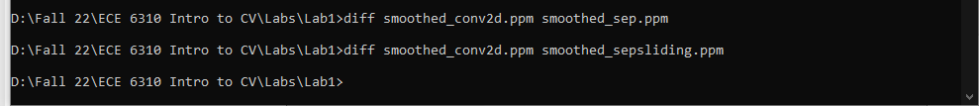  
Fig 6 - Diff command to check differences between files.

Fig 7 – Output Image

[All files can be found [here](https://github.com/Abetelgeusian/ECE631).]