KATHMANDU UNIVERSITY

DHULIKHEL, KAVRE



COMP 202

Lab Report: 1

Submitted By: Submitted To:

Abhyudit Adhikari Dr. Rajani Chulyadyo

CE (II/ I) DOCSE

Roll no. 2

Date: 24 April 2023

Description:

The GitHub repository attached below contains The Implementation of Stack using Linked Lists in C++. A class called “node” is created in the header file, which acts as a node of the list. Another class of the same file, “linkedList” contains the HEAD and TAIL pointers along with the declaration of all functions used in the program. A source file, “linkedlist.cpp” contains all the definition of the functions to be used and finally a “main.cpp” file is created which contains the object of the “linkedList” class. The functions of these class are utilized using the object created.

Output:

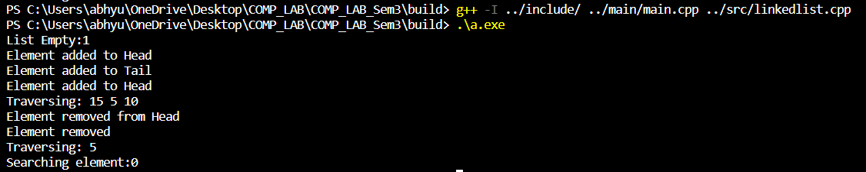

GitHub Repository:

<https://github.com/Abh03/COMP_LAB_Sem3>