**EXPERIMENT NO.-1**

***Acceleration Due to Gravity***

**Object:** To study the variation of *T* with *l* for a compound pendulum (bar pendulum) and then to determine:

1. the value of the acceleration due to gravity (*g*) in the laboratory,
2. the position of centre of gravity of the bar,
3. the radius of gyration *K* of the bar about an axis passing through C.G. and perpendicular to its length.

**Apparatus used:** Bar pendulum, stop watch, knife edges fixed to a rigid support and

metre scale.

**Formula used:**

The value of *g* can be calculated with the help of the following formula:



Or



*L* = distance between centers of oscillation and suspension.

i.e., the equivalent length of simple pendulum (It can be obtained from graph).

*T* = periodic time.

**Description of Apparatus:**

A bar pendulum consists of a uniform rectangular bar about a meter long with holes drilled along its length at equal distances from each other. The centre lies on the straight line passing through the centre of gravity of the pendulum. A sharp knife edge is attached to some heavy frame provided with leveling screws to make the knife edge horizontal. The bar can be suspended from any hole with the help of knife edge as shown in fig. (1).

***(NOTE: The bar pendulum is a section of a rigid body)*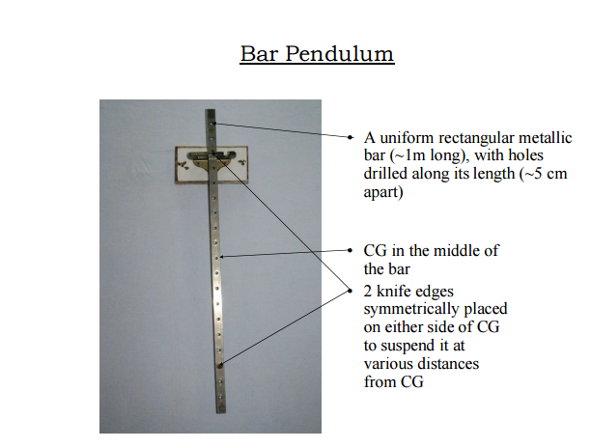**

**Principle:** The principle is based on the interchangeability of the centres of suspension and oscillation. We know that for a point of suspension, there is another point on the other side of centre of gravity, known as centre of oscillation about which the time period is the same; there are also two other such points. The distances between centre of suspension and centre of oscillation is known as the length of equivalent simple pendulumknowing this distance ‘*g*’ can be calculated.

**Procedure:**

1. The bar pendulum is hung vertically by means of a knife edge.
2. Allow the bar to oscillate through a small angle with knife edge passing through hole no. (1) and note the time for 20 oscillations with the help of a stop watch. Find the time period of one oscillation. Remember that the knife edge at the lower end should be in hole no. (1).
3. Insert the knife edge in the next holes and find the time periods till the centre of gravity is approximately reached. The knife edge at the lower end should be changed accordingly.
4. Turn the bar pendulum and repeat the same procedure.
5. A graph is plotted between *T* (time period) and the distance of knife edge *x* taking origin in the centre of the graph.

**Observations :**

**Table for measurement of *l* and *T*.**

|  |  |  |  |  |  |  |
| --- | --- | --- | --- | --- | --- | --- |
| No. of hole | Distanced of the hole from C.G. meter | No. of oscillations | Time taken | | | Periodic Time *T*secs. |
| Min. | Secs. | Total secs. |
| 1  2  :  :  7  8 | 0.40  0.35  :  :  0.10  0.05 | 20  20  :  :  :  : | …  …  :  :  …  … | …  …  :  :  …  … | …  …  :  :  …  … | …  …  :  :  …  … |
| Position of centre of gravity (Turn the bar pendulum) | | | | | | |
| 9  10  :  :  :  1  16 | 0.05  0.10  :  :  :  0.35  0.40 | 20  20  :  :  :  :  : | …  …  :  :  :  …  … | …  …  …  …  … | …  …  :  :  :  …  … | …  …  :  :  :  …  … |

**Calculations:** Plot a graph between period of oscillation *T*, against the distance of the hole from the centre of gravity, taking origin at the centre of the graph so that distances on one side of C.G. be taken positive, while on the other side as negative. The graph is one of the shape as shown in fig. (2).

Draw a line *AD* on the graph which cuts the graph at four points about which the time periods are the same. If the point *A* is centre of suspension then *C* is the centre of oscillation and the distance between the two is the length of the equivalent simple pendulum (*L*). Corresponding to these points, time periods may be obtained from

A

B

C

C.G.

DISTANCE OF HOLES DISTANCE OF HOLES

FROM C.G. (IN METRE) FROM C.G. (IN METRE)

PERIODIC TIME

Y

X

X

L

T

D

L

period axis. Now ‘*g*’ can be calculated by applying the following formula:



From graph



and

∴

**Result:** The value of acceleration due to gravity at … (Name of city) = … m/sec2

**Standard result:** The value of *g* at … = 9.8 m/sec2

**Percentage error:** = … %

**Sources of error and Precautions:**

1. Before starting the experiment, the knife edge is made horizontal.
2. The amplitude of oscillations should be kept small.
3. The time of oscillations should be counted at least for 40 oscillations.
4. The pendulum should vibrate only in a vertical plane.
5. Curves on the graph should be drawn smoothly.

**Theoretical error :**

*g* is given by the formula



Taking log and differentiating,



= …

Maximum possible over = … %

More correct way of plotting graph in period of oscillation *T* and hole distance :

For the centre of gravity to be at the centre of bar, it is necessary that distribution of mass in the bar should be uniform all along its length. A small non-uniformity will, however, shift the position of C.G. from centre of bar. It is, therefore, always preferred to measure the distance of holes from one end of the bar fig. (3a) instead of measuring from its centre and then plot a graph as shown in fig. (3b).



o

o

o

o

o

o

o

o

o

o

0.1m

0.2m

0.3m

0.4m

0.5m

0.6m

0.7m

0.8m

0.9m

1.0m

PERIODIC TIME T SEC.Y

T

G

C

A

B

G

L

L

C

D

X

0 0.1 0. 2 0.3 0.4 0.5 0.6 0.7 0.8 0.9 1.00

DISTANCE OF HOLES FROM END A′

(IN METRE)

(a) (b)

Fig. (3)

Observations :

Table for measurement of *l* and *T*

|  |  |  |  |  |  |  |  |
| --- | --- | --- | --- | --- | --- | --- | --- |
| S.No. | Number of the hole | Distance of point of suspension (Knife edge) from one end of bar / meter | No. of oscillations | Time | | | Periodic Time *T*secs. |
| Min | Sec. | Total sec. |  |
| 1  2  3  :  :  9  10 | …  …  …  :  :  …  …  … | …  …  …  :  :  …  …  … | 20  20  20  :  :  20  20  20 | …  …  …  :  :  …  …  … | …  …  …  :  :  …  …  … | …  …  …  :  :  …  …  … | …  …  …  :  :  …  …  … |